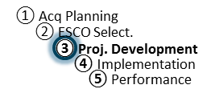
IGA/Proposal Review Workshop Agenda
ESPC Process Doc. P3-04
Rev. 08-27-18
Responsibility: PF

IGA/Proposal Review Workshop Agenda*

(minimum topics required to be covered are listed)

Introductions/Roles
- Welcome by Agency
- Introductions (as needed by PF)

Objectives of the IGA Workshop
- Bring all parties together to identify, discuss, and reach agreement on all remaining issues to enable Task Order award.

Resolution of Remaining Issues
- Final project scope
  - ECMs
  - M&V
  - Risk, Responsibility, and Project Performance
  - O&M, Repair & Replacement
  - Training
- Price Proposal
  - TO Schedules (sourced from eProject Builder)
  - Pricing
  - Financing
  - O&M, Repair, and Replacement
- Schedule
- Discuss transition from award to post-award and construction planning
- Other Items

Award Plan
- Plan/schedule for Task Order award.
- Plan/schedule for final eProject Builder verification

* Agenda is useable for both original task order or subsequent modifications. See the IDIQ contract for further requirements for modifications.

