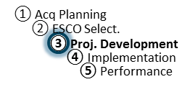
IGA Midpoint Review Meeting Agenda
ESPC Process Doc. P3-02
Rev. 11-14-18
Responsibility: PF

IGA Midpoint Review Meeting Agenda
(topics are suggestions)

Introductions/Roles
- Welcome by Agency
- Introductions and roles of each person in the project (PF)

Objectives of the Meeting
- Achieve understanding of what is proposed
- Gather all comments to deliver to ESCO

Review Items
- ECM technical descriptions, baselines, and savings
- M&V Plan
  - Witnessing
- Management Approach
  - Risk, Responsibility, and Performance Matrix
  - O&M, Repair & Replacement
- Updated TO Schedules

Wrap-Up/Next Steps
- Discussion of steps following comment delivery to ESCO
- Comment finalization completed by: __________________
- Send further comments to: _____________________
- Is a follow up call or meeting required prior to sending comments to ESCO?

