
June 2010
Version 1.2

D
[Type a quote from the document or the summary of an interesting point. You can position the text box anywhere in the document. Use the Text Box Tools tab to change the formatting of the pull quote text box.]

Table of Contents
An Invitation from Secretary Steven Chu 4
Introduction: DOE Open Government Plan 5
DOE Openness Innovation 6
The DOE Approach to Open Government 10
Developing the DOE Open Government Plan 11
DOE Open Government Governance Framework 12
DOE Open Government Program Timeline 13
DOE Open Government Web Site 14
Public Participation on DOE Open Government Program 14
DOE Congressional Testimonies, Public Meetings, Briefings and Press Releases 15
DOE Open Government Performance Measures 15
Flagship Initiatives 16
Open Energy Information, www.openei.org 16
ScienceEducation.gov, www.scienceeducation.gov 17
EIA Energy Education and Literacy Initiative 18
Transparency 20
DOE Financial Visibility 20
Current High-Value Datasets 21
Current High-Value Information 31
Future High-Value Information and Datasets 33
Presidential Open Government Initiatives 34
The DOE Freedom of Information Act Program 36
Congressional Correspondence and Requests for Information 39
DOE Declassification Programs 40
Additional DOE Transparency Programs 41
Participation 44
Collaboration 48
Conclusion 51
Appendix A - The President’s Memorandum and the OMB Open Government Directive 52
Appendix B – DOE Open Government Progress and Key Dates 54
Appendix C - Key Links Supporting DOE Open Government Initiatives 56
Appendix D – DOE Open Government Initiative Contact Sheet 58
Appendix E - The Department of Energy’s History, Missions and Organizational Structure 59
Appendix F -Key DOE High Value Dataset Audiences 62

Table of Figures
Figure 1 - Secretary of Energy Steven Chu 4
Figure 2 - DOE Flagship Initiative Summary 5
Figure 3 - The DOE Open Government Plan Highlights 5
Figure 4 - DOE L-Prize Fast Facts 6
Figure 5 - DOE Green Portal Topics 7
Figure 6 - National Lab Day 7
Figure 7 - Secretary Chu and Mrs. Obama with 2010 Science Bowl Middle School Championship Team 8
Figure 8 - DOE's Openness Goals & its Management Principles drive its Strategic Success 9
Figure 9 - The DOE Open Government Governance Framework 11
Figure 10 - The DOE Open Government Program Timeline 12
Figure 11 - Secretary Chu's Statement on Transparency at DOE 15
Figure 12 - OpenEI 16
Figure 13 - ScienceEducation.gov 16
Figure 14 - Energy Kids 17
Figure 15 - Congressional Correspondence Process 36
Figure 16 - DOE YouTube Channel 41
Figure 17 - Energy Empowers 43
Figure 18 - WorldWideScience.org Banner 44
Figure 19 - The DOE Functional Organization Diagram 55
Figure 20 - The DOE Lines of Reporting Organization Chart 56

An Invitation from Secretary Steven Chu

From his first day in office, President Obama has pushed to make the federal government more open and more accessible to the American people. The Department of Energy is proud to be doing our part. In the past year, we have significantly expanded the amount of information available online about our programs, our funding awards, and our progress, as well as valuable data about energy production and consumption and trends within the energy industry. We have also used social media outlets such as YouTube and my personal Facebook page to engage the public directly and expand the national conversation on energy.
Figure 1 - Secretary of Energy Steven Chu

In December, the Administration directed federal agencies to take several additional steps to implement the principles of transparency, participation, and collaboration. You can find all of the steps we're taking in the full Open Government Directive.
The Department of Energy is making steady progress in implementing the Open Government Directive and giving citizens more access to your government, but we still have more to do. Throughout this process, we'll continue to confront challenges such as identifying the information of greatest interest to the public, developing more user friendly interfaces to make the information available, and strengthening cooperation with other agencies to better serve the American people. I invite you to review the Department of Energy's Open Government plan and share your ideas with us on how we may meet these challenges. As always, I appreciate your feedback at Facebook.com/StevenChu and open@hq.doe.gov .
Secretary Steven Chu

Introduction: DOE Open Government Plan
//The Department of Energy is pleased to invite the American Public to study and reference our Open Government Plan. The DOE plan is governed around three priority areas:
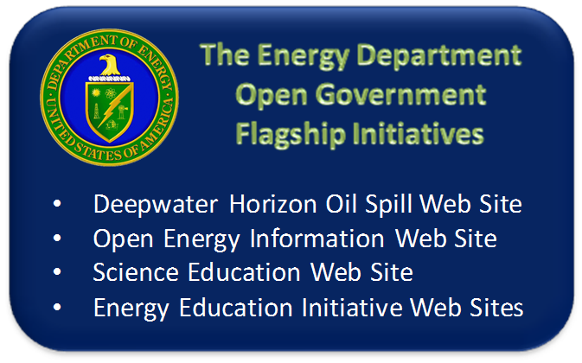
/
- Maintaining and increasing transparency.
- Increasing participation between the Department, its program offices, sites and the American Public.
- Increasing collaborative efforts between the Department and its stakeholders.
These three priorities are key to ensuring the Department achieves its strategic goals in areas ranging from energy security and environmental management to renewable energy technologies and energy efficiency. Transparency, participation and collaboration are also instrumental in advancing the Department’s commitment to its management principles.
Figure 2 - DOE Flagship Initiative Summary
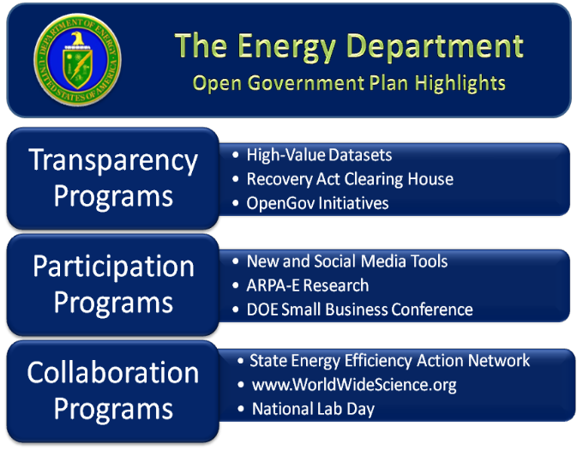
The Department of Energy’s Open Government Plan highlights three flagship initiatives. These include, Open Energy Information, an open source web platform featuring over 60 clean energy information resources and datasets; ScienceEducation.gov, an interagency website and networking tool for the Science, Technology, Education and Math (STEM) education community; and the Energy Information Administration’s (EIA) Education and Literacy Initiative. The EIA Initiative includes Energy Explained, an encyclopedia of energy issues; the Energy in Brief article series; and Energy Kids, an interactive website for students and teachers.
The Open Government Plan also features a number of transparency, participation and collaboration programs, such as the High-Value Information and Datasets from the Energy Information Administration, the Recovery Act Clearing House, the DOE SmallBusiness Conference, and the State Energy Efficiency Action Network.
Figure 3 - The DOE Open Government Plan Highlights

DOE Openness Innovation
The Department of Energy is committed to furthering its openness initiatives with new and innovative programs. In the first version of the DOE Open Government Plan, this section highlighted the Office of Energy Efficiency’s Weatherization Assistance Program and news service blog, Energy Empowers. In the updated version of the DOE Open Gov Plan, this section highlights two recently inaugurated programs, as well as two DOE-sponsored national competitions.

The L-Prize Competition, www.lightingprize.org/index.stm

The L Prize competition is the first government-sponsored technology competition designed to spur development of ultra-efficient solid-state lighting products to replace the common light bulb. The competition challenges industry to develop replacement technologies for two of today's most widely used and inefficient technologies: 60W incandescent lamps and PAR 38 halogen lamps. It also calls for development of a 21st Century Lamp that delivers more than 150 Lumen per Watt (lm/W). The competition will award significant cash prizes, plus opportunities for federal purchasing agreements, utility programs, and other incentives for winning products.
Figure 4 - DOE L-Prize Fast Facts
OpenNet, www.osti.gov/opennet/
In support the DOE’s commitment to openness, DOE has developed OpenNet. OpenNet provides easy, timely access to recently declassified documents, including information declassified in response to Freedom of Information Act requests.
As an example, the U.S. Department of Energy (DOE) has embarked on the Nuclear Weapons Film Declassification Project to make available to the public and many users films that contain historically significant events in the development of the U.S. nuclear weapons program. This is being done under the Department's Openness Initiative. The film project is being carried out by DOE's Albuquerque Operations Office (AL) in cooperation with the U.S. Department of Defense (DoD).

Green Energy Portal, www.osti.gov/greenenergy
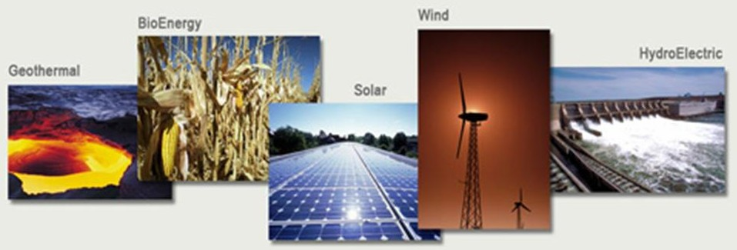
In Spring 2010, the Office of Scientific and Technical Information (OSTI) launched the Green Energy Portal. The portal hosts green energy results from research and development conducted throughout the Department and by DOE-funded awards at universities. These green energy results consist of over 30,000 technical reports and over 2,000 patents from R&D projects representing an investment of several billion dollars.
Figure 5 - DOE Green Portal Topics
This data collection has been developed for researchers to accelerate scientific discovery and innovation and for business and industry to stimulate economic growth related to renewable energy and energy efficiency. To contribute suggestions while OSTI works to improve the Green Energy Portal, please send comments and questions to GreenEnergy@osti.gov.

National Lab Day, www.nationallabday.org
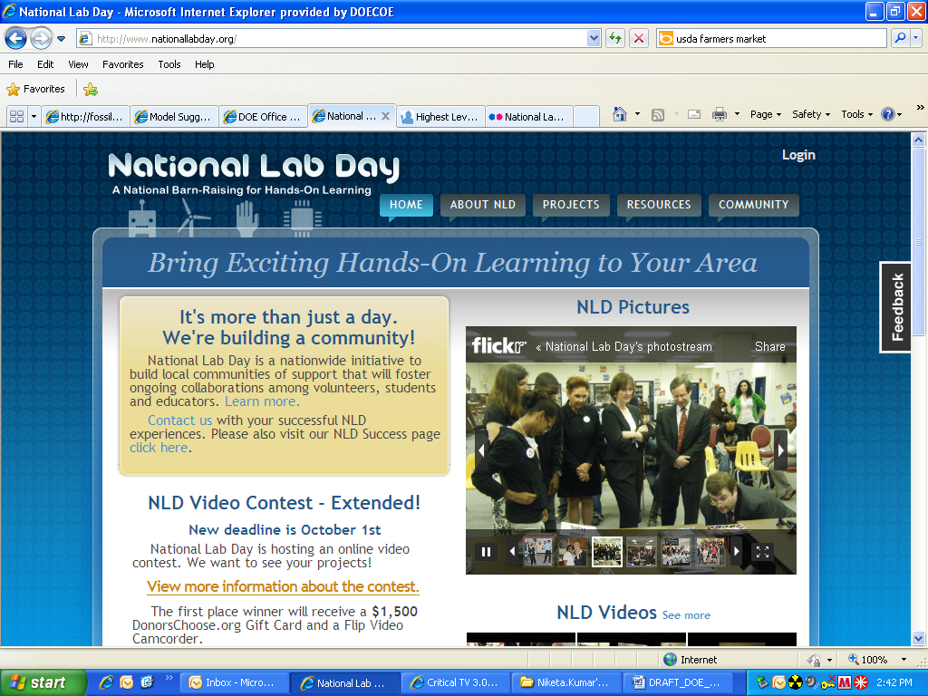
On May 12, 2010, the Department of Energy and its national laboratories celebrated the inaugural National Lab Day. In November 2009, President Obama announced this initiative as part of the Educate to Innovate campaign, a nationwide effort to foster student excellence in science and math. National Lab Day is a collaborative effort between government agencies and grassroots organizations to upgrade science labs, support project-based learning, and build communities of support for science, technology, engineering and math (STEM) teachers. The National Institutes of Health, the National Science Foundation and the Department of Energy are working with professional societies and foundations to connect Federal experts and scientists with teachers and local schools. As part of National Lab Day, DOE Under Secretary for Science Dr. Steven Koonin visited a bridge building competition at Roosevelt High School in Washington, DC. He spent time chatting with students about his experience as a young science student and gave advice to the aspiring scientists. Dr. William Brinkman, director of DOE’s Office of Science visited The School without Walls in Washington, DC and discussed the causes and potential solutions to global climate change.
Figure 6 - National Lab Day

National Science Bowl, www.scied.science.doe.gov/nsb/

In May 2010, the Department of Energy hosted the 20th annual National Science Bowl in Washington, DC. Sixty-eight high school teams and thirty-seven middle schools competed for the championship titles. The students were quizzed on range of science disciples including biology, chemistry, earth science, physics and astronomy, as well as math. Top prizes included $1,000 for schools’ science programs and an all-expense paid research trip for the high school champion to study the ecosystems of Belize in Central America. Middle school teams also raced model solar cars.
Figure 7 - Secretary Chu and Mrs. Obama with 2010 Science Bowl Middle School Championship Team

Created in 1991, the National Science Bowl is the nation’s largest academic competition of its kind. This year, First Lady Michelle Obama and Energy Secretary Steven Chu participated in the middle school championship round. Secretary Chu served as one of the judges, and Mrs. Obama asked the bonus point questions.

Solar Decathlon, www.solardecathlon.gov
In April 2010, Energy Secretary Steven Chu announced the 20 collegiate teams selected to compete in the next DOE Solar Decathlon in the Fall 2011. The applications for the 2011 competitions were evaluated by a panel of engineers, scientists, and experts from DOE’s National Renewable Energy Laboratory. Secretary Chu said, “

For two weeks on the National Mall, teams of college and university students from across the United States and the world will compete to design, build, and operate the most affordable, attractive, and energy-efficient solar-powered house.

The DOE Approach to Open Government
The U.S. Department of Energy is a diverse and dynamic federal agency. The Department has approximately 14,000 federal employees, 93,000 contracted employees and more than 80 sites and facilities, including 17 national laboratories, four power marketing administrations and one Energy Information Administration, along with seven international offices. The Department’s mission is focused on advancing national, economic and energy security in the United States. To fulfill this mission, DOE is committed to fostering US leadership in science, engineering and energy technology, implementing effective and innovative solutions to the nation’s energy challenges and continuing the environmental clean-up of the national nuclear weapons legacy. The Department of Energy’s Strategic Plan is being updated and will be available to the public when completed.

The Department of Energy’s strategic priorities, as Secretary Chu testified in early March 2010 before the U.S. House of Representatives Committee on Science and Technology, include:
- Transitioning to a low-carbon economy by developing and deploying clean and efficient energy technologies, increasing generation capacity and improving our transmission capabilities;
- Investing in scientific discovery and innovation to find solutions to pressing energy challenges and maintain American economic competitiveness; and
- Enhancing national security by ensuring the safety, security and effectiveness of the nuclear stockpile, working with our international partners to secure vulnerable nuclear material around the world within four years and advancing our nuclear legacy cleanup.
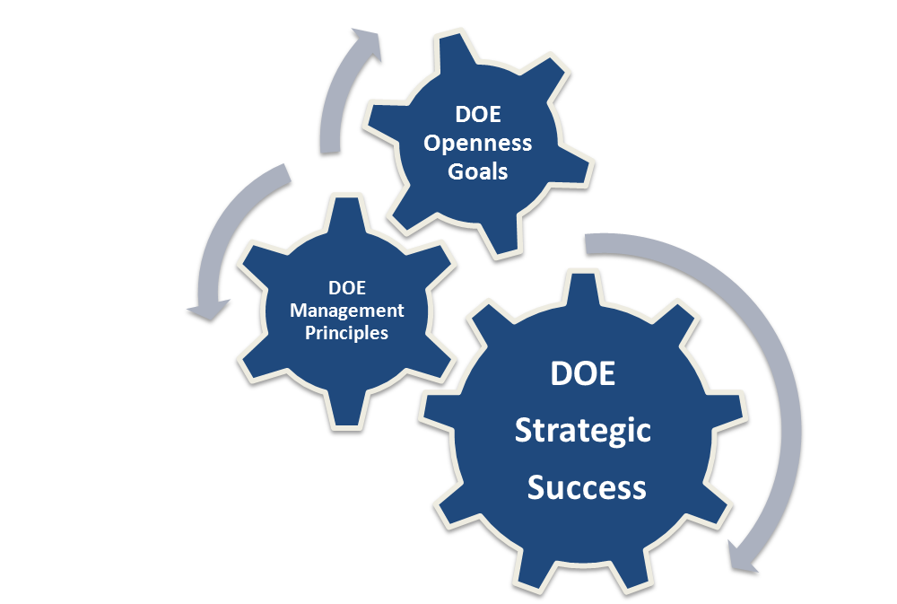
The Department is aligning the Open Government Plan with DOE strategic initiatives and its Openness Goals to increase transparency, participation and collaboration across its unique programs and offices. The Department has already fulfilled a number of key milestones towards making the federal government more open. There is still a lot of work left to do. The Department of Energy is committed to advancing open government in support of a more effective Department for its employees and for American people, businesses and communities.
Figure 8 - DOE's Openness Goals & its Management Principles Drive its Strategic Success

DOE Openness Goals and Strategic Initiatives
The Department is committed to integrating DOE its openness goals and strategic initiatives as well as its management principles. This integration is essential to developing the most effective DOE Open Government Plan.
The openness goals that the Department is pursuing are principally:
- Sharing DOE expertise with the public
- Increasing DOE accountability to the public
- Fostering leadership in scientific discovery and innovation
- Partnering with the public and outside groups on advanced research and engineering projects

These goals guide DOE Open Government initiatives. Moreover, the associated DOE management principles reinforce the objectives of DOE’s openness goals and strategic themes. These principles are:
- Our mission is vital and urgent.
- Science and technology lie at the heart of our mission.
- We will treat our people as our greatest asset.
- We will pursue our mission in a manner that is safe, secure, legally and ethically sound, and fiscally responsible.
- We will manage risk in fulfilling our mission.
- We will apply validated standards and rigorous peer review.
- We will succeed only through teamwork and continuous improvement.

The Department’s Open Government Plan is designed to leverage these fundamental goals and principles. Furthermore, integral to the Department’s approach to the Open Government Initiative is the belief that this must be a continuous process for improvement, entailing ongoing employee and public engagement, regular opportunities for input and feedback, and periodic reviews and measures of progress. The Department of Energy’s Open Government Plan will be updated every two years at minimum and will incorporate the products of these conversations and evaluations.

Developing the DOE Open Government Plan
In April 2009, Secretary of Energy Steven Chu sent a message to all DOE employees encouraging them to participate in the Open Gov process. The Secretary wrote, “I encourage everyone to think big, challenge conventional wisdom and identify the barriers that have hampered progress in the past….There is no doubt in my mind that together we can transform the Department of Energy and play a vital role in rebuilding our country and charting a path forward into the 21st Century. It is simply a matter of how we best do it, and for help with that, we are looking to you.”

The Department of Energy tapped its program offices, national laboratories and staff support offices to develop a plan founded on in-house collaboration and ingenuity, public input and strong partnerships with other agencies and stakeholders. Within the Department, the Office of the Chief Information Officer (OCIO) took the lead. OCIO reached out to DOE program offices, support and staff offices and national laboratories. These offices and labs responded with their best open government ideas and initiatives and how they are working to be more transparent, cultivate participation among the public, and foster collaboration with other agencies and institutions. These ideas and initiatives established the foundation for the DOE Open Government Plan. Moving forward, the OCIO continues to work with these offices and labs to improve open government at the Department and establish a sustainable plan that grows more effective with each updated version.

DOE Open Government Governance Framework
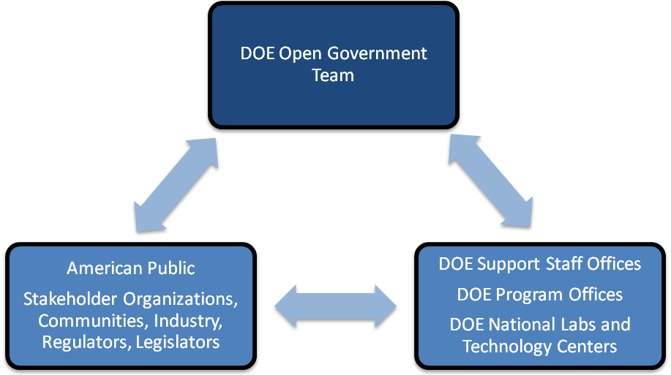
The Department of Energy’s Open Government team is in the Office of the Chief Information Officer (OCIO) and works collaboratively with the Office of Public Affairs. TheAnne Gordon, the Associate CIO for IT Planning and Architecture, is the Department of Energy’s Open Government Representative. The Open Government Team works with DOE offices and programs on the Department’s openness goals and initiatives, preparing the DOE Open Government Plan, and executing the Department’s Open Government Program.
Figure 9 - The DOE Open Government Governance Framework
Just as the Open Government team works to collaborate with internal DOE stakeholders and offices to plan and execute Open Government initiatives at the Department, the team collaborates with the American public through a variety of communication strategies, including online forums, social media tools and stakeholder meetings.

The DOE Open Government team is also supported by and works in conjunction with the DOE Office of the Chief Financial Officer, the Office of the General Counsel, and the Office of Management to carry out its mission.

DOE Open Government Program Timeline
Over the coming years, the Department of Energy is committed to progressively expanding the openness of its information and programs to the American public. This commitment comes from Secretary Chu’s conviction that there is a central role for the public to play in the DOE Open Government Program. The timeline below will guide our current efforts as well as our planning moving forward.

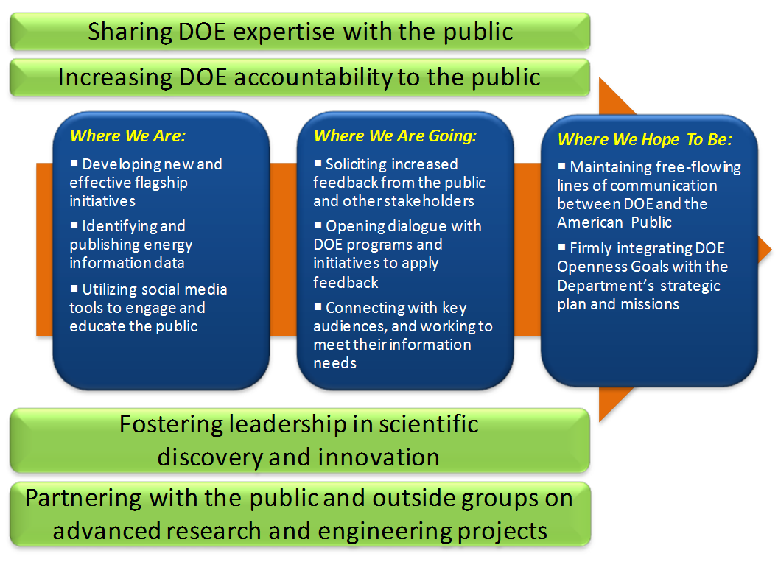
Figure 10 - The DOE Open Government Program Timeline

DOE Open Government Web Site
The Department developed its Open Government website, www.energy.gov/open, to serve as an online resource for the public, DOE employees, and stakeholders. Visitors can download the DOE Open Government Plan from this site and view additional open government resources, including links to key high value datasets, FOIA information, Secretary Chu’s Facebook page, and the DOE YouTube Channel. Further, the website hosts links to the DOE Open Government Self-Evaluation and the White House Open Government Dashboard. DOE was the first Federal agency to use the MOBI format to enable access from mobile book readers. Over the next six months, the Department plans to re-launch a more user-friendly Open Government website.

Public Participation on DOE Open Government Program
The Department of Energy encourages public participation and recognizes it as a fundamental part of Open Government. The Department utilizes web-based collaboration tools, such as email, website, and social media tools (Facebook, Twitter, YouTube) to allow employees, the public, and stakeholders to participate in discussions, and provide feedback on energy related topics.

The Department of Energy utilized IdeaScale, a public engagement tool to gather ideas from the public on how the Department can improve the availability and quality of information, work better with others inside and outside the government, and be more efficient and innovative. The Department will be re-launching an IdeaScale comment period to gather public feedback on the latest update to the DOE Open Government Plan.

DOE utilizes machine generated captioning, that can be toggled on and off by the end user, on all our YouTube videos. In addition, DOE uses social media companies that have worked with GSA to develop terms of service that assures accessibility with the social media sites. Ideascale, for example, made some modifications to their site to make it more accessible for screen readers.

The Open Government Team monitors the Open Government mailbox (open@hq.doe.gov) on a daily basis. We will make every effort to refer public comments to the appropriate office within the Department and will strive to respond and resolve comments within 6 weeks of submission. The OCIO has responded to 92% of comments from the first Ideascale comment period.

DOE Congressional Testimonies, Public Meetings, Briefings and Press Releases
The opportunities available for the American Public to participate in and contribute to the way that the Department of Energy conducts its business are numerous. Below are links to find information about DOE’s overall public events and those of its program offices.

- Department of Energy Events: www.energy.gov/news/events.htm
- Office of Science: http://www.sc.doe.gov/News_Information/speeches_testimony.htm
- National Nuclear Security Administration: http://nnsa.energy.gov/mediaroom/pressreleases
- Office of Environmental Management: http://www.em.doe.gov/Pages/AllNews.aspx
- Office of Energy Efficiency & Renewable Energy: http://www.eereblogs.energy.gov/energysavers/post/Be-Part-of-the-Solution!.aspx
- Office of Fossil Energy: http://fossil.energy.gov/
- Office of Nuclear Energy: http://www.ne.doe.gov/students/Track_teachers.html
- Office of Electricity Delivery & Energy Reliability: http://www.oe.energy.gov/newsroom.htm

DOE Open Government Performance Measures
The Department of Energy has established performance measures to evaluate the success and impact of its Open Government Plan. These performances measures fall into the three Open Gov categories: transparency, participation and collaboration. As the DOE Open Government Plan evolves, so will the performance measures.
Transparency
- Number of downloads per DOE dataset
- Data.gov ongoing goals
- DOE Open Government response rate evaluations, i.e. time to respond and types of responses
- Public participation statistics on DOE rulemakings
- DOE Freedom of Information Act office statistics
Participation
- Number of joint public-private sector project reports and feedback to program offices
- Number of social media and other public engagement tools
- Feedback from IdeaScale comment periods and emails to Open Government team
Collaboration
- DOE organizational assessments from the Office of Management
- DOE patent office statistics, including number of patents granted and pending

Flagship Initiatives
The Department of Energy’s Open Government Plan features four flagship initiatives. These initiatives advance the Department’s efforts to be more transparency and increase participation and collaboration.

Deepwater Horizon Response Oil Spill Data, www.energy.gov/oilspilldata
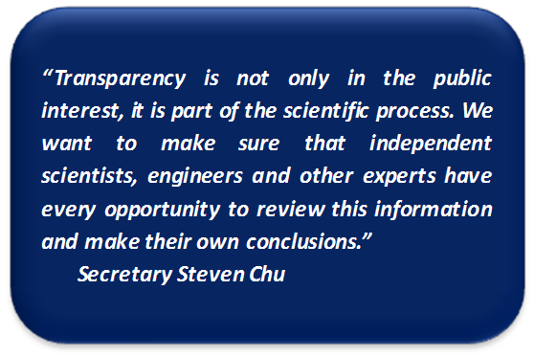
As part of the Obama Administration’s ongoing commitment to transparency surrounding the response to the BP oil spill, the Department of Energy is providing online access to schematics, pressure tests, diagnostic results and other data about the malfunctioning blowout preventer. The site includes oil and gas collection data and high-definition footage of the oil leak. This high-definition footage is also available on the Department’s YouTube Channel.

Secretary Chu insisted on making the data widely available to ensure the public is as informed as possible, and to ensure that outside experts making recommendations have access to the same information that BP and the government have. This site is updated regularly with new data and additional documentation.
Figure 11 - Secretary Chu's Statement on Transparency at DOE

The Department has also developed an online Gulf Coast Oil Spill Resource Center. This webpage includes detailed information on how the Secretary’s response team has been monitoring the progress of efforts to contain the leak and helping design strategies for moving forward, along with the latest DOE news updates and photographs from the Secretary’s trips to the BP Command Center in Houston.

Open Energy Information, www.openei.org
In December 2009, as part of its efforts to promote clean energy technologies, the Department of Energy launched Open Energy Information. This open-source web platform makes a range of DOE resources and open energy data widely available to the public. The free, editable and evolving wiki-platform enables the sharing of resources by government officials, the private sector, project developers, the international community and others.

The Department’s Office of Energy Efficiency and Renewable Energy worked closely with the National Renewable Energy Laboratory (NREL) and other National Laboratories to develop and populate the Open Energy Information platform. The site hosts more than 60 clean energy resources and datasets, including project and system modeling software, international financing initiatives, clean energy training materials, maps of worldwide solar and wind potential, information on climate zones, and energy analysis and impact assessments. OpenEI.org also links to the Virtual Information Bridge to Energy (VIBE), a dynamic portal for energy data analysis. The American public and the global energy community now have the opportunity to upload additional data to the site and download the information in user-friendly formats.
Figure 12 - OpenEI
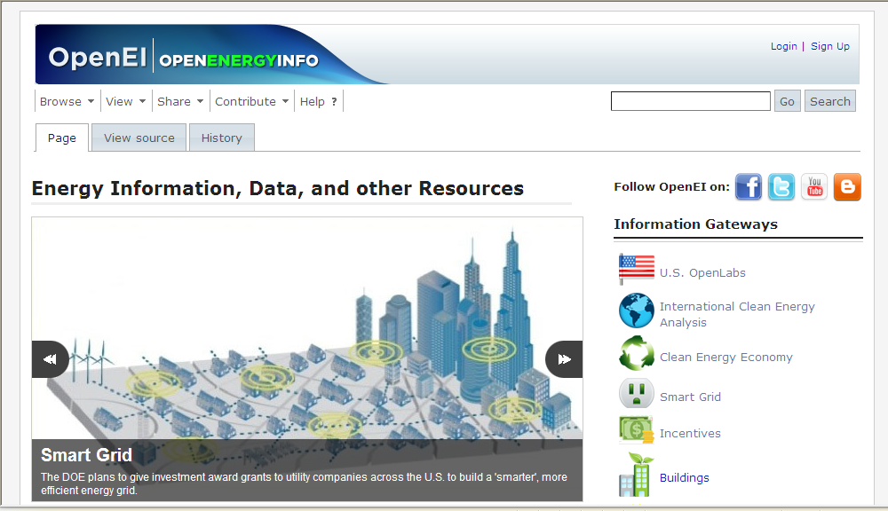
The Open Energy Information team understands that is it vital that the website is transparent and accessible to all users, not just labs and professionals interested in energy data. The data and tools available through the Open Energy Information platform will help consumers and business evaluate and select clean energy technologies for their homes and offices. The platform will also serve as an educational and reference tool for students, communities and researchers. OpenEI.org will play an important role providing technical resources, including US lab tools, to government agencies and other institutions across the country and around the world. Over time, this portal will include expanded on-line training, technical expert networks, and new data and information from US national labs and international partnerships.

ScienceEducation.gov, www.scienceeducation.gov
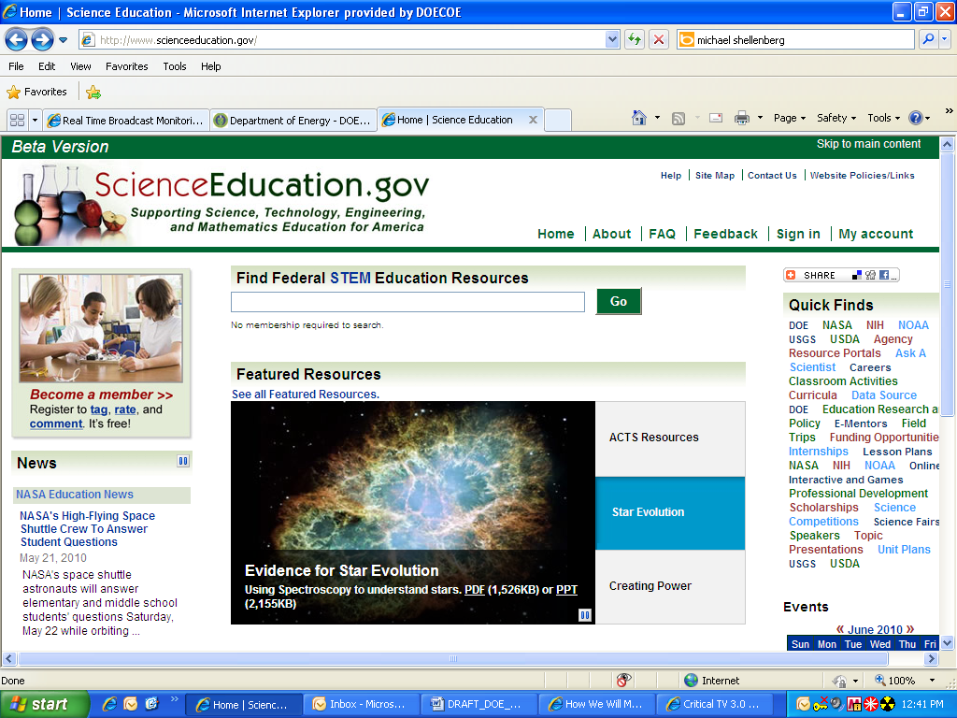
Early in 2010, the Department of Energy unveiled a beta version of a new interagency website with a web 2.0 platform, collecting the science, technology, engineering and mathematics (STEM) education resources from several federal agencies. ScienceEducation.gov features STEM education information from the National Aeronautics and Space Administration (NASA), the National Institutes of Health (NIH), the National Oceanic and Atmospheric Administration (NOAA), the Department of Agriculture (USDA), and the U.S. Geological Survey (USGS), and the Department of Energy.
Figure 13 - ScienceEducation.gov

Within the Department of Energy’s Office of Science, the Office of Workforce Development for Teachers and Scientists and the Office of Scientific and Technical Information partnered to develop this important resource for STEM educators, students and researchers. Federal agencies have also formed a voluntary interagency collaboration, the Interagency Science Education Portal Coordinating Group, which is advising the development of ScienceEducation.gov.

Scienceeducation.gov employs social networking software designed to encourage participation by the STEM education community through feedback, comments and ratings. Through this website, visitors have unprecedented access to STEM lesson plans, classroom activities, homework help and information relating to professional development, all searchable via a single query. Registered members can tag content by subject, grade range and content type. This framework provides an opportunity to use educators’ expertise to improve the website and increase access to STEM resources for students, parents and schools. Scienceeducation.gov furthers efforts to improve STEM education in the United States and enhance American competitiveness in science and technology.

EIA Energy Education and Literacy Initiative
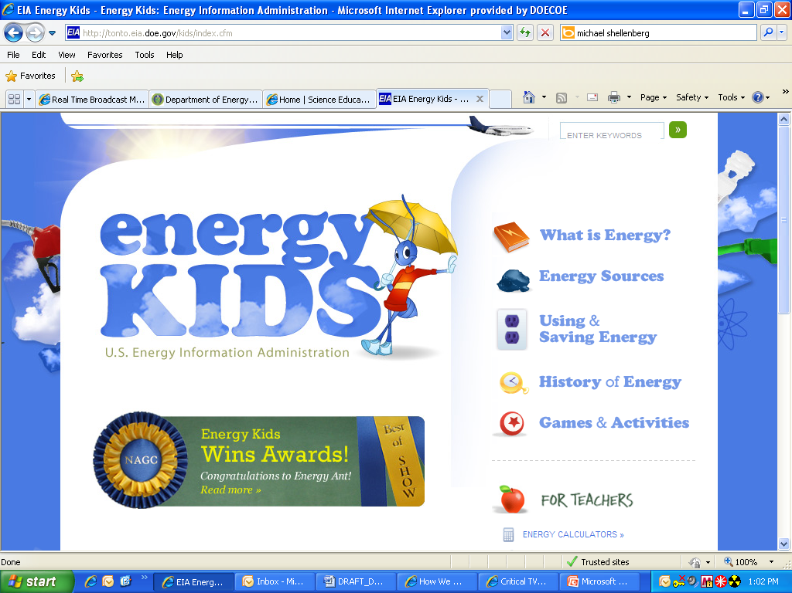
In 2009, the Energy Information Administration (EIA) launched Energy Explained and a redesign of its popular Energy Kids website. Energy Explained offers an encyclopedia of energy topics. The site explains where gasoline comes from, what determines the price of electricity, how much renewable energy the United States uses, and hundreds of other energy topics. It also features a user “star rating” and commenting system to facilitate audience feedback and engagement and builds in viral marketing techniques to market the product and further get the word out. Energy Kids features more than 100 pages of fun educational content for kids, parents, and teachers. Kids can learn about energy and challenge their brains with energy Sudoku, crossword puzzles, and word searches. The site also features energy-related stories, hands-on activities, and research articles for the classroom. It has used audience polling to determine final designs for promotional materials for kids and crowdsourcing to solicit lesson plans from teachers and make them available on the site.
Figure 14 - Energy Kids

EIA also publishes an “Energy in Brief” series, which presents a number of short articles on prominent energy issues. The articles explain important energy topics in plain language, provide a valuable tool to help the public understand these issues, help the Department of Energy understand topics of public interest and develop better ways to share this information.

These education initiatives strive to engage with a broader audience online and advance the public’s energy literacy. In May 2010, the National Association of Government Communicators (NAGC) honored Energy Kids as the first recipient of its "Best in Show" award, and as the first-place recipient of awards for "Best Website" and "Shoestring Budget." In April 2010, Energy Explained earned a "ClearMark" Award of Excellence in the category of "Best Website" from the Center for Plain Language. An Energy Education team within EIA is tasked with managing the content, adding innovative features and developing new products.

Transparency
Transparency promotes accountability by providing citizens with information about what the Government is doing.
- Open Government Directive

The DOE Open Government Plan’s transparency initiatives cover a wide range of departmental activities. These include: high-value information and datasets, Presidential Open Government initiatives, the Freedom of Information Act program, Congressional correspondence and declassification programs.

DOE Financial Visibility
Consistent with transparency, accountability, and informed participation across the government, DOE provides on-line access to agency budget justification documents submitted to Congress with the annual budget request. DOE’s public website provides various budget related documents including: DOE’s Budget Request to Congress (both Summary and Detail/Control tables), a laboratory breakout of the request, a state breakout and DOEs statistical tables. DOE also publishes its annual agency financial report online. DOE provides detail into the various program area specific budgets by providing direct links to their detailed budget and performance sites and reports.

Information available on the DOE web site includes:
- The DOE Annual Performance Report as well as its Summary of Performance and Financial Information report (formerly known as the Citizen’s report)
- Contract and award documents including Requests for Proposals, Contracts, Task Orders and Contract Modifications
- Written communications from registered lobbyists concerning the Recovery Act

DOE submits business opportunity notices to the Federal Business Opportunities (FBO) and Grants.gov web sites. Additionally, DOE’s procurement system (STRIPES) provides information to Federal Procurement System Next Generation (FPDS-NG). FPDS-NG includes procurement contract transactions reported directly through the contract writing systems of approximately 65 U.S. Government, Executive Branch, departments, bureaus, agencies, and commissions. FPDS-NG is one of the main sources for USASpending.gov, which provides a single searchable website, accessible to the public at no cost to access, that includes each DOE Federal award.

Current High-Value Datasets
The Department of Energy hosts a variety of high-value information and datasets which available to the public online. The Department is currently completing the necessary planning and governance processes to develop a timeline for the release of future high-value information and datasets.

The Department has established a Work Group to identify and develop high-value datasets that contain information that is distinctly different than already existing DOE datasets. The Work Group is charged with:

- Maintaining inventories of high-value datasets currently available for download
- Establishing a process to identify future high-value datasets
- Developing open format standards for the publication of these datasets
- Encouraging public use and awareness of these datasets
- Establishing and publishing a timeline and milestones for the preparation and release of future datasets
The Energy Information Administration and the Office of Science and Technical Information have made their High Value Datasets available through www.Data,gov.

In addition, The National Nuclear Security Administration (NNSA) is working to explore opportunities for increased public access to agency information. NNSA recognizes the public's interest in the U.S. Government's initiatives to reduce nuclear weapons and eliminate the threat of nuclear terrorism. While much of NNSA's involvement remains sensitive or classified due to its implications for national security, the NNSA is committed to ensure that information is accessible by the public when determined possible. While some information is already posted in various public domains and in the media, NNSA will work to inventory candidate data and make it centrally accessible through the Data.gov website.

Energy Information Administration, http://www.eia.doe.gov
The Energy Information Administration (EIA) is a statistical agency within the Department of Energy. EIA’s mission is to provide policy-independent data, forecasts and analyses to promote sound policy making, efficient markets and public understanding on energy and its interaction with the economy and the environment. By law, the Energy Information Administration’s products are developed independently and are not subject to clearance by the Department or other government agencies. EIA maintains and makes available on its public web site a large number of datasets. These datasets cover:
- Fuel reserves, production, prices, storage, transportation, demand, and imports and exports;
- End-use energy consumption by sector (residential, commercial, manufacturing and transportation);
- Short- and long-term forecasts of energy supply, demand, prices and other factors;
- Energy balances by country and by region around the world; and
- Financial and environmental information related to energy production and consumption.

The Energy Information Administration invites public and stakeholder input on its mission:
- EIA’s Customer Contact Center, which is open 9:00-5:00 ET every business day, responds to about 20,000 email and telephone inquiries from the public and stakeholders each year.
- Before seeking approval from the Office of Management and Budget for an information data request, EIA solicits public comments on proposals in a Federal Register Notice. EIA also obtains input from stakeholders on the proposed data collections at trade association meetings and other forums.
- Several times each year, EIA solicits input on its models and data collection programs from energy experts and academia through a program called Independent Expert Reviews.

In addition, the Energy Information Administration’s main public website conducts an online customer survey every year and collects feedback from over 5,000 customers and stakeholders.

Office of Scientific and Technical Information, http://www.osti.gov
The Department of Energy’s Office of Scientific and Technical Information (OSTI) fulfills the agency’s responsibilities to collect, preserve and disseminate scientific and technical information (STI) emanating from the Department’s R&D activities. OSTI’s mission is to advance science and creativity by making R&D findings available to the Department of Energy and other researchers and the public.

In April 2007, OSTI introduced Science Accelerator, a searchable database of the Department’s scientific and technical information, including research documents and summaries and results from DOE R&D projects.

The following sections list the High Value Datasets that the Department of Energy has published on Data.gov to date. Included within each section is a “Dataset Summary” that provides the basic information about that dataset.

1. Alternative Transportation Fuels (ATF) & Alternative Fueled Vehicles (AFV)
Historical Data: Alternative Transportation Fuels (ATF) and Alternative Fueled Vehicles (AFV)
DATASET SUMMARY
Agency | Department of Energy
Sub-Agency | Energy Information Administration
Category | Energy and Utilities
Date Released | March 2008
Date Updated | April 2009
Time Period | 1994, 1995, 1996, 1997, 1998, 1999, 2000, 2001, 2002, 2003, 2004, 2005, 2006, 2007
Frequency | Annual
Description | Data on alternative fueled vehicles in use and alternate transportation fuel consumption.

2. Annual Electric Generator Report
EIA-860 Annual Electric Generator Report

DATASET SUMMARY
Agency | Department of Energy
Sub-Agency | Energy Information Administration
Category | Energy and Utilities
Date Released | 1986
Date Updated | February 2009
Time Period | 2007
Frequency | annual
Description | This is a generator level data file that includes specific information about generators at electric power plants owned and operated by electric utilities and nonutilities (including independent power producers, combined heat and power producers, and other industrials). The file contains generator-specific information such as initial date of commercial operation, prime movers, generating capacity, energy sources, status of existing and proposed generators, proposed changes to existing generators, county and State location (including power plant address), ownership, and FERC qualifying facility status. Also included are data related to the ability to use multiple fuels; specifically, data on co-firing and fuel switching are included.

3. Annual Electric Power Industry Database
Form EIA-861 Annual Electric Power Industry Database

DATASET SUMMARY
Agency | Department of Energy
Sub-Agency | Energy Information Administration
Category | Energy and Utilities
Date Released | January 1985 to collect data as of year-end 1984
Date Updated | March 2009 for 2007 data
Time Period | 2007
Frequency | annual
Description | This is electric utility data in seven files that include information on generation, electric purchases, peak load, sales, revenues, customer counts, demand-side management programs, green pricing, net metering programs, and distributed generation capacity.

4. Coal Production by MSHA ID, Mine Operation, Union Status, and Average Number of Employees and Hours
Coal Production by MSHA ID, Mine Operation, Union Status, and Average Number of Employees and Hours

DATASET SUMMARY
Agency | Department of Energy
Sub-Agency | Energy Information Administration
Category | Energy and Utilities
Date Released | 1991
Date Updated | 2008
Time Period | 2007.0
Frequency | annual
Description | Coal Production Data Files contain information which identify the mining operation (i.e., operation name, mailing address, telephone number, State and county of operation, etc.), annual coal production, and code definitions.

5. Company Level Petroleum Imports
Company Level Imports (Petroleum)

DATASET SUMMARY
Agency | Department of Energy
Sub-Agency | Energy Information Administration
Category | Energy and Utilities
Date Released | 01/01/1986
Date Updated | 07/07/2009
Time Period | 2008
Frequency | Monthly
Description | Data on imports of crude oil and/or petroleum products into the 50 States, the District of Columbia, Puerto Rico, the Virgin Islands other U.S. possessions, and Foreign Trade Zones located in the 50 States and DC by each importer of record.

6. Conference Information XML Data Service
DOEConference XML Data Service

DATASET SUMMARY
Agency | Department of Energy
Sub-Agency
Category | Science and Technology
Date Released | 01-Jan-2006
Date Updated | 19-Nov-2009
Time Period | continuous
Frequency | bi-weekly
Description | Contains bibliographic data for science and technology conference proceedings and conference papers from the Energy Citations Database.

7. DOE Patents XML Data Service
DOEpatents XML Data Service

DATASET SUMMARY
Agency | Department of Energy
Sub-Agency
Category | Science and Technology
Date Released | 01-Jan-2006
Date Updated | 19-Nov-2009
Time Period | continuous
Frequency | bi-weekly
Description | Contains bibliographic data for a database of patents resulting from sponsored research by the Department of Energy and predecessor agencies.

8. DOE R&D Project Summaries XML Data Service
DOE Research and Development Project Summaries XML Data Service

DATASET SUMMARY
Agency | Department of Energy
Sub-Agency
Category | Science and Technology
Date Released | 01-Jan-2001
Date Updated | 23-Nov-2009
Time Period | continuous
Frequency | daily
Description | Contains bibliographic data for summaries of energy-related scientific projects performed since 1995 by DOE laboratories and other research facilities.

9. Energy Citations Database XML Data Service
Energy Citations Database XML Data Service

DATASET SUMMARY
Agency | Department of Energy
Sub-Agency
Category | Science and Technology
Date Released | 01-Jan-2001
Date Updated | 19-Nov-2009
Time Period | continuous
Frequency | bi-weekly
Description | Contains bibliographic data for The Energy Citations Database (ECD) providing access to historical and current research (1948 to the present) from the Department of Energy (DOE) and predecessor agencies.

10. Geothermal/Geothermal Legacy Data XML Data Service
Geothermal/Geothermal Legacy Data XML Data Service

DATASET SUMMARY
Agency | Department of Energy
Sub-Agency
Category | Science and Technology
Date Released | 01-Jan-2006
Date Updated | 19-Nov-2009
Time Period | continuous
Frequency | bi-weekly
Description | Contains bibliographic data for the Geothermal Technologies Collection providing access to Department of Energy sponsored current and historical full-text reports plus journal literature and documents from other governments, state agencies and organizations and the geothermal industry.

11. Information Bridge XML Data Service
Information Bridge XML Data Service Search Tool

DATASET SUMMARY
Agency | Department of Energy
Sub-Agency
Category | Science and Technology
Date Released | 01-Jan-1997
Date Updated | 19-Nov-2009
Time Period | continuous
Frequency | bi-weekly
Description | Contains bibliographic data for Department of Energy (DOE) research report literature available in full-text online.

12. Monthly Electric Utility Sales and Revenue Data
EIA 826 Monthly Electric Utility Sales and Revenue Data (1990 – 2009)

DATASET SUMMARY
Agency | Department of Energy
Sub-Agency | Energy Information Administration
Category | Energy and Utilities
Date Released | 1990
Date Updated | 4/24/09
Time Period | 2008
Frequency | Monthly
Description | Utility level retail sales of electricity and associated revenue by end-use sector, State, and reporting month.

13. Raw Data for U. S. Department of Energy (DOE) Categorical Exclusion (CX) Determinations Under the National Environmental Policy Act (NEPA)
DOERawData for CategoricalExclusion (CX) under NEPA

DATASET SUMMARY
Agency | Department of Energy
Sub-Agency
Category | Geography and Environment
Date Released | 16-Feb-2010
Date Updated | 16-Feb-2010
Time Period | 11/2/2009 - 2/12/2010
Frequency | approximately monthly
Description | To further transparency and openness, DOE established a policy to document and post online all CX determinations involving classes of actions listed in Appendix B to Subpart D of the DOE NEPA regulations (10 CFR Part 1021). This raw data set contains CX determinations required to be posted under the policy, and also some for which documentation and posting are optional, i.e., determinations involving classes of actions listed in Appendix A or made before the policy's effective date of November 2, 2009. The data set includes information by state, CX applied, date range, DOE Program, Field, or Site Office, keyword, and whether the CX determination is for a project related to the American Recovery and Reinvestment Act (Recovery Act or ARRA) of 2009. The web address to the CX determination documents are provided. This data set will be updated approximately monthly. See www.gc.doe.gov/NEPA/categorical_exclusion_determinations.htm for information on DOE CX procedures. For further information on DOE's NEPA compliance program, see www.gc.energy.gov/nepa or email: askNEPA@hq.doe.gov.

14. Refiner Petroleum Product Prices by Sales Type
Refiner Petroleum Product Prices by Sales Type

DATASET SUMMARY
Agency | Department of Energy
Sub-Agency | Energy Information Administration
Category | Energy and Utilities
Date Released | Depends on petroleum product refined; some types as early as Jul/1975
Date Updated | 4/1/2009; updated monthly by product type
Time Period | Monthly Data updates
Frequency | Monthly
Description | Petroleum Prices by Sales Type for end users and resale by month

15. Residential Energy Consumption Survey (RECS) Files, All Data
Residential Energy Consumption Survey (RECS (All Data)

DATASET SUMMARY
Agency | Department of Energy
Sub-Agency | Energy Information Administration
Category | Energy and Utilities
Date Released | 1978
Date Updated | 2005
Time Period | Annual
Frequency | Quadrennial
Description | The Residential Energy Consumption Survey (RECS), which is conducted every four years, provides national statistical survey data on the use of energy in residential housing units including physical housing unit types, appliances utilized, demographics, fuels, and other energy use information. This dataset (i.e., the full RECS dataset) is very large in size and may require specialized software to open on your computer. The file might not open completely in Excel 2003 or earlier versions. For a subset of the data pertaining only to Energy Consumption component of RECS, please go to: http://www.data.gov/details/59

16. Residential Energy Consumption Survey (RECS) Files, Energy Consumption, 2005
Residential Energy Consumption Survey (RECS (2005)

DATASET SUMMARY
Agency | Department of Energy
Sub-Agency | Energy Information Administration
Category | Energy and Utilities
Date Released | 1978
Date Updated | 2005
Time Period | Annual
Frequency | Quadrennial
Description | Provides national statistical survey data on the use of energy in residential housing units including physical housing unit types, appliances utilized, demographics, fuels, and other energy use information. This data set features a subset of the full RECS data set and includes data on energy consumption. To view the complete dataset, you may require specialized software on your computer that is designed for manipulating large files. The file might not open completely in Excel 2003 or earlier versions. The complete dataset can be downloaded at: http://www.data.gov/details/10

17. Retail Gasoline Prices All Grades, Areas and Formulations
Retail Gasoline Prices, U.S. All Grades, Areas and Formulations

DATASET SUMMARY
Agency | Department of Energy
Sub-Agency | Energy Information Administration
Category | Energy and Utilities
Date Released | 1990
Date Updated | Updated each Monday week except on government holidays, when the data are released on Tuesday.
Time Period | Weekly data; back to 1990 for some series
Frequency | Weekly
Description | Weekly retail gasoline prices by grade and by formulation, by PADD and for selected states and cities.

18. Short-Term Energy Outlook - Real Petroleum Prices
Short-Term Energy Outlook – Real Petroleum Prices (With Real Gasoline Pump Price: Annual Averages)
International Energy Statistics, Total Oil Supply, by Month and Year

DATASET SUMMARY
Agency | Department of Energy
Sub-Agency | Energy Information Administration
Category | Energy and Utilities
Date Released | 06/01/04
Date Updated | 8/11/2009; Updated monthly
Time Period | Monthly Data updates
Frequency | Monthly
Description | Provides Real gasoline pump prices on an annual basis back to 1919 and monthly prices for gasoline, heating oil, diesel fuel, and imported refiners acquisition cost of crude oil from January 1980 through the end of the forecast. Monthly Real Petroleum Prices are computed by dividing the nominal price in a given month by the ratio of the Consumer Price Index (CPI) in that month to the CPI in the current STEO month, the "base" period. Example: The current base period for the August 2009 data is August 2009. The base period for the annual data is the previous year, in this case is 2008. So the real annual prices are in 2008 dollars. The base period for the annual data will be updated in January 2010.

19. State Energy Data System (SEDS) [Dataset upload #1]
State Energy Data System (SEDS – Upload #1)

DATASET SUMMARY
Agency | Department of Energy
Sub-Agency | Energy Information Administration
Category | Energy and Utilities
Date Released | State consumption estimates first released in 1978. State price data first released in 1979. State energy expenditure data first released in 1983 State energy production data first released in 2008. Many SEDS data span from 1960 to current release (mostly 2007).
Date Updated | November 12, 2009
Time Period | Usually 1960 to current release (mostly 2007).
Frequency | annual
Description | EIA's State Energy Data System (SEDS) is a comprehensive data set that consists of annual time series estimates of State-level energy use by major economic sectors, energy production and State-level energy price and expenditure data. Data are presented in physical units, BTUs, and dollars.

20. State Energy Data System (SEDS) [Dataset upload #2]
State Energy Data System (SEDS – Upload #2)

DATASET SUMMARY
Agency | Department of Energy
Sub-Agency | Energy Information Administration
Category | Energy and Utilities
Date Released | State consumption estimates first released in 1978. State price data first released in 1979. State energy expenditure data first released in 1983 State energy production data first released in 2008. Many SEDS data span from 1960 to current release (mostly 2007).
Date Updated | November 12, 2009
Time Period | 1960 - 2007 (consumption and production); 1970 - 2007 (prices and expenditures)
Frequency | annual
Description | EIA's State Energy Data System (SEDS) is a comprehensive data set that consists of annual time series estimates of State-level energy use by major economic sectors, energy production and State-level energy price and expenditure data. Data are presented in physical units, BTUs, and dollars.

21. Weekly Retail On-Highway Diesel Prices
Retail On-Highway Diesel Prices Data

DATASET SUMMARY
Agency | Department of Energy
Sub-Agency | Energy Information Administration
Category | Energy and Utilities
Date Released | March 21, 1994
Date Updated | Updated each Monday week except on government holidays, when the data are released on Tuesday.
Time Period | Weekly data; back to March 1994
Frequency | Weekly
Description | Retail cash price of self-serve, motor vehicle No. 2 diesel fuel sold for on-highway use.

22. BP Recovery Data
BP Recovery Data

DATASET SUMMARY
Agency | Department of Energy
Sub-Agency
Category | Energy and Utilities
Date Released | 06/08/2010
Date Updated | 05/25/2010
Time Period | 5/16/2010-5/25/2010
Frequency | Average every 6 hours
Description | British Petroleum (BP) provided data file from its Oil & Gas Recovery efforts at its off-shore leaking well

Current High-Value Information

American Recovery and Reinvestment Act
The Department of Energy’s website features a full listing of the DOE’s Recovery Act Awardees. The list, which is updated weekly, shows award amounts and how much recipients have spent.

To expedite resolution of legal issues related to Recovery Act programs, the DOE Office of General Counsel has created an email hotline, GChotline@hq.doe.gov. State, county, municipal, and tribal government representatives can email questions to DOE attorneys. Answers are posted on a FAQ page and are simultaneously emailed out to a listserv.
Further, the DOE Recovery Act Clearinghouse provides initial consultations, and also makes referrals when appropriate to other information sources.
For additional information, please contact the Recovery Act Clearinghouse staff directly by submitting your inquiry using the web submission form or by calling the toll-free number 1-888-DOE-RCVY (1-888-363-7289).
DOE Loan Programs
The Department of Energy maintains updated information about the Loan Guarantee Program and the Advance Technology Vehicle Manufacturing Initiative Program (ATVMIP). A principal purpose of the Loan Guarantee Program is to encourage innovative and commercial use of new or significantly improved technologies in U.S. energy projects. ATVMIP provides loans to automobile manufacturers for the cost of re-equipping, expanding or establishing manufacturing facilities in the U.S. to produce advanced technology vehicles and qualified other components. DOE provides updated information about the progress of both programs including solicitation and application information, all offers of conditional commitments, and closed loans and loan guarantees.

Fossil Energy R&D Project Database
The Department of Energy Office of Fossil Energy regularly manages more than 300 active research and development projects spanning a wide range of coal, petroleum and natural gas topics. The public can access information on each of these projects through the Fossil Energy Online Project Database.

2008 Presidential Transition Materials
During the 2008 Presidential Transition, four detailed volumes were prepared on the Department of Energy. These volumes are available online in the DOE Freedom of Information Act reading room, along with all other documents provided to the DOE Transition Team.

Nuclear Waste Fund Fee Adequacy Reports
In February 2010, the Department of Energy General Counsel announced that all future determinations about the adequacy of the Nuclear Waste Fund Fee will be made available to the public on the DOE website, starting with a fee adequacy determination for 2008.

Patent Waivers and Ex Parte Communications Postings
The Department of Energy General Counsel’s office grants patent waivers which determine the ownership of patents generated under DOE awards. DOE is required by law to make waiver determinations public. Patent waiver determinations are posted on the Department of Energy General Counsel website.

In October 2009, the Office of General Counsel released guidance on ex parte communications (i.e., written, electronic, or oral communication that is not provided to all interested parties) during informal rulemaking proceedings. Memos concerning ex parte communications must be emailed to expartecommunications@hq.doe.gov.

Future High-Value Information and Datasets
The Energy Information Administration and the Office of Science and Technical Information have identified high-value information and datasets to be released in the future.

Energy Information Administration
EIA plans to post more High-Value Information and Datasets in the future including those listed below.

DOE Organization | Dataset # | Details of Future Datasets to be Posted to Data.gov
Office of Oil and Gas | 1 | Annual 2008 U.S. Crude Oil, Natural Gas, and Natural Gas Liquids Reserves  http://www.eia.doe.gov/oil_gas/natural_gas/data_publications/crude_oil_natural_gas_reserves/cr.html  File type: XLS
Office of Oil and Gas | 2 | Natural Gas Price Data  http://tonto.eia.doe.gov/dnav/ng/ng_pri_sum_dcu_nus_m.htm  File type: XLS
Office of Energy Markets and End Use | 3 | 1949-2008 Heating Degree-Days by Month  URL: http://www.eia.doe.gov/emeu/aer/overview.html  File type: XLS  1949-2008 Cooling Degree-Days by Month  URL: http://www.eia.doe.gov/emeu/aer/overview.html  File type: XLS
Office of Coal, Nuclear, Electricity and Alternative Fuels | 4 | Annual 2008 Shipments of Solar Thermal Collectors by Market Sector, End Use, and Type  URL: http://www.eia.doe.gov/cneaf/solar.renewables/page/solarthermal/solarthermal.html  File type: XLS  Annual 2008 Electric Sales, Revenue, and Price - Table 10  URL: http://www.eia.doe.gov/cneaf/electricity/esr/esr_sum.html  File type: XLS  Annual 2008 Net Generation by State by Type of Producer by Energy Source  URL: http://www.eia.doe.gov/cneaf/electricity/epa/epa_sprdshts.html  File type: XLS

Office of Scientific and Technical Information
OSTI plans to post more High-Value Information and Datasets in the future including adding the Green Energy Data Service and publishing Comma-separated value (CSV) formats for the other datasets listed below.

DOE Organization | Dataset # | Details of Future Datasets to be Posted to Data.gov
Office of Scientific and Technical Information | 1 | DOE Green Energy Data Service  Available Years: TBD File type: TBD
Office of Scientific and Technical Information | 2 | Information Bridge XML Data Service  Available Years: All Recorded Data To Date File type: XML
Office of Scientific and Technical Information | 3 | Energy Citations Database XML Data Service  Available Years: All Recorded Data To Date File type: XML
Office of Scientific and Technical Information | 4 | DOEpatents XML Data Service  Available Years: All Recorded Data To Date File type: XML
Office of Scientific and Technical Information | 5 | Geothermal/Geothermal Legacy Data XML Data Service  Available Years: All Recorded Data To Date File type: XML

Presidential Open Government Initiatives
The Open Government Directive requires each agency to detail how it is implementing the Presidential Open Government Initiatives. These transparency programs include Data.gov, eRulemaking, IT Dashboard, Recovery.gov and USAspending.gov, among others. Additionally, the Department of Energy has designated its Chief Financial Officer to be accountable for the Department’s publicly disseminated spending information.

Data.gov, http://www.data.gov
Launched in May 2009, Data.gov opens up the workings of government by making economic, energy, environmental, healthcare and other information available on a single website, and by allowing the public to access this raw data and transform it in innovative ways. Data.gov provides descriptions of its Federal databases, information about how to access the datasets, and user-friendly tools that leverage the datasets. The data catalogs will continue to grow as datasets are added.

The Open Government Directive required that each agency publish at least three new, high-value datasets at Data.gov by January 22, 2010. The Department of Energy published seven high-value datasets. In addition, the Department uploaded 19 raw data catalog entries, and 16 tool catalog entries.

The Department of Energy’s Chief Information Officer has identified points-of-contact across the Department who are tasked with selecting high-value datasets for posting. These contacts are surveyed on a regular basis to ensure that as new datasets are identified, they are published on data.gov.

eRulemaking and regulations.gov, http://www.regulations.gov
eRulemaking was established through the Office of Management and Budget’s e-Gov initiative to increase public accessibility and participation in the development of regulations and promote a more efficient and collaborative rulemaking process. In 2003, eRulemaking launched regulations.gov. Through this website the public can search and comment on Federal regulations.
The Department of Energy fully complies with eRulemaking requirements. The Department manages rulemaking materials, such as Federal Register dockets, supporting analyses and public comments through the Federal Docket Management System. The Department’s rulemaking materials are posted transparently, and the public is encouraged to participate in rulemaking proceedings.

IT Dashboard, http://it.usaspending.gov/
Launched in June 2009, the IT Dashboard, a part of USASpending.gov, allows the public to track federal information technology initiatives and investments and hold the government accountable for progress and results. The IT Dashboard displays data received from agency reports to the Office of Management and Budget, including information on more than 7,000 Federal IT investments.
IT Dashboard gives the public a detailed look at the Department of Energy’s IT portfolio and access to monthly performance data for the Department's 27 major IT investments, which totaled $1.6 billion in 2009. The site also shows the total amount of funding the investments have received over time and how effectively these funds have been managed. In addition, IT Dashboard features the Chief Information Officer’s monthly evaluation and performance rating of each investment.

USA Spending.gov, http://www.usaspending.gov
USASpending.gov provides the public with information from the Federal Procurement Data System and the Federal Assistance Award Data System. USAspending.gov was launched in December 2007 to meet the mandates of the Federal Funding Accountability and Transparency Act of 2006. The Department of Energy reports all data required by the Transparency Act on the bimonthly schedule prescribed by the Office of Management and Budget.

Recovery.gov and FederalReporting.gov, http://www.recovery.gov/Pages/home.aspx and
https://www.federalreporting.gov/federalreporting/home.do
As required by the 2009 American Recovery and Reinvestment Act (ARRA), Recovery.gov tracks ARRA funds and provides lists of projects by state, Congressional district, counties and zip codes. FederalReporting.gov collects quarterly reports from recipients of Recovery Act grants, loans and federally awarded contracts. The Department of Energy also prepares two weekly reports on Recovery Act awards, the Financial and Activity Report and the Funding Notification Report. These reports are posted on Recovery.gov.

Grants.gov, http://www.grants.gov/
Grants.gov is an online portal where potential grant recipients can find and apply for over 1,000 grant programs. The portal has helped the Department of Energy streamline its grants process and standardize a common set of forms. In Fiscal Year 2008, the Department posted 133 synopses and 134 application packages on Grants.gov, and received a total of 6,507 applications.

GovBenefits.gov, http://www.govbenefits.gov/
GovBenefits.gov helps users determine eligibility for government benefits and services. The Department of Energy uses GovBenefits.gov to provide information on the Office of Energy Efficiency and Renewable Energy’s (EERE) Weatherization Assistance Program. This program helps low-income families permanently reduce their energy bills by making their homes more energy efficient.

The DOE Freedom of Information Act Program
In March 2009, Attorney General Eric Holder issued a memorandum to the heads of executive departments and agencies detailing comprehensive new guidelines for government-wide administration of the Freedom of Information Act (FOIA). The new guidelines directed all executive branch departments and agencies to apply a presumption of openness when administering the FOIA and to have in place effective systems for responding to FOIA requests.

Attorney General Holder’s FOIA memorandum emphasized that FOIA is the responsibility of everyone in each agency, and that in order to improve FOIA performance, agencies must address the key roles played by a broad range of personnel who work with each agency’s FOIA professionals.

The Attorney General’s FOIA guidelines built on the principles announced by President Obama on his first full day in office when he issued a presidential memorandum calling on agencies to “usher in a new era of open government” and to reaffirm the government’s commitment to accountability and transparency.

The Department of Energy’s FOIA Program is administered by the Office of Management, and the Director, Office of Management, is the Chief FOIA Officer for the Department. The FOIA Program is managed by the Headquarters FOIA Officer with a staff of Departmental specialists who provide agency-wide policy, guidance, and training for all employees with FOIA responsibilities. In addition, each DOE Program and Headquarters staff office has a designated FOIA Coordinator who facilitates searches and reviews of records. FOIA Coordinators consult with subject-matter-experts in their offices and Attorneys in the Office of the General Counsel to prepare the written responses to FOIA requesters.

A FOIA Officer is designated for each DOE Field Office and is responsible for processing requests for records under the jurisdiction of the Field Office. Most Field FOIA Offices are located in the Office of the General Counsel or the Office of Public Affairs. The staffs of the Headquarters FOIA Program and most Field FOIA Programs include full time FOIA Specialists.

Since the Attorney General’s March 2009 FOIA memorandum, the Department has been working diligently to improve its FOIA performance. First, an assessment of the Department’s FOIA policies and procedures was undertaken. It was determined that reforms were needed to improve the time it takes to process each FOIA request. Two areas in particular were targeted for improvement: increasing face-to-face communication between DOE employees assigned FOIA responsibilities; and, ensuring there is sufficient visibility of FOIA Programs throughout the DOE.

In July 2009, DOE hosted a FOIA training workshop, which was attended by 90 specialists and other personnel from across the country. The workshop featured presentations on the roles and responsibilities of the many DOE organizations responsible for key FOIA functions, including the Office of Management; the Office of General Counsel; the Office of Classification; the Office of Hearings and Appeals; DOE’s program, staff and support offices, which maintain the Department’s records; and the Office of the Chief Information Officer, which oversees DOE’s information technology. Workshop participants were introduced to FOIAXpress and taught the importance of maintaining communications with FOIA requesters to clarify requests, updating the status of requests and providing interim responses to demonstrate progress in responding to requests. DOE plans to offer additional FOIAXpress training on a regular basis for any new FOIA specialists and as a refresher course for current FOIA specialists.

In October 2009, the Department began using the FOIAXpress tracking and processing software system agency-wide to better coordinate processing agency responses to requesters. The software also provides management the ability to establish and monitor metrics regarding timely processing.

DOE Under Secretaries, Assistant Secretaries and the heads of other Department offices now are regularly advised of pending FOIA requests assigned to their organizations. In addition, the Headquarters FOIA Officer and his staff conduct bi-weekly meetings/conference calls with every DOE office/record holder regarding the status, issues and progress made in processing FOIA requests.

The National Nuclear Security Administration (NNSA) Service center in Albuquerque, New Mexico handles a significant number of the Department’s FOIA cases. This center is now conducting bi-weekly conference calls with NNSA site offices’ points-of-contact and with NNSA Headquarters divisions to track the status of pending FOIA requests. NNSA provides a weekly report to senior management on FOIA requests and processing.

The Department also is focusing on reducing the number of backlogged cases and administrative appeals, a challenge facing agencies throughout the Federal Government. All Federal agencies have been called on to reduce FOIA backlogs by 10 percent annually. The Department of Energy has established a 15 percent reduction goal as part of a three-year plan established in 2008. The Department of Energy’s Chief Freedom of Information Act (FOIA) Officer Report for FY2009 details DOE efforts to reduce its FOIA backlog and improve timeliness in responding to requests. During the 2009 fiscal year, DOE processed 69 percent of the cases that were reported as backlogged and pending in the FY 2008 DOE Annual FOIA Report. This included 58 percent of cases that were five or more years old. There also was a 33 percent reduction in the number of backlogged administrative appeals between FY 2008 and FY 2009. To further reduce the backlog, the DOE FOIA Program is compiling a list of FOIA requests that are two or more years old and assigning a staff member to focus exclusively on monitoring FOIA specialists’ progress on these older requests.

It will be a significant challenge to manage the steadily increasing volume of DOE FOIA requests, while also continuing progress in reducing FOIA backlogs. The Department received 1809 FOIA requests in FY 2009, a 12 percent increase over the 1605 cases that were opened in FY 2008. During the first six months of FY 2010, DOE received 1160 new FOIA requests – and if this rate continues for the next six months, the Department will receive 28 percent more requests in FY 2010 than necessary in FY 2009. If this trend continues, DOE may see an increase in FOIA requests of between 10 percent and 30 percent annually for at least the next three years.

Still, the DOE FOIA Program is updating and soon will publish DOE FOIA regulations embracing the letter and spirit of the Attorney General’s FOIA memorandum. For the Department of Energy is committed to improving its FOIA performance, by favoring disclosure and transparency, engaging DOE’s leadership and staff more fully, working cooperatively with FOIA requesters, anticipating interest in records before requests are made and making requested records available promptly. To enhance transparency, the Department of Energy plans to launch the FOIA Portal in spring 2011.

The American public can submit their FOIA requests to DOE through an online electronic form on the public DOE web site. The process for submitting and tracking requests is described on the electronic form page. To access contact information for FOIA Requester Service Centers, Public Liaisons and Officers at DOE Headquarters, field offices, power administrations and national labs, please visit the DOE FOIA Contacts page.

Congressional Correspondence and Requests for Information
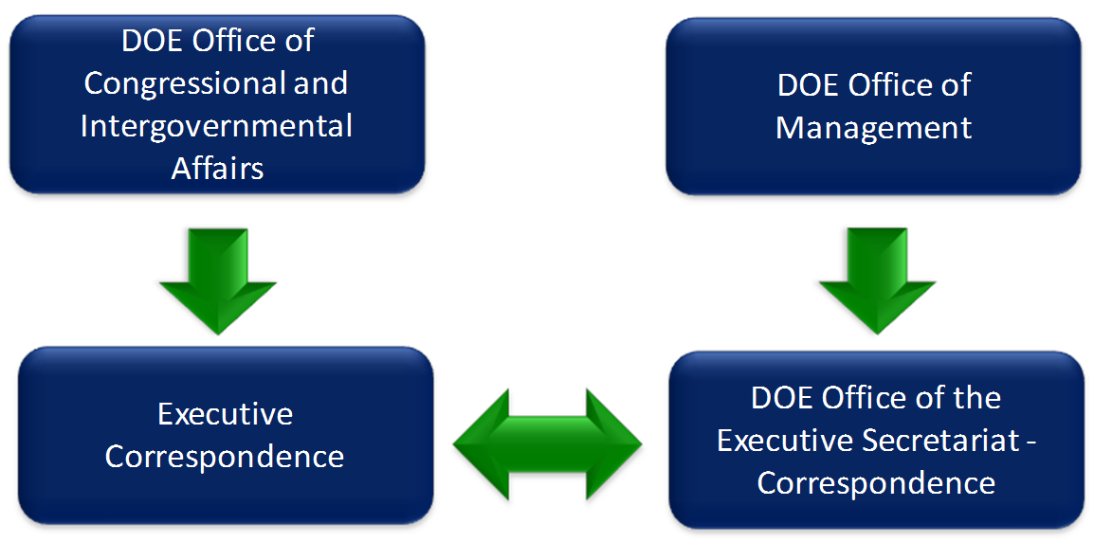
The mission of the Office of Congressional and Intergovernmental Affairs (CI) is to promote Department of Energy policies, programs and initiatives through liaison, communications, coordination and interaction with Congress, State, Tribal, City, and County Governments, other Federal agencies, stakeholders, and the general public. For more information about this office, visit their web site at http://congressional.energy.gov/index.htm. To serve the purpose of Openness at DOE, this site provides a ready rundown of DOE Congressional Testimonies and Documents and Publications related to DOE's Congressional Affairs.
Figure 15 - Congressional Correspondence Process

Congressional Correspondence and Requests for Information are managed in a coordinated and consistent manner between the Office of Congressional and Intergovernmental Affairs and the Office of the Executive Secretariat. The DOE Office of the Executive Secretariat processes all Congressional correspondence. When a Congressional letter or request for information is received by the Department, it is entered into a tracking system, and tasked out to the appropriate program for response. The Office of the Executive Secretariat works with other departments, as appropriate, to keep correspondence on track and ensure that these items are closed out responsively. In a similar manner, this office maintains a database of reports due to Congress, and tracks them appropriately to make sure they are completed. For more information about DOE Congressional correspondence, contact 202-586-2032.

DOE Declassification Programs
The Department of Energy’s Office of Classification has developed OpenNet to provide easy, timely access to recently declassified documents, including information declassified in response to Freedom of Information Act requests.

The OpenNet database is updated regularly as more information becomes available. For questions about OpenNet or ideas for improving the site, contact Richard Lyons in the Office of Classification at richard.lyons@hq.doe.gov. In addition, the DOE Historical Research Center, maintained and operated by DOE’s Office of History and Heritage Resources, is located at the Germantown facility in suburban Maryland. The mission of the Historical Research Center is to:
      - Preserve the Department’s historic records and artifacts,
      - Prepare and transfer the records to the National Archives and Records Administration (NARA), including where necessary arranging for declassification, and
      - Provide access to the records, in the interim, both to DOE officials and to outside researchers to the greatest extent possible.

The Historical Research Center contains over 3,000 cubic feet of headquarters historic records and is open to public tours and visits. The main research room is equipped with a photocopier, access to online resources, and bibliographic and research aids, including AEC and DOE annual reports and a complete set of AEC and DOE headquarters press releases. The Historical Research Center is in a secure building, and access is by appointment only. International researchers must allow 1-2 months lead time in order to process the required paperwork for a visit. To contact the Historical Research Center:
Mailing address:
Office of History and Heritage Resources, MA-75
F-031, GTN
Department of Energy
1000 Independence Ave, SW
Washington, DC 20585-1290
Phone: 301-903-5431
Fax: 301-903-9673
E-mail: HistoryDivision@hq.doe.gov

The Historical Research Center has records from the Atomic Energy Commission, Energy Research and Development Administration, Federal Energy Office/Federal Energy Administration, and Department of Energy. The Historical Research Center also contains a small amount of Manhattan Engineer District records. The materials are organized by collection.

The DOE Office of History and Heritage Resources is preparing a Guide to the DOE Historical Research Center. The guide will provide an overview, organized by agency of origin, of the records collections in the archives. More detailed guides exist for the primary collections of the Historical Research Center. These are available from the History Office.

Additional DOE Transparency Programs
Since the last DOE Open Government plan was released, the Department launched a new dataset, Public Final Occurrence Reports. This program is detailed below along with a number of additional ongoing DOE transparency programs.

DOE Health, Safety and Security Datasets
The Department of Energy’s Office of Health, Safety and Security (HSS) is deploying a business intelligence (BI) tool to analyze datasets from the Computerized Accident/Incident Report System, the Occurrence Reporting and Process System and the eDOE Information Security System. The business intelligence tool will be used to make the three datasets publicly available on a searchable website over the course of the next few years.

As part of Phase 1 of this initiative, HSS has made Final Occurrence Reports available to the public through its Occurrence Reporting and Processing System. The data covers reporting years 2005 to present and is available here. The available data is updated daily and can be narrowed by reporting organization and event-oriented keywords. HSS is working on the final stages of this phase to formally introduce the dataset to the Department and the public.

Phase 2 consists of making information available from the DOE Computerized Accident and Incident Reporting System (CAIRS). This dataset will be available through the same BI tool used for the Final Occurrence Reports. HSS is working to remove personally identifiable information from this dataset prior to publication. HSS plans to deploy this dataset in Fall 2010. Finally, Phase 3 of this initiative consists of implementing the HSS BI tool on the eDISS personnel security datasets. This dataset will be used to provide information on the length of time to process security clearances within DOE. HSS plans to launch this dataset by Winter 2011.

Environmental Management Newsletter
Since last year, the Department of Energy’s Office of Environmental Management (EM) has published the EM Update Newsletter twice each month on projects and programs funded by EM’s $6 billion base program. The EM American Recovery and Reinvestment Act (ARRA) Newsletter is published each month and focuses on Recovery Act-funded EM programs and related job creation. These newsletters are emailed to key stakeholder groups and are posted on the EM webpage. Additionally, the Department’s EM field sites are utilizing new media tools to expand their outreach and transparency efforts. For example, the Savannah River Site is accessible through Twitter and regularly posts news for public comment and feedback.

National Environmental Policy Act Categorical Exclusions
The Department of Energy’s National Environmental Policy Act (NEPA) Program fosters public participation and engagement through several features, such as the Public Participation Calendar, online draft and final NEPA documents, Lessons Learned Quarterly Reports and NEPA Document Status and Schedules. In October 2009, the Department adopted a new policy requiring online publication of Categorical Exclusion (CX) NEPA determinations. The Department of Energy is the first Federal agency to systematically publish its Categorical Exclusions on its website. The General Counsel’s office can host workshops and webcasts to help interested agencies adopt similar policies.

Records Management
The Department of Energy Records Management Program ensures compliance with existing Federal requirements, by promoting the management of records throughout their life cycle in an economical, efficient and effective manner. The Program provides guidance for the creation, maintenance and use, and disposition of Federal records. The Records Management Program is also responsible for the Department’s Information Collection Program under the Paperwork Reduction Act of 1975 and the Information Quality Program in accordance with guidance set forth by the Office of Management and Budget. Information pertaining to the Records Management Council, Disposal Schedules, Forms, Information Management and more is available from the DOE Records Management Program site.

National Library of Energy
The National Library of Energy a science-driven, virtual library which will integrate information collections from the Department of Energy's Office of Scientific and Technical Information (OSTI) and the Office of Energy Efficiency and Renewable Energy (EERE). The National Library of Energy will be a tool for accelerating energy-focused scientific discovery that engages its audience through web-based participation and collaboration mechanisms, supporting and promoting energy-related education in schools, universities and laboratories. The NLE activity will complement the work of the Energy Information Administration (EIA), the statistical and analytical agency within the Department, whose mission is to provide independent and impartial energy information. By law, EIA products, including the extensive datasets it maintains and makes available on its public website, are developed independently and are not subject to review or approval by the Department or other government agencies.

The Department of Energy is currently working to secure funding to advance this project. In its initial deployment, the National Library of Energy will integrate the OSTI and EERE information collections into one public website. In its second phase, the National Library of Energy will offer interactive tools for teachers and students and tools to encourage collaboration across the science community.

Department of Energy FOIA Portal
In spring 2011, the Department of Energy will launch the FOIA Portal. Currently, FOIA materials are available in 20 different DOE Reading Rooms. The portal will consolidate these documents into one, searchable database. Public users will be able to register their interests and receive notifications of relevant FOIA records as they are made available. The Portal will help DOE officials understand the needs and interests of the public.

Participation
Participation allows members of the public to contribute ideas and expertise so that their government can make policies with the benefit of information that is widely dispersed in society.
    - Open Government Directive

New and Social Media Tools

Secretary of Energy Steven Chu and the Department of Energy are using Energy.gov, Facebook and other new media tools to educate and engage the public about the Department’s plans and priorities. Secretary Chu’s Facebook page offers readers a series of regular updates and perspectives from the Secretary on a range of issues, and gives Facebook users the chance to comment, discuss, and offer feedback.
Figure 16 - DOE YouTube Channel
Similarly, the Department’s YouTube Channel gives the public another way to learn about the Department and our National Laboratories, including how Recovery Act funding is spent. Recent videos include:
- The Weatherization Training Program at Pennsylvania College
- A New Biofuels Technology Blooms in Iowa
- Faces of the Recovery Act: 1366 Technologies
- It Starts with Science…
- Home Energy Assessments
- The Kill-a-Watt Competition at University of Central Florida
In addition, a number of Department of Energy program offices have Facebook pages, including:
- National Nuclear Security Administration
- Office of Renewable Energy and Environmental Efficiency
- Office of Fossil Energy

DOE utilizes machine-generated captioning which can be toggled on and off by the end user on all of its YouTube videos. Additionally, the Department partners with social media companies and the General Services Administration (GSA) to maintain user-friendly social media websites. For example, DOE’s Open Gov comment webpage collaborated with Ideascale which made modifications to the website interface to make it more accessible for screen readers.
DOE Small Business Conference
Office of Economic Impact and Diversity assists small businesses that are interested in working with the Department of Energy. In May 2010, the Department hosted its 11th annual Small Business Conference and Expo in Atlanta, Georgia. The event featured plenaries, educational workshops, an Exhibit Hall with over 200 exhibitors and business matchmaking sessions. Over 1,500 attendees represented all levels of federal, state and local government agencies, small businesses, contractors and minority educational institutions.

During his keynote address, Bill Valdez, the acting director of the Office of Economic Impact and Diversity, highlighted the Department’s commitment to supporting and collaborating with the small business community.
- From FY2000 through FY2009, the Department of Energy increased its total prime and subcontract contribution to small business concerns from $3.77 billion to $6.23 billion, a 65.3 percent increase.
- Eight-five percent of DOE’s procurement dollars are obligated to site and facility management contractors (FMC). In FY 2009, the Department’s large FMCs subcontracted $4 billion, representing 51.3 percent, to small business concerns.

Find more information about the Expo on its Facebook page.

Advanced Projects Research Agency – Energy (ARPA-E)
The Advanced Projects Research Agency – Energy (ARPA-E) was authorized by the 2007 America COMPETES Act to fund projects that will reduce our nation’s dependence on foreign energy imports, curb U.S. energy-related emissions, and improve energy efficiency across all sectors of the U.S. economy. The initial funding for ARPA-E, $400 million, was provided by the American Recovery and Reinvestment Act.

In March 2010, the Department of Energy hosted the inaugural ARPA-E Energy Innovation Summit in Washington, DC as an opportunity for the country’s energy leaders to share ideas and identify key technology opportunities in the field. The Summit showcased many of the winning research projects from the first funding round. Approximately 1,300 attendees participated in the Summit.

Carbon Sequestration Leadership Forum
The Carbon Sequestration Leadership Forum (CSLF) is an international initiative focusing on the development of cost-effective carbon sequestration technologies. CSLF was created in 2004 by the Department of Energy’s Office of Fossil Energy. Membership is open to national government entities, and CSLF is currently comprised of 23 countries and the European Commission. The Forum features an online Registry of CSLF Stakeholders, and CSLF meetings are open to the public.

Energy Empowers, www.energyempowers.gov
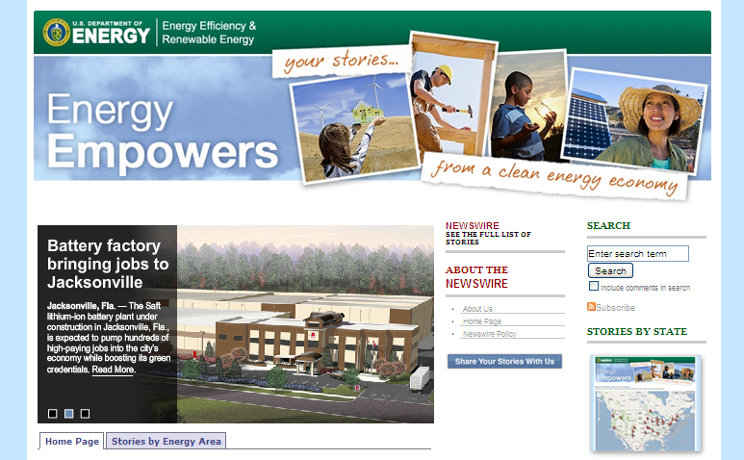
The Department’s Office of Energy Efficiency and Renewable Energy (EERE) has developed a new service blog to share stories from American citizens, businesses and towns that are pushing the limits of energy efficiency and renewable energy technologies. The Energy Empowers team is made up of writers who work with various programs and offices within EERE. Share your story here.
Figure 17 - Energy Empowers

Enforcement and Verification of Appliance Energy and Water Conservation Standards
As part of the Department of Energy’s efforts to step up enforcement and verification of appliance energy and water conservation standards, the Office of General Counsel has created a webpage and email, energyefficiencyenforcement@hq.doe.gov, where the public can report an appliance regulation violation.

DOE Office of Science Committees of Visitors
The Department of Energy’s Office of Science has established at least one Federal Advisory Committee for each of its science programs in accordance with the Federal Advisory Committee Act of 1972. These expert committees provide independent advice to the Director of the Office of Science on scientific and technical issues relating to the Offices of Advanced Scientific Computing Research, Basic Energy Sciences, Biological and Environmental Research, Fusion Energy Sciences, High Energy Physics and Nuclear Physics.

Federal Advisory Committees manage Committees of Visitors (COV), which assess Office of Science programs on a regular basis. These sub-committees feature a panel of scientists and researchers, and every Office of Science program element must be reviewed by a COV panel every three years. As part of this review process, COV panels present assessment reports to the appropriate Federal Advisory Committee at a public meeting. Within 30 days of this submission, an associate director in the Office of Science provides a response to the review. Following review by the Federal Advisory Committee, the report is sent to the Director of the Office of Science and publicly released.

Collaboration
Collaboration improves the effectiveness of government by encouraging partnerships and cooperation within the Federal government, across levels of government and between the government and private institutions.
    - Open Government Directive

Multilingual WorldWideScience.org, http://worldwidescience.org/multi
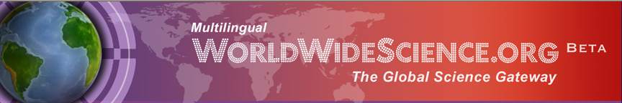
In June 2010, the Department of Energy launched the beta version of Multilingual WorldWideScience.org at the International Council for Scientific and Technical Information annual conference in Helsinki, Finland. The site offers real-time searching and translation of globally-dispersed collections of scientific literature. This new capability is the result of an international public-private partnership between the WorldWideScience.org Alliance and the Microsoft Research.
Figure 18 - WorldWideScience.org Banner

Multilingual WorldWideScience.org builds on its previous English-only capabilities to allow users to search non-English databases in China, Russia, France and several Latin American countries and receive search results translated into one of nine languages, including English, Chinese, French, German, Japanese, Korea, Portuguese, Spanish and Russian. More languages will be added in the coming months.

The Office of Scientific and Technical Information (OSTI) within the DOE Office of Science co-developed and hosts WorldWideScience.org as a gateway to international science. Launched in June 2007, the website features information on science and technology research and development from 65 countries. In addition to other WorldWideScience Alliance members, key partner organizations include the Russian Academy of Sciences, the Chinese Ministry of Science and Technology and the British Library. WorldWideScience.org advances OSTI’s mission to foster collaborative between the scientific community and the Department of Energy.

State Energy Efficiency (SEE) Action Network
In February 2010, the Department of Energy and the Environmental Protection Agency (EPA) jointly announced the creation of the State Energy Efficiency (SEE) Action Network to help states achieve maximum cost-effective energy efficiency improvements in homes, offices and buildings by 2020. The SEE Action Network will drive energy efficiency through a set of goals developed in the National Action Plan for Energy Efficiency.

DOE and NSF Collaboration: Large Hadron Collider
U.S. participation in the design and construction of the Large Hadron Collider (LHC) at CERN in Geneva, Switzerland is supported by the Department of Energy’s Office of Science and the National Science Foundation (NSF). More than 1,700 scientists, engineers and graduate students from U.S. universities and national laboratories have participated in six LHC experiments. DOE and NSF have developed a website highlighting American participation in LHC experiments. This website features blogs written by American scientists working on the accelerator and resources for teachers and students. In May, the US LHC launched its own Facebook page which includes blog posts, presentations, videos and photographs from the scientists.

DOE Science News via the AAAS EurekAlert!
EurekAlert! is an online global news service operated by the American Association for the Advancement of Science (AAAS). Through collaboration with the Department of Energy Office of Science, EurekAlert! features “Department of Energy Science News” with press releases and information about research advances funded by the Department.
Energy Information Administration Collaborations
The Energy Information Administration (EIA) partners with a number of organizations and stakeholder groups. Examples of EIA’s leadership in collaboration include:
- Partnering with the Center for Strategic and International Studies (CSIS) to host the EIA’s International Energy Outlook
- Collaborating with National Energy Education Development (NEED) to promote educational materials and lesson plans for teachers and students
- Joining with the National Association of State Energy Officials (NASEO) to connect with state agencies and authorities
- Working with the National Academy of Science’s (NAS) Committee on National Statistics to conduct a 30-month study of the Commercial Buildings Energy Consumption Survey and the Residential Energy Consumption Survey.
- Participating in Stanford University’s Energy Modeling Forum (EMF) and two other EMF projects, Technology Strategies for Achieving Climate Policy Objectives and Efficiency and the Shape of Future Energy Demand.
- Partnering with the National Institute of Statistical Sciences (NISS) to manage the Energy Micro Data Research Program

Science.gov
The Department of Energy’s Office of Scientific and Technical Information (OSTI) launched Science.gov in December 2002 as an interagency initiative among 18 U.S. government science organizations within 14 Federal agencies. This website serves the information needs of science professionals, students, educators and the business community. Now in its fifth generation, Science.gov features over 40 databases.

Conclusion
The Department of Energy is hard at work to develop solutions to secure the nation’s energy future. The Department is focused on achieving a number of strategic priorities. DOE is investing in scientific research development and deployment, pursuing clean and renewable energy initiatives to help reduce America’s dependence on oil and protecting the nation’s energy security. The Department is advancing economic prosperity by creating clean energy jobs and increasing American competitiveness.

Throughout its history, the Department of Energy has sought to engage our stakeholders and the general public and to partner with a wide range of entities inside and outside government to address national challenges.

The Department of Energy recognizes that transparency, partnership and collaboration are critical to the success of the Department and the nation. DOE will continue employing these principles in our strategic planning and operations, but it needs the help of the American people. Please continue the conversation about open government at the Department of Energy at www.facebook.com/stevenchu and send your ideas on how the Department can improve its Open Government Plan and initiatives to open@hq.doe.gov.

Appendix A - The President’s Memorandum and the OMB Open Government Directive
President Obama launched the Open Government Initiative as his very first executive action, reflecting his commitment to making the federal government work better for the American people. On January 21, 2009, he signed the Memorandum on Transparency and Open Government.

The President directed the Department of Energy (DOE) and other federal agencies to make the Department’s work more transparent, improve the quantity and quality of the information we provide to the public, and create innovative new opportunities for the public to offer feedback about their needs and priorities.

The memorandum defined these core values:

Government should be transparent. Transparency promotes accountability and provides information for citizens about what their Government is doing. Information maintained by the Federal Government is a national asset. My Administration will take appropriate action, consistent with law and policy, to disclose information rapidly in forms that the public can readily find and use. Executive departments and agencies should harness new technologies to put information about their operations and decisions online and readily available to the public. Executive departments and agencies should also solicit public feedback to identify information of greatest use to the public.

Government should be participatory. Public engagement enhances the Government's effectiveness and improves the quality of its decisions. Knowledge is widely dispersed in society, and public officials benefit from having access to that dispersed knowledge. Executive departments and agencies should offer Americans increased opportunities to participate in policymaking and to provide their Government with the benefits of their collective expertise and information. Executive departments and agencies should also solicit public input on how we can increase and improve opportunities for public participation in Government.

Government should be collaborative. Collaboration actively engages Americans in the work of their Government. Executive departments and agencies should use innovative tools, methods, and systems to cooperate among themselves, across all levels of Government, and with nonprofit organizations, businesses, and individuals in the private sector. Executive departments and agencies should solicit public feedback to assess and improve their level of collaboration and to identify new opportunities for cooperation.

On December 8, 2009, OMB Director Peter Orszag issued the Administration’s Open Government Directive. The Directive laid out an action plan for agencies to implement the principles of transparency, participation and collaboration that the President set forth in his memorandum.
- Within 45 days, or by January 22, 2010:
  - Each agency should publish at least three new, high-value datasets at Data.gov.
  - An Open Government Working Group, comprised of representatives of all federal agencies, should be established.
  - Each agency should designate a senior-level official accountable for the quality of federal spending information.
- Within 60 days, or by February 6, 2010:
  - Each agency should create an Open Government webpage to serve as the gateway for agency activities to implement the Open Government Directive.
  - An Open Government Dashboard should be created to track agencies’ development and implementation of Open Government Plans and assess open government in the Executive branch.
- Within 120 days, or by April 7, 2010:
- Each agency should publish an Open Government Plan describing steps to improve transparency and promote public participation and collaboration.

Appendix B – DOE Open Government Progress and Key Dates
To date, the Department of Energy has met all of the Open Government Directive deadlines through initiatives such as:
- Publishing seven high-value raw datasets on www.data.gov
- Actively participating in the Open Government Working Group. A roster is available at http://www.whitehouse.gov/open/documents/open-government-directive/working-group.
- Designating Chief Financial Officer, Steve Isakowitz, as accountable for the quality and objectivity of, and internal controls over, the federal spending information that the Department disseminates. Mr. Isakowitz participates in the agency’s Operation Management Council (OMC) for the agency-wide control assessment pursuant to the Federal Managers’ Financial Integrity Act (FMFIA).
- Launching the DOE Open Government Webpage. Visit www.energy.gov/open to explore Secretary Steven Chu’s personal Facebook page, download high-value datasets and share your ideas about how DOE can improve its Open Gov initiatives.
- Utilizing Ideascale, a public engagement tool available in conjunction with the General Services Administration, to gather feedback and suggestions. Though the comment period ended on March 19, 2010, DOE encourages the public to continue to submit ideas to open@hq.doe.gov on how the agency may foster transparency, participation and collaboration.
- Posting an evaluation of the Department’s accomplishments under the Open Government Directive on the Open Government Dashboard, http://www.energy.gov/open/8626.htm.
Key Date | Description
January 21, 2009 | President Barack Obama signs the Memorandum on Transparency and Open Government
February 17, 2009 | Recovery.gov launched
March 19, 2009 | Attorney General issues memorandum regarding agency FOIA implementation
May 21, 2009 | Data.gov launched
June 30, 2009 | IT Dashboard launched as part of the USAspending.gov portal
July 2009 | DOE Secretary Chu launched his Facebook page
October 1, 2009 | DOE began utilizing FOIAXpress tracking and processing software system
October 2, 2009 | DOE Deputy Secretary Poneman issued a policy requiring online publication of NEPA Categorical determinations
October 2009 | DOE General Counsel released guidance on ex parte communications during informal rulemaking proceedings.
December 8, 2009 | OMB Director Peter Orszag issues the Administration’s Open Government Directive
December 2009 | DOE launched Open Energy Information
2009 | DOE launched Energy Information Education Literacy Initiative
January 22, 2010 | AGENCY ACTIONS DUE:  Publish at least three new, high-value datasets at Data.gov  Participate in Open Government Working Group, comprised of representatives of all federal agencies  Designate a senior-level official accountable for the quality of federal spending information
January 28, 2010 | DOE categorical exclusion determinations posted online
Winter 2010 | DOE launched ScienceEducation.gov
February 6, 2010 | AGENCY ACTIONS DUE:  Create an Open Government webpage  Create an Open Government Dashboard to track development and implementation of Open Government Plans
February 2010 | DOE and EPA jointly announced the creation of the State Energy Efficiency (SEE) Action Network
February 2010 | DOE Office of General Counsel announced all future determinations regarding the adequacy of the Nuclear Waste Fund Fee will be publicly available
March 1-3, 2010 | DOE inaugural Advanced Projects Research Agency (ARPA-E) Energy Innovation Summit held in Washington, DC
March 2010 | DOE Office of Scientific and Technical Information launched the Green Energy Portal
March 19, 2010 | DOE Ideascale Open Gov comment period ends. DOE encourages the public to continue to submit ideas to open@hq.doe.gov
April 7, 2010 | AGENCY ACTIONS DUE:  Publish Open Government Plan describing steps to improve transparency, and promote public participation and collaboration.
May 10-12, 2010 | DOE Small Business Conference held in Atlanta, GA
May 12, 2010 | DOE participated in the inaugural National Lab Day
June 2010 | Multilingual WorldWideScience.org launched

Appendix C - Key Links Supporting DOE Open Government Initiatives
Department of Energy Open Government Initiatives
DOE Flagship Initiatives | Primary Link
OpenEI.gov | www.openei.org
ScienceEducation.gov | http://scienceeducation.gov
Energy Explained, Energy in Brief and Energy Kids | www.eia.gov/energyexplained, http://tonto.eia.doe.gov/energy_in_brief/, and www.eia.doe.gov/kids/
DOE Transparency Programs | Primary Link
DOE Loan Programs | www.energy.gov/recovery/lgprogram.htm
Fossil Energy R&D Project Database | www.netl.doe.gov/technologies/coalpower/cctc/index.html
2008 Presidential Transition Materials | http://management.energy.gov/FOIA/1669.htm
Nuclear Waste Fund Fee Adequacy Reports | http://gc.energy.gov/documents/2008_Fee_Adequacy_Letter_Report.pdf
Patent Waivers and Ex Parte Communications | www.gc.doe.gov/patents.htm and http://gc.energy.gov/rulemaking_policies.htm
Freedom of Information Act | www.management.energy.gov/foia_pa.htm
Congressional Correspondence | http://congressional.energy.gov/index.htm
Declassification Programs | www.osti.gov/opennet
Environmental Management Newsletter | www.em.doe.gov/pages/emupdatenewsletters.aspx
NEPA Categorical Exclusions | www.nepa.energy.gov
Records Management | http://cio.energy.gov/records-management.htm

DOE Participation Programs | Primary Link
Secretary Chu’s Facebook Page and Flickr Site | www.facebook.com/stevenchu and www.flickr.com/photos/departmentofenergy
DOE YouTube Channel | www.youtube.com/usdepartmentofenergy
DOE Small Business Conference | http://smallbusinessconference.energy.gov
Advanced Projects Research Agency – Energy (ARPA-E) | http://arpa-e.energy.gov
Carbon Sequestration Leadership Forum | www.cslforum.net
Energy Empowers | www.energyempowers.gov
Appliance Energy and Water Conservation Standards Enforcement | www.gc.energy.gov/energy_efficiency_enforcement.htm
Office of Science Committees of Visitors | www.sc.doe.gov/SC-2/Committee_of_Visitors.htm
DOE Collaboration Programs | Primary Link
State Energy Efficiency (SEE) Action Network | www.oe.energy.gov/efficiency.htm
Large Hadron Collider | www.uslhc.us
DOE Science News on EurekAlert! | www.eurekalert.org/doe
EIA Collaborations | www.eia.doe.gov
Science.gov | www.science.gov
WorldWideScience.org | http://worldwidescience.org

Appendix D – DOE Open Government Initiative Contact Sheet
Organization | Email | Phone
Office of Energy Efficiency and Renewable Energy | https://www1.eere.energy.gov/informationcenter/#submission_form | 1-877-337-3463 (toll-free)
Office of Electricity Delivery and Energy Reliability | OEwebmaster@hq.doe.gov | 202-586-1411
Office of Environmental Management | EM.WebContentManager@em.doe.gov | 202-586-7709
Office of Fossil Energy |  | 202-586-6660
Office of Legacy Management | LM@hq.doe.gov | 202-586-3559
Office of Nuclear Energy | Contact.NE@nuclear.energy.gov | 202-586-6450
Office of Science | http://www.er.doe.gov/Contact/index.htm | 202-586-5430
Loan Guarantee Program Office | lgprogram@hq.doe.gov | 202-586-8336
Advanced Technology Vehicle Manufacturing Program | atvmloan@hq.doe.gov | 202-586-8336
National Nuclear Security Administration | NNSA.Contact@nnsa.doe.gov | 202-586-7371
Energy Information Administration | InfoCtr@eia.doe.gov | 202-586-8800
Office of Scientific and Technical Information | OSTIWebmaster@osti.gov | 865-576-1188

Appendix E - The Department of Energy’s History, Missions and Organizational Structure
The nation that leads the world in creating new sources of clean energy will be the nation that leads the 21st century global economy.
    - President Obama, Earth Day address, April 22, 2009

If there ever was a time to help steer America and the world towards a path of sustainable energy, now is the time…. The task ahead is daunting, but we can and will succeed…. We have the opportunity to lead in the development of a new, industrial revolution.
    - Secretary of Energy Steven Chu, Harvard University commencement address, June 4, 2009

The Department of Energy is proud to be doing its part to make the federal government more open and accessible to the American people. The DOE Open Government Plan will help the Department do a better job of engaging our many stakeholders at a critical juncture in our nation’s history.

The Department of Energy was established in 1977, but it traces its lineage to the Manhattan Project and the race to develop the atomic bomb during World War II. Predecessor agencies include the Atomic Energy Commission, the Nuclear Regulatory Commission, and the Energy Research and Development Administration. The extended energy crises of the 1970s highlighted the need for unified energy organization and planning. On October 1, 1997, DOE became the twelfth Cabinet agency under the Department of Energy Organization Act, and assumed the responsibilities of the Federal Energy Administration, the Energy Research and Development Administration, the Federal Power Commission. On March 1, 2000, the National Defense Authorization Act established the National Nuclear Security Administration as a semi-autonomous organization within the Department.

Over its 32-year history, DOE has served the evolving needs of the nation. During the late 1970s, the Department emphasized energy development and regulation. In the 1980s, nuclear weapons research, development and production were the priority. Since the end of the Cold War through the 1990s and into the 2000s, the Department focused on environmental cleanup of the nuclear weapons complex, non-proliferation and stewardship of the nuclear stockpile, energy efficiency and renewable energy and technology transfer and industrial competitiveness.

Today, the Department of Energy has a budget of $28 billion and is managing an additional $36.7 billion in investments received through the American Recovery and Reinvestment Act. The Department has approximately 14,000 federal employees, 93,000 contracted employees and more than 80 sites and facilities – including 17 national laboratories – across the United States, along with seven international offices. The DOE Management Principles are seven individual statements on the Department’s prescribed management conduct as listed in an earlier figure in this plan.

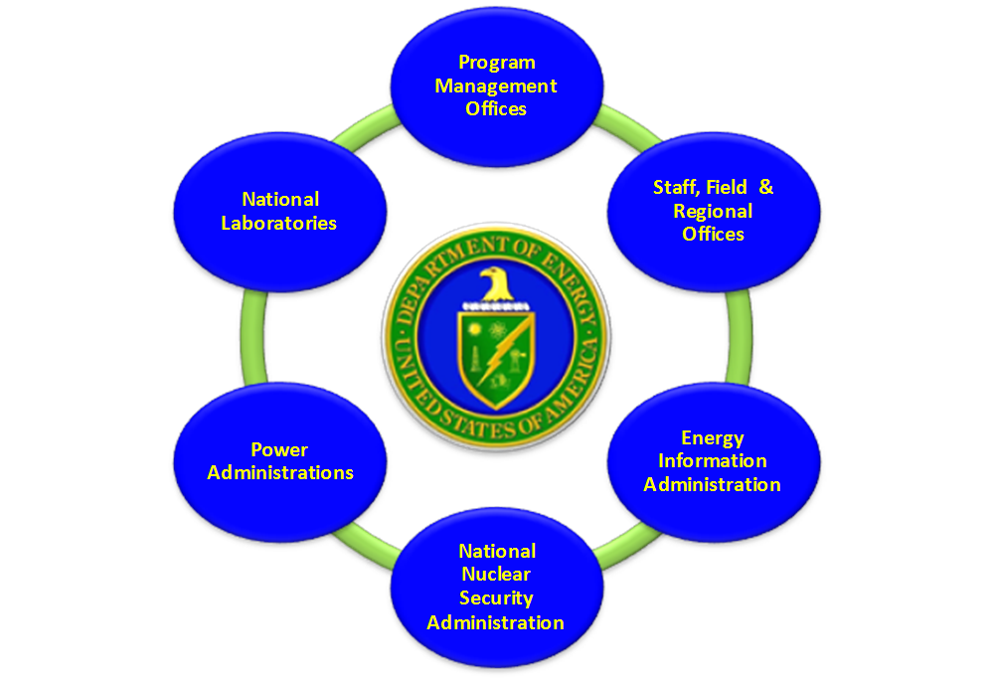
In general though and at this time, the Department is operates with six distinct functional areas as shown in the Functional Organizational Diagram figure below.

In addition, the Department has six key Administration Offices, the National Nuclear Security Administration (NNSA), the Energy Information Administration (EIA), the Bonneville Power Administration (BPA), the Western Area Power Administration (WAPA), the Southeastern Power Administration (SEPA) and the Southwestern Power Administration (SWPA) which are semi-autonomous organizations within the Department of Energy. The Department of Energy’s lines of reporting are shown in the organizational chart below.
Figure 19 - The DOE Functional Organization Diagram

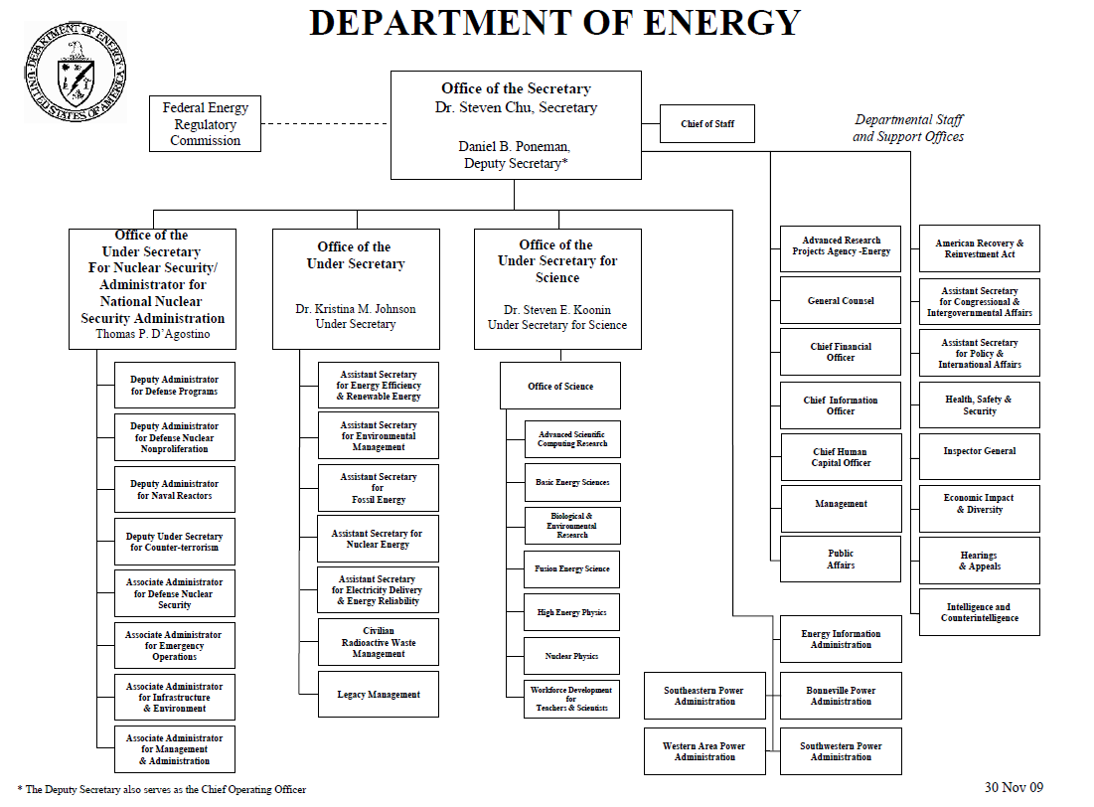
Learn more about the Department of Energy’s organizational structure at:
Figure 20 - The DOE Lines of Reporting Organization Chart
http://www.energy.gov/organization .

Appendix F -Key DOE High Value Dataset Audiences

DOE has broadly identified the following audiences of individuals with notable interest in the Department’s publicly available data and information. These audiences include stakeholders, scientists, engineers, educators, students, universities, investors, consumers and DOE employees.

Universities, businesses and industry institutions are especially interested in financial assistance solicitations. These key audiences customarily seek out financial opportunities with respect to their energy projects such as tax credits, grants, rebates, financing for energy efficiency homes, and assistance for low-income families.

