

**Reporting Guidance for**

**Federal Agency Annual Report on Energy Management**

(per 42 U.S.C. 8258)

September 2019

Federal Energy Management Program

Office of Energy Efficiency and Renewable Energy

U.S. Department of Energy

**Introduction**

This guidance outlines annual reporting procedures with respect to Federal agency energy and water management activities. The Department of Energy’s (DOE) Federal Energy Management Program (FEMP) has prepared this guidance for consolidated data collection to meet reporting requirements established under the National Energy Conservation Policy Act (NECPA), as amended, Energy Policy Act of 2005 (EPACT ’05), Energy Independence and Security Act of 2007 (EISA), and Executive Order (E.O.) 13834, *Efficient Federal Operations*.

**Purpose of Reporting**

Section 548(a) of NECPA (42 U.S.C. 8258(a)) requires each Federal agency to submit a report each year to the Department of Energy on their activities to meet the energy management requirements of Section 543 of NECPA (42 U.S.C. 8253). Information and data collected from the agencies will be used to develop DOE’s *Annual Report to Congress on Federal Government Energy Management*. This report is required under Section 548 of NECPA (42 U.S.C. 8258(b)) and describes energy management activities in Federal facilities and operations and progress in implementing the requirements of NECPA, EPACT ’05, and EISA. Final distribution of the report includes the House Committee on Energy and Commerce and the Senate Committee on Energy and Natural Resources.

Data collected through this consolidated report is also provided to the Office of Management and Budget (OMB) and the Council on Environmental Quality for the purpose of tracking compliance and progress toward statutory requirements and Executive Order goals, per *Implementing Instructions for Executive Order 13834*.

Data contained in the annual report is publicly released and made available to other Federal agencies, including the Bureau of Economic Analysis and Energy Information Administration; State and local governments; private companies and citizens, and non-government organizations. Most-recent and past fiscal year data is also available in detail on FEMP’s website at <http://energy.gov/eere/femp/federal-facility-annual-energy-reports-and-performance>. This guidance document is also available at the following web page: <http://energy.gov/eere/femp/federal-facility-consolidated-annual-reporting-requirements>.

**Reporting Package Components**

**Due Date**

The completed FY 2019 Annual Energy Management Report is required to be submitted to DOE no later than **January 31, 2020** per direction of the Office of Management and Budget (OMB)**.** The reporting package submittal includes:

* Energy Management Report Summary with all required narratives,
* [*Annual Energy Management Data Report* workbook](http://energy.gov/eere/femp/downloads/annual-energy-data-report) for FY 2019 reporting of energy, water, cost, and square footage data and associated greenhouse gas emissions,
* If applicable, corrections to prior year *Data Reports* in the *Data Report* edition for those years, and
* Completed Energy Performance Goal Excluded Buildings List (included as part of the [*Annual Energy Management Data Report* workbook](http://energy.gov/eere/femp/downloads/annual-energy-data-report)). Tab 4.7 in the workbook provides a template for agencies to submit the list of facilities excluded from the energy intensity (Btu per gross square foot) reduction requirement and an explanation of why they were excluded. Refer to DOE’s[Criteria Guidelines Establishing Criteria for Excluding Buildings from the Energy Performance Requirement](https://www.energy.gov/eere/femp/downloads/guidelines-establishing-criteria-excluding-buildings-energy-performance). These guidelines establish criteria for exclusions from the energy performance requirement for a fiscal year, any Federal building or collection of Federal buildings, within the statutory framework provided by the law**.**

**Point of Contact**

Requested information, along with the *Annual Energy Management Data Report* workbook(s) should be sent electronically to: [chris.tremper@ee.doe.gov](mailto:chris.tremper@ee.doe.gov).

If you have any questions, please contact Chris Tremper at (202) 586-7632. Thank you for your cooperation and diligence in managing and promoting energy and water efficiency and the use of renewable energy.

**Attachments**

**Attachment 1 - Energy Management Report Summary Instructions** –Provides instructions for the agency to provide the minimal required narrative information and details of energy and water management activities. Agency energy consumption and associated data will be collected from the [*Annual Energy Management Data Report* workbook](http://energy.gov/eere/femp/downloads/annual-energy-data-report). **Note:** As part of efforts to further streamline energy and sustainability reporting and remove burden on agencies, the template for the narrative report, which duplicated information reported by agencies in annual Sustainability Plans, has been eliminated. For the report to FEMP, agencies are only required to provide extenuating factors that may be skewing the agency progress, data variances, or other anomalies that are pertinent to the data review.

**Attachment 2 - Guidance for Receiving Credit on Energy Performance Goal for Projects That Save Source Energy But Increase Site-Delivered Energy** – This guidance describes how agencies can receive credit towards their energy reduction goals for life-cycle cost-effective projects in which source energy decreases even when if site-delivered energy use increases (as electricity production is moved on site for combined heat and power applications, for example). This guidance provides calculator tools and instructions on how to document the project(s) and correctly calculate the necessary adjustment to the site Btu-per-square-foot performance metric.

**Attachment 3 - Guidance to Receive Credit on Energy Performance Goal to Normalize for Weather in Benchmarked Buildings** – Provides guidance on the approach for reporting an adjustment to the energy intensity goal performance metric (Btu/Gross Square Foot) to normalize for weather based on locality-specific benchmarking findings for individual buildings.

**Attachment 4 - Guidance to Receive Credit on Energy Performance Goal for Energy Intensity Improvements in Goal-Excluded Buildings** – Provides guidance for reporting an adjustment to the energy intensity goal performance metric (Btu/Gross Square Foot) to encourage efficiency upgrades at goal-excluded buildings by allowing agencies to credit verified energy efficiency improvements toward the agency's progress on the energy intensity reduction goal.

**ATTACHMENT 1**

**Energy Management Report Summary Instructions**

The Annual Energy Management Report should contain minimal required narrative information and details of energy and water management activities not collected by other means, such as the *Annual Energy Management Data Report*, the *Sustainability Report and Implementation Plan*, or the [FEMP Compliance Tracking System](https://www.energy.gov/eere/femp/eisa-federal-facility-management-and-benchmarking-reporting-requirements) (CTS).

**SECTION 1 – Performance Metrics Progress Details, Explanations of Data Variances**

1. **Energy Consumption Results Explanations**
   1. **Goal Subject Buildings**

Discuss any extenuating factors that may be skewing the agency progress toward the energy intensity reductions reported in FY 2019. Explain any variances of greater than 5% from the prior year in Btu, Gross Square Footage, or Btu/GSF. (Note: The energy intensity reductions will be calculated and reported in the Results Summary spreadsheet located in the *Annual Energy Management Data Report* workbook.)

* 1. **Goal-Excluded Facilities**Explain any variances of greater than 5% from the prior year in Btu consumed or Gross Square Footage of goal-excluded facilities.
  2. **Vehicles and Equipment**  
     Discuss trends pertaining to this category of fuel use for non-fleet vehicles and other equipment not captured by the Federal Automotive Statistical Tool (FAST) reporting system. Explain any variances of greater than 5% from the prior year in Btu consumed.

1. **Renewable Energy Use**
   1. **On-Site generated renewable energy**Explain any variances of greater than 5% from the prior year in renewable electricity generated from on-site projects. If applicable, highlight specific recent projects contributing to increases in on-site generation from renewable.
   2. **Purchased renewable energy**Discuss highlights of major purchases and approaches taken to obtain renewable energy through purchases which may have contributed to a variance of greater than 5% from the prior year.
2. **Potable Water Consumption**Discuss any extenuating factors that may be skewing the agency progress toward the water intensity reductions reported in FY 2019. Explain any variances of greater than 5% from the prior year in Gallons, Gross Square Footage, or Gal/GSF.

**SECTION 2 – Efficiency Investment Project Details**

Please report summary data on energy and water efficiency projects awarded in FY 2019 below only if these projects have not already been reported in the [FEMP Compliance Tracking System](https://www.energy.gov/eere/femp/eisa-federal-facility-management-and-benchmarking-reporting-requirements) (CTS) as required under Section 432 of the Energy Independence and Security Act. These data sets will be used to reconcile totals reported by the agency in tables 2-1, 2-2, and 2-3 of Tab 4.4 of the *Annual Energy Management Data Report*.



**ATTACHMENT 2**

**Guidance for Receiving Credit on Energy Performance Goals for Projects That Save Source Energy but Increase Site-Delivered Energy**

**Intent**

The purpose of 43 U.S. Code Part B―Federal Energy Management is promote the conservation and the efficient use of energy and water, and the use of renewable energy sources, by the Federal Government. In addition to energy delivered to the site of use, this also includes energy as measured at the source of generation and including conversion and transmission losses. To that end, agencies shall undertake life-cycle cost-effective projects in which source energy decreases, even if site-delivered energy use increases (as electricity or thermal energy production is moved on site). Since progress toward the Btu-per-gross-square-foot performance requirements of NECPA (42 U.S.C. 8253) is measured in terms of site-delivered Btu, agencies may receive a “site/source credit” for projects that save source energy but increase site-delivered energy (combined-heat-and-power-plant projects, for example).

**Background**

In June 1996, the Federal Interagency Energy Policy Committee (656 Committee) (42 U.S.C. 7266) unanimously approved a policy statement encourages cost-effective energy projects that result in reduced energy consumption regardless of whether that consumption is measured on a site basis or source basis. This policy statement was utilized by the Interagency Energy Management Task Force (42 U.S.C. 8257) to develop and issue in April 2000, “Guidance for Providing Credit Toward Energy Efficiency Goals for Cost-Effective Projects Where Source Energy Use Declines but Site Energy Use Increases.” The reason for the credit is to prevent the site-delivered Btu performance metric from penalizing agencies for implementing cost-effective projects where source energy decreases but site-delivered energy increases.

Energy measured at the point of use is termed “site energy.” Energy measurement that accounts for the generation, transmission and distribution of the energy is called “source energy.”

Whichever way consumption is measured, cost-effectiveness remains the mandated criteria for assessing, selecting, and funding potential Federal energy efficiency projects (42 U.S.C. 8254(b)(1)). Since agency progress toward the NECPA energy performance requirement (30 percent energy reduction in 2015 compared to 2003) is measured in terms of *site-delivered* Btu per gross square foot, an adjustment to the metric is required for source energy saving projects.

For agencies reporting projects that reduce source energy use while increasing site energy use, the source energy savings will be subtracted from the agency site energy use before the final calculation of goal performance in terms of site Btu per gross square foot.

**Calculating Project-Specific Source Energy Reductions**

Agencies can receive credit for life-cycle cost-effective projects where source energy declines and site energy increases. For each such completed project, agencies should calculate source energy savings for the reported fiscal year.

Here are the factors that DOE uses to determine site Btu equivalents from native units for energy types not typically reported as Btu:

|  |  |
| --- | --- |
| **Energy Type** | **Site Btu Conversion Factor** |
| Electricity | 3,412 Btu/kWh |
| Natural Gas | 1,028 Btu/cubic foot |
| Fuel Oil (Distillate No. 2) | 138,000 Btu/gallon |
| Propane & Liquid Propane | 92,000 Btu/gallon |
| Steam | 1,000 Btu/pound |

To convert site Btu to source Btu, agencies may use the one-year national average source conversion factors promulgated by DOE or may choose the multi-year national average factors promulgated by EPA’s Energy Star Program for its Portfolio Manager benchmarking tool.

**Source-Site Btu Ratios for Energy Star Portfolio Manager Fuels and**

**§ 433.301 Fossil fuel-generated energy consumption determination**

|  |  |  |
| --- | --- | --- |
| **Source-Site Ratio/Multipliers** | **EPA Energy Star calculator Ratios** | **DOE 433.301 Fossil Fuel Ratios** |
| **Fuel Type** |  |  |
| Electricity (Grid Purchase) | 3.14 | 3.16 |
| Electricity (on-Site Solar or Wind Installation) | 1.0 | n/a |
| Natural Gas | 1.05 | 1.046 |
| Fuel Oil (1,2,4,5,6,Diesel, Kerosene) | 1.01 | 1.00 |
| Propane & Liquid Propane | 1.01 | 1.00 |
| Steam | 1.20 | n/a |
| District Steam (non-CHP) | n/a | 1.35 |
| District Steam (CHP) | n/a | 2.30 |
| Hot Water | 1.20 | 1.28 |
| Chilled Water | 1.0 | 1.28 |
| Wood | 1.0 | n/a |
| Coal/Coke | 1.0 | 1.00 |
| Other | 1.0 | n/a |

Sources: <https://www.energystar.gov/sites/default/files/tools/QuickConverter_v2014.xls>

<http://www.regulations.gov/document?D=EERE-2010-BT-STD-0031-0034> (Sec 433.201)

Agencies should use the following worksheet to calculate the annual site energy increase and energy saved with the projects, for each applicable project for which source energy is reduced but site energy increases.

|  |  |  |  |  |  |
| --- | --- | --- | --- | --- | --- |
| **Project Worksheet** | | | | **Example: XYZ** | |
| **Base Case (without Project)** | | | |  | |
| Line 1 | Annual Source Energy Used  (if using conversion factors; multiple Site Energy by Ratio amount) |  | MMBtu | *225,900* | MMBtu |
| Line 2 | Annual Site Energy Used |  | MMBtu | *107,770* | MMBtu |
| **With Project** | | | |  | |
| Line 3 | Annual Source Energy Used |  | MMBtu | *178,800* | MMBtu |
| Line 4 | Annual Site Energy Used After Project |  | MMBtu | *128,170* | MMBtu |
| Line 5 | Annual Source Energy Saved After Project  (subtract Line 3 from Line 1, this is:) |  | MMBtu | *47,100* | MMBtu |
| Line 6 | Annual Site Energy Increase After Project  (subtract Line 2 from Line 4, this is:) |  | MMBtu | *20,400* | MMBtu |

Qualifying projects receive a credit in the amount of the annual source energy savings (line 5 above), which is used to adjust downward the agency site energy use before the final calculation of goal performance in terms of site Btu per gross square foot. An agency’s existing site tracking system may automatically recognize part of the credit as many qualifying projects report similar characteristics that the utilization of on-site energy produces while also reducing purchases of electricity from the grid. The purpose of the adjustment is to account for the rest of the source energy savings credit.

For example, consider a large cogeneration (combined heat and power or CHP) project. Electricity is generated on-site with natural gas backed up with liquid fuel, and heat is recovered from the generation process and recycled to reduce purchases of boiler fuels, and/or to generate chilled water, further reducing grid electricity purchases. As a result of the project, fuel use for on-site power generation increases, fuel use for boilers decreases, and grid electricity purchases decrease. Site Btu and source Btu are substantially identical for all energy forms impacted by the project except for grid electricity, where 1 kWh equals 11,396 source Btu (using the Energy Star ratio) but only 3,412 site Btu. With the exception of grid electricity, all forms of energy affected by the project have essentially the same Btu value whether site or source. Therefore, backing out the grid electricity displaced by the project (self-generation, electric chiller load displaced by chilled water from recycled heat, etc.), on a source-Btu basis, is all that needs to be done. The agency’s site energy tracking system will already have backed out displaced grid electricity because it no longer appears on the utility meter, but only at a rate of 3,412 Btu per kWh. An adjustment is needed to account for the rest of the source energy savings, at a rate of 7,984 Btu per kWh (11,396 minus 3,412). The adjustment for the cogeneration project equals the displaced grid electricity in kWh per year multiplied by 7,984 Btu per kWh.

After calculating adjustments for each qualifying project, compile the data into the worksheet listed in the *FEMP Annual Energy Management Data Report*, Tab 4.3, as illustrated below and located at:

<http://energy.gov/eere/femp/downloads/annual-energy-data-report>.

|  |  |  |  |
| --- | --- | --- | --- |
| **AGENCY COMPILATION WORKSHEET FOR CREDIT FOR PROJECTS THAT INCREASE SITE ENERGY USE BUT SAVE SOURCE ENERGY** | | | |
|  | |  |  |
| **NECPA Goal Subject Buildings** |  |  |  |
| Name of Project Saving Source Energy in Current Fiscal Year (insert additional rows as necessary) | Annual Site Energy Increase with the Project (line 6 from worksheet) | Annual Source Energy Saved with the Project  (line 5 from worksheet) | Adjustment to Annual  Site Energy  (If CHP project, typically kWh of grid electricity displaced  x 7,984 Btu/kWh) |
| (Million Btu) | (Million Btu) | (Million Btu) |
| Project No. 1 | 0.0 | 0.0 | 20.0 |
| Project No. 2 | 0.0 | 0.0 | 0.0 |
| Project No. 3 | 0.0 | 0.0 | 0.0 |
| Totals | 0.0 | 0.0 | 0.0 |
|  |  |  |  |
|  |  |  |  |

**Reporting to DOE FEMP**

Agencies do not need to submit any additional information besides what is entered in the *Annual Energy Management Data Report*, Tab 4.3 worksheet. DOE will compile the data in this workbook and apply the credit automatically in to the Agency’s Energy Report.

**Point of Contact**

If you have any questions, please contact Chris Tremper at (202) 586-7632 or email [chris.tremper@ee.doe.gov](mailto:chris.tremper@ee.doe.gov).

**ATTACHMENT 3**

**Guidance to Receive Credit on Energy Performance Goal to Normalize for Weather in Benchmarked Buildings**

**Background**

Under section 432 of the Energy Independence and Security Act of 2007 (EISA 432) (42 U.S.C. § 8253(f)), agencies are required to annually benchmark their metered buildings covered under these energy and water efficiency management requirements. These building-level findings may be used to provide a weather normalization adjustment to the agency-wide Btu/Gross Square Foot performance metric in the current reporting year. Agencies may receive an adjustment to the energy intensity goal performance metric (Btu/Gross Square Foot) to normalize for weather based on locality-specific benchmarking findings for individual buildings ([Implementing Instructions for *Executive Order 13834 Efficient Federal Operations*](https://www.sustainability.gov/pdfs/eo13834_instructions.pdf)(page 9))

**Calculating the Adjustment**

Agencies may use the Environmental Protection Agency’s ENERGY STAR Portfolio Manager® tool to benchmark their metered buildings covered under 42 U.S.C. § 8253(f) requirements. Portfolio Manager calculates weather-normalized energy use for benchmarked buildings in terms of site-delivered Btu based an average (normal) climate year using the following steps (see: <https://www.energystar.gov/buildings/tools-and-resources/portfolio-manager-technical-reference-climate-and-weather>):

1. User Enters energy data into Portfolio Manager (only step required by user)
2. Portfolio Manager splits energy data into whole calendar months
3. Portfolio Manager plots energy use and actual temperature for each fuel
4. Portfolio Manager calculates the relationships between energy and temperature
5. Portfolio Manager computes a normalization ratio for each fuel type
6. Portfolio Manager computes normalized energy

Under the existing EISA 432 requirements, agencies are required to release the annual benchmarking findings of their metered buildings in their EISA 432-covered facilities to DOE FEMP's web-based Compliance Tracking System (CTS). Within CTS, the weather-adjusted Btu consumption will be compared to unadjusted Btu consumption. If weather-adjusted Btu consumption is lower than unadjusted consumption, then the weather-adjusted Btu will be used for that building. The adjustment at the agency-level is the subtraction of the difference between weather-adjusted and unadjusted Btu consumption for all benchmarked buildings covered under 42 U.S.C. § 8253(f). There is no adjustment (or penalty) for mild-weather years (weather-adjusted Btu is higher than actual Btu consumption). The CTS benchmarking metrics report for the current reporting year includes the Weather-Normalization Adjustment in terms of site-delivered million Btu in the last right column of the data table for the agency and for individual buildings (see: <https://www.eisa-432-cts.eere.energy.gov/EISACTS/Reports/Reports.aspx>).

To be eligible for the weather-adjustment (and to be included in the CTS benchmarking activity report), the benchmarked building must be part of a Goal-Subject (energy intensity reduction goal) covered facility as designated in CTS. To receive the credit, agencies will need to release their Portfolio Manager benchmarking findings for the prior fiscal year to CTS by end of January (to coincide with annual reporting due date).

**Reporting to DOE FEMP**

Agencies are to report the Weather Normalization Adjustment in the *Annual Energy Management Data Report* on tab 4.4, Other Data in cell F14. The adjustment should be entered as a negative number in terms of billion Btu. (The CTS benchmarking metrics report calculates the adjustment in terms of million Btu, so divide by 1,000 before entering the adjustment as a negative number in cell F14.) Example below:

***CTS Benchmarking Metrics Report***



***Annual Energy Management Data Report, tab 4.4, Other Data, cell F14***



**ATTACHMENT 4**

**Guidance to Receive Credit on Energy Performance Goal for Energy Intensity Improvements in Goal-Excluded Buildings**

**Background**

Agencies may receive an adjustment to the energy intensity goal performance metric (Btu/Gross Square Foot) for verified energy efficiency improvements at goal-excluded buildings ([Implementing Instructions for *Executive Order 13834 Efficient Federal Operations*](https://www.sustainability.gov/pdfs/eo13834_instructions.pdf)(page 9)). Measured and verified annual Btu savings from an efficiency improvement in a goal-excluded building are deducted from the total Btu consumed by the agency's goal-subject buildings while holding gross square feet constant.

**Calculating the Adjustment**

Under section 432 of the Energy Independence and Security Act of 2007 (EISA 432) (42 U.S.C. § 8253(f)), agencies are required to follow-up and verify savings of efficiency/conservation measures (ECMs) implemented in facilities covered by the statutory requirement. FEMP’s [*Guidance for the Implementation and Follow-up of Identified Energy and Water Efficiency Measures in Covered Facilities*](http://energy.gov/sites/prod/files/2013/10/f4/eisa_project_guidance.pdf), September 2012, outlines the appropriate level of measurement and verification (M&V) to determine that the energy savings derived from completed projects or ECMs can be verified with a certain degree of confidence. More detailed M&V approaches and guidance are also included in FEMP’s [*M&V Guidelines: Measurement and Verification for Performance-Based Contracts, Version 4.0*](http://energy.gov/sites/prod/files/2016/01/f28/mv_guide_4_0.pdf), November 2015.

The findings of this project follow-up activity, in terms of measured and verified annual energy savings attributable to the implemented projects, are required to be reported in DOE FEMP's web-based Compliance Tracking System (CTS). CTS will be the documenting system for capturing and reporting the measured savings from projects implemented in facilities excluded from the energy intensity performance goal. Agencies should report in the CTS Projects Module the measured savings revealed in the follow-up activities conducted for implemented projects as required by 42 U.S.C. § 8253(f)(5).

CTS typically captures data for “covered facilities” designated by agencies as subject to the EISA 432 requirements. EISA 432 “covered facilities” are a distinct category from “goal-subject” and “goal-excluded” buildings as defined under the energy intensity reduction goal. Recognizing that some agencies may not consider “goal-excluded” facilities as “covered facilities” under EISA 432 requirements, CTS has the capability to accept data for facilities designated as “non-covered” under EISA 432. This will allow agencies to report their measured savings from projects in “goal-excluded” buildings into CTS even though they are not EISA 432 “covered facilities”.

Agencies designate “Non-Covered Facilities” in CTS in the Facility Detail tab as illustrated below: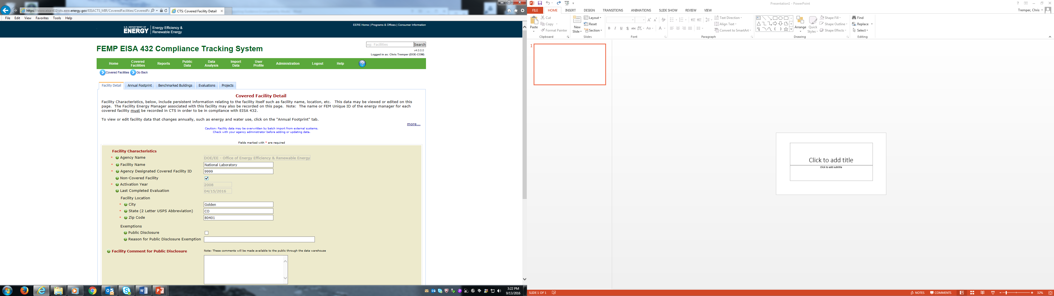

Agencies designate energy intensity goal status in CTS in the Annual Footprint tab as illustrated below:

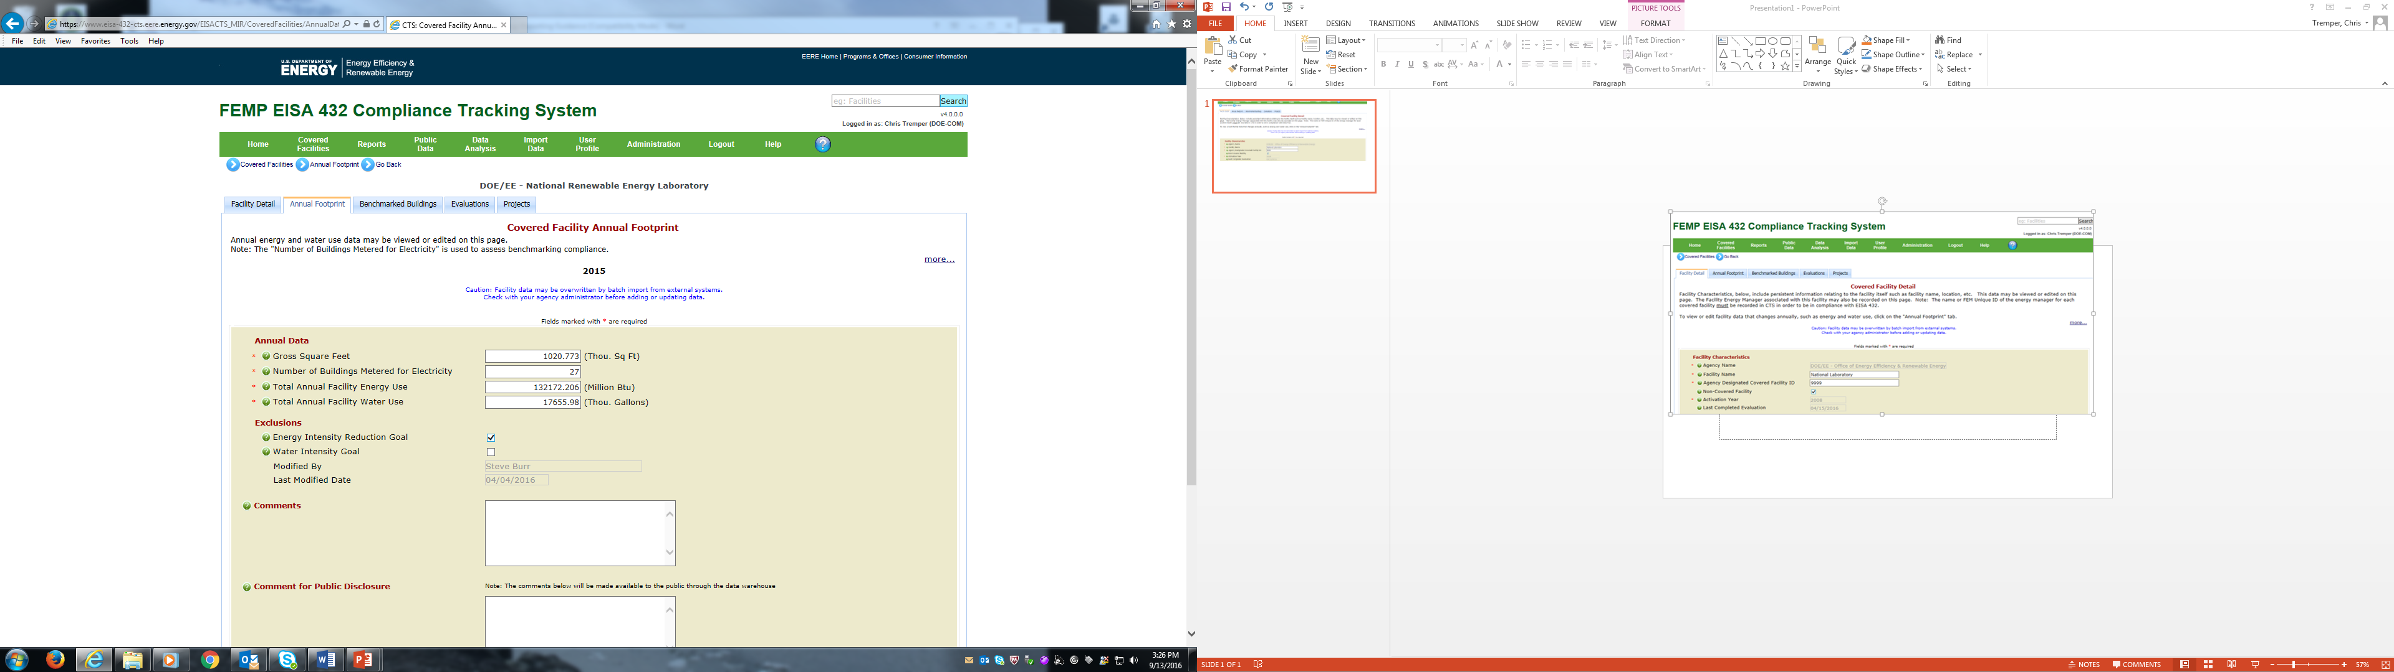

Only measured savings from projects in “goal excluded” buildings are included in the energy intensity performance goal credit. Measured project savings in “goal-subject” buildings are, by definition, already impacting the energy intensity goal performance metric of Btu/Gross Square Foot. Therefore, agencies will need to filter the CTS Follow-up Activity report (see: [https://www.eisa-432-cts.eere.energy.gov/ EISACTS/Reports/Reports.aspx](https://www.eisa-432-cts.eere.energy.gov/%20EISACTS/Reports/Reports.aspx)) to include project follow-up findings for only “goal-excluded” buildings for both EISA 432 “covered” and “uncovered” facilities. This is illustrated below:

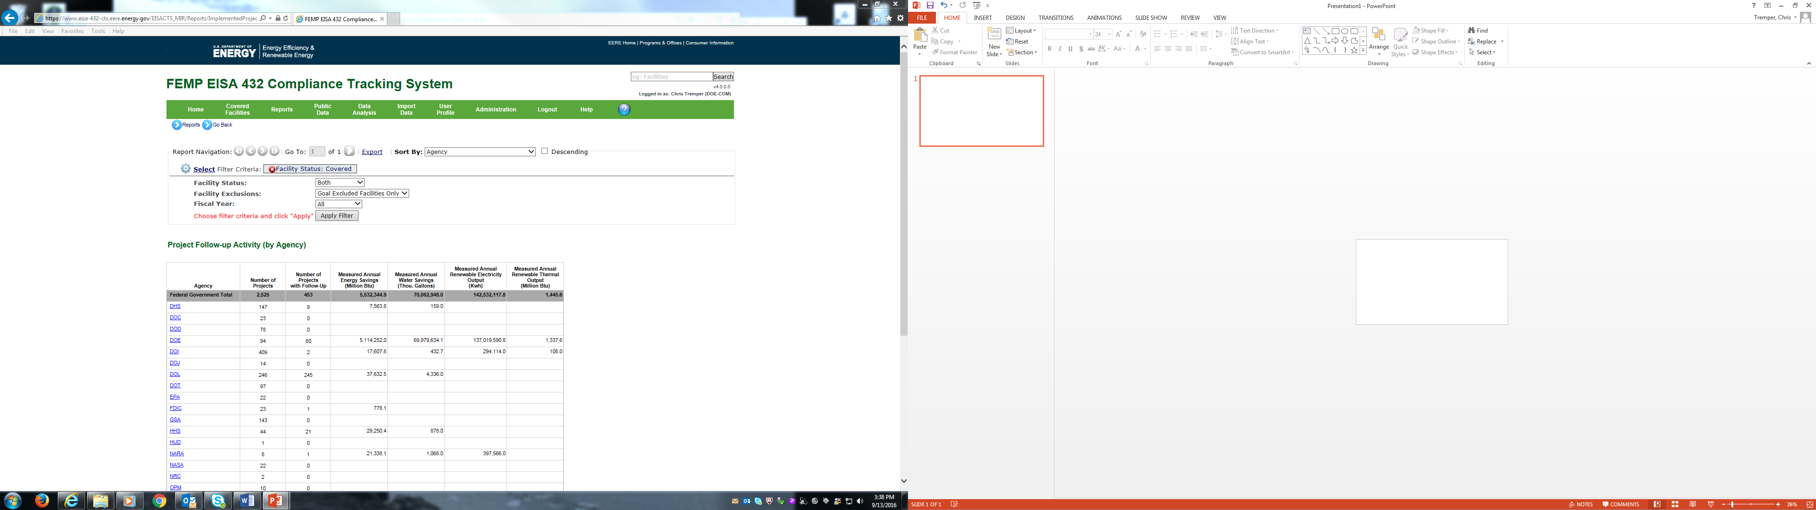

The FEMP CTS team (email: [EERE_CTS@ee.doe.gov](mailto:EERE_CTS@ee.doe.gov)) is also available to assist. In the near future, FEMP will develop a custom report for this purpose with the filters pre-set.

The CTS Follow-up report includes the agency total of Measured Annual Energy Savings in terms of site-delivered million Btu in the fourth column of the data table for the agency.

**Reporting to DOE FEMP**

Agencies are to report Energy Savings in Goal Excluded Facilities in the *Annual Energy Management Data Report* on tab 4.4, Other Data in cell F11. The adjustment should be entered as a negative number in terms of billion Btu. (The CTS Project Follow-up Activity report calculates the adjustment in terms of million Btu, so divide by 1,000 before entering the adjustment as a negative number in cell F11.) Example below and on the next page:

***CTS Follow-up Activity Report***



***Annual Energy Management Data Report, tab 4.4, Other Data, cell F11***

