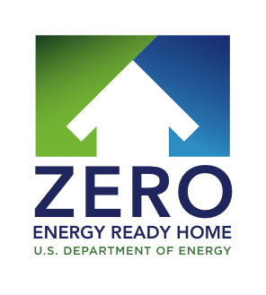
JUDGE:______________________________________

2019 Housing Innovation Awards
Category

Application Summary
Application ID:
Application Name:
Builder Name:
HERS Index w/PV:
HERS Index w/o PV:
Size:
Other Items of note:

THE STORY OF THIS HOME AND BUILDER
Review written text and score each row according to maximum number of points for given criteria.
Category/Criteria | Score: | Notes:
Performance (Max 15 pts)
Look for:
- Materials and energy efficiency features of walls, roof, attic, foundation, windows; air sealing, ventilation, HVAC, hot water, lighting, appliances, renewables, etc.
- System Integration
- HERS Score/energy modeling estimates
- Energy cost savings
- Climate appropriate optimization of energy efficiency apart from onsite renewable energy
- Other
Land Development (Max 3 pts)
Look for:
- Solar Orientation
- landscaping consideration related to energy efficiency and
- Landscaping consideration related to water conservation.
- Other
Design (Max 5 pts)
Look for:
- Design style is clearly expressed
- Architectural integration with performance including examples of natural comfort factors, disaster resistance and sustainable materials
- Regional design factors
- Energy efficient design prioritized (apart from renewable energy)
- Cost-effectiveness of design relative to performance achievements
- Other
Quality Construction (Max 3 pts)
Look for:
- A quality management plan and/or formal quality assurance program
- Coordination efforts such as pre-construction team meetings; staff and subcontractor training; and comprehensive construction documents
- Examples of process efficiency such as material waste management; building integrated modeling; etc.
- Other
Business Metrics (Max 8 pts)
Look for a fully realized business model for Zero Energy Ready Homes. Examples could include descriptions of:
- Incremental cost of construction above code
- Time-to-sale
- Number of homebuyer visitors
- Media coverage
- Customer satisfaction
- Actual energy billing data
- Any analysis demonstrating cost optimization while achieving performance goals
- Other
Sales, Marketing and Consumer Education (Max 10 pts)
Look for examples of Marketing the Zero Energy Ready Home Brand including:
- Description of sales training
- Displays
- Warranties
- Sales data comparisons to standards construction
- Tours
- Articles and videos
- Homeowner’s manual
- Social Media
- Marketing techniques
- Other
Sophistication of Application (worth 3 points):
Look for Complete application with all required items submitted including:
- Certified DOE Zero Energy Ready Home submitted
- Fully completed application spreadsheet
- All mandatory supporting materials
BONUS: Homeowner testimony (worth 1 point)

BONUS: Homeowner Video or Audio Recording (worth 1 point)
BONUS: Utility Bill or Energy Data (worth 1 point)
BONUS: (builder completed “my story” portion of application (worth 1 point)
Total Score (Max score w/Bonus: 51)

SUMMARY COMMENTS | What makes this home and builder special? Why do they stand out? What could be improved?

