July 18, 2014

Rec’d DOE/FE via email 7/18/14

Benjamin A. Nussdorf, Esq.

United States Department of Energy, FE-34.2

Electronically Delivered

Re: Docket No. 14-83-CGL

Dear Mr. Nussdorf: :  
  
We regret the delay in responding to your recent query concerning the sourcing of feedstock for the SeaOne Pascagoula facility and assurance of access to the proposed Port of Pascagoula location.  
  
As to the sourcing question:  
  
SeaOne Pascagoula LLC will receive its feedstock entirely from domestic sources. Feedstock will be delivered, via a new offtake pipeline located upstream from the existing Pascagoula Gas Processing Plant in Jackson County Mississippi, to SeaOne’s dedicated private plant pipeline.  
  
As to the access issue:

We are enclosing a letter from the Mississippi Development Authority confirming the site’s continued availability and the intention to formalize Port Commission approval and finalize access and occupancy agreements promptly upon issuance of DOE’s export approval.  
  
SeaOne is anxious to proceed with this project. We appreciate your attention.  
  
Regards,   
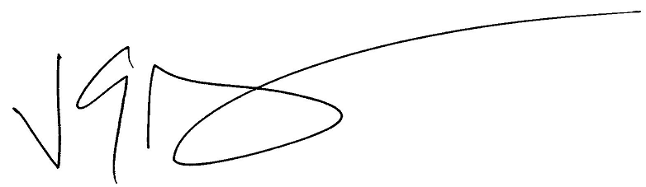  
  
Gordon Arbuckle  
Counsel to SeaOne Pascagoula LLC