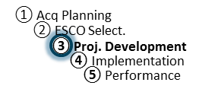
IGA Review Workshop Agenda
ESPC Process Doc. P3-04
r. 10-15-14
Responsibility: PF

Agenda: Investment-Grade Audit Review Workshop

Introductions/Roles
- Welcome by site person (Agency)
- Introductions (as needed by PF)

Objectives of the IGA Workshop
- Bring all parties together to identify, discuss, and reach agreement on all remaining issues to enable Task Order award.

Resolution of Remaining Issues
- Final project scope
  - ECM technical descriptions
  - M&V
  - Risk, Responsibility, and Project Performance
  - O&M, Repair & Replacement
  - Training
- Price Proposal
  - TO Schedules
  - Pricing
  - Financing
  - O&M, Repair, and Replacement
- Other Items

Award Plan
- Plan/schedule for Task Order award.

