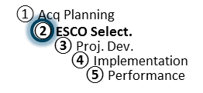
Agenda: PA Development Telecon
ESPC Process Doc. P2-08
r. 10-6-14
Responsibility: PF

Agenda:
Preliminary Assessment Development Teleconference

- Introductions
  - Agency CO & COR
  - ESCO Project Manager

- Status of PA development Schedule
  - ESCO Input on status of PA submittal Schedule
  - Discuss Timeline and pending actions

- Status of Data Collection from site visits
  - Discuss any issues (site access/security)

- Discuss any initial findings on proposed ECMs

- Project discussions on meeting customer expectations

- Discuss availability of ESCO’s PA components for review prior to PA submittal
  - Risk/Responsibility Matrix
  - Utility rate baseline and escalation rates
  - Other:

