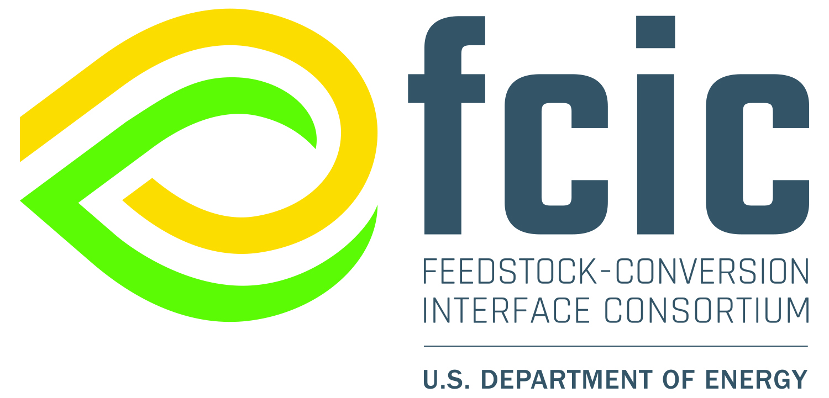

Feedstock-Conversion Interface Consortium (FCIC) Industry Partnership Call Proposal – Topic Area 2: Rapid Technical Assistance

This document is for Topic Area 2 ONLY! Download this template as a Word document. Delete blue instructions before submitting.

Applicant/Participant: (Legal company name)
- Is the applicant incorporated in the United States: Yes/No
- Is the company owned by a foreign entity: Yes/No (If Yes, provide parent name and country.)
- Company description: (Provide a brief description of your company.)
- Unique Entity ID (UEI): (Provide UEI from www.sam.gov.)
- Location(s): (List your company’s major U.S. manufacturing or research and development sites.)

- Participant Point of Contact:
Name:
Address:
Telephone:
E-mail:
- Identified national laboratory partner principal investigator (PI) and laboratory affiliation

By submitting this proposal, the applicant certifies they:
☐ Is requesting assistance that is not reasonably available in the private sector. Projects are intended to make available the specialized expertise and equipment at the FCIC national laboratories, not compete with the private sector.
☐ Will allow non-proprietary information about your organization and the success of the assistance to be featured in publicly available stories by the U.S. Department of Energy (DOE) and the national laboratories.
☐ Will be subject to DOE reviews and reporting requests, regular reports detailing how this requirement is being met, as well as the execution of all appropriate partnership documents required by DOE.

Each section of this template is aligned with the specific review criteria. Please complete each section. Proposals should be sufficiently long to make a compelling case, with the total length varying by project, but should be no more than 3 pages in length. The proposal title, company background, and non-proprietary project summary may be used in public announcements of winning proposals.

Proposal Title:

Non-Proprietary Project Summary (~0.25 pages)

Provide a brief non-proprietary description of project, including the technical challenge to be addressed, the approach, the expected outcome(s) and the potential impact(s).

___________________________________________________________________________
Technical Approach is 50% of total score.
Potential for Impact is 40% of total score.
Appropriateness of Government Resources is 10% of total score.

Technical Approach (~1 page, 50% of total score)

Purpose:
A one or two sentence statement of project purpose.

Reasons for Cooperation:
Briefly describe each party’s interests and strengths and how they are complementary with respect to developing the technology.

Duration of Project:
(Maximum duration is 6 months.)

Technical Objective:
Describe the technical goals of the project.

Task Descriptions and Deliverables:
Organize proposed work into discrete tasks. Subtasks may also be included if desired. Describe work in sufficient detail so that project progress can be easily tracked, and to allow reviewers to understand and evaluate the overall project and individual task scope and level of effort. Provide clear and specific deliverables for both participant and national laboratory partner(s), and start and end dates, expressed as the month after the start date (e.g., M0–M6). Deliverables are due at the end of the task duration unless otherwise specified. Include a task covering the explicit, non-proprietary dissemination of key results to the bioenergy community (e.g., through trade journals, technical reports, conference presentations, data sharing).

Task 1 Name:
Description:
Laboratory Partner Deliverables:
Participant Deliverables:
Start and End Dates:

Task 2 Name:
Description:
Contractor Deliverables:
Participant Deliverables:
Start and End Dates:

Task Summary Table
Summarize project task information in table below.
Task # | Task Name | Month Start | Month End

Risk Identification and Mitigation Strategies:
Describe the risks associated with the approaches outlined above and the risk mitigation techniques and strategies proposed to address them.
The goal of this topic area is to provide rapid and timely support to industry stakeholders. Please identify, and specific execution risks that might prevent timely completion of the project such as the availability of hardware or personnel at the national laboratory and how these risks might be mitigated.

2.0 Potential for Impact (0.50-0.75 pages, 40% of total score)
- Describe the potential impact of the project’s success
  - How will this increase the probability of success of the participant’s biorefinery project(s), e.g., reducing a known risk, solving a specific technical problem, others?
  - How is the proposed project consistent with the objectives of DOE Bioenergy Technologies Office (BETO) goals, targets, and metrics?
    - BETO Multiyear Program Plan (MYPP) - https://www.energy.gov/eere/bioenergy/articles/2023-multi-year-program-plan
    - Sustainable Aviation Fuel (SAF) Grand Challenge - https://www.energy.gov/sites/default/files/2022-09/beto-saf-gc-roadmap-report-sept-2022.pdf
  - How will the public dissemination plan help the bioenergy community?

Appropriateness of Government Resources (~0.5 page, 10% of total score)
- Why is government investment required, and why can’t the participant independently perform this project?
- Why are FCIC resources the best fit for this project? Indicate specific capabilities being requested.
FUNDING AND COSTS
The minimum DOE funding for a proposed project is $50,000 and the maximum is $150,000.

