IEDO Cross-Sector Technologies Workshop: Decarbonization Challenges and Priorities Across the Industrial Sector

Background
The Industrial Efficiency and Decarbonization Office (IEDO) leads the development and accelerates the adoption of sustainable technologies that increase efficiency and eliminate industrial greenhouse gas (GHG) emissions. IEDO plays a strategic role in building a strong decarbonized economy through investments in research, development, and demonstration activities, as well as technical assistance and workforce development. IEDO partners with corporations, nonprofits, individuals, universities, laboratories, state/local government, and consortia.
To achieve decarbonization in the industrial sector, IEDO is organized into three subprograms: Energy- and Emissions-Intensive Industries (EEII), Cross-Sector Technologies (CST), and Technical Assistance and Workforce Development. CST accelerates the readiness of energy- and emissions-reducing components, systems, and operational technologies, across a broad range of industries, including thermal processes and systems, enabling technologies for low carbon fuels and feedstocks, and emerging efficiency and other decarbonization technologies. Subprogram priorities are identified through analysis, which uncover knowledge gaps and barriers, and stakeholder engagement activities.
Stakeholder engagement, including workshops and roundtables, provide a direct interface between government, research institutions, national labs, academia, and industry. This permits insight into the priorities and the challenges regarding decarbonization that guide IEDO’s program objectives. Stakeholder engagement activities will also serve as a mechanism to evaluate DOE’s RD&D technology priorities, metrics, and targets. Communication with stakeholders is critical to ensure that funding opportunities for specific areas of interest address the most critical technical challenges that preclude industrial energy and GHG emissions reduction.

Motivation
The industrial sector, composed of manufacturing, agriculture, mining, and construction, accounted for 33% of the nation’s primary use and 30% of energy-related CO₂ emissions in 2020. The industrial sector is considered one of the most difficult to decarbonize due to the diversity and complexity of energy inputs, processes, and operations. However, a significant number of energy and emissions reduction opportunities, as identified in DOE’s Industrial Decarbonization Roadmap, are common across industrial subsectors.
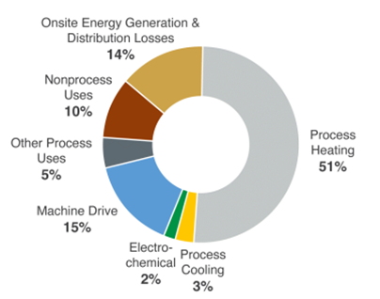
Figure 1: Breakdown of Onsite Energy Use at Manufacturing Facilities, 2018.

Process heating represents the largest opportunity for cross-sector impact. It is the single largest end use of energy and emissions in the manufacturing sector. In 2018, process heating in manufacturing was estimated to account for over 7 quads of energy use and nearly 300 million metric tons of onsite GHG emissions. More than 90% of this energy is generated from the combustion of fossil fuels. Approaches that rely on electricity, low- or no-heat alternatives, and low-carbon fuels, such as hydrogen, are needed.

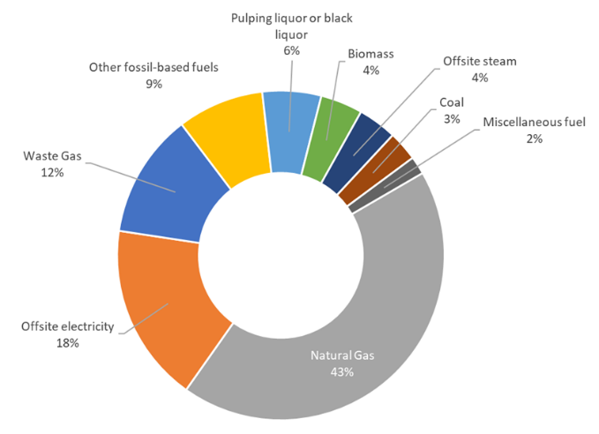
Figure 2: Breakdown of Energy Sources at Manufacturing Facilities, 2018.

Transitioning to low carbon fuels and energy sources offers a tremendous opportunity to broadly enable decarbonization. Bio-derived fuels, waste/byproducts, and hydrogen use can reduce fossil fuel and offsite electricity demand. However, development of process equipment and auxiliary component technologies is needed, such as advanced controls and sensors, burners, and other industrial furnace equipment.
Energy efficiency is the most cost-effective option for near-term GHG emissions reduction and is a foundational cross-cutting decarbonization strategy. Emerging efficiency and other decarbonization technologies can improve industrial production system efficiencies and process yield. Energy systems analysis and data analytics and modeling can further uncover opportunities for decarbonization.
In September 2022, DOE announced its sixth Energy EarthShot, the Industrial Heat Shot. The Industrial Heat Shot aims to develop cost-competitive industrial heat decarbonization technologies with at least 85% lower GHG emissions by 2035. The CST subprogram is closely coordinated with Heat Shot activities, and the portfolios within CST are well aligned with these pathways.
The section below briefly describes the workshop topics, which align with CST portfolio areas.

Topics
Thermal Processes and Systems
Thermal process and systems are both essential and pervasive in industry, yet every major industrial subsector uses heat in different ways. Thermal processes can include drying, steam generation and use, distillation, melting, smelting, calcining, and others, ranging from low temperature needs (~ 300°C) to high temperatures greater than 800°C. Altogether, industrial heat results in 11% of all U.S. energy-related emissions.,
To decarbonize industrial heat, the Heat Shot identifies the following three pathways: generation of heat from clean electricity, innovative low- or no-heat process technologies, and integration of clean heat from alternative sources. Equipment that supports electrification (i.e., electrotechnologies) and use of clean electricity, along with energy efficiency, can include heat pumps, microwave heating, resistive heating, and thermal storage. Low- or no-heat process technologies can be enabled through new chemistry and emerging approaches to reduce heat demand, such as through advanced separations, electrolysis, ultraviolet curing, and bio-based manufacturing. Finally, clean heat can be achieved by switching to low-emissions heat sources and increasing thermal storage capabilities to further reduce emissions.
Low-Carbon Fuels and Feedstocks
Low-carbon fuels, feedstocks, and energy sources (LCFFES) is one of the four pillars established in the DOE Industrial Decarbonization Roadmap for reaching net-zero emissions by 2050. LCFFES encompasses clean fuel technologies, clean energy sources, and alternative feedstocks, and the key technical areas of interest include hydrogen, biofuels, biomass, processing of byproducts, and integration of renewables (i.e., concentrating-solar power, geothermal, and nuclear) within industrial processes. Use of low-carbon fuels is also a key alternative for hard-to-electrify applications requiring high-temperatures and/or direct-fired heating. IEDO’s LCFFES portfolio is specific to end-use (i.e.: not significant focus on production, storage, and transportation). Thus, the main goal for this portfolio is to invest in RD&D that supports the adoption and/or use of low-carbon energy sources and feedstocks to achieve net-zero emissions by 2050.
Emerging Efficiency and Other Decarbonization Technologies
Emerging efficiency and other decarbonization technologies can encompass a wide breath of technologies. Within the CST subprogram, this portfolio focuses on four key areas: industrial flexibility, advanced material and heat management, smart manufacturing, and low thermal budget processes. Industrial flexibility can be achieved through demand flexibility with a grid-interactive industry where energy storage is integrated into industrial processes. Advanced auxiliary equipment like ultra-high efficiency heat exchangers and waste heat recovery systems to support reuse tie to advanced materials and thermal management, while smart manufacturing includes the use of machine learning/AI and advanced sensors and controls to improve energy efficiency through optimization of processes in real-time. Low thermal budget processes are transformative technologies that use alternative process routes or technologies to achieve the same end products manufactured by the current processes. These technologies may not use thermal processing, or they may significantly reduce the consumption of thermal energy in production. Examples of alternative process technologies include non-thermal separations via durable and scalable membranes, non-heat-based technologies that rely on mechanical vibrations, electromagnetic (EM) radiation, and other manufacturing methods that can eliminate or reduce thermal processing steps for a given operation. Given the lack of auxiliary equipment to address infrastructure needs and limitations associated with legacy process equipment that stand as barriers, the goal is to invest in next-generation technologies to achieve an efficient and competitive industrial sector with net-zero GHG emissions.
Additional Resources
For additional resources on decarbonization of the manufacturing sector, please see the links below to additional reading materials.
- 2022 Decarbonization Roadmap
- Manufacturing Energy and Carbon Footprints
- Thermal Process Intensification (TPI) Report
- DOE Quadrennial Technology Review 2015

Objectives
The objectives of the workshop are to solicit stakeholder feedback for the purpose of:
- Identifying and prioritizing emerging component and equipment technologies.
- Identifying the challenges and RD&D opportunities for transformative, decarbonization technology innovations.
- Informing CST’s RD&D goals and metrics.
Workshop participants will hear presentations and engage in facilitated discussions on the topics listed above.
Technology areas of interest will include but are not limited to:
- Electrotechnologies
- Low-carbon fuels and energy sources
- Low-thermal budget processes
- Biomanufacturing
- Feedstocks
- Smart manufacturing
- Waste heat recovery
- Machine learning/AI
- Thermal energy storage
- High-efficiency heat exchangers

U.S. Energy Information Administration, Annual Energy Outlook 2021 with Projections to 2050, 2021.
DOE Industrial Decarbonization Roadmap. 2022. https://www.energy.gov/sites/default/files/2022-09/Industrial Decarbonization Roadmap.pdf
DOE AMO, Manufacturing Energy and Carbon Footprints (2018 MECS), 2021, https://www.energy.gov/eere/iedo/manufacturing-energy-and-carbon-footprints-2018-mecs
AMO 2018 Manufacturing Energy and Carbon Footprints (2022)
U.S. Energy Information Administration, Annual Energy Outlook 2021 with Projections to 2050, 2021.

