Counter Nuclear Smuggling Assessment Metric Determination Guide
Nuclear Smuggling Detection and Deterrence

Content
General Overview 1
Metric Determination 2
Question 1 - Policies and Procedures: Does the partner agency have a concept of operations defining their CNS operation? 2
Question 2 - NSDA Operations: Does the partner agency conduct operations in accordance with their CONOPS? 3
Question 3 - Training: Are the partner agency's relevant personnel trained on the required knowledge and skills to conduct operations? 5
Question 4 - Maintenance: Is the partner agency's radiation detection equipment operational and capable of fulfilling the mission? 6
Question 5 – Assessment: Is the effectiveness of the partner agency's CNS system being routinely evaluated? 8
Appendix A: NSDD Official Partner Agencies 10

Acronyms
CAS central alarm station
CNS counter nuclear smuggling
CNSA Counter Nuclear Smuggling Assessment
CONOPS concept of operations
DART Desktop Analysis Reporting Tool
IAEA International Atomic Energy Agency
NSDD Office of Nuclear Smuggling Detection and Deterrence
NSDA Nuclear Security Detection Architecture
RDS radiation detection system
RPM radiation portal monitor
SOP standard operating procedure
SV sustainability visit
USG U.S. government

NSDD Metric
The Office of Nuclear Smuggling Detection and Deterrence (NSDD) metric is the annual percentage of partner agencies demonstrating operational capability of counter nuclear smuggling (CNS) systems. The Counter Nuclear Smuggling Assessment (CNSA) is conducted quarterly, with results reported annually to Congress. As needed, country managers meet with NSDD management to discuss and finalize the CNSA for each partner agency.

General Overview
- Operational capability is defined as a partner agency meeting baseline qualification in each of the five performance categories:
- Policies and Procedures
- Nuclear Security Detection Architecture (NSDA) Operations
- Training
- Maintenance
- Assessment
- Using current information, the CNSA is performed quarterly. Results are used to track NSDD’s progress toward meeting the CNSA baseline operability target at the end of the fiscal year.
- A partner agency should be evaluated based on the expected status of its CNS architecture/system at the end of the current quarter of assessment. If any partner agency engagement is planned between the time of the CNSA by the country team and the last day of the current quarter of assessment, that engagement should be considered when justifying the CNSA for that quarter.
- Baseline operability credit is given regardless of whether the partner agency or other support entity (e.g., U.S. government [USG], International Atomic Energy Agency [IAEA], in-country reachback agency) provides the qualifying measure (e.g., an IAEA-led training course). If the partner agency does not have the authority/ability to meet all the qualifying measures for all five performance categories, with or without support from an external entity, and this situation is not expected to change during the reporting period, the partner agency does not demonstrate baseline operational capability.
- Many partners operate CNS systems at multiple sites and across different vectors. For answering the metric questions, all the partner agency’s CNS systems should be considered as a whole.
- NSDD partner agencies assessed for the metric are those that conduct radiation detection operations, typically customs service, border guard, law enforcement, or security services. Technical reachback/expert support organizations that conduct operations following initial detection fall under the umbrella of investigation support; these agencies are not assessed separately for the metric, though they are critical to partner agency qualification in some performance categories. Appendix A provides guidance on which partner agencies are evaluated under the CNSA.
- Radiation detection equipment is equipment that directly supports the detection and interdiction of radioactive materials (i.e., instruments and systems that detect the presence of radiation and/or identify isotopes) and are subject to metric evaluation. Auxiliary equipment (e.g., binoculars, X-ray imaging devices, unattended ground sensors) that facilitates a partner agency’s ability to execute the overall CNS mission will not be evaluated for maintenance but should be considered as part of a partner agency’s CNS system.

Metric Determination
A binary, yes/no question for each performance category is answered by the country manager for each partner agency based on assessments conducted throughout the year. The five assessment questions are:
- Policies and Procedures: Does the partner agency have a concept of operations (CONOPS) defining their CNS operation?
- NSDA Operations: Does the partner agency conduct operations in accordance with their CONOPS?
- Training: Are the partner agency's relevant personnel trained on the required knowledge and skills to conduct operations?
- Maintenance: Is the partner agency's radiation detection equipment operational and capable of fulfilling the mission?
- Assessment: Is the effectiveness of the partner agency's CNS system being routinely evaluated?
Details associated with each answer are to be submitted as justifications within the CNSA collection tool. Justifications should contain context and supporting statements relevant to the performance category in which they are entered. Justifications should contain the date of last occurrence of the qualifying event, or confirmation of occurrence by partner, to support informing the current quarter’s CNSA.

Question 1 - Policies and Procedures: Does the partner agency have a concept of operations defining their CNS operation?

Purpose/Definition
The purpose of this question is to assess whether a partner agency has a CONOPS describing their CNS duties. For the purposes of the metric, a CONOPS is a description of who will do what and how they will do it. This may include an alarm adjudication flowchart illustrating a common understanding of who is conducting primary and secondary inspections and how they will occur. The CONOPS should clearly indicate the partner agency’s range of CNS responsibilities and may identify other entities responsible for subsequent or supporting actions. The CONOPS should identify mitigation activities in the event of radiation detection equipment performance degradation or failure. A standard operating procedure (SOP) is also acceptable, understanding that a SOP is a more detailed document and presumes the existence of a CONOPS.

Considerations/Instructions
Answer “yes” to this question if the partner agency has adopted a CONOPS delineating how CNS operations are conducted by their agency, regardless of whether the CONOPS was developed by the partner agency or provided by another entity (e.g., the USG, IAEA). A CONOPS is typically developed during the implementation phase of the project or provided by NSDD during the initial operator training.

Example Questions/Applications
- What if the partner agency states they have a CONOPS, but is not willing to share it with NSDD? Answer: Yes. The partner does not have to produce a documented CONOPS.
- The partner agency was given a CONOPS by the USG, but they have not developed their own CONOPS. Is this acceptable? Answer: Yes, the CONOPS provided by the USG is an acceptable baseline capability and would count toward the metric.
- The partner agency was given a CONOPS by the USG during initial operator training, but there is no indication they are following the CONOPS or that the site operators are aware of it. Should this count? Answer: Yes, the agency has a CONOPS. This question is to determine if the agency has a CONOPS, not the effectiveness of operations or training.
- The partner agency has a CONOPS, but it lacks definition of the reachback agency providing technical support following an interdiction (investigation support). Does that document meet the metric? Answer: Yes. While actions subsequent to a detection and alarm adjudication are critical to nuclear security, the metric assessment is restricted to the NSDD partner agency responsible for the initial radiation detection operations. Nevertheless, country teams should work with partners to develop and implement a comprehensive CONOPS, as well as related regulatory and administrative guidance.
- The USG provided a CONOPS several years ago, but since then a new partner agency has taken over detection operations. The new partner agency is not aware of the original CONOPS and does not appear to have a functioning CONOPS. Should this count, since a CONOPS was originally provided? Answer: No. If the current partner agency does not have a CONOPS in place, they do not meet the intent of this question.

Question 2 - NSDA Operations: Does the partner agency conduct operations in accordance with their CONOPS?

Purpose/Definition
The purpose of this question is to assess the partner agency’s baseline operations capability through observable outcomes. It is not meant to evaluate the effectiveness of the CONOPS, or the operations they define, only that:
- operations are being conducted, and
- they are in accordance with the established CONOPS.
At the time of the metric evaluation, an agency should be evaluated based on the status of its CNS operations.

Considerations/Instructions
Answer “no” if the partner agency is not conducting operations.
Answer “yes” to this question if CNS operations are being conducted as defined in the partner agency’s CONOPS. This means both that operations are proceeding, and that the agency is generally/reasonably following their plans regardless of how many sites they operate at any given time. In some cases, the partner agency may have a need to temporarily exclude sites or systems due to seasonal concerns, natural disasters, and/or geopolitical shifts. Such partner agencies would be considered to meet the baseline operability threshold if they have accounted for such in their CONOPS. If operations have ceased completely at a majority of sites, this becomes a ‘no’, irrespective of the partner agency’s normal adherence to the CONOPS.
For systems with fixed radiation portal monitors (RPMs), the number of inspections is likely predetermined by the vehicle traffic through the RPMs. For radiation detection systems (RDS) that contain mobile detection systems or handheld equipment only, the number of primary scans should be commensurate with the intended use of the equipment as defined in the CONOPS or understood by the partner agency. For the partner agency operating any of these types of sites to demonstrate a baseline operability, they should be conducting both primary and secondary inspections.
There are activities critical to nuclear security (e.g., investigation support) that are outside the range of the NSDD partner agency responsibilities associated with the initial radiation detection operations. While country teams should encourage partners to operate according to a comprehensive CONOPS, the metric assessment is restricted to detection and alarm adjudication.

Example Questions/Applications
- If the partner agency’s RDS is inoperable or performing in a degraded manner agency-wide, how would I answer this question? Answer: It depends on two things:
- whether operations have ceased completely at the majority of sites, and
- the partner agency’s CONOPS.
  - First, if the partner agency is conducting operations with most of their RDS, the system is considered to be operating.
  - Second, if the CONOPS accounts for anomalies by indicating actions to take in the event of system disruption, and the partner is operating in accordance with their CONOPS then the answer would be “yes.” Otherwise, the answer would be “no.”
- Would a partner agency meet the metric if they conduct operations in accordance with the CONOPS at some of their sites, but not all? Answer: This is a judgment call on the part of the country team, taking into consideration all sites as a whole.
- Does this question consider the partner agency conducting operations with equipment provided by others (e.g., IAEA, European Commission Joint Research Centre, internally procured)? Answer: Yes, if the equipment is being used in accordance with the CONOPS for the detection operations supported by NSDD.
- If operations are being conducted according to the CONOPS, but the CONOPS is insufficient, does the partner agency meet the metric for this performance category? Answer: Yes. The intent of this question is to determine whether the partner agency is conducting operations in accordance with the CONOPS, not to determine the effectiveness.
- Is using mobile or handheld equipment once or twice a year (or never) considered in answering a yes/no for baseline operability? Answer: It depends on the CONOPS. Yes, if the CONOPS allows for that periodicity of usage, and the system is used in accordance with those operations. No, if not.

Question 3 - Training: Are the partner agency's relevant personnel trained on the required knowledge and skills to conduct operations?

Purpose/Definition
This question is intended to determine if the partner agency has
- trained staff, and
- access to training resources to help ensure current and future staff have the necessary training to continue to operate.
It is not meant to evaluate how effective the training is, how universally it is applied, or who provides the training, but rather to determine if the partner agency has tools/resources to conduct training and is making efforts to do so.

Considerations/Instructions
Answer “yes” to this question if all of the following are true and answer “no” if any of the following are not true:
- Partner agency staff has participated in relevant training activities, regardless of who provides the training (i.e., self-led, USG, third party, etc.), within the past eight quarters, including the current quarter being assessed.
- Partner agency has some sort of training process/materials (e.g., training course materials, checklists for on-the-job training, etc.), regardless of who provided the information or how effectively they are using it.
- Partner agency has access to equipment/facilities (e.g., handhelds, central alarm station [CAS], lab facilities, etc.) to conduct training.

Example Questions/Applications
- Partner agency sent four people to a U.S.-led operator training course during the current fiscal year. They have over 50 staff and there is no other indication that any other staff have participated in any formal training. Does this count? Answer: Yes, this would count toward consideration #1. The fact that the partner agency participated in any type of relevant training course means they are taking some training steps.
- Partner agency has sent staff to U.S.-led operator training courses in the past, but not for several years, and there is no indication that they are conducting any formal on-the-job training on their own. Does historical operator training count for consideration #1? Answer: No. If there is no indication that the partner agency is continuing to support operator training activities (i.e., in the last eight quarters at a minimum), then no credit should be given for past participation in operator training.
- Partner agency has stated that they do conduct formal operator training, but this has not been observed by the U.S. project team and operators appear to be untrained (i.e., they do not understand how to appropriately use the RDS). Should this count toward consideration #1? Answer: Yes, if the partner country indicates that they are conducting operator training, it would count since this question is not addressing the effectiveness of training.
- Partner agency has been given operator training materials from the USG in past courses, but there is no indication they are using those materials. Should this count for consideration #2? Answer: Yes, if the partner agency has access to operator training materials, regardless of how effectively they are being used, that would count.
- Partner agency sends staff to a Nuclear Security Support Center in a neighboring country for operator training. Given that this facility is not owned by the partner agency, nor is it a resource within the agency’s home country, should this count toward consideration #3? Answer: Yes, this would count. Access to training facilities, wherever they are located, are appropriate.

Question 4 - Maintenance: Is the partner agency's radiation detection equipment operational and capable of fulfilling the mission?

Purpose/Definition
The purpose of this question is to determine whether maintenance is being performed on the partner agency’s radiation detection equipment. If the partner agency’s radiation detection equipment is operating according to design, it is assumed that this is indicative of a baseline maintenance capability (regardless of who performs the maintenance).

Considerations/Instructions
Answer “yes” to this question if the partner agency’s radiation detection equipment is operating sufficiently to conduct CNS operations as defined in the partner agency’s CONOPS. This means the partner agency is generally/reasonably provisioning maintenance activities, regardless of how many sites they operate at any given time. As with the NSDA Operations Performance Category, in some cases, the partner agency may have a need to exclude sites due to seasonal concerns, natural disasters, and/or geopolitical shifts. Such partners would be considered to meet the baseline threshold for maintenance if they have plans to maintain the equipment once the situation resolves.
At the time of the metric evaluation, a partner agency should be evaluated based on the status of its radiation detection equipment and the expected long-term state, considering the partner agency’s capability/track record to address maintenance issues.
For partner agencies operating multiple sites, the focus remains on the maintenance being performed and the observable outcomes across their entire RDS architecture. As mentioned above, the partner agency’s demonstrated historical capability and commitment to addressing equipment corrective and periodic maintenance issues should be considered when evaluating their capability to meet the mission requirements.
At the site level, the CNS equipment is deemed completely inoperable only if the entire site’s capability is diminished such that it cannot detect target quantities and types of special nuclear material and other radioactive materials of concern. If a system has significant problems, but the partner agency is taking compensatory measures outside the normal system design, the equipment is still considered operational.

Example Questions/Applications
- Multiple RPMs at a site are not functional. While the maintenance provider is preparing for and performing repairs, the partner agency reroutes traffic at the site through other functional RPMs to fulfill the radiation detection mission. Does this situation count? Answer: Yes. This site is experiencing a major issue but has other measures in place to conduct some level of detection, so it is still considered operational.
- The alarm communications system at a site is not functional because the motherboard in the CAS server failed. The maintenance provider activated the alarm lights and sirens on the RPMs and the partner agency stations front line officers near the RPMs to control traffic. Does this count as being operational? Answer: Yes. Although the partner agency cannot adjudicate alarms using the CAS, the site maintains full radiation detection capability.
- All RPMs and the alarm communications system at a site are fully functional. However, the radioisotope identification devices are not functioning, and secondary inspections cannot be conducted. Does this count as being operational? Answer: No. Secondary inspection is a critical part of an operational RDS, so unless the CONOPS designates an alternative approach to secondary inspections, maintenance baselines are not met as the handhelds are inoperable.
- A partner agency is responsible for operating four sites. Only three of the sites are operational, and the fourth site is non-functioning. Does this count? Answer: Generally, yes, provided the partner agency has a maintenance system and procedures in place that address, in a timely fashion, the corrections needed, and a demonstrated routine of preventive maintenance measures to avoid future equipment failures and/or early degradation. As emphasized above, their track record needs to be considered in answering this question. Equipment down at any one snapshot in time does not necessarily indicate a failure to meet this metric provided the partner agency has a plan and is employing corrective measures to remedy the equipment deficiency.
- Due to a change in leadership, the partner agency stopped maintaining all their radiation detection equipment and several sites were non-operational for over nine months during the past year. After additional training and encouragement, the partner agency resumed maintenance and most sites have been restored to operations. Given the sites were not operational for most of the year, would this count? Answer: Yes. The metric is based on equipment operation at the time of evaluation, not an evaluation of the past, and the expected long-term state of the RDS is operational.
- At the time of the metric evaluation, a partner agency’s RDS is non-operational due to a recent storm. The system had been operational during 11 of the past 12 months. However, the partner agency is self-performing maintenance and is unlikely to be able to restore the system to baseline operability for a significant period of time. Does this count? Answer: No. Although the equipment was operational for most of the past year, the current expected long-term state of the system is not operational. However, if the partner has a proven maintenance capability and track record, or access to other resources, such as a regional maintenance provider, and is expected to restore operations, the system could be counted as operational.

Question 5 – Assessment: Is the effectiveness of the partner agency's CNS system being routinely evaluated?

Purpose/Definition
The purpose of this question is to determine whether the partner agency’s CNS system is being periodically assessed. It is not meant to evaluate the results of any assessments, how effective the systems are, or who does the assessments, but whether assessments are actually conducted. Assessments could range from a basic walkdown of a radiation detection lane by a customs supervisor to a sustainability visit (SV) conducted by the partner agency or an NSDD team, to a multilateral, full-scale exercise or evaluation conducted by the IAEA, NSDD, or combination of organizations.

Considerations/Instructions
Answer “yes” to this question if a partner agency’s policies and procedures, operations, training, or maintenance capabilities have been assessed, reviewed, and/or revised for improvement, or exercised within the past eight quarters, including the current quarter. Criteria are met whether the assessments were conducted by the partner agency or an external partner, e.g., another agency within the country, a regional leader from another country, or the NSDD country team.

Example Questions/Applications
- Does a routine SV by the NSDD country team count as an assessment? Answer: Generally, yes. SVs nearly always have an assessment objective related to at least one of the performance areas. The program expects that if a site is visited, general assessments of all the performance areas are made with possible recommendations provided to the partner. The date of the SV should be added to the CNSA justification.
- Do remote SVs count? Answer: Yes. Remote execution will sometimes be necessary and counts as an assessment. The date, or dates, of the remote SV should be noted in the justification.
- The partner agency conducts self-assessments regularly, but the frequency of the assessments is unknown. Does this count? Answer: Yes, if the frequency of assessments can be reasonably assumed to be more than once per eight quarters, based on discussions with the partner and/or other evidence. Examples:
  - The partner agency conducts TTX activities to review Policies and Procedures or FTX activities to assess NSDA Operations and apprises the country team. In that case, it is sufficient to make that statement in the Assessment justification with the date of discussion.
  - The partner agency may conduct DART [Desktop Analysis and Reporting Tool] analysis and let the country team know the results. In that case, the date of the country team discussion with the partner agency on this topic can be noted in the justification.
- The partner agency states they are conducting assessments, but operations seem to be ineffective. Should this count? Answer: Yes, if they claim they are doing assessments, then this does count, as this metric is not meant to measure the effectiveness of their assessments. The CNSA justification can note the date the partner agency confirmed, or reconfirmed, that these assessments were occurring.
- The partner agency sends daily files. Can they be counted as an assessment? Answer: Yes. If DART analysis is performed and a direct inference can be made between the data and the performance of equipment or operators, and discussions are held with all stakeholders (NSDD country team, data analysts, partner agency points of contact) to address deficiencies in the RDS and implement improvements as a result of the data analysis. Results of the analysis need to be noted in the justification to count toward assessment. Note that the exchange of DART reports with the partner is not sufficient justification to answer “Yes” in this performance category.
- The partner agency has participated in an exercise development workshop to learn how to plan, execute, and evaluate exercises, but it is unclear if they have actually conducted exercises. Does their participation in a workshop count? Answer: No, participation in the workshop does not count as conducting assessments. The team should get an indication from the agency if assessments (i.e., exercises) are occurring.
- Partner agencies in a given country participated in a field-training exercise run by NSDD and another organization (Interpol, European Commission, etc.) to examine gaps in detection and technical reachback procedures. Does this count? Yes. This sort of exercise would serve as an assessment. The justification can note the date of the exercise.

Appendix A: NSDD Official Partner Agencies
The NSDD metric assesses partner agencies demonstrating operational capability of CNS systems. NSDD maintains a list of official partner agencies which are counted toward the CNSA. Official partner agencies are, therefore, eligible for evaluation (and reporting) against the five performance areas when the following conditions have been met:
  - CONOPS: A plan for how CNS operations should be conducted is provided to, or developed by, the operating agency.
- NSDD considers the type of inspections (i.e., pedestrian, containerized cargo, luggage), agency roles and responsibilities, operational level constraints (i.e., traffic flows at a border site, patrol areas, physical space available for inspections), primary and secondary inspection processes, and equipment performance and capability when developing a CONOPS. CONOPS organize, and ultimately, finalize operational plans. More detailed procedures, such as SOPs, can and should be developed as partner agencies determine the details of the CNS operation. CONOPS should be updated if there is a change in CNS operations.
  - Radiation Detection System Operator Training: Front line officers responsible for the assessment of information alerts and instrument alarms are trained on the operation of the RDS.
- NSDD has developed course modules based upon job roles specific to operators of radiation detection equipment; courses are adapted to the type of operation.
  - Proven/Tested Equipment: The operational capability of the equipment is established through formal program acceptance testing and operations are formally turned over to the partner agency.
See Figure A.1 for a workflow of the partner agency process.
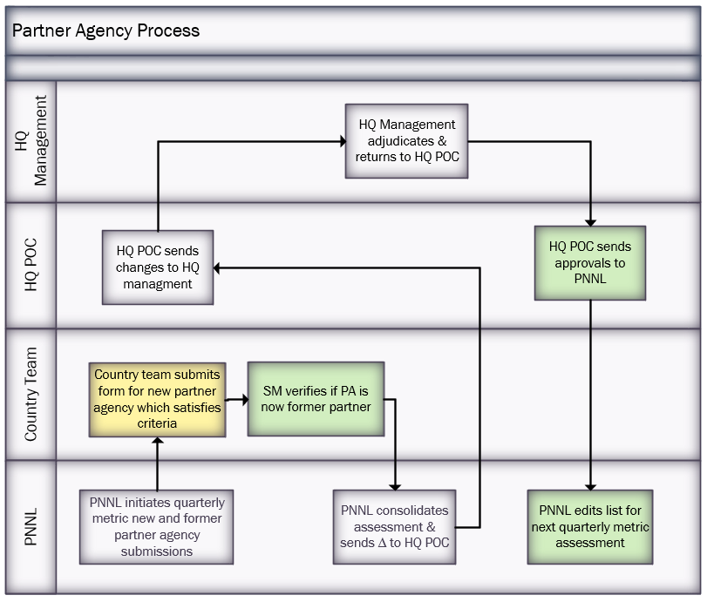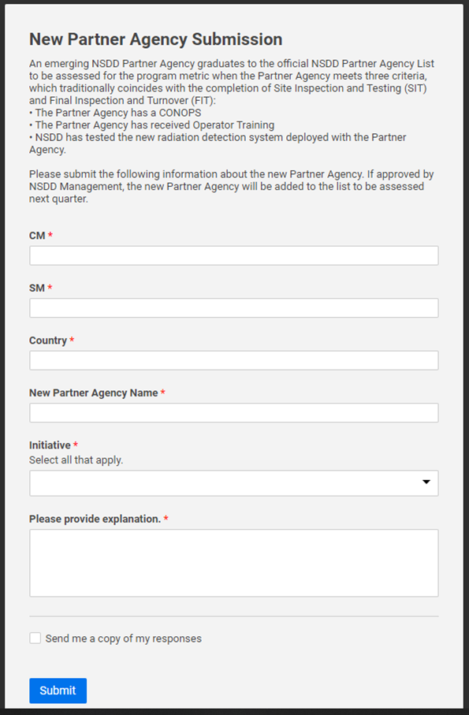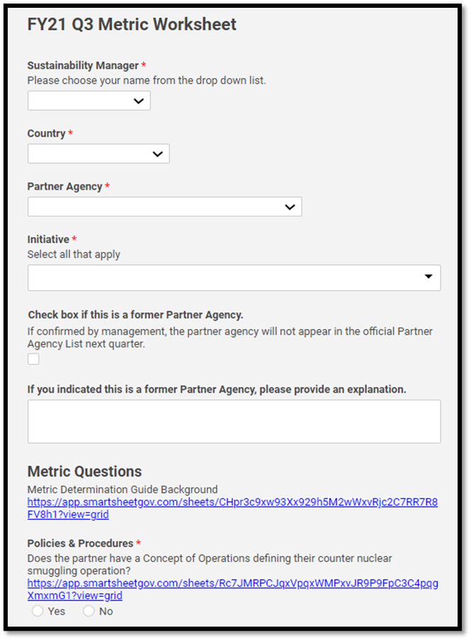
Figure A.1. Partner Agency Process

