Proposed layout for PV Installation, Battery Energy Storage System, and Electric Vehicle Charging Station
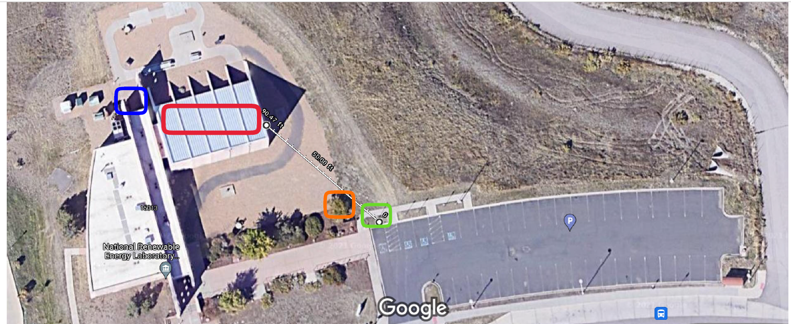

Red=100kW PV panels
Blue=Battery Energy Storage System
Green=Electric Vehicle Charging Station
Orange=Tree to be removed
Purple=Existing transformer
White Line=Approximately 90 feet of trenching for underground conduit

