Vulnerability Assessment and resilience planning guidance

This guidance outlines a climate change vulnerability assessment and resilience planning process to help the Department of Energy assess and manage climate change related risks to Departmental assets and operations.

  - U.S. Department of Energy, Sustainability Performance Division

Table of Contents
Introduction 2
Key Steps to Climate Change Vulnerability Assessment and Resilience Planning 3
Step 1: Identify VARP Planning Team 4
Step 2: Identify Critical Assets and Infrastructure 4
Step 3: Characterize Climate Trends and Events 4
Step 4: Characterize the Likelihood of Climate Change Hazards 5
Step 5: Characterize Current and Projected Impacts of Climate Change Hazards on Assets and Infrastructure Systems 6
Step 6: Characterize Vulnerabilities with a Risk Matrix 6
Step 7: Identify and Assess Resilience Solutions 8
Step 8: Develop and Implement a Portfolio of Resilience Solutions 9
Step 9: Monitor, Evaluate, and Reassess the Resilience Plan 9
Appendix A: Vulnerability Screening Tool 11
Appendix B: National Climate Assessment 11
Appendix C: U.S. Climate Resilience Toolkit 12
Appendix D: Climate Explorer 12
Appendix E: Climate Impact Lab 12
Appendix F: DOE Orders Crosswalk 12
Appendix G: 2017 Vulnerability Screening Guidance 15
Appendix H: 2015 Vulnerability Assessment Guidance 15
Appendix I: Pilot Climate Vulnerability Assessments 15

Introduction
The U.S. Department of Energy is committed to managing the short and long-term effects of climate change on its mission and operations. To support this priority, DOE sites are expected to conduct vulnerability assessments and develop resilience plans within the next year. The vulnerability assessment and resilience plans (VARPs) will enable sites to identify, prepare for, and meet the challenges posed by climate change, and will build upon other existing DOE risk assessments processes.
To meet the requirements for a VARP and to simplify the process, this guidance consolidates previous climate change vulnerability screening and assessment steps and incorporates planning steps for resilience solutions that will be tracked in the DOE Sustainability Dashboard. It also defines September 30, 2022 as the due date for completion of the VARPs. Sites will prioritize resilience solutions for implementation by considering the following:
- Number and magnitude of key vulnerabilities mitigated
- Mission and operational impacts avoided
- Capital and operational costs avoided
- Co-benefits of greenhouse gas (GHG) emission reductions
- Enhanced sustainability and resilience
- Effects on energy efficiency
- Costs and benefits of resilience investments
The scope of a VARP may vary across the DOE complex. For example, multiple sites that are co-located in the same climate zone with similar operations and/or assets may conduct a single, consolidated VARP. Additionally, it may be more efficient for a multi-location site to conduct one VARP covering all locations across multiple climate zones. Whether multiple VARPs or a single consolidated VARP is conducted, the plan should account for all relevant climate hazards and operational risks. Multiple risk matrices may be necessary. VARPs will be revised at least every four years to incorporate new information and data from the latest National Climate Assessment (NCA).
To conduct the VARP, sites should utilize this implementing guidance and related resources, such as the National Climate Assessment (Appendix B) and the U.S. Climate Resilience Toolkit (Appendix C). Sites are also encouraged to use the Federal Energy Management Program’s (FEMP) Technical Resilience Navigator (TRN) to complement the VARP. In addition, sites should leverage related risk assessment processes outlined in various DOE Orders that can inform the VARP process (See DOE Orders Crosswalk, Appendix F). For example, sites should utilize their Threat and Hazard Identification and Risk Assessment (THIRA) and other hazard analysis and risk assessments in support of continuity of operations, safety, and emergency response directives.
The Office of Asset Management’s Sustainability Performance Division (SPD) is available to provide assistance during the assessment process and will periodically update the guidance documents based on new information and feedback, including the incorporation of lessons learned. Throughout this process, SPD will work closely with the DOE Program Offices to identify common challenges and resilience strategies, as well as share best practices. The Office of Environment, Health, Safety and Security’s Office of Environmental Protection and Environmental, Safety, and Health Reporting and Office of Sustainable Environmental Stewardship are gathering input from sites on how they are utilizing vulnerability assessment and resilience tools and can also provide technical assistance to sites.
Within the VARP processes, sites will identify a range of climate hazards for which they may be at risk. Plans must consider multiplier effects from compounding threats (e.g., droughts leading to increased wildfires) and the extent that vulnerabilities affect mission critical functions and operations. Throughout this process, sites will evaluate the potential life-cycle costs and consequences of inaction, both to DOE sites and external communities, including the assessment impacts on energy and environmental justice communities. To the extent possible, sites should evaluate the potential costs and benefits of proposed resilience solutions, including the quantification of key metrics that show changes to resilience, energy efficiency, and GHG emissions. Sites should leverage partnerships with various entities such as utility providers, State, local, and Tribal governments, neighboring municipalities, and emergency responders. Each step of the VARP must describe how the step was undertaken at the site level.
Once complete, the VARP should be submitted to SPD via the Dashboard. Any site with a VARP that contains sensitive national security information, if feasible, should submit a version with the sensitive information removed. Otherwise, submit a password protected version or encrypted email directly to SPD. Resilience solutions will be tracked through the Dashboard and will be reported at least annually. SPD will monitor progress and provide periodic reports to DOE’s Chief Sustainability Officer, and Sustainability Steering Committee. VARP assessment and implementation information should also be integrated with other DOE Program Office, site or laboratory planning documents, procedures, and policies.

Key Steps to Climate Change Vulnerability Assessment and Resilience Planning
The following guidance highlights the key steps for completing a VARP which will enhance a site’s resilience to climate change impacts.

Step 1: Identify VARP Planning Team
Sites should begin the VARP process by forming a planning team. Possible members include staff from Federal field offices, site sustainability programs, energy programs, research and development, business continuity, emergency management, site planning, procurement, and the environmental management system team. If the site has already created a THIRA team, the site should consider leveraging this established team. The VARP team will guide the process by identifying critical assets and infrastructure, identifying projected climate change and extreme weather hazards and vulnerabilities, and proposing and assessing climate resilience solutions.

Step 2: Identify Critical Assets and Infrastructure
Sites should identify critical assets and infrastructure. The VARP should describe the process for determining the importance of assets and infrastructure systems to maintain core mission activities and capabilities. To complete this step, sites should leverage critical assets and infrastructure systems previously identified to comply with emergency planning, continuity of operations, and safeguard and security requirements (Appendix F). In addition, relevant sources of information may include non-DOE generated resources, such as state energy assurance plans or state and community hazard mitigation plans.
Examples of critical site assets and infrastructure systems include the following:
- Site workforce (e.g., outdoor workers, researchers, office staff)
- Site buildings (e.g., may be broken down by type, those with critical functions, office buildings)
- Specialized or mission-critical equipment (e.g., lasers, high performance computing, particle accelerators, HVAC systems)
- On-site waste disposal facility
- Energy generation and distribution systems
- IT and telecommunication systems
- Transportation and fleet infrastructure
- Water and wastewater systems
- Supply chains for critical materials
- Site ecology and land preservation
The project team should ensure that critical assets and infrastructure are denoted in the Dashboard’s Facility Goal Category.

Step 3: Characterize Climate Trends and Events
The VARP planning team should look at historical weather data, climate projections, and the latest climate science to understand future climate scenarios. The team should assess the potential impact of extreme weather events and climate change on the site-specific operational viability of critical assets, infrastructure, and programs. This assessment should consider both near-term climate impacts, as well as long-term impacts over the expected lifespan of critical assets and infrastructure systems. To ensure consistency in approach and comparability of results across the DOE complex, sites should use the climate scenarios represented by Representative Concentration Pathway (RCP) 4.5 and RCP 8.5, in addition to any other scenarios deemed appropriate. RCP 4.5 represents the Intergovernmental Panel on Climate Change’s (IPCC) scenario for lower concentrations of GHG emissions, while RCP 8.5 represents a scenario of higher GHG emissions resulting in greater projected impacts (e.g., temperature extremes, sea level rise and storm surge, droughts and extreme precipitation events) that lead to severe consequences and higher costs.
In addition to the IPCC scenarios, the NCA provides regional reports that describe specific climate hazards projected for geographic regions (Appendix B). Besides the NCA reports, other local plans, assessments, and resources may be valuable sources of information. For example, the Climate Resilience Toolkit (Appendix C) and Climate Explorer (Appendix D) provide tools, information, graphs, maps, downloadable data of observed and projected climate variables, and subject matter expertise to help users identify and manage climate-related risks and increase resilience. Additionally, the Climate Impact Lab (Appendix E) provides downloadable data on climate impacts at a more granular level, which can help inform asset level decisions. Sites with locations in multiple climate zones should identify climate impacts for critical assets and infrastructure systems at each location. VARPs should reference the sources of information used to identity climate hazards, including the NCA.

Step 4: Characterize the Likelihood of Climate Change Hazards
The VARP planning team should use NCA regional climate reports and vulnerability/hazard assessments, as well as current and historical climate change hazards that impact operations to identify relevant climate hazards (e.g., increased frequency/intensity of extreme heat events, drought, wildfires), and the associated likelihood/uncertainty. When determining whether a hazard applies to the site, the VARP team should consider potential implications of synergistic and cumulative effects that may, even indirectly, compromise the operational capacity of current assets and infrastructure that support mission critical DOE operations. For each relevant climate hazard identified, sites should identify the likelihood either quantitatively or qualitatively (e.g., low, medium, high), and the criteria used to form the basis for the determination. Figure 1 provides an illustrative example.
Climate Hazard | Likelihood | Expected Frequency | Secondary impacts | Site Resource Implications | Basis for Determination
Increasing Thunderstorms | High | 30% increase in frequency and 50% increase in severity over the next decade | Precipitation pattern changes may lead to decreased snowpack and limit water availability | Energy, workforce, facility access, workforce | 2015 site vulnerability assessment, NCA, Climate Explorer, recent events, historical record
Drought | Already occurring | Multi-year | Increased wildfire likelihood | Water, energy, workforce, site ecology | NCA, Climate Impact Lab, recent events, historical record
Figure 1: Example of an identified climate hazards table.

Step 5: Characterize Current and Projected Impacts of Climate Change Hazards on Assets and Infrastructure Systems
For each critical asset and infrastructure item identified, explain why/how it is vulnerable to the identified climate hazard (e.g., increased frequency of extreme heat events) and the expected impact, including the impact of no action. See Figure 2 below for an example of a vulnerability and risk table. The following is an illustrative example of how a site may categorize the impact of a workforce vulnerability due to increased frequency and intensity of heat events:
Site Y has 300 employees whose day-to-day work involves operating heavy-duty machinery to meet the clean-up mission. Average temperatures are currently 85 degrees Fahrenheit in the summer with typically 10 days of extreme heat events. The duration of extreme heat events is projected to increase by 25 percent by 2035, and the number of lost work hours due to heat-related work stoppages is projected to increase by 30 percent.
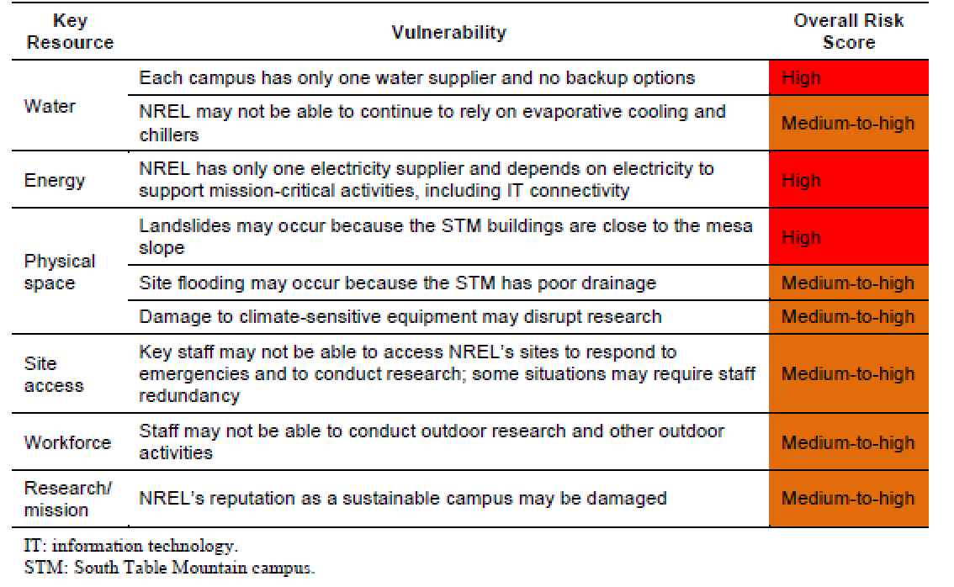
Figure 2: Example Vulnerability and Risk Table. Note, each site should categorize vulnerabilities based on their own unique circumstances.

Step 6: Characterize Vulnerabilities with a Risk Matrix
Use the work performed in Steps 2 through 5 to develop a risk matrix to characterize site vulnerabilities and help visualize the impacts of climate hazards on critical assets and infrastructure.
The Vulnerability Screening Tool (Appendix A) offers a standardized method of analysis to help prioritize the need for resilience solutions. The five input tabs within the Vulnerability Screening Tool incorporate VARP Steps 2 through 5. The following provides an overview of the input tabs within the screening tool and their correlation with the VARP steps:
- Identification of DOE Site Assets and Infrastructure Systems – Step 2
- Documentation of Historical Weather and Identify Likelihood and Impact of Climate Hazards – Steps 3 and 4
- Characterization of Climate Hazard Impacts on Site Assets and Infrastructure Systems – Step 5
The output of the Vulnerability Screening Tool is a Risk Matrix for a DOE site. The Risk Matrix (Figure 3) provides an illustrative example that characterizes the potential vulnerabilities based on the likelihood of each climate hazard and the potential impact to each critical asset and infrastructure system (i.e., determined as low/medium/high for each combination).
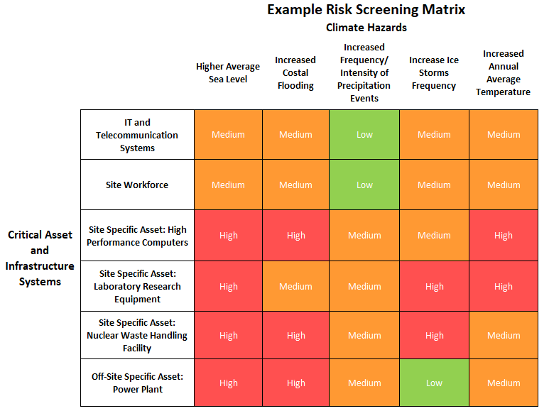 Figure 3: Example Risk Screening Matrix.

The Risk Matrix categorizes vulnerabilities and enables DOE sites to identify, compare, and rank vulnerabilities by determining priority climate hazards and critical assets and infrastructure systems. When assigning risk levels, the impact of multiple threats should be considered. For example, if the risk for both increased coastal flooding and increased frequency of precipitation is medium, then the overall risk from coastal flooding and increased precipitation might be high due to the compounding effects. Compounding effects should be considered when assigning the impact score in the Vulnerability Screening Tool.

Step 7: Identify and Assess Resilience Solutions
Determine possible resilience solutions for the climate hazards and the associated critical assets and infrastructure systems, including the known barriers to implementation. In determining the appropriateness of resilience solutions, sites should assess effectiveness, feasibility, cost, community benefit, and timeline for implementation. The following should be identified:
- Solution: Identify the solution being considered.
- Brief Description: Provide an overview of the solution and why it is needed.
- Critical Asset(s): Identify the assets/infrastructure identified in Step 2 that will be made more resilient by the solution.
- Potential Hazard: Identify the anticipated climate-related impact(s) being addressed by the solution.
- Expected Effectiveness: Identify the resilience solution’s capacity to reduce the overall risk. Risk is defined as the combined magnitude of consequences and likelihood that a vulnerability will affect the site.
- Feasibility: Provide an assessment of whether the solution can be implemented, financially, legally, technically, and organizationally.
- Cost and Funding Type: Estimate the expected monetary cost and likely funding source(s) (e.g., appropriated funds, performance contract).
- Benefit: Provide the benefits that the DOE site will receive from the resilience solution.
- Community Impact: Provide the impacts (positive or negative) that the surrounding community will receive from the resilience solution. If the impacts will affect an energy or environmental justice community, please specify.
- Environmental Impact: List benefit or detriment to the site ecology and GHG emissions, if any.
- Recommended Approach: Provide the site’s recommended path forward.
The comprehensive table below is an illustrative example of what could be utilized:
Solution | Brief Description | Critical Asset(s) | Potential Hazard(s) | Expected Effectiveness | Feasibility (Easy, Moderate, Difficult) | Cost & Funding Type | Community Impact | Environ-mental Impact | Recommended Approach
On-site renewable energy production | Develop 20MW PV array on-site to ensure electricity availability | Electricity | Heat, drought & wildfires causing excessive peak demand & brownouts | 70% | Moderate | $500k, Energy Savings Performance Contract (ESPC) | Reduce burden on utility, allowing more electricity availability for community | Impact on-site ecology | Proceed to Step 8
Figure 4: Example of a comprehensive resilience solutions table.

Step 8: Develop and Implement a Portfolio of Resilience Solutions
Following the assessment of identified resilience solutions, the VARP team will identify the most appropriate solutions for inclusion in the solution portfolio (Figure 5). The development process will require an evaluation of the candidate solution, including a comparison of refined cost/benefit estimates to specified criteria and an assessment of each solution’s feasibility, efficacy, co-benefits, and ability to withstand a range of climate impacts. The resulting benefits will vary with asset and system conditions, the probability of climate impacts, the timing of those impacts, and the collective mix of selected solutions.
For implementation, the timing and funding mechanisms (i.e., appropriated funds, ESPC) should be identified. Implementation status will be tracked in the Dashboard and should be updated by sites annually, at a minimum. Tracking implementation solutions in the Dashboard will help provide a standard way of reporting progress on implemented resilience solutions and will be used by SPD to update DOE’s progress.
Priority Rank (High, Medium, Low) | Solution | Critical Asset(s) | Impacts, Unintended Consequences, Co-benefits | Resilience Planning Gaps | Funding Mechanism | Planned Start/End Dates | Implementation Status
High | PV array | Electricity | May impact pollinator habitat.  Allows site to retire old generators and reduces the need for fossil fuels. | May need to set aside additional land for pollinators. | Utility Energy Services Contract (UESC) | 7/1/2022 – 6/30/2023 | Planning stage
Medium | Reconfigure outdoor worker shift structure to avoid excessive summer heat. | Workforce | Labor cost will increase.  Worker productivity expected to remain the same. | No gaps identified. | Appropriated funds | 6/1/2021 – 6/14/2021 | Complete
Figure 5: Example portfolio of resilience solutions.

Step 9: Monitor, Evaluate, and Reassess the Resilience Plan
Planning for climate change and extreme weather hazards includes uncertainty not only about how the climate will differ in the future, but also how technologies and climate policies may change in parallel. A robust plan should be adaptable to changing expectations and evidence as well as facilitate monitoring of progress and evaluation of implemented solutions. The VARP should describe how the following are addressed:
- Monitoring progress: Measuring implementation milestones against the resilience plan and gathering feedback from various site organizations implementing the plan.
- Evaluation of implementation: Assessing the effectiveness of completed adaptation/resilience solutions and incorporating and comparing feedback with new information about climate change, energy policies, installation costs, resilience technologies, and implementation experience.
- Reassessing the plan: Reassessing the VARP by completing a periodic review or by repeating steps at least every four years to incorporate new information such as updated climate science information from the latest NCA.

Appendix A: Vulnerability Screening Tool
The Vulnerability Screening Tool offers a standardized method to help sites identify regional climate hazards, critical assets and infrastructure, the likelihood of each climate hazard, and score the impacts on assets and infrastructure. The Vulnerability Screening Tool can be accessed below or via the Dashboard. Note, the SPD may update the screening tool based on feedback. If updated, the most recent version will be posted to the Dashboard.

Appendix B: National Climate Assessment
The National Climate Assessment (NCA) is a Congressionally mandated report that analyzes the effects of global climate change on the natural environment, agriculture, energy production and use, land and water resources, transportation, human health and welfare, human social systems, and biological diversity. The NCA also analyzes current trends in climate change, both natural and human-induced, and projects major trends for the subsequent 25 to 100 years. This report is submitted to Congress every four years. The report is designed to help decision-makers, utility and natural resource managers, public health officials, emergency planners, and other stakeholders examine the impacts of climate change across the United States. The 2018 NCA analyzes U.S. climate change impacts by region, as noted in the table below.
Geographic Location of DOE Site | NCA Region | Full Chapter
CT, DE, MA, ME, MD, NJ, NY, NH, PA, RI, VT, WV | Northeast | https://nca2018.globalchange.gov/downloads/NCA4_Ch18_Northeast_Full.pdf
AL, AR, FL, GA, KY, LA, MS, NC, SC, TN, VA | Southeast | https://nca2018.globalchange.gov/downloads/NCA4_Ch19_Southeast_Full.pdf
IN, IL, IA, MO, MI, MN, OH, WI | Midwest | https://nca2018.globalchange.gov/downloads/NCA4_Ch21_Midwest_Full.pdf
MT, NE, ND, SD, WY | Northern Great Plains | https://nca2018.globalchange.gov/downloads/NCA4_Ch22_Northern-Great-Plains_Full.pdf
KS, OK, TX | Southern Great Plains | https://nca2018.globalchange.gov/downloads/NCA4_Ch23_Southern-Great-Plains_Full.pdf
AZ, CA, CO, NM, NV, UT | Southwest | https://nca2018.globalchange.gov/downloads/NCA4_Ch25_Southwest_Full.pdf
ID, OR, WA | Northwest | https://nca2018.globalchange.gov/downloads/NCA4_Ch24_Northwest_Full.pdf
AK | Alaska | https://nca2018.globalchange.gov/downloads/NCA4_Ch26_Alaska_Full.pdf
HI and Pacific Islands | Hawai'i and Pacific Islands | https://nca2018.globalchange.gov/downloads/NCA4_Ch27_Hawaii-Pacific-Islands_Full.pdf
PR | Caribbean | https://nca2018.globalchange.gov/downloads/NCA4_Ch20_US-Caribbean_Full.pdf

Appendix C: U.S. Climate Resilience Toolkit
The U.S. Climate Resilience Toolkit provides tools, information, and subject matter expertise to help users identify and manage climate-related risks and build resilience. The U.S. Climate Resilience Toolkit compiles climate resilience information from U.S. Federal agencies into one easy-to-use location. For example, sites can access various tools and publications on the toolkit by looking under the “Topics” tab and selecting the “Energy” topic.

Appendix D: Climate Explorer
The Climate Explorer offers graphs, maps, and downloadable data of observed and projected climate variables for every county in the contiguous United States. The tool offers graphs and maps of climate projections for temperature, precipitation, and related climate variables for two possible futures—one in which humans make a significant attempt to reduce global emissions of heat-trapping gases, and one in which the rate of global emissions continues to rise through 2100.

Appendix E: Climate Impact Lab
The Climate Impact Lab offers maps and downloadable data of observed and projected climate variables to quantify the impacts and costs of climate change by sector in communities around the world. The Climate Impact Lab leverages climate and economic data to estimate the relationship between a changing climate and human well-being across eight categories: human health, labor productivity, energy demand, agriculture, manufacturing, damage to coastal infrastructure, increased social conflict and crime, and altered migration patterns.

Appendix F: DOE Orders Crosswalk
The following table provides a high-level summary of the overlap between the VARP steps and existing DOE resilience requirements. The table is not an exhaustive analysis, but provides an indication of where common themes exist between the various DOE orders and the VARP. Note, VARP Steps 1 and 9 are not included in the table as they do not overlap with existing DOE resilience requirements. A blank cell indicates that there are no common themes.
 | DOE VARP Steps
 | Step 2. Identify Critical Assets and Critical Infrastructure | Step 3. Identify Projected Climate Trends and Events | Step 7. Identify and Assess Resilience Solutions | Step 8. Develop and Implement a Portfolio of Resilience Solutions
 |  | Step 4. Characterize Current and Projected Impacts of Climate Change Hazards on Assets and Infrastructure
 |  | Step 5. Characterize Vulnerabilities
DOE Order (O) 150.1A, Continuity Programs | Identify Mission Essential Assets (MEAs) and Mission Essential Functions (MEFs)  Conduct Business Impact Analysis | Identify Hazards and Threats | Determine Solutions | Financing Resilience Driven Projects
 |  | Identify Vulnerabilities
 |  | Analyze Risks
 |  | Prioritize Liabilities
DOE O 470.4B, Safeguards and Security Program | Identify Mission Essential Assets (MEAs) and Mission Essential Functions (MEFs)  Conduct Business Impact Analysis | Identify Hazards and Threats | Determine Solutions | Financing Resilience Driven Projects
 |  | Identify Vulnerabilities
 |  | Analyze Risks
 |  | Prioritize Liabilities
DOE O 420.1C, Facility Safety | Assign Mission Criticality Level to Mission Essential Assets (MEAs) and Mission Essential Functions (MEFs) | Identify Hazards and Threats | MEA Current Condition Assessment | Implementing Resilience
 |  | Prioritize Liabilities | Input Other Infrastructure Assessment
 |  |  | Determine Solutions
DOE O 470.3 Chg. 1, Design Basis Threat | Identify Mission Essential Assets (MEAs) and Mission Essential Functions (MEFs)  Assign Mission Criticality Level to Mission Essential Assets (MEAs) and Mission Essential Functions (MEFs) | Identify Hazards and Threats |  | Implementing Resilience
 |  | Analyze Risks
DOE Standard (STD)-1066-2016, Fire Protection | Identify Mission Essential Assets (MEAs) and Mission Essential Functions (MEFs) | Assess Liabilities | Identify Resilience Gaps and Determine Resilience Readiness Solutions
 |  | Identify Hazards and Threats
 |  | Analyze Risks
DOE STD-1020-2016, Natural Phenomena Hazards Analysis and Design Criteria for DOE Facilities | Identify Mission Essential Assets (MEAs) and Mission Essential Functions (MEFs) | Identify Hazards and Threats | Determine Solutions
 |  | Analyze Risks
DOE STD-1189-2016, Integration of Safety into the Design Process |  | Identify Hazards and Threats | Identify Resilience Gaps and Determine Resilience Readiness Solutions
 |  | Analyze Risks | Input Other Infrastructure Assessment
DOE O 205.1C, Department of Energy Cyber Security Program |  | Assess Liabilities | Identify Resilience Gaps and Determine Resilience Readiness Solutions
 |  | Identify Hazards and Threats
 |  | Analyze Risks
DOE O 151.1D, Comprehensive Emergency Management System |  | Identify Hazards and Threats | Identify Resilience Gaps and Determine Resilience Readiness Solutions
DOE O 436.1, Departmental Sustainability |  |  |  | Financing Resilience Driven Projects
 |  |  |  | Implementing Resilience
10 Code of Federal Regulation (CFR) Part 830, Nuclear Safety Management |  | Identify Hazards and Threats | Determine Solutions
DOE O 461.1C, Packaging and Transportation for Offsite Shipment of Materials of National Security Interest |  | Identify Hazards and Threats
 |  | Analyze Risks
DOE O 461.2, On-site Packaging and Transfer of Materials of National Security Interest |  | Identify Hazards and Threats
 |  | Analyze Risks
DOE O 413.3B, Program and Project Management for the Acquisition of Capital Assets | Conduct Criticality Assessment | Identify Hazards and Threats
DOE Guidance (G) 151.1-1A, Emergency Management Fundamentals and the Operational Emergency Base Program |  | Identify Hazards and Threats
DOE O 430.1C, Real Property Asset Management | Identify Mission Essential Assets (MEAs) and Mission Essential Functions (MEFs)

Appendix G: 2017 Vulnerability Screening Guidance
SPD’s 2017 Vulnerability Screening Guidance, Climate Change Vulnerability Screenings, provides a general framework and approach to screen assets and operations for vulnerabilities to climate change risks. This enables DOE Program Offices and sites to prioritize planning and decision-making to ensure the agency is climate resilient. The Vulnerability Screening Guidance can be accessed here. Note, this document serves as a reference only. Sites should refer to the VARP Guidance for the most recent requirements.

Appendix H: 2015 Vulnerability Assessment Guidance
SPD’s 2015 Vulnerability Assessment Guidance, Practical Strategies for Climate Change Vulnerability Assessments, can be accessed here. Note, this document serves as a reference only. Sites should refer to the VARP Guidance for the most recent requirements.

Appendix I: Pilot Climate Vulnerability Assessments
To help DOE sites develop climate vulnerability assessments, SPD launched a pilot program in 2014, which provided funding for four national laboratories to jump-start their vulnerability assessment and planning efforts. The pilot assessments conducted at Idaho National Laboratory (INL), Thomas Jefferson National Accelerator Facility (TJNAF), National Renewable Energy Laboratory (NREL), and Pacific Northwest National Laboratory (PNNL) are summarized in this guidance. Links, where available, are provided to the case studies in their entirety. Note, these examples follow the prior Vulnerability Screening and Assessment Guidance (Appendix G and H). These assessments are only provided as a resource, and are not consistent with the VARP Guidance.
Idaho National Laboratory (INL)
Climate Change Vulnerability Assessment for Idaho National Laboratory: October 2014
INL’s Climate Change Vulnerability Assessment Stakeholder Presentation: July 2014.
Thomas Jefferson National Accelerator Facility (TJNAF)
Climate Vulnerability Screening at Thomas Jefferson National Accelerator Facility: October 2014. Contact SPD directly to obtain a copy of the TJNAF pilot assessment.
National Renewable Energy Laboratory (NREL)
A Climate Change Vulnerability Assessment Report for the National Renewable Energy Laboratory: May 23, 2014 -- June 5, 2015
A Resiliency Action Plan for the National Renewable Energy Laboratory: May 23, 2014 -- June 5, 2015
Pacific Northwest National Laboratory (PNNL)
Climate Resiliency Action Planning at Pacific Northwest National Laboratory: September 2015

