Scratch Building a Model Mobile Home Prop
Scale models of building systems or even full sized homes are very useful teaching aids. They add a dynamic third dimension to traditional lecture and image based presentations and are a great classroom prop.
Because of their relatively simple design, building a more or less scale model of a mobile home is fairly achievable for someone with the right tools and materials. A certain amount of ingenuity, patience and skill can’t hurt either. Scale lumber and specialized materials are easily available through hobby shops or art supply stores.
You can design and build an accurate scale model of a mobile home from a good set of blueprints or build one whose proportions are intentionally stretched or compressed. The dimensions of a prototype 12 X 60 foot home built to 1 inch scale (1” = 1’) will yield a model whose overall dimensions will be 1 X 5 feet. While accurate its 12 inch width may be insufficiently sized for the amount of interior detail required. Going to a larger scale may help offset that problem but the proportionately increased length may cause the model to become too cumbersome to handle, ship, or store.
A more than adequate representation of a mobile home would be one that’s stretched enough at its width to accommodate enough interior detail and shortened along its length to display no more than necessary.
Important design features:
- Sufficient depth and breadth to fit and adequately display interior and exterior components
- A combination of transparent and opaque exterior coverings.
- Removable roof section.
- Tilt or rotating feature to enable a view of the mobile home belly and duct system
Resources for modeling tools and materials:
- Micro-Mark –tools, adhesives, fasteners, hardware and specialty materials
Phone: (800) 225-1066, Web site: www.micromark.com
- North Eastern Scale Lumber Co. - scale lumber and sheet materials
Phone: (978) 688-6019, Web site: www.northeasternscalelumber.com
- BLICK art materials – scale lumber for architectural modeling
Phone: (800) 828-4548, Web site: www.dickblick.com/products/scale-lumber

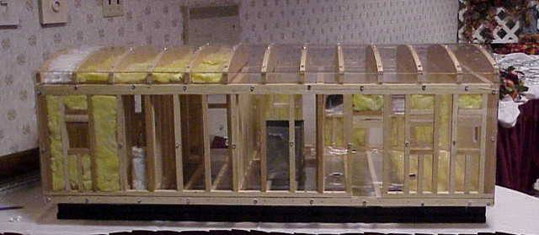
A custom designed mobile home model features clear acrylic exterior paneling that exposes the floor, wall, and roof truss framing. Note insulation, interior wall partitions and exterior openings. The model is not exactly to scale but serves the purpose of highlighting the major construction features of a mobile home.

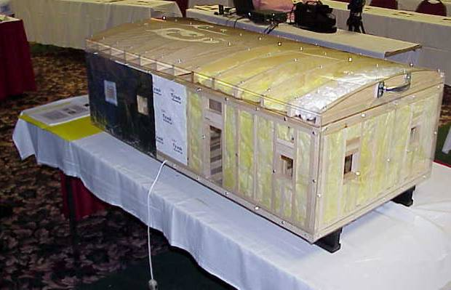
The side and end view shows partially installed exterior siding, and a reinsulated roof cavity on the near end. This model features a removable roof system that allows a view of interior detail such as a furnace and duct system.

