Ramona Reservation Renewable Energy
Housing and Ecotourism
Power System Project

Final Report

Cooperative Agreement # DE-FC48-99R810675
Period of Performance: 9/30/99 – 9/30/2002

Project Title: Conservation Research and Development

Prepared by Recipient
DOMESTIC TECHNOLOGIES, Inc.
PO Box 44
29025-A Upper Bear Creek Rd.
Evergreen, CO 80439
Phone: 303 674-7700
Fax: 303 674-7772
E-mail: dti@domtech.com

Technical Contact: Malcolm Lillywhite

Table of Contents

Executive Summary 1

I. Project Overview 2

A. Background
1. The Opportunity
2. Reservation Location

II. Project Goals and Objectives 4

Project Goal

B. Project Objectives

C. Project Scope of Work
D. Tribal Economic Development Goals and Objectives

III. Project Activities 8
A. Problems Encountered
B. Technical Accomplishments
1. Reservation Site Meetings
2. Wind Resource Assessment
3. Load Profiles
4. Renewable Energy Hybrid System Design
5. Environmental Analysis
6. Training and Tribal Capacity Building
7. Operation and Management Plan (O/M)
8. Economic Analysis

IV. Benefits 14

V. Conclusion 15

VI. Recommendations 16

VII. Lessons Learned 17

VIII. Photos of Ramona Reservation and Project Area 18

Executive Summary

This final report presents information developed under this DOE-funded project by Domestic Technologies (DTI), the Ramona Band of Cahuilla Mission Indians (Tribe) and some of its contractors during the period from September 30, 1999 to September 30, 2002. This Cooperative Agreement (project) was awarded to DTI to provide technical support to the Tribe for reservation hybrid system design, system performance monitoring, cultural impact analysis, and training of Tribal members in the operations and maintenance of their hybrid energy systems. The DOE project served as the common thread (renewable energy) over this three-year period that wove grants from nine (9) agencies into the overall fabric comprising the Ramona Reservation Development Program.

The Ramona Reservation is located in the San Bernardino National Forest on completely undeveloped land. A HUD grant awarded to the Tribe in 1999 provided approximately $102,000 for electric power lines, mini-grids, and related environmental impact studies. All power line route options had to go through USFS and BLM land and had to be underground, which would create a visible scar 20’ wide along a 7 to 9 mile route causing erosion problems and negative view shed impacts. The total cost of this line would approach $115,000 and utility rates would begin at 12.8 cents per kWh plus a surcharge, and could increase each year by as much as10-15%. After considering a number of economic development projects, the Tribe decided to develop an ecotourism and training business powered by renewable energy technologies. Such a project will fit well with the Tribe’s desire to preserve natural resources, generate tribal revenues, offer job opportunities to tribal members, and benefit other tribes by providing information and training in renewable energy technologies and applications.

The Ramona Reservation Master Development Plan and Economic Development objectives remain unchanged over the last three years. The reservation cultural and economic development strategy is based on the use of renewable energy/energy conservation technologies which will provide 90% of the electrical/thermal energy needed to meet the demands of the tribal housing complex and the Ramona ecotourism and training businesses. The tribal business revenues will be derived from tourism and training product and services sales. The hybrid renewable energy system makes possible the operation of this remote ecotourism business and provides an important tool for training other Native Americans to replicate this model on their reservation. The Tribe has taken three years to organize and obtain funding to implement this program. Nine federal agencies including DOE as well as state agencies, universities, community colleges, cultural centers and other organizations have been part of the development of this highly evolved program. These include: DOE, HUD, HUD-CDBG, USDA-RD, IHS, CA Dept. of Mines and Geology, Bureau of Reclamation, USFS, and University of California.

Seventy percent of this project’s objectives were achieved. Performance evaluation of the housing complex renewable energy hybrid system was not completed because it wasn’t until the third project year (2002) that the Tribe had received all the funding (grants) necessary to purchase the hybrid energy systems (and construct the ecotourism buildings). Consequently it was not possible to conduct system performance evaluation (Task Two) under this agreement, and the project was closed out one year earlier than planned. Performance evaluation of all energy systems will now be conducted under a DOE Cooperative Agreement award made to the Tribe in September 2002.
I. Project Overview

This final report presents information developed by Domestic Technologies (DTI) the Ramona Band of Cahuilla Mission Indians (Tribe) and some of its contractors during the period from September 30, 1999 to September 30, 2002. The period of performance for the Cooperative Agreement between DOE and DTI in support of the Tribe was originally scheduled from September 30, 1999 to September 30, 2003 to allow for performance evaluation of the housing complex renewable energy hybrid system which was to be installed during this period. However it wasn’t until the third project year (2002) that the Tribe had received all the funding necessary to purchase the hybrid energy systems (and construct the ecotourism buildings) and consequently it was not possible to conduct system performance evaluation (Task Two) under this agreement, so the agreement was closed out one year earlier than planned. Performance evaluation of all energy systems will now be conducted under a DOE Cooperative Agreement award made to the Tribe in September 2002.

The Ramona Reservation Master Development Plan and Economic Development objectives remain unchanged over the last three years. However activities necessary to accomplish these objectives have been refined. The reservation cultural and economic development strategy is based on the use of renewable energy/energy conservation technologies which will provide 90% of the electrical/thermal energy needed to meet the demands of the tribal housing complex and the Ramona ecotourism and training businesses. (Propane will be used as a back-up energy source.) The tribal business revenues will be derived from tourism and training product and services sales. The hybrid renewable energy system makes possible the operation of this remote ecotourism business and provides an important tool for training other Native Americans to replicate this model on their reservation. The Tribe has taken three years to organize and obtain funding to implement this program.

Several federal agencies including DOE as well as state agencies, universities, community colleges, cultural centers and other organizations have been part of the development of this highly evolved program. The following is a partial list of contributing and funding agencies:

- DOE Cooperative Agreement #DE-FC48-99R810675 $182,000
- HUD - Housing $390,000
- HUD-CDBG - Ecotourism Infrastructure $550,000
- USDA-RD - Ecotents $490,000
- IHS - Water System $ 60,000
- DOE – Macro Grid Hybrid System (9/30/02) $280,000
- CA Dept. of Mines and Geology -Seismic In-kind Services
- Bureau of Reclamation – Water System In-kind Services
- USFS – NMR and Fire Control In-kind Services
- University of California – SD – Inventory In-kind Services

The DOE project served as the common thread (renewable energy) over this three-year period that wove these agencies into the overall fabric comprising the Ramona Reservation Development Program. Much of the effort expended under this project was in the education of tribes, Tribal members, and funding agencies about applications of renewable energy technologies on reservations and powering remote economic development businesses.

Background

- The Opportunity

The Ramona Reservation is located in the San Bernardino National Forest on completely undeveloped land. The National Forest is used for skiing, hunting, camping, and hiking. A HUD grant awarded to the Tribe in 1999 provided approximately $102,000 for electric power lines, mini-grids, and related environmental impact studies. All power line route options had to go through USFS and BLM land and had to be underground, which would create a visible scar 20’ wide along a 7 to 9 mile route causing erosion problems and negative view shed impacts. The total cost of this line would approach $115,000 and utility rates would begin at 12.8 cents per kWh plus a surcharge, and could increase each year by as much as10-15%.

This issue of power has been difficult for the Tribe to address. Due to the remote and rural location of the reservation, extension of power lines is expensive and environmentally and aesthetically undesirable. Because the Tribe is surrounded by the U.S. Forest Service and Bureau of Land Management lands, the issues related to acquiring access permits for power line easements, and the need to install power lines underground results in a very costly undertaking. In addition, tribal lands house many archaeologically sensitive areas that could be disturbed by the installation of numerous power poles and trenches through the reservation. As a result, the Tribe determined that on-site renewable energy would be the most cost-effective long-term solution to power tribal residences and economic development activities.

After considering a number of economic development projects, the Tribe decided to move forward with an ecotourism lodge and training facility project. Such a project will fit well with the Tribe’s desire to preserve natural resources, generate tribal revenues, offer job opportunities to tribal members, and benefit other tribes by providing information and training in renewable energy projects and applications.

- Reservation Location

The Ramona Band of Mission Indians Reservation was established on December 27, 1891 by Executive Order under President Benjamin Harrison. Present day members of the Ramona Tribe are direct descendants of the last Shaman for the Tribe. In the past, tribal members had their own plot of land to live on, farm, and collect medicinal herbs for the use of tribal people. The last ceremonial house of the Cahuilla Mountain Tribes existed on the Ramona Reservation. In 1935, the Medicine Bundle was buried on this reservation. The Ramona Tribal burial grounds also exist on the reservation.
Today, Ramona Tribal members still live on this land and make use of the many gifts from nature that flourish there. The reservation is located on the Southwest side of Thomas Mountain and has been protected from pollution from outside sources and damage of lands that has occurred on so many other reservations in Southern California. The cultural history and natural resources of the Ramona Reservation are important to tribal members who wish to insure that the reservation remains undisturbed and in its natural state.

A wide variety of natural herbs and plants grow wild on the Ramona Reservation. White sage, herbasanta, elderberry tree, and milkweed are scattered throughout the entire reservation and are used for medicinal and ceremonial purposes. Plants such as the piñon trees, yucca plant, and wild cherries are used for food. A large amount of natural cultural plants still exist on the reservation. Deer grass, Spanish daggers, and Indian paintbrush are used for weaving baskets, which is one art the Cahuilla Nations are known for.

The tranquil and natural surroundings of the reservation are an ideal setting for ecotourism. Wildlife travels freely in and around the reservation without interference. Hunting is not allowed on reservation lands. Due to the fact that the reservation is bounded by U.S. Forest Service lands on one side, and Bureau of Land Management lands on another side, natural resources are generally not threatened by outsiders.

Ecotourism, tied with a renewable energy system, will continue to protect the tribal culture and preserve the natural habitat. With renewable energy, the Tribe will be able to create a successful ecotourism enterprise that will generate revenues in a manner consistent with tribal goals to preserve and protect natural resources. The serene surroundings will allow people to get away from the hectic pace of their everyday lives. Visitors would be able to unwind and fill their days with relaxation, quiet, hiking, enjoying the environment, and learning about Indian culture. Due to the remote rural location of reservation lands coupled with renewable energy technologies and the tribal development policies, the Tribe can offer a visit free from overcrowding which will insure that the ambiance is not destroyed and the habitat is not disturbed. The Ramona Band of Mission Indians are eager to share their rich history and cultural and natural resources with others that wish to learn some of the ways of Native Americans.

The reservation is located at the confluence of the San Jacinto and Buck Ridge seismic fault zones. This imposes more stringent design requirements for buildings but will not affect the design of the elevated platform ecotents and training center structures due to their innate flexibility.

II. Project Goals and Objectives

The objectives of this DOE project were the foundation for the creation of the Ramona Reservation Master Economic Development Plan goals and objectives. Therefore a summary of both sets of objectives are provided below to demonstrate how well renewable energy technologies can respond to tribal needs and how compatible these new technologies are with traditional values and beliefs.

A. Project Goal

To develop and penetrate the renewable energy power market for off-grid housing and economic development applications on Native American lands and buffer zones.

B. Project Objectives

- To demonstrate the reliability, cost-effectiveness, market potential, and replicability of a variety of renewable energy power generation, (i.e. PV, wind, and propane hybrids) and passive and active solar thermal commercial systems on Native American lands and buffer zones as well as on other rural lands not supplied by a utility grid.

- To demonstrate how renewable energy power systems can be used to eliminate the environmental impact of electric grid power lines on Indian lands, National Forests, National Parks, other protected areas, and the general rural environment.

- To build a renewable energy powered ecotourism infrastructure as part of a modern Native American village that will be used for a tourism business and as a Native American “hands-on” training center (business).

- To provide employment for the Ramona Tribe and a “green” electrification model to generate employment for other tribes using a variety of renewable energy power systems.

- To develop a renewable energy power system procurement specifications, a procurement process training manual and materials which the Ramona Tribal trainers will use to sell on-site training services to HUD, IHS (Indian Health Services), and other tribes.

- To monitor power system technical performance and sociological/cultural impacts over a three (3) year period using tribal members and a Native American company (“TERO”) to collect data and operate and maintain equipment with on-site training and back-up by DTI staff.

C. Project Scope of Work

The scope of work for this project includes the following:

Task One– Renewable Energy Power System Design:

- The participant will design and prepare procurement specifications for a 10 kW and a 25-30 kW PV (wind) propane or diesel hybrid system to power the Ramona ecotourism lodge. This system will have user-friendly features to facilitate appropriate training methods and will accommodate the option of a wind turbine at a later date.

- The participant will develop load profiles for the ecotourism lodge based on the building design provided by DTI under the HUD CDBG grant
- The participant will develop a conceptual design, preliminary engineering schematics, load profiles, and cost estimates for a single power system that would supply electricity to the entire reservation including housing and ecotourism lodge, shop, well water pumping, and other demands. The preliminary design would be used for cost and performance, O/M requirements, and training applicability comparison to the stand-alone system proposed herein.

- The participant will prepare bid solicitations to announce bid competition to U.S. suppliers and will evaluate the bids in cooperation with the tribal partners and National Renewable Energy Laboratory (NREL) to select supplier(s).

- The participant will oversee installation of power systems by suppliers.

- The participant will install a tower with anemometers and solar radiometers to assess the site-specific wind and solar insolation characteristics in cooperation with NREL’s National Wind Technology Center.

- The participant will coordinate on-site installation and system integration and compatibility testing of renewable energy equipment, monitoring units, and training features of energy and water systems installed as a part of this project.

- The participant will develop design and procurement/construction documents to expand the renewable energy hybrid well water pumping and distributions systems to provide service for the entire reservation water demand.

Task Two – Monitor and Evaluate Power System Performance
- The participant shall install a computerized data logging system that will record the critical performance parameters necessary to assess the technical and cost performance of each power system. This monitoring will continue for three years using trained tribal members for daily oversight and DTI as technical backup for tribal members.

Task Three – Develop Power System Modules and Replication Package

- The participant will design, field test, and validate training modules which will be used by the Ramona tribal trainers and consultant trainers to conduct orientation, procurement, and Operations and Maintenance (O/M) workshops for other tribes.

- The participant will develop a Native American Renewable Energy Remote Power Systems Replication Kit to be given to trainers at workshops. The kit will consist of generalized power systems characteristics, U.S. systems suppliers and costs, and procurement specifications for soliciting bids.

- The participant will develop O/M training modules and procedures in cooperation with suppliers, NREL, and the Tribe which will be used to train tribal maintenance staff attending workshops. These modules will be designed to access suppliers or service contractors via Internet or phone for technical assistance.

- The participant will conduct a series of pilot workshops for training of trainers and partners from the Ramona Tribe, other tribes, and related Native American organizations that can be involved in installation and maintenance of the renewable energy and water distribution systems used in this project. The objective of this task element shall be the targeted replication of ecotourism development on other Native American lands. The training shall involve experienced personnel from DTI, DOE, NREL, and vendors.

Task Four – Reporting Deliverables

- The participant will prepare systems performance reports as systems start up, and annually for each of the three system monitoring years.

- The participant will write an annual project progress report presenting the progress of the overall project, including training programs, ecotourism business development, and survey results from tourists, trainers, and tribal members.

- The participant will prepare a project final report at the end of the fourth year summarizing the findings and recommendations of the components reporting process.

- As part of the Final Report, the participant shall develop a plan for sustaining the integrity of the project after the period of performance is completed. This plan might include such factors as routine system maintenance and operations, funding provisions for system parts replacement, and provisions for management responsibilities to assure the integrity of the renewable energy system installed. The participant shall work with DOE in incorporating the concept of sustainability into the required education and training element of the project. DOE shall provide staff from appropriate national laboratories to instruct Tribal members in the techniques and methods involved in system sustainability. This portion of the project shall be coordinated through the designated DOE Project Manager.

- The participant will prepare a project final report at the end of the fourth year summarizing the findings and recommendations of the components

D. Tribal Economic Development Goals and Objectives

The Ramona Band has decided to make their reservation non-gaming tribal land that generates all electrical and thermal power used by tribal members’ housing, tribal offices and its economic development ecotourism and training businesses. Therefore the Ramona reservation will not be dependent on the interstate electrical grid system for power, heat, and communications. In taking this action, the Ramona tribe will be the first “off grid” reservation with full renewable energy power for all facilities on the reservation. This will be accomplished using proven commercially available renewable energy and building technologies that will provide all modern conveniences and tourism amenities without using utility generated electricity. This action will make a statement to other Native Americans and to the American and international ecotourism/ cultural tourism market that will position the Ramona Band and its neighboring tribes in a totally unique position to exploit this ecotourism market niche. This will also position the Tribe as the only Native American owned facility to train other rural/ remote Native American tribes to adapt this model to their residential and economic development needs.

The Ramona Band of Cahuilla Mission Indians has determined that their priority economic development need is the development and implementation of a sustainable, proven, and culturally appropriate eco-tourism enterprise. Eco-tourism with sustainable natural resource management and renewable energy systems will serve to protect the Tribal culture and preserve the natural habitat. With this approach, the Tribe will be able to create a successful ecotourism enterprise that will generate revenues in a manner consistent with Tribal goals - to create employment and to preserve and protect natural and cultural resources. This ecotourism business and a training center pavilion, restaurant, a store and ecotents will provide the business base for the Tribe to achieve its broad based goals.

The broad goals of this economic development strategy described above are as follows:

- To provide employment for Ramona Tribal members and a “green” electrification model other tribes can adopt to generate employment using a variety of renewable energy power systems, green niche tourism marketing and customized training technologies.
- To establish a highly profitable renewable energy powered ecotourism business as part of a modern Native American reservation.
- To establish a training business that provides renewable energy technology and tourism development on-site training services to those served by HUD, IHS (Indian Health Services), and other tribes.
- To monitor the performance and the social/cultural/ and economic impacts of tourism and of new technologies used in this project by collecting technical performance and socioeconomic data.
- To demonstrate the reliability, cost-effectiveness, market potential, and “replicability” of a variety of renewable energy power generation options (i.e. PV, wind, and diesel or propane hybrids) and solar thermal systems on Native American lands.
- To demonstrate how renewable energy power systems can be used to eliminate the environmental impact of electric grid power lines on Indian lands, National Forests, National Parks, other protected areas, and the general rural environment.
- To demonstrate how an ecotourism business-based natural and cultural stewardship tribal land management plan can forge new working relationships between tribes and Federal Agencies (NFS, BLM, etc.) that enhance the small tribes’ business development and natural resource management potential.

III. Project Activities

Many of the activities proposed for execution under this project were dependant on grant awards from other agencies and prompt timely decisions by those agencies and by the Tribe to execute these grants. This did not happen for a variety of reasons which are discussed under the section “Problems Encounter” below. However 70% of the tasks proposed under this project were accomplished. The comparison of complete and incomplete milestones can be seen in the Final Report Schedule. Because the reservation housing renewable energy hybrid systems were not purchased and installed and the ecotourism infrastructure was not built during this three-year period, it made it impossible to complete the system performance evaluation, training modules, and related tasks. These were the only tasks not completed under this project.

A number of activities were executed under this DOE project out of necessity and were not included in the Cooperative Agreement. These activities centered around the education of Tribal members and particularly participating Federal and state agencies. Working with the California Department of Mines and Geology, the US Geologic Survey, and the California Uniform building Code Office to develop seismic engineering guidelines for tower structures, ecotents, and the underground macro electrical grid broke new ground within these agencies and for remote power systems industry where seismically active areas are concerned. Meeting with other tribes to discuss their interest in renewable energy may be the most rewarding of these ancillary activities in the long run. The fact that the DOE project was there, in place, for three years gave credibility to the concepts being promoted and support was available to keep Tribal momentum moving towards completing their economic development program while they were trying to obtain funding for other components of their Master Development Plan. Finally it can now be said that the Tribe has all major program components funded at this time.

A. Problems Encountered

The Ramona Reservation Development and Economic Development programs are funded by seven to nine different agencies with as many budgets, grant agreements, different timelines, and difficult regulations. This is and will continue to be true for most Native American Tribes that use government or private grant funding for development projects on the reservations. The way Federal and State funding is made available to Tribes makes planning and designing a reservation-wide economic development program comprising several projects and funded by several agencies very complex – even when traditional structures, interstate grid power, and conventional businesses are the basis for the development. Agency proposal cycles are staggered; grant awards may or may not be forthcoming; and implementation regulations differ from one agency to another. The Ramona program is subject to those conditions and has added to this complex mix two new factors which further complicate and slow down this process: 1) using an off-grid renewable energy powered reservation grid, and 2) using a non-traditional business model (i.e. ecotourism) which incorporated non-traditional structures and amenities. When a renewable energy powered off-grid reservation energy system is added to a multi-agency funded economic development program, extra effort and time are required to educate the tribe and associated funding agencies of its value and how it works. The same is true for ecotourism. Explaining how renewable energy will reduce long-term reservation and business costs and improve the tourism business “green” market appeal of the products or services produced must be fit into each agency’s grant niche.

Traditionally tribes submit proposals to HUD, BIA, IHS, USDA-RD, i.e. to design and build houses, develop water supplies and reservation business structures or create a business. Each proposal to each agency usually has a single function or component and manifests as a single separate project. Normally each funded project can be executed relatively independently of the others, i.e. houses can be built on their own schedule and business structures and operations can have their own implementation schedule. However when a renewable energy hybrid central grid or several renewable energy mini grid systems were incorporated into the Ramona tribal development program, this changed. In the Ramona case, it also added another agency, DOE (and NREL/NWTC). The primary complication results from the fact that the size, cost, location and design of the central RE hybrid systems depends on the electrical and thermal load profiles, location and design of all structures/uses which it serves. Therefore all facilities or energy uses must be completely designed and engineered before electrical and thermal load profiles and other conservation design factors can be used to determine the size, configuration and cost of the central renewable energy hybrid systems. This requires that design and engineering for separately funded projects for housing, business structures, water pumping, etc. be completed prior to the design of the energy system and therefore the grant awards for these projects must be solicited, proposed, and made before the energy system can be designed. This is difficult for tribes to do because of funding cycles, uncertainty of grant awards, and their project and program management capacity. The net result is that it will usually take a longer period of time to implement a multi-agency renewable energy reservation program (sum of the projects) than to implement a similar program using grad-supplied electricity. Part of this problem results from the fact that DOE/NREL/NWTC are project initiators and the promoters of renewable energy projects on tribal lands and the traditional agencies that fund tribes’ economic development projects are unfamiliar with renewables and their funding cycles are not synchronized or coordinated with the DOE/NREL/NWTC initiatives. If this were corrected, RE projects should not require long periods of time to implement.

The Tribe was also developing its organization structure, management capacity and office facilities during the last three years. This resulted in preoccupation by the Tribal administration with inter and intra-tribal issues and in some instances, this project and related projects did not get prompt attention. The Tribe now has a staffed office and a cadre of consultants and service providers and much of this problem has been eliminated. Most of the delays in project decision-making are now due to the availability of Tribal members and its cadre of advisors for meetings and teleconferences. This problem should be minimal once all grant funded project contracts are awarded and daily decision-making is delegated to contractors.

The Tribe found it necessary to involve their legal advisor in the details of this project and others after a non-performances issue by an excavating contractor working on site preparation for housing construction occurred. While this was probably a necessary step by the Tribe, the degree of this involvement and the required time to bring the legal advisor up to date on this and other projects, coupled with the staggered grant awards, essentially put a hold on most of the work that DTI could have been doing for the Tribe for almost a year. This resulted in increased cost by DTI in the execution of Ramona related tasks. It is hoped that if the Tribe awards contracts promptly and aligns all project activities with a synchronized, coordinated master program schedule that this type
of delay will be minimal in the future. Based on this experience with the Ramona Tribe over the last three years, DTI believes that technical problems with renewable energy components and systems have and will continue to be a minimal problem in the implementation of the program.

B. Technical Accomplishments

- Reservation Site Meetings

During the period of performance DTI made five trips to the Ramona Reservation for meetings and mini-workshops including as session to raise a 30m anemometer tower and installing the central data logger system. In addition a Tribal delegation traveled to Denver to meet with DOE and DTI in the spring of 2002.

The meetings held at the Ramona reservation were primarily for orientation, education, or training purposes. This was possible because the technical nature of the material being presented by DTI was new to Tribal members, i.e. system design options, lifestyle impacts of renewable systems options, required appliances, maintenance, siting, etc. Numerous teleconference and phone conversations, e-mails, and blueprint mailings have been used to maintain the flow of information between DTI, the Tribe, and its advisors on this project in between site visits.

- Wind Resource Assessment

A NRG NOW anemometer sensor system on a 30m tower was installed by Tribal members as part of a training activity conducted by DTI under this project in July of 2001. A NRG 9200 data logger was also installed and Tribal members have been successfully managing data collection since the installation. NWTC and DTI have been transferring the wind data from the 32 KB chips sent by the Tribe every two weeks. A preliminary wind assessment analysis was conducted in January 2002 which included only a five-month data collection period. These results are shown on the Resources Assessment Graphic Profile. The results were preliminary and inconclusive. The next analysis will be conducted in October 2002, representing a 15-month data collection period and this information will be used to design and configure the reservation hybrid system.

The tower location is shown on the Ramona Reservation Master Site Plan aerial photograph as being the east wind turbine location, positioned several hundred yards south and east of Hog Lake and north of the “Old House” (@32°19’ x 116°42’29” or Universal Transverse Mercator Coordinate System GPS location 3719475 x 527250). This location is in the ecotourism infrastructure cluster. Additional anemometer towers may be installed on the ridges surrounding this ecotourism development zone to evaluate wind resources for powering remote ecotents. The terrain and vegetation are discussed in the “Reservation Location” section. A standard 7.5 minute series topographical map of the Anza Quadrangle showing the reservation is available.

- Load Profiles

Electrical and thermal demand load profiles as well as appliance specifications and costs of the Ramona solar housing development units and the ecotourism infrastructure (i.e. restaurant, office, ecotents) and training center were developed under this project and summaries are available. These profiles are comprehensive and self-explanatory. However these profiles are based on specific solar housing and ecotourism structure designs and if these structures are not built to these design specifications or building materials are altered, these profiles may no longer be accurate. For budgetary and construction management reasons, the Tribe is considering housing design changes and the ecotourism structures have not been through the final design and approval phase yet. Therefore the load profiles and hybrid system configuration will probably change. These changes will be incorporated into the design activities of the 2002 DOE Cooperative Agreement award to the Tribe for design and procurement of a central renewable energy macro grid hybrid system to power the ecotourism complex.

- Renewable Energy Hybrid System Design

The Housing Complex (2 houses) renewable energy (PV/wind/propane) hybrid system was designed and bid solicitations were sent to suppliers as scheduled. No qualifying bids were received. The reason for this was probably due to the extensive HUD boilerplate requirements including performance bond (25% of the total contract value) and the Native American small business preference clause. It is not clear at this point whether the Tribe will procure the housing hybrid energy system components directly and install them as part of their training program or solicit bids again combined with the larger ecotourism macro grid hybrid system. The Tribe has contracted DTI to complete engineering of the system so they will have these options and will be able to install the underground grid themselves. The water pumping subsystems design for the housing complex was completed and the well, power lines, pipe distribution, and storage tanks are all installed.

System performance and optimization computer modeling has been done for the housing, water pumping, ecotents, and ecotourism infrastructure using the HOMER model developed by NWTC. The housing/water pumping analysis is considered final but the tourism modeling is preliminary because the associated structure and energy loads have not been engineered yet. The system configurations being considered for each hybrid system are shown below:

Housing Complex/Water Pumping/RE Micro-Grid Hybrid System Configuration
- 10kw wind turbine capacity with controls
- 1.5kw large photovoltaic modular array
- Dual axis solar tracking units
- Cool cell batteries plus storage box
- Continuous inverter
- 12kw propane generator
- Two propane storage tanks

Ecotourism Infrastructure Macro-Grid Hybrid Power System
- 40-50kw wind turbine capacity with controls
- 10kw photovoltaic modular array
- 20 dual axis solar tracking units for PV array
- FLA (forklift) battery banks (not all centralized)
- 15kVA continuous inverter with 175A disconnect
- 20kw propane generator integrated rectifier
- Power station building 12’ x 16’
- Monitoring system, inverter, breaker box, wiring, etc.

The final design process of the ecotourism hybrid system is being executed under the September 2002 Cooperative Agreement to the Ramona Tribe. This activity will determine whether the two hybrid systems should be stand-alone interconnected or combined into one reservation wide macro grid system.

- Environmental Analysis

Numerous environmental impact analyses associated with grants awarded to the Tribe (i.e. HUD, USDA-RD, etc.) have been conducted by the Tribe to meet these grant requirements for the impact of housing construction, ecotourism infrastructure construction, well water system supply, etc. and all of these analyses have included the renewable energy systems being used to power these facilities. These analyses have demonstrated that the Ramona concept for reservation development has more flexibility to have minimal negative impact on flora, fauna, and cultural/historical resources than more traditional development approaches. This is primarily due to the use of renewables and to the “minimal footprint” design of structures being built on the reservation. The most apparent short-term environmental benefit was the elimination of a 7 to 9 miles above ground power line to the reservation that would have crossed USFS, BLM, and private land. This benefit is only enhanced by the fact that the Tribal economic development strategy (ecotourism) is based on the use of “green” energy. A byproduct that has resulted from these environmental reports is that many of the participating agencies are now interested in exploring broader applications of renewable energy, remote power systems, energy conservation, and “soft” architecture in rural areas.

- Training and Tribal Capacity Building

The scheduled project training activities were only partially completed because the equipment, systems, and construction of houses, ecotents, etc, could not take place during this time period. The necessary funding for other agencies to build the ecotourism infrastructure was received by the Tribe in late 2001. The Tribe solicited and received competitive bids to design and build these structures however chose to wait until a later date to award these contracts. At the completion date of this project, these subcontracts still have not been awarded. It is expected that these awards will be made soon so that all of the tribal development program components will be started up in parallel.

Most of the training activities undertaken by this project were informal educational discussions in meetings, telephone conversations, or via the transmission of data, documents, and analyses summaries. A workshop was conducted for Tribal members in conjunction with the 30m anemometer tower raising in July of 2001. Pursuant to the workshop, the Tribe has been managing data collection and could provide training to other tribes in this procedure.

- Operation and Management Plan (O/M)

DTI was not able to complete the O/M plan for this project because the Tribe was not able to build any structures or procure and install any of the renewable energy equipment that the O/M plan would be based on. The long-term resource assessment management component of the plan has been in place since July 2001 and is working well. This baseline O/M structure using Tribal members can be expanded to include more complex system maintenance as they are installed.

- Economic Analysis

The Tribe’s economic development strategy is to sell “green” tourism products (tours) and renewable energy training services for other Native American tribes using renewable energy technology to power these infrastructures. The Tribe is not selling (exporting) energy. The sample Cash Flow Projection for Green Path Resorts (a representative corporation typical of Ramona) was developed. These projections assume 50% annual average occupancy and yield a 26% IRR, 99% 5 year ROI and a 37% 10 year IRR. These projections are in keeping with other similar community based projects that DTI has managed in Africa and the Caribbean and are considered to be conservative. If the Tribe can achieve a 70-80% occupancy rate, the IRR values will almost double and the ROI will increase substantially.

IV. Benefits

There are two categories of benefits that accrue to the Tribe from the DOE project and the use of renewable technologies to power their reservation: 1.) low cost or free energy to power their housing complex as a subsidy from the Tribal tourism business, and 2.) a range of benefits from the ecotourism business powered by renewable technologies. This project focused on both of these development sectors and therefore the combined Ramona program benefit will be discussed here in.

The economic benefits to the Tribe accrue primarily from the ecotourism business operation revenues, secondarily from the training business revenues, and thirdly from long term energy cost savings and reliability of power for the reservation. These revenues are very large when compared to a successfully operated casino on tribal lands. This is shown in the business cash flow and pro forma projections. In spite of the wealth that the Tribe could accumulate from their businesses, the major benefit may be the pride that is felt by being the “first” to achieve this degree of independence in terms of tribal “energy” sovereignty and by being able to teach other Native Americans to replicate this business on their reservations.

Therefore, there are a number of benefits that can accrue to the Tribe, to Native Americans in general, and to Federal and state agencies through dissemination of information to other tribes without having to continually fund this process from outside sources. Some of these benefits are quantifiable and some are not quantifiable. Both types are extremely important to the adoption of renewable energy systems by ethnic peoples domestically and internationally.

The “green” market added value achieved by combining renewable energy and ecotourism will greatly increase the value and marketability of tribal ecotourism and training products and services and of renewable energy products and services. This is particularly true in the ecotourism market. The increased “green” added market value can often make small scale hybrid renewable energy systems commercially competitive domestically without subsidy while satisfying the individual tourist’s desire to purchase “green” products and services. This project uses this marketing phenomenon to make renewables more attractive to Native Americans and their customers (i.e., ecotourists, spiritual and heritage tourists, trainees, organic/ethnic food producers, etc.).

Specific quantitative economic benefits include:
- Full and part-time employment and revenue generation for Tribal members and their neighboring community on the reservation without disrupting cultural activities and lifestyles of the community.
- Reduced recurrent cost of energy (i.e., utility bills) to Tribal members housing and businesses while improving their quality of life.
- Dissemination of a Native American economic development model based on renewables through on-site “hands-on” training of other tribes in the technology options, procurement process, operation, and maintenance of the renewable energy demonstration systems.
- Demonstration that the negative environmental impact and cost of electric power line grids on tribal lands and protected management areas can be eliminated.

Specific unquantifiable benefits are:
- The feeling of independence, self-sufficiency, and financial security which tribal members may achieve by using their own resources.
- The satisfaction of living modern lifestyles without damage to sacred archaeological sites, culture, or the surrounding environment.
- Helping other tribes to achieve the same standard of living and cultural pride as the Ramona Mission Indians.

The ultimate use of the renewable energy power system funded by this application and used by the Tribe will be to reduce their cost of energy and provide a livelihood by educating others about these systems and their culture. The harmony between the “green” technologies, the land and culture will be featured though tourism and training activities. Part of the Ramona Reservation will be a showcase of power and solar thermal systems, part of it a private reserve (including the National Forest) for ecotourism, and another part will be a secluded village for tribal residents. This is truly an interesting and unique mix of the new and the old for others to experience.

V. Conclusion

DOE/NREL/NWTC are the lead agencies in the United States promoted the use of “renewable energy development on tribal lands.” As such, DOE/NREL/NWTC have become involved in the “development” (economic development) business by virtue of the applications of renewable energy technologies. Therefore DOE/NREL/NWTC are playing a role different from and additional to energy R&D and commercialization roles which are well established. The lead agency role in promoting new technologies in a developing environment is one of long-term commitment and perseverance coupled with cultural sensitivity, and being able to manage projects and provide technical support in new and creative ways. This can be seen by looking at the history and track record of USAID, the World Bank, UNDP, and other development agencies’ renewable energy, natural resource management and agricultural technologies programs in the 1970s – 90s. Native American lands are a more defined target than the whole developing world but there are many programmatic and cultural similarities between their environments.

In short for DOE/NREL/NWTC to be successful in this endeavor, it will take a sustained effort, flexible management, and making good use of feedback from tribes and contractors (i.e. listening to what tribes are saying even if it seems to be coming from non-commercial energy perspectives) – in short “build trust”. The following general conclusions have been reached by DTI during the project.

- Small renewable energy hybrid systems may be more costly on a per kW basis but they are much easier for tribes to relate to and understand. The benefits of a small system can be immediately and directly perceived by tribal members if it reduces or eliminates their electricity bill and powers an enterprise owned by the tribe. Native Americans are largely visual, experiential, hands-on learners. Programs incorporating small systems used for economic development may still take 2-4 years to complete the whole program but wind farms may take 5-10 years because they are abstract and their benefits are hard to define while their disbenefits (i.e. view shed) are obvious. Small hybrid systems can help overcome tribal skepticism and serve as a bridge among tribes (particularly small tribes) leading to the possibility of more rapid acceptance and development of larger interstate grid connected wind farms on reservation lands.

- Installing a central renewable energy hybrid power system to power a reservation requires a substantial educational effort to help tribal residents prepare for lifestyle changes and impacts and for O/M responsibilities. For example, the purchase of appliances and use of electricity in the renewable-powered home are different than what they may have been used to when living in a prefabricated house powered by an interstate grid. To make the decision to be off grid requires tribal members to be informed about these lifestyle changes and to be willing to accept them without feeling cheated or second-class.

VI. Recommendations

- DOE/NREL/NWTC should develop a strategy for funding small to medium systems for on-reservation economic development that gradually builds trust, educates tribes, and generates confidence in the technology and which could lead to acceptance of and investment in larger wind farms.

- As the lead agency in promoting renewable development on tribal lands, DOE/NREL/NWTC should make sure that the timeframe of Native American economic development projects which DOE funding is provided for is sufficient to allow tribes to obtain all additional funding necessary from other agencies and sufficient to implement all projects as a coherent program.

- DOE/NREL/NWTC should fund or help create projects on tribal lands that provide immediate or short term perceived benefits to tribal members.

- DOE/NREL/NWTC should promote intra-agency renewable development information dissemination and specifically to agencies that work with tribes on a regular basis (i.e. HUD, HIS, BIA, USDAA-RD and state agencies).

- DOE/NREL/NWTC should promote and support projects that promote “Indian to Indian” promotion and communication about the options for renewable development on tribal lands.

- DOE/NREL/NWTC should promote and fund multi-tribal hands-on training and education activities on reservation lands (i.e. anemometer tower raisings, systems installation, school and clinic projects).

VII. Lessons Learned

The lessons learned from this projects overlap in this report with information provided in other sections (i.e. III. A. Problems Encountered, IV. Conclusions, V. Recommendations). The comments in this section therefore will only focus on how to improve the execution of the new 2002 DOE Cooperative Agreement award to Ramona and other similar renewable energy based reservation development programs.

- Procurement of small RE systems using HUD funding has not been successful in obtaining high-quality bids from experienced suppliers. This is due to several factors but the primary barrier is the HUD regulations that a supplier must meet and the cash performance bond a supplier must submit with the proposal. This situation must be overcome to enable small businesses to participate in the bid process by either bundling projects to achieve larger bid values or by simplifying bid requirements.

- Traditional funding agencies that work with tribes (primarily HUD) initially had difficulty in understanding, accepting the economics, and in evaluating the Ramona proposals that combined off-grid renewable energy hybrid power systems and ecotourism as an economic development strategy. This has improved in the western regional offices over the last three years but efforts should be made to expand this cross agency education process.

- The program development and management framework for staggered multi-agency funded projects that comprise a renewable energy based tribal reservation development master plan have and will continue to be the most challenging task facing the Tribe (see section III. A. Problems Encountered)

- The degree to which technical problems would have affected the project or the Ramona development program could not be completely assessed during this project because the necessary equipment was not installed. However the DTI experience in working with the tribe on technical tasks has indicated that the technical O/M problems will not be a significant barrier in this case. Tribal members and their employees have a high degree of aptitude for mechanical hands-on tasks and have executed them safely and in a timely manner.

- The experience from this project has confirmed what previous Native American and foreign community based projects have revealed – implementation of renewable energy projects must move at a pace that does not exceed the tribal capacity to understand and administer them and that allows a trusting relationship to develop between the tribe and the participating outside organizations.

VIII. PHOTOS OF RAMONA RESERVATION AND PROJECT AREA

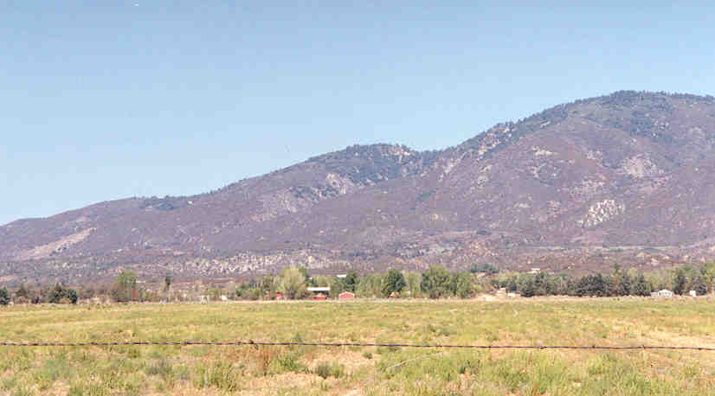

View of Reservation Area from Anza, CA

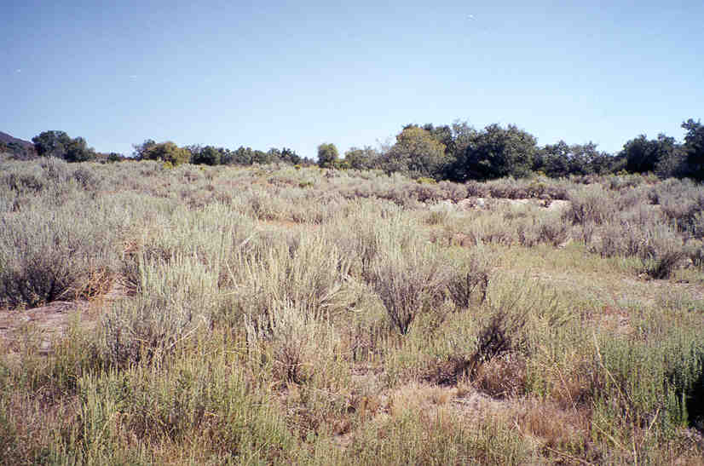

Typical Area of Pristine Reservation Site

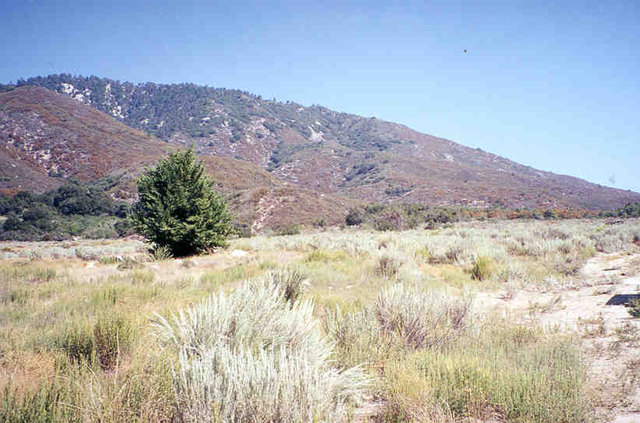

Looking East Towards the San Bernardino National Forest

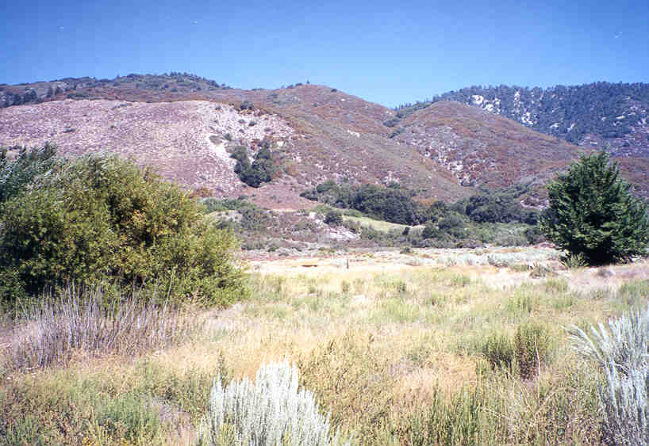

Looking Northeast from the Reservation

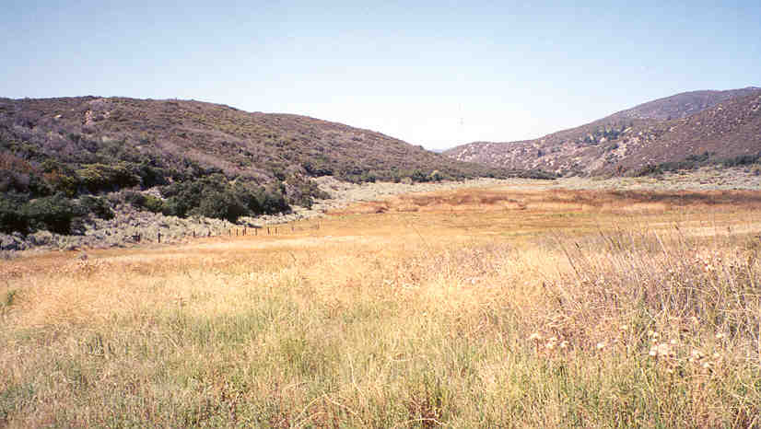

Site of Dry Lake and Fault Zone Area

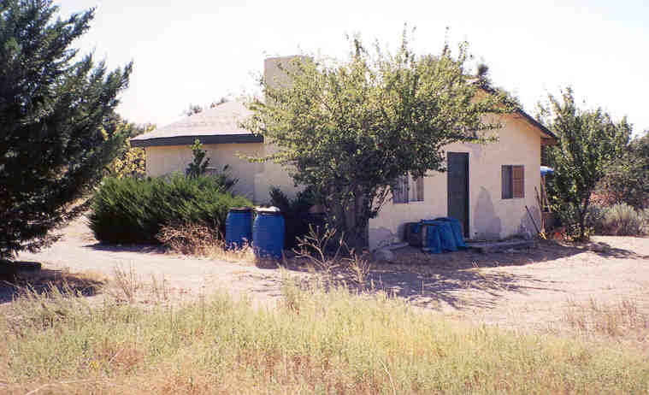

Old Reservation Facility in Northwest Sector

