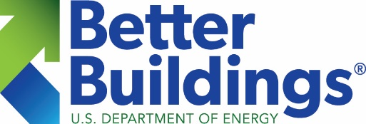
Reporting & Recognition Template
BETTER BUILDINGS RESIDENTIAL NETWORK
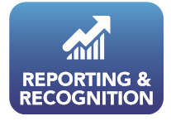
Please submit your organization’s number of upgrades and associated benefits from fiscal year (FY) 2021 using this template by April 22, 2022, to bbresidentialnetwork@ee.doe.gov, or provide the information requested below in another format, such as via email, document, spreadsheet, graphic, or chart.
Organization name: ______________________________________
Contact name: _______________________________________
UPGRADES:
____ Home energy upgrades completed in FY 2021 (October 1, 2020 – September 30, 2021)
The Better Buildings Residential Network defines a home energy upgrade as: Any transaction intended to improve a residential building’s (e.g., single-family home, multifamily unit, multifamily building) enclosure or mechanical system (e.g., insulation, air sealing, windows, HVAC, ducts, hot water).

BENEFITS:

Examples:

- Build It Green: 18,632 home energy upgrades; and annual energy savings of 3,289,275 kwh and 37,796 therms saved through home energy upgrades.
- Efficiency Maine: 9,310 upgrades; annual energy savings of 79,600 MMBtu and 12,696,791 kWh
- Center for Energy and Environment: 3,250 upgrades; annual energy savings of 2,266,000 kwh and 398,000 therms

OTHER ACCOMPLISHMENTS:
If your organization doesn’t directly complete home energy upgrades, share your achievements that have impacted residential energy efficiency. You may also attach any relevant annual reports or accomplishment information.

______________________________________________________________________________________

______________________________________________________________________________________

Email the Better Buildings Residential Network with any questions at bbresidentialnetwork@ee.doe.gov.

