News Updates

- The NRC Atomic Safety and Licensing Board (ASLB) has ruled that Toshiba’s participation in Nuclear Innovation North America’s South Texas Project does not violate federal rules on foreign ownership, control or domination of nuclear reactors. NRC staff had previously stated that despite having only a 10% ownership stake in the project, Toshiba’s level of financial support constituted an impermissible level of foreign control. The ASLB’s April 21st ruling stated that NINA’s corporate governance provisions ensure that Toshiba is not in a position to control or dominate decisions related to nuclear safety or security and that Toshiba, operating through their North American subsidiary, lacks financial control over the project.

Regulatory Status

- Eighteen Combined Construction and Operating License (COL) applications have been docketed; two have received COLs; eight (totaling 12 nuclear reactors) remain under active Nuclear Regulatory Commission (NRC) review, and 8 have been suspended¹ due to utility economic considerations. The Calvert Cliffs application continues to face foreign ownership issues. The Reference COL (R-COL) application has been submitted for five reactor designs; subsequent COLs (S-COLs) will incorporate the corresponding R-COL application by reference, noting any site-specific departures. Southern Nuclear’s Vogtle Units 3 and 4 and SCE&G’s VC Summer Units 2 and 3 have received COLs.

¹ Bellefonte 3&4, Callaway 2, Grand Gulf 3, River Bend 3, Victoria County 1&2 (later withdrawn), Shearon Harris 2&3, Comanche Peak 2, Nine Mile Point (later withdrawn)

 | UTILITY | SITE/LOCATION |  | REACTOR/  NO. UNITS |  | COLA DATES |  |  | REVIEW PHASE  IN PROGRESS
 |  |  |  |  |  | Submitted | Docketed | Issued | Safety ³ | Environ.⁴
Issued | Southern Nuclear | Vogtle | GA | AP1000 | 2 | 03/31/08 | 05/30/08 | 02/10/12 | Completed | Completed
Issued | SCE&G | V.C. Summer | SC | AP1000 | 2 | 03/27/08 | 07/31/08 | 04/10/12 | Completed | Completed
Active COL Applications | Duke Energy | Levy | FL | AP1000 | 2 | 7/30/08 | 10/6/08 | - | Ph. D | Completed
Active COL Applications | STP Nuclear Operating Co. | South Texas Project | TX | ABWR ² | 2 | 9/20/07 | 11/29/07 | - | Ph. 4 | Completed
Active COL Applications | UniStar | Calvert Cliffs | MD | US-EPR ² | 1 | 3/14/08 | 6/3/08 | - | Ph. 2 | Completed
Active COL Applications | DTE Energy | Fermi | MI | ESBWR ² | 1 | 9/18/08 | 11/25/08 | - | Ph. 2 | Completed
Active COL Applications | Duke Energy | William States Lee | SC | AP1000 | 2 | 12/13/07 | 2/25/08 | - | Ph. B | Completed
Active COL Applications | Florida Power and Light | Turkey Point | FL | AP1000 | 2 | 6/30/09 | 9/4/09 | - | Ph. A | Ph. 2
Active COL Applications | PPL (UniStar) | Bell Bend | PA | US-EPR | 1 | 10/10/08 | 12/19/08 | - | Ph. A | Ph. 2
Active COL Applications | Dominion Energy | North Anna | VA | ESBWR | 1 | 11/27/07 | 1/28/08 | - | Ph. 4 | Complete
² Reference COL Application (R-COL)
³ Safety Review: | R-COL→ | Ph 1 Issue RAIs | Ph 2 SER w/Open Items | Ph 3 ACRS Review | Ph 4 Advanced SER/ No OI | Ph 5 ACRS Review | Ph 6 Final SER
S-COL→ |  |  | Ph A Issue RAIs and supplemental RAIs |  | Ph B Advanced SER/ No OI | Ph C ACRS Review | Ph D Final SER
⁴ Environmental Review Phases: |  |  | Ph 1 Environmental Scoping Report |  | Ph 2 Draft EIS | Ph 3 Public comment | Ph 4 Final EIS

Small Modular Reactors
- Small modular reactors are defined as those having a capacity of less than 300 MWe and are transportable to a site by truck, barge, or rail. Nine SMR vendors have initiated contact with the NRC regarding their reactor designs.

 | Company | Reactor | Size (MWe) | Application | Expected DC Submittal Date
Light Water Reactors | Babcock &Wilcox mPower, Inc. | mPower SMR | 180 | DC/CP | TBD
Light Water Reactors | Holtec International | SMR-160 | 160 | DC | Q4 CY 2016
Light Water Reactors | NuScale Power, LLC | NuScale SMR | 45 | DC | Q3 CY 2015
Light Water Reactors | Westinghouse Electric Co. | W-SMR | 225 | DC | TBD

Reactor Design Certification (DC)
Summary: Two reactor designs that are being considered for future builds in the U.S. are certified and two renewal applications are under NRC review.
- AREVA US-EPR – Submitted December 12, 2007, and docketed February 25, 2008; certification schedule is under review.
- GEH ESBWR – Final Design Approval in March 2011; rulemaking expected 2014.
- Mitsubishi Heavy Industries US-APWR – Submitted December 31, 2007 and docketed February 29, 2008; MHI has requested a deferral of the review due to their work on reactor restarts in Japan.
- Korea Electric Power Corporation (KEPCO) APR1400 – Pre-application interactions continue. Korea Hydro and Nuclear Power Company and KEPCO plan to submit an application in late 2014.
- GEH ABWR – Certified in 1997. Toshiba and GEH have also separately submitted Design Certification renewal applications that are currently under review.
- Westinghouse AP1000 – Amended design certified on December 30, 2011.

Early Site Permits (ESP)
Summary: Four ESPs issued; one under review:
- PSEG submitted an ESP application for its nuclear plant site in Salem County, New Jersey, on May 25, 2010. The final environmental impact statement (EIS) is expected in September 2015; the safety review schedule is under review due to problems related to documentation of the hydrology portion of the ESP application.
- The following ESPs have been issued: Exelon – Clinton (IL), 3/15/07; Entergy – Grand Gulf (MS), 4/5/07; Dominion – North Anna (VA), 11/27/07; Southern – Vogtle site (GA), 08/26/09.

Decommissioning
- Four plants have announced decommissioning plans. Entergy plans to close its single unit Vermont Yankee plant in late 2014; sustained low natural gas prices, financial impacts of cumulative regulations, and the wholesale market structure all contributed to the company’s decision to shutter the plant. Dominion’s closure of its single unit Kewaunee plant in May 2013 also followed from low wholesale electricity prices; closures at San Onofre and Crystal River were both due to problems related to steam generator replacements. There are currently 100 reactor units operating.

New Plant Construction Progress
Summary: Full nuclear construction has begun for V.C. Summer Units 2 and 3 and Vogtle Units 3 and 4. TVA is proceeding with the completion of Watts Bar 2.
New Nuclear Plants under Construction: COLs for Vogtle Units 3 and 4 and V.C. Summer Units 2 and 3 have been issued.
Vogtle  Unit 3: 760 cubic yards of concrete have been placed inside the Unit 3 Containment Vessel Bottom Head (CVBH). This is the first placement of concrete in containment around structural modules.  Unit 4:The Containment Vessel Bottom Head (CVBH) has been set in place on May 8, 2014. The 284 ton reactor vessel was delivered to the site in mid-May. | 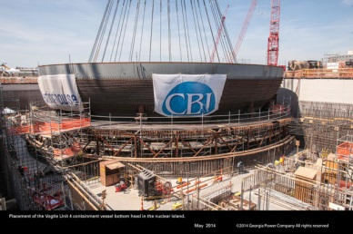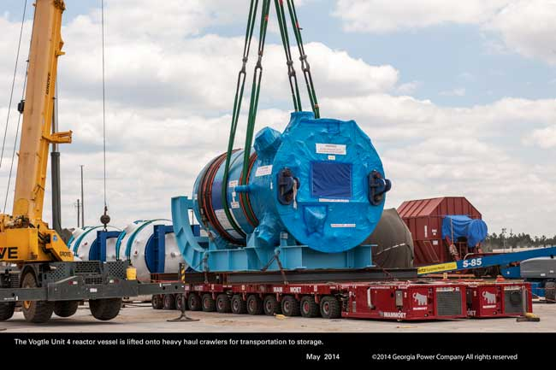  Placement of CVBH on the Unit 4 Nuclear Island and arrival of Unit 4 reactor vessel (Courtesy of Georgia Power/Southern Company)
VC Summer  Unit 2: The CA20 (auxiliary components) module and CA04 (reactor vessel structural support) module were set in place in May 2014. Ring 1 of the containment vessel was put in place in June. Unit 3: CVBH was set in place in May 2014. Assembly of the CR10 module (cradle for containment vessel) has been completed. | 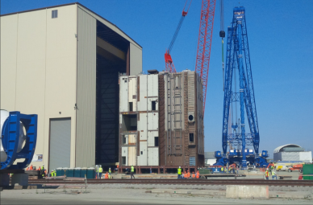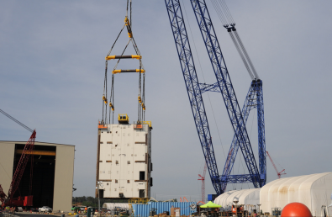  VC Summer Unit 2 CA20 module being removed from module assembly building and set in place (Courtesy of SCANA)

Watts Bar 2
- Most systems were scheduled to be released for pre-operational testing this Spring. Open vessel testing has been completed. The project continues to track to a most likely commercial operation date of December 2015.

Expected Operation Dates
- TVA expects Watts Bar 2 to be completed by late 2015.
- Southern Nuclear’s Vogtle Units 3 and 4 are expected to come online in late 2017 and 2018, respectively.
- SCE&G’s VC Summer Units 2 and 3 are expected to come online in late 2017 and 2018, respectively.

