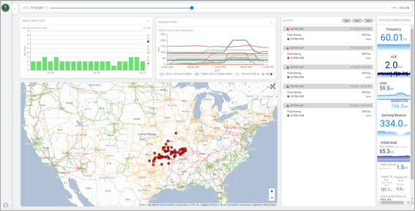
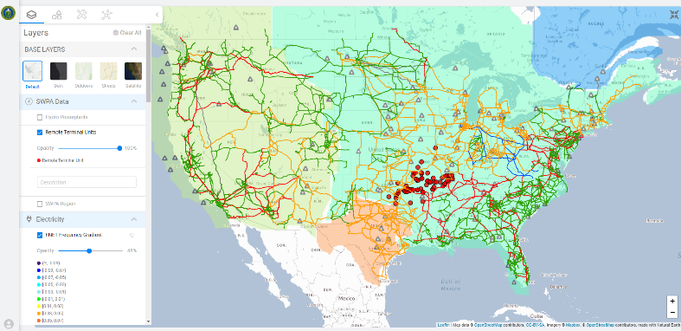

Figure 2: RTSA Mapper, showing Remote Terminal Units, FNET Frequency Gradient, and Transmission Lines layers
Figure 1: RTSA Dashboard, with Space Weather, Generation, Alerts, System Indicators, and Mapper widgets.

Using real-time situational awareness, NAERM RTSA addresses optimal energy operation resilience and recovery across multiple energy sectors.

The availability of real-time data across multiple sectors and sources is essential for a comprehensive understanding of the state of a system. The objective of the RTSA in NAERM is to deliver a visually interactive platform to explore static and dynamic data, including system-scale data describing various aspects of the nation’s energy infrastructure. The platform enables the end-user to assess system-level resilience and understand the interdependency across energy infrastructures.

The initial capability has been developed using NAERM’s existing data capabilities to include three key elements:
1. Incorporate energy infrastructure data at interconnect level with high-resolution (substation-level) data.
2. Incorporate overlays of relevant dynamic (streaming) data, which includes SCADA data, weather, hazards, FNET frequency, communications, NG EBB data, and other critical infrastructure data.
3. Incorporate data analytics capabilities that provide situational awareness, including system indicators and flagged alerts for NWS notices, FNET EBB alerts, and Genscape Critical Notices.

What datasets are used for situational awareness?
- Wildfire Perimeters from the National Interagency Fire Center
- Weather Watches and Warnings from the National Weather Service
- Planetary K Index from the NOAA Space Weather Prediction Center
- Nationwide real-time frequency gradient (FNET)
- Drought Prediction
- Sperry- Piltz Ice Accumulation Index
- NAESCCM Connectivity Model for communications infrastructure
- Forecasted data for solar, bus load, and wind energy data.
- Coming soon: SCADA data from PMAs will populate the interface with generation, frequency, ACE, load, and Spinning Reserve data.

Figure 1 shows the dashboard for NAERM RTSA while Figure 2 shows the Mapper.

More cool information… maybe describe some of the figures or reference other work
- The distribution layer will make distribution network selection more realistic and allow visualization at spatial resolutions fine enough to capture individual customer outages.
- Current DER_A representation unable to represent the voltage diversity and inverter configuration diversity expected.
- Idealized conservative settings

NAERM RTSA combines real-time data with interdependency analysis models to enhance the capability for reliable and resilient energy delivery across multiple energy sectors from a range of large-scale, emerging threats.
Overview of NAERM Real-Time Situation Awareness
Overview of NAERM Real-Time Situation Awareness
Overview of NAERM Real-Time Situation Awareness Tool
NAERM RTSA
North American Energy Resilience Model - Real-Time Situation Awareness Tool
RTSA Interdependency Analysis
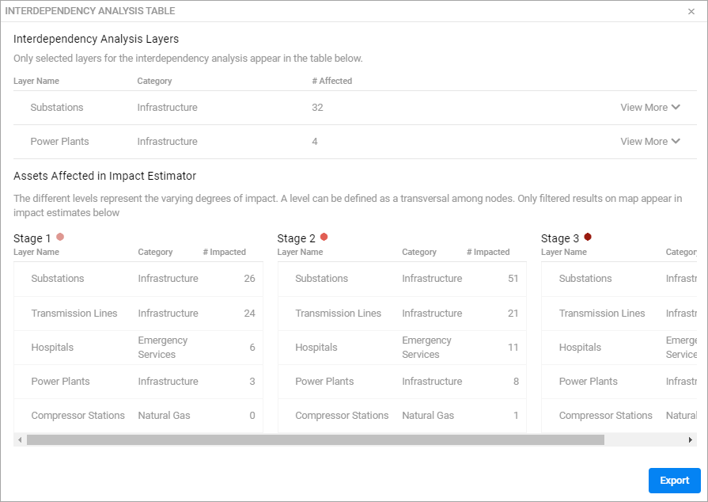
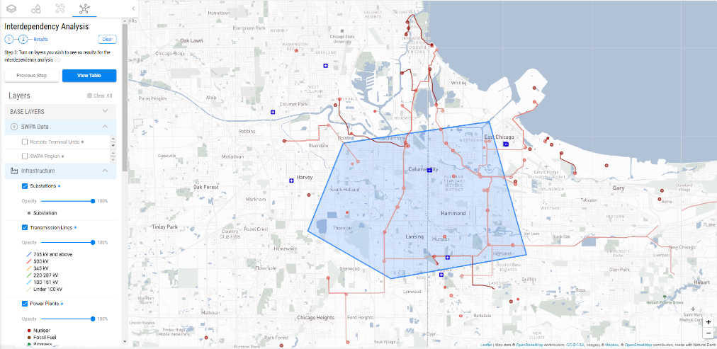
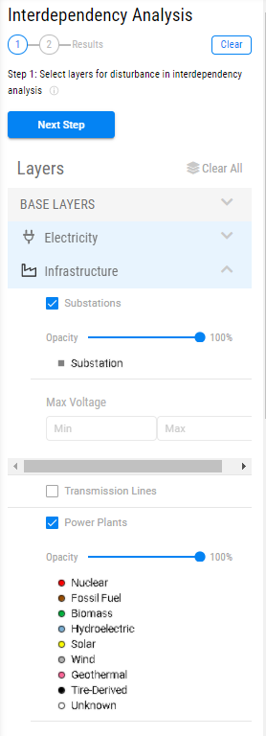
Figure 5. Results table. Press the Export button to export a .csv or .zip file. Stage 1 represents immediately impacted components, while stages 2 and 3 represent extended impacts that are near the core outage.
Figure 4: Draw polygon over the area of interest. Then, turn on layers to see results. Blue dots next to layer names indicate affected layers while gray dots are for unaffected layers. Substations, Transmission Lines, Power Plants, Compressor Stations, and Hospitals have been selected in this image.
Figure 3. Select layer(s) to disrupt. Substatoins and Power Plants were selected.
What’s next
- Ability for a user to initialize an interdependency analysis scenario using real-time NWS alerts and pre-defined inputs to see potential consequences of an incoming weather event
- Incorporation of System Resiliency Curves to analyze power outage recovery estimates after utility power outages
- Interaction between the NAERM RTSA interdependency Analysis and the NAERM power system modeling capabilities

How do we evaluate interdependencies?
Each critical infrastructure layer included in the interdependency analysis has a defined relationship to all other individual infrastructure layers. These relationships are defined based on a combination of academic literature, Homeland Security publications on infrastructure, and conversations with Subject Matter Experts (SMEs). With these definitions, cascading failures can be visualized on the interactive map; an initial piece of infrastructure is disrupted, and the analysis shows what other entities in the area may also be affected. Figure 3 shows the selection of layers for disturbance, Figure 4 shows a polygon drawn over the area of interest with selected layers for the interdependency analysis results on the map, and Figure 5 shows the results table for the interdependency analysis (press the View Table button).

