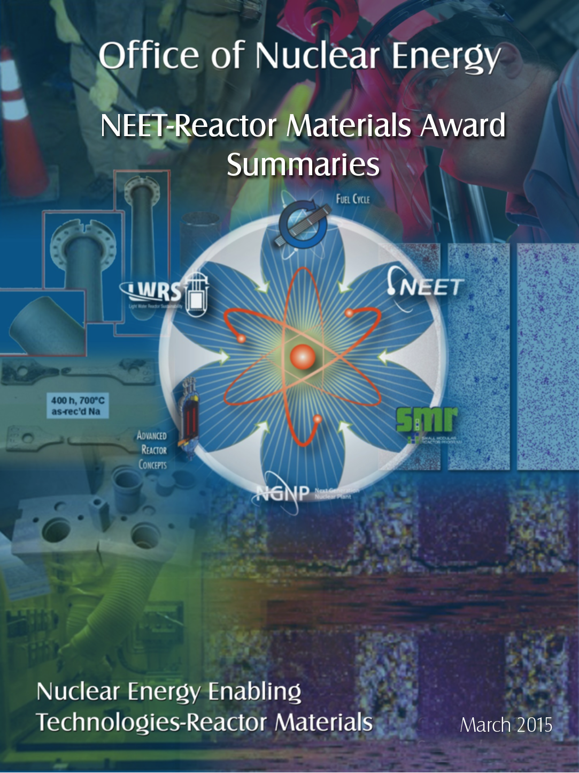

Material science plays a pivotal role in the extension of the life of the existing fleet of nuclear reactors; in the deployment of new modern light water reactors, advanced reactors with non-water coolants, and small modular reactors and in the storage, recycling and disposal of used nuclear fuel. Understanding and overcoming material degradation in an extreme environment is essential for safe and efficient operation. Deployment of new, advanced materials may make construction of new plants more economical. Materials research is featured in all of the major research thrusts within Department of Energy Office of Nuclear Energy (DOE-NE) research portfolio. The Nuclear Energy Enabling Technologies–Reactor Materials Crosscut (NEET-RM) is designed to provide support and coordination amongst these programs by enabling the development of innovative and revolutionary materials and provide broad-based modern materials science support to the materials research within all of the DOE-NE programs and providing coordination of research with the five other DOE-NE R&D programs (Light Water Reactor Sustainability, Small Modular Reactors, Very High Temperature Reactor, Advanced Reactor Technologies, and Fuel Cycle Research and Development). This provides an opportunity to coordinate responses and provide additional gains from joint research nationally and internationally by sharing research with all relevant programs. There are ongoing needs for new research tools, improved infrastructure, and coordination efforts to improve research efficiency.

The needs can be categorized into three major categories:

- Research and development needs: The major DOE-NE programs are making strides in a number of key areas. However, new tools, techniques, and capabilities may make research more efficient and enable new discoveries. For example, the development of computational thermodynamic tools may enable accelerated aging tests and reduce experimental burden during alloy development. Ion irradiation may be used to complement neutron irradiation at a reduced cost. Advanced welding or joining techniques may overcome traditional component limitations but will require dedicated research.

- Infrastructure needs: Available tools limit some of the research. New tools and facilities may enable research in multiple programs. For example, there is currently no fast reactor irradiation capability in the United States.

- Coordination and collaboration needs: Finally, in some areas, formal collaboration and discussion between the programs within DOE-NE and other relevant efforts may promote more efficient research and eliminate overlap. Code qualification and alloy development are examples of common research topics that may benefit from additional, broad discussion.

The Reactor Materials Crosscut effort will enable the development of innovative and revolutionary materials and provide broad-based modern materials science support to the materials research within all of the DOE-NE programs. This will be accomplished through innovative materials development; promoting the use of modern materials science; and establishing new, shared research partnerships. Today, the NEET-RM Crosscut is pursuing all of these areas actively via a competitive process. Three rounds of competition for three year research awards have been completed. Also, one round of competition exclusively for universities was completed in 2011 through the Nuclear Energy University Program (NEUP).

In 2011, four awards, totaling $2,011,730, were granted through NEUP in advanced materials development.

In 2012, nine awards, totaling $7,954,651, were given for advanced materials development concepts. These ranged from Fe-based steels to radiation-tolerant cable insulation.

In 2013, seven awards, totaling $6,898,673, were granted for the development of advanced characterization techniques. These projects ranged from synchrotron diffraction techniques to spherical nano-indentation.

The 2014 competition was focused on the development of advanced joining methods for advanced materials. Descriptions of the three awards, totaling $3,000,000 are provided and research began in October 2014.

Since FY 2012, NEET-RM has funded 19 projects for a total cost of $17,853,324.

Overall, the open competition has been very successful with high quality proposals from a very diverse set of institutions. Participation and partnerships have grown with each solicitation. As shown in the following sections, the technical quality and innovation have been very high, consistent with the expectations and goals of the NEET program.

2011 NEET-RM University Award Research Summaries

In 2011, a competition was open to university researchers in the area of materials discovery and development. Three of these project have been completed and one will be completed in September 2015. The projects focus on researching new classes of materials, not yet developed for use in nuclear reactors, which may enable transformational reactor performance. The custom design of innovative materials using modern materials science techniques, industrial knowledge, and previous experience can improve performance over traditional materials by a factor of five to ten, increasing the maximum operating temperature by 200 degrees Celsius for a period of at least 80 years. Concepts that were awarded under this solicitation include steel foams for lightweight shielding applications, austenitic oxide dispersion strengthened steels, MAX phases and high entropy alloys.

FY11
Radiation Behavior of High-Entropy Alloys for Advanced Reactors

Peter K. Liaw, The University of Tennessee
Takeshi Egami and Yanwen Zhang, The University of Tennessee / Oak Ridge National Laboratory
Fan Zhang, CompuTherm LLC
Funding: $538,159 (9/15/2011-9/30/2014)

Description of project: The work aims to gain critical knowledge of high-entropy alloys (HEAs) with potential applications in nuclear reactors and related elevated-temperature and high-pressure systems by integrating both theoretical-modeling and focused-experimental efforts. Unlike conventional materials, which develop a large number of crystal defects in a radiation environment, HEAs may transform locally into a glass as a result of extensive radiation damage, and, hence, re-crystallize into disordered solid solutions. Thus, HEAs are highly disordered throughout the radiation process, and easily return to their initial state, resulting in a “self-healing” effect. The project will build upon recent HEA studies, and obtain new results to rigorously investigate specific HEAs for applications in advanced nuclear reactors. Promising types of HEAs will be designed, fabricated, tested, and optimized.

Impact and value to reactor applications: The results of the project will provide fundamental understanding of the behavior of HEAs in extreme environments with an ultimate goal of optimizing the composition and properties for use in nuclear reactors and related elevated-temperature and high-pressure systems. The potential impact will make HEAs favorable candidates for various elevated-temperature applications, such as advanced reactors, which require operating temperatures in excess of 750 – 850 °C for the next 80 years.

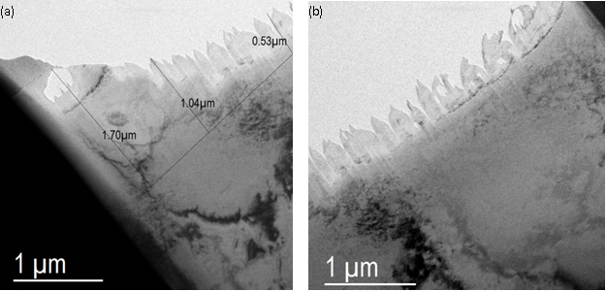
Recent results and highlights: The Al_{0.3}CoCrFeNi HEA shows good radiation resistance up to 60 peak dpa. No voids or dislocations are observed. The crystal structures remain face-center-cubic (FCC) before and after 5 MeV Ni irradiation. Figure 1(a) shows the traditional Transmission Electron Microscopy (TEM) image of the irradiated sample after lift-out. The specimen was prepared from the highest fluence area (2 x 10¹⁶ ions/cm²), corresponding to roughly 60 dpa at the peak. The peak damage region is 1.7 um below the surface, based on The Stopping and Range of Ions in Matter (SRIM) calculation. Traditional radiation damages are not observed in the Figure 1(b), including voids or dislocations. The irradiated region remains crystalline and shows no difference compared to the bulk (un-irradiated) region. Higher dpa might be required to study defect-formation mechanisms.
Figure 1. TEM images of the irradiated sample, lift-out from the 2 x 10¹⁶ ions/cm². (a) Depth below the surface was marked to guide; (b) Peak damage region with 1.7 um below the surface.

We also have demonstrated the radiation damage and the recrystallization behaviors in HEAs through molecular-dynamics simulations. It is found that by alloying with atoms of different sizes, the atomic-level strain increases, and the propensity of the radiation-induced crystalline to amorphous transition increase as the defects cluster in the cascade body. Recrystallization of the radiation induced supercooled or glass regions show that by tuning the composition and the equilibrium temperature, the HEAs can be healed. The crystalline-amorphous-crystalline transitions predict the potential high radiation resistance in HEAs.
FY11
Diffusion, Thermal Properties and Chemical Compatibilities of Select MAX Phases with Materials For Advanced Nuclear Systems Radiation

Michel W. Barsoum, Drexel University
Brenda Garcia-Diaz, Michael Demkowicz, Savannah River National Lab
Elizabeth Hoffman, Savannah River National Lab
Robert Sindelar, Savannah River National Lab
Funding: $535,927 (9/15/2011-9/30/2015)

Description of project: The demands of Generation IV nuclear power plants for long service life under neutron radiation at high temperature are severe. Advanced materials that would withstand high temperatures (up to 1000+ °C) and high neutron doses would be ideal for reactor internal structures and would add to the long service life and reactor reliability. The objective of this work is to investigate the chemical compatibility of select MAX with potential materials that are important in the nuclear energy field, as well as, to measure the thermal transport properties as a function of neutron irradiation. The chemical counterparts chosen for this work are: pyrolytic carbon (PG), SiC, U, Pd, FLiBe, Pb-Bi and Na; the latter 3 in the molten state. The thermal conductivities and heat capacities of non-irradiated MAX phases will also be measured.
Impact and value to reactor applications: Before the MAX phases can be even considered for use in Generation IV nuclear reactors and to better understand where they would be most judiciously used, much needs to be better understood and quantified. A systematic research effort into the chemical stability/reactivity of the MAX phases is thus required to determine their feasibility in nuclear applications such as high temperature structural components or diffusion barrier coatings for nuclear fuels. In fuel applications, such as coatings, the candidate materials must be evaluated for chemical interactions from the outside of the fuel pellet, as well as, the fuel and fission product inside the fuel pellet. Furthermore, joining the MAX phases to the fuel, graphite, SiC, and other materials needs to be quantified. This proposal thus addresses the following facets that are crucially important to potential nuclear applications.
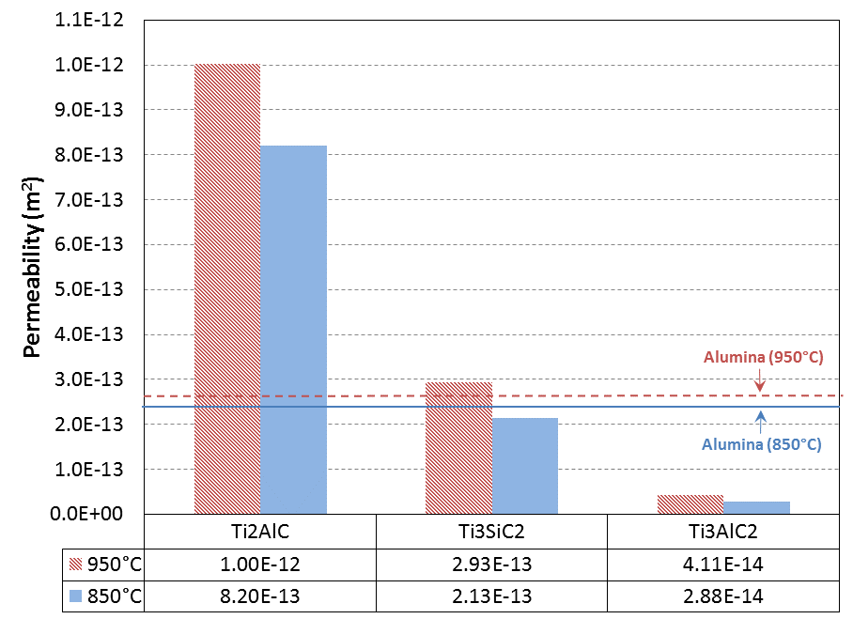
Recent results and highlights: He perm-eability tests were performed at 850°C and 950°C for Ti₂AlC, Ti₃AlC₂ and Ti₃SiC₂. At constant temperature, the He permeability was highest for Ti₂AlC, lowest for Ti₃AlC₂ with Ti₃SiC₂ in between (Fig. 1). These materials showed between 15.5% and 35.3% increase in the He permeability at 950°C as compared to their respective permeabilities at 850°C. The He perm-eability results are comparable to those for alumina at the same temperatures. In a paper on the reactivity of Ti₃SiC₂ and Ti₂AlC with Zr (J. Nuclear Mater., 460, 122-129 (2015)) we showed that both react with Zr, but that the extent of reaction is significantly higher in the case of Ti₂AlC. With the exception of Ti₃AlC₂ that appears to be the most reactive, Ti₃SiC₂, Ti₂AlC and Cr₂AlC did not react with molten Na after a week at 750 °C. Neither Ti₃SiC₂ nor Ti₂AlC reacted with SiC and PG even after 30 h at 1300 °C; Ti₃AlC₂ and Cr₂AlC did react, however. Manuscripts on the reactivity with molten Na, and with SiC and PG have been submitted for publication. A third manuscript on interactions with Pd foils is being readied for publication.
Figure 1: Permeability coefficient of Ti₂AlC, Ti₃AlC₂ and Ti₃SiC₂ at 850 ºC and 950 ºC.

FY11
A New Light Weight Structural Material for Nuclear Structures

Afsaneh Rabiei and Mohamed Bourham
North Carolina State University
Funding: $399,490 (9/15/2011-9/30/2014)
Description of Project: The objective of this research is to design, manufacture, and test a new light weight structural material which will maximize shielding characteristics and mechanical strength while maintaining a characteristically low weight. Metal foams are a new class of materials offering an order of magnitude higher energy absorption under compression compared to the bulk materials that they are made of, at an order of magnitude lower density. Composite metal foam (CMF) has up to 7 to 8 times higher energy absorption compared to any other metal foam and over 70-80 times higher energy absorption under loading compared to the bulk materials used to construct the foams. In this study, we utilized the advantages of metal foams to design, manufacture, and test a new light weight structural material. These materials include composite stainless steel foams with various porosity sizes and matrix material; and open cell aluminum foam filled with low-Z materials such as paraffin wax, borated polyethylene, water or borated water. A study of the shielding effectiveness of these materials under various conditions of gamma-ray, neutron, or X-ray radiation, heat and loading conditions is underway.

Impact and Value to Reactor Applications: The results of this study will allow us to evaluate the feasibility of using new multi-layer structure including composite steel foams for protection against radiation while providing additional mechanical strength with a very low weight. The application of new composite steel foam structure in production of novel safety devices such as dampers for spent nuclear fuel casks transferring nuclear wastes, or shielding layer in nuclear power plants can revolutionize the performance and protection rate of such devices.

Results and Highlights: A study of the properties of composite metal foams in various nuclear environments is being conducted on samples made with a variety of different cell sizes and morphologies (thicknesses of different layers of open and closed cell foams separated from each other with solid layers of metal). These samples were tested under various radiation transmission, mechanical loading and thermal conditions to simulate the radiation, mechanical loading and thermal environment that the material may be exposed to when used in a nuclear structure. In gamma ray transmission measurements, total mass attenuation coefficients for both close-cell CMFs and open-cell Al foam with various fillers were measured. The dependency of transmission on sample thickness has been compared with tabulations based upon the results of XCOM (Photon Cross Section database) code (version 3.1) from National Institute of Standards and Technology. In neutron transmission measurement, the experiments were carried out at beam tube (BT) #4 of the North Carolina State University PULSTAR reactor, and simulations were performed with Monte Carlo N-Particle Transport Code version 5 (MCNP5) to validate the accuracies of the experimental results. X-Ray shielding effectiveness measurements of the samples were carried out on a high-resolution micro-computed tomography (micro CT) system, and the results were compared with those of Aluminum A356 and lead standards. Thermal conductivity, thermal expansion, and flame resistivity of the novel composite metal foams were evaluated for the first time through an extensive experimental approach and high-performance modeling and simulation efforts.

The results indicated that the material has great potential to offer excellent mechanical strength while maintaining a low weight, good shielding capability, and thermal characteristics. These are all necessary components for effective shielding of nuclear reactor’s structural material or storage cask materials. Two journal papers and one proceeding paper have been published and three journal papers and an additional proceeding paper are being developed. One PhD student is scheduled to defend her final dissertation on this research in June 2015.

FY11
Development of Austenitic ODS Strengthened Alloys for Very High Temperature Applications

James F. Stubbins, Ian M. Robertson, Huseyin Sehitoglu, Petros Sofronis,
University of Illinois at Urbana-Champaign
Funding: $538,154 (10/3/2011-12/31/2014)

Description of project: The objective of this research project is to develop an understanding of the microstructural and micromechanical processes which control high temperature materials performance in austenitic oxide dispersion-strengthened (ODS) alloys. The ultrafine oxide dispersoids provide the ODS alloys with excellent mechanical strength and radiation tolerance. These advantages, along with the superior creep properties and outstanding corrosion resistance of austenitic stainless steels, should provide exceptional performance of austenitic ODS steels for service in extreme environments. In this project, the austenitic ODS steels were investigated by a coordinated combination of advanced microstructural characterization techniques. The results clarified the strengthening mechanism of austenitic ODS alloys, expanded the understanding of the effects of various factors on the performance of austenitic ODS alloys, and therefore provide guidance for the development of austenitic ODS steels that are practical for advanced nuclear applications.

Impact and value to reactor applications: Both Generation IV fission reactor conceptions and prospective fusion facilities involve higher operation temperatures, more intense neutron flux and more aggressive coolants, calling for advanced structural materials that are capable of surviving those extreme service conditions. This project aims to develop austenitic ODS steels that are promising candidates for future nuclear applications. The potential impact is the development of a series of high-performance steels that can solve the structural material challenges of advanced nuclear systems.
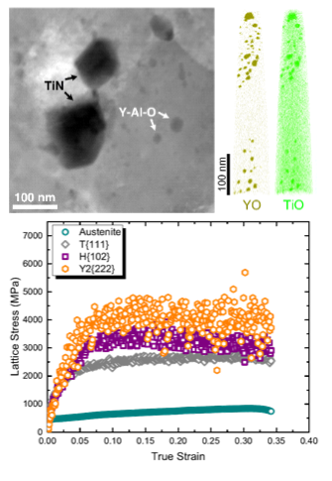
Recent results and highlights: A series of precipitate phases with different size distributions, including large-sized Ti(C,N), intermediate-sized Y-Al-O, and small-sized Y-Ti-O, were found in austenitic ODS steels (Fig. 1). Their elemental compositions and morphologies have been investigated by analytic scanning transmission electron microscopy (STEM), atom probe tomography (APT, supported by the Center for Nanophase Materials Sciences, Oak Ridge National Laboratory) and high-resolution transmission electron microscopy (HRTEM). In situ TEM deformation investigations revealed several particle-dislocation interaction mechanisms and their respective influence to the precipitate-strengthening effect.

In situ synchrotron tensile experiments were performed in sector 1-ID at Advance Photon Source (APS), Argonne National Laboratory (ANL). Both size dependence and temperature dependence were observed. Only those ultrafine precipitates are capable of maintaining their strengthening contributions at elevated temperatures, emphasizing the value of using austenitic ODS steels for high-temperature applications.
Figure 1 shows the three precipitate phases with various size distributions and their respective contributions to the load-partitioning in an ODS 316 stainless steel.

2012 NEET-RM Open Award Research Summaries

In 2012, the NEET Crosscutting Reactor Materials program sought applications for advanced materials discovery and development. Successful completion of awards will provide piping, structural, or clad materials that dramatically improve performance over traditional materials used in terrestrial and space reactors and in the nuclear fuel cycle.

Specific goals may include:

- Improvement in mechanical performance by a factor of 5-10 over traditional materials
- Increase in maximum operating temperature of greater than 200 C over an 80 year lifetime
- Increased radiation tolerance to beyond 300 dpa

Such performance would enable significantly improved safety, performance and reliability for future advanced reactor and fuel cycle designs. However, such improved performance cannot be at the expense of other properties or performance.

Applications were requested that describe innovative materials concepts, concept advantages, concept limitations, and key development needs. Successful applications described innovative materials that offer the potential for revolutionary gains in reactor and fuel cycle performance. Materials that could be applied to multiple reactor designs, components, and concepts were given preference over materials restricted to a single reactor concept, component, or coolant.

FY12
Radiation Tolerance and Mechanical Properties of Nanostructured Ceramic/Metal Composites

Michael Nastasi, University of Nebraska-Lincoln
Michael Demkowicz, Massachusetts Institute of Technology
Lin Shao, Texas A&M University
Funding: $979,978 (10/1/2012-9/30/2015)

Description of project: The objective of this proposal will be to explore the development of advanced metal/ceramic composites with greatly improved radiation tolerance, stability above 500ºC, and improved mechanical performance combining the good properties of glasses (high strength and elastic limit, corrosion resistance) with those of crystals (high toughness, strain hardening). The ceramic component of the composite will consist of a high crystallization temperature amorphous material composed of Si-C-O, while the metal component will be Fe or Fe(Cr), chosen as a model material for steel. We hypothesize that the combination of the composite constituents as well as the interfaces between them will provide significantly enhanced radiation tolerance, similar to or superior to those observed in metallic nanolayered structures, but in a more engineering-relevant material system.

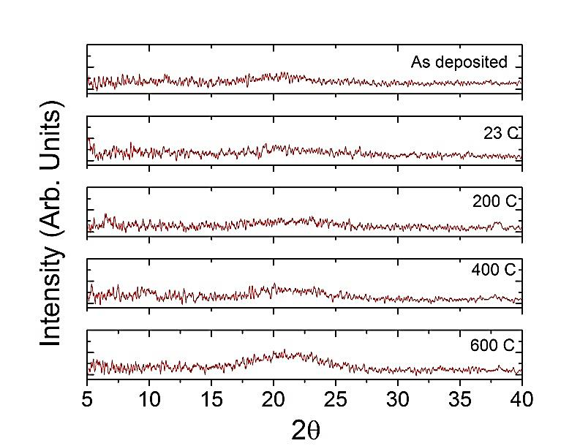
Impact and value to reactor applications: The need to develop advanced cladding that does not react to form hydrogen is urgent considering past accidents at Fukushima. The project will aim to develop super-tough and ultra-high temperature resistant materials that are in critical need for nuclear applications under extreme conditions where in-core materials have to withstand neutron damage and high temperature. The potential impact will be the development of a new class of ceramic/metal composites that can be adapted for engineering applications, resulting in dramatically improved materials performance for advanced reactors.

Recent results and highlights: Studies have shown that the amorphous Si-C-O material is stable under irradiation to 1 dpa at temperatures at high as 600 C. Structural characterization of the amorphous compound was performed using grazing incidence X-ray diffraction (GIXRD). Figure 1 shows the GIXRD data collected as a function of irradiation temperature. The feature at around 21° provides evidence of the amorphous character of the alloy. Transmission electron microscopy (TEM) analysis confirms the 23C data. Additional TEM work is in progress for samples irradiate to 20 dpa at 600 C.

We have been conducting atomistic simulations to gain insight into the structure and radiation response of amorphous silicon oxycarbides. We have developed a novel approach to studying radiation effects in this material using the linear scaling density functional theory (DFT) code, ONETEP. To maximize efficiency, we are using the Si-O-C ReaxFF potential to generate initial structures, which we then relax using linear scaling DFT. System sizes of approximately 1000 atoms may be modeled this way.
Figure 1 Shows the grazing incidence diffraction spectra obtained for the He⁺ irradiated Si-C-O alloy at 1.0 dpa as a function of temperature.

FY12
Accelerated Development of Zr-Containing New Generation
Ferritic Steels for Advanced Nuclear Reactors

Lizhen Tan, Ying Yang, Oak Ridge National Laboratory
Kumar Sridharan, Beata Tyburska-Pueschel, and Lingfeng He, University of Wisconsin-Madison
Funding: $849,000 (10/1/2012-9/30/2015)

Description of project: The project seeks to develop a new generation zirconium-containing ferritic steels, with the aid of modern computational microstructural modeling tools, to enhance high temperature creep resistance and improve radiation resistance.

Impact and value to reactor applications: Development of the inherently low-swelling ferritic steels with enhanced high-temperature creep resistance, which is produced by conventional economic steelmaking techniques, would represent a significant step towards development of components for high temperature, high dose reactors. The thermodynamic property database of the Fe-Cr-Zr-X system enables broader applications in nuclear power plants for understanding the interaction between the Zr-alloy fuel cladding and the structural steel core components.

Recent results and highlights:
- A thermodynamic database containing Fe, Cr, Zr, W, Mo, Nb, Ti, C has been developed and used to design alloy chemistries and heat treatment schemes.
- Three series of Zr-containing ferritic alloys, denoted as Z (high Zr > 4 wt.%), T (9Cr), and L (15Cr), have been developed and are being tested. The Z and T series alloys demonstrated superior high temperature mechanical properties as compared to conventional ferritic/martensitic steels, e.g., Grade 91.
- Microstructures are being characterized using advanced techniques including XRD, SEM to high resolution TEM/STEM-EDS to establish their relationships with material properties, e.g., strength, fracture toughness, and resistance to aging, creep and ion irradiation (See figure below).

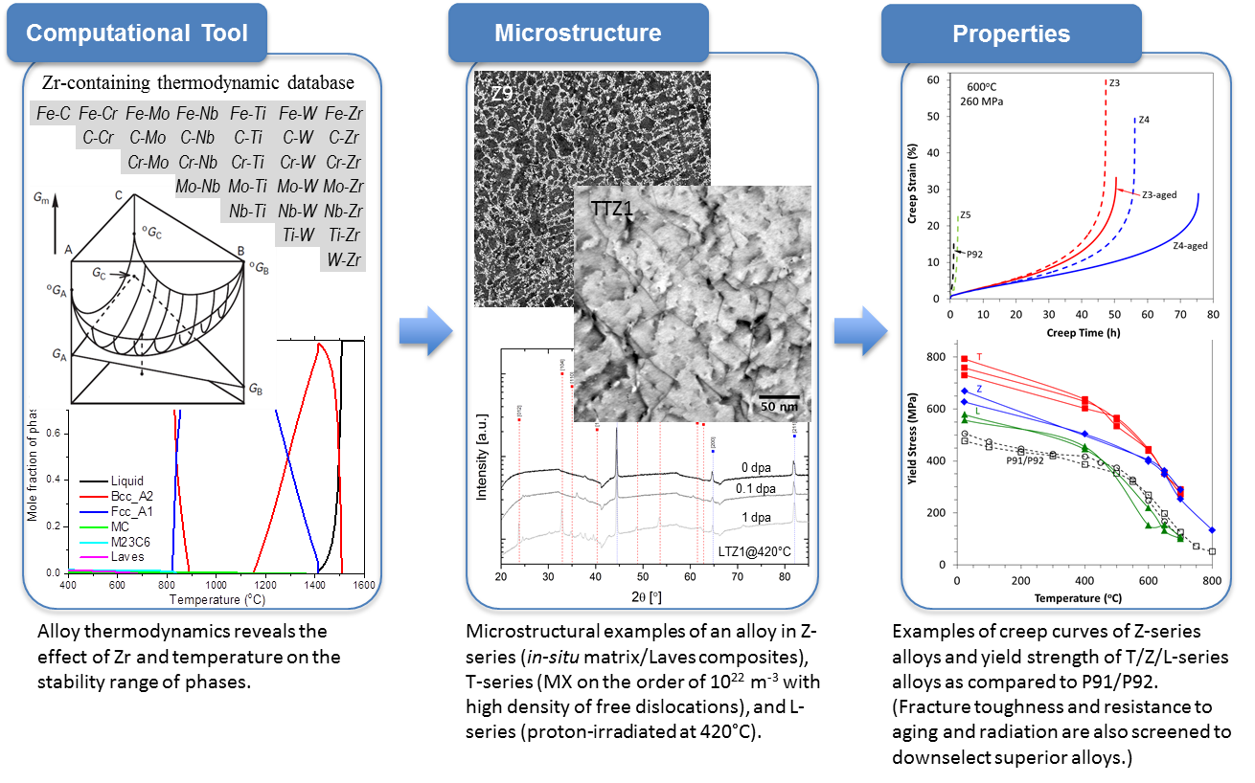
FY12
Nanocrystalline SiC and Ti₃SiC₂ Alloys for Reactor Materials

C. H. Henager, Jr., Pacific Northwest National Laboratory
Funding: $977,577 (10/1/2012-9/30/2015)

Description of project: The research seeks to develop a new high-temperature structural material based on nanocrystalline silicon carbide (SiC) alloys that can be used in advanced reactors as an accident tolerant replacement for zircaloy cladding or as an improved SiC cladding for TRISO fuel, as well as for certain other in-core applications that require higher temperature properties. These materials are anticipated to have temperature utility up to 1700K (~1425˚C). The focus will be on the synthesis of a carbon nanotube (CNT)-reinforced SiC/Ti₃SiC₂ nanocomposite using textured CNT mats to achieve improved mechanical and thermal properties. The composite material will be evaluated with microscopy to determine CNT/SiC adhesion and to determine strength and toughness. The results will be used with mechanical models to help design a 3D texture in the CNT mats for optimal mechanical properties. Laser flash diffusivity measurements will be used to determine thermal conductivity of the composites.

Impact and value to reactor applications: The value of this material for reactor applications is that it can potentially be made dense with good fracture toughness and reasonably high thermal conductivity compared to SiC/SiC composites. The use of polymer processing will allow near net shape processing to be used. One caveat for the use of Ti₃SiC₂, and potentially other such MAX phases, in reactor applications is that preliminary data taken for this project suggest that fission produce diffusion appears to be much higher compared to SiC. This may have serious implications for the use of this type of material for fuel cladding.

Recent results and highlights: The synthesis of SiC-based alloys with the general structure of SiC/Ti₃SiC₂ dual phase composites formed by simultaneous polycarbosilane pyrolysis and Si + TiC displacement reactions has been accomplished (see Figure 1a). To the best of our knowledge these are the first such dual phase composites made by combining these two methods. Data for thermal conductivity (see Figure 1b) and fracture toughness indicate that properties of these composites agree with what others have measured for similar materials synthesized by different methods. This is a positive result and indicates that the polymer pyrolysis methods can likely be used to combine in situ displacement reactions with CNT mats to make tough composites.

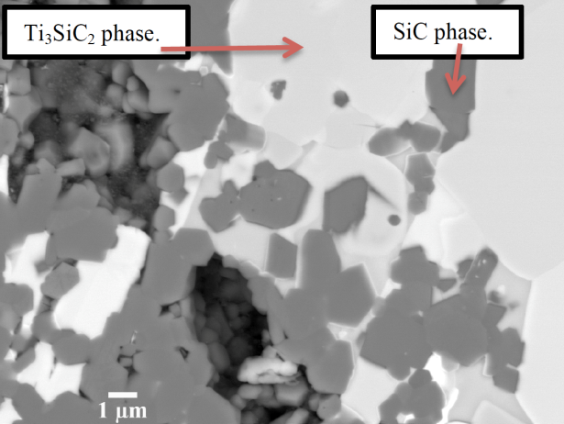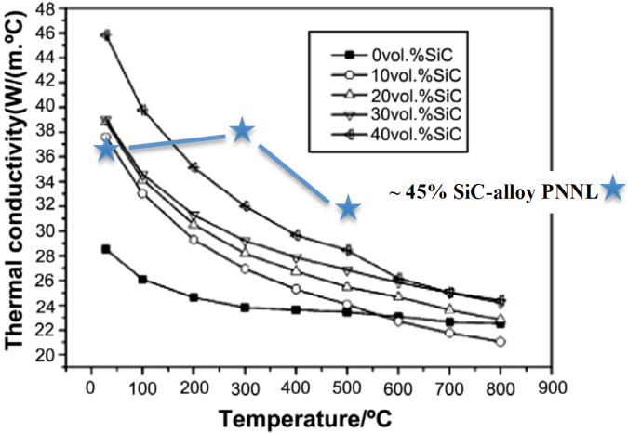
- (b)

Figure 1. Shown in (a) is the dual phase microstructure consisting of Ti₃SiC₂/SiC and in (b) is an average of thermal conductivity showing agreement with other measured data.
FY12
Study of Intermetallic Nanostructures for Light-Water Reactors

Prof. Niels Gronbech-Jensen and Dr. Benjamin Beeler, University of California-Davis
Profs. Mark Asta and Peter Hosemann, University of California-Berkeley
Dr. Stuart Maloy, Los Alamos National Laboratory
Funding: $749,940 (10/1/2012-9/30/2015)

Description of project: This project aims to study and utilize self-forming precipitates in structural steels for nuclear applications. We are utilizing the concept of interfaces as sinks for radiation induced defects, as has been studied for oxide dispersion strengthened (ODS) alloys, and expanding it to intermetallic precipitates. Certain commercially available tool steels, commonly known as MarAging steels, form NiAl based nanoclusters by a simple heat treatment. The question is if these clusters provide radiation tolerance benefits comparable to oxide clusters in ODS alloys. These precipitates could act as defect sinks while yielding radiation self-hardening, since more clusters precipitate under radiation and therefore provide more defect sinks. Atomistic computational modeling and experiments address this basic concept and evaluate its feasibility.

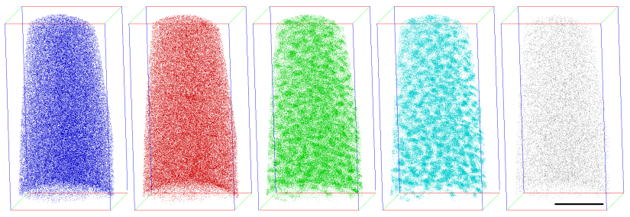
Impact and value to reactor applications: This work can potentially lead a path towards a new class of radiation tolerant alloys, as well as provide important insight into the fundamentals of radiation precipitation behavior and the role of coherent interfaces as defect sinks. These insights are likely to be relevant to a wide variety of materials.

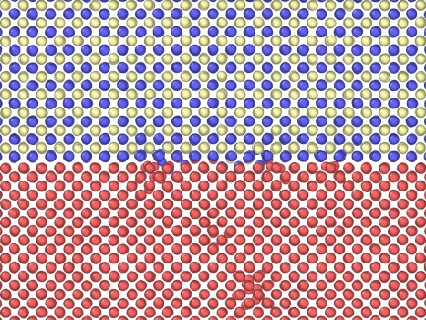
Recent results and highlights: Our recent experimental results on the material with and without precipitates show that low temperature irradiations (RT) do cause the development of cluster precursors in a material, which has no clusters prior to irradiation. In a material with preexisting clusters the Ni-Al precipitates stay of similar dimension, and a small amount of Si enrichment was found in the clusters after radiation. Figure 1 shows the APT data of the material before and after radiation. We will evaluate if severe mechanical property changes occur at long times or the radiation causes significant changes in the microstructure. Our recent modeling efforts have produced the first interatomic potential capable of reasonably describing the ternary FeNiAl system. Systems with (100), (110) and (111) BCC-Fe/B2-NiAl interfaces are being investigated with and without radiation to determine the potential role of such interfaces as defect sinks. Radiation damage is varied in depth and angle with respect to the interface, as well as energy of the impinging particle. In Figure 2, an example (100) interface of BCC-Fe with B2-NiAl is displayed.
Figure 1

Fig. 1. APT data.
Figure 2

FY12
Nanoscale Stable Precipitation-Strengthened Steels for Nuclear Applications

Kester D. Clarke (PI), Clarissa A. Yablinsky, Amy J. Clarke, Stuart A. Maloy, Osman Anderoglu, Robert E. Hackenberg: Los Alamos National Laboratory
Ömer N. Doğan, Paul D. Jablonski: National Energy Technology Laboratory
Kristin Tippey, Kip O. Findley, John G. Speer: Colorado School of Mines
Semyon Vaynman, Morris E. Fine, Yip-Wah Chung: Northwestern University
Funding: $880,000 (10/1/2012-9/30/2015)

Description of project: The objective of this investigation is to use cutting-edge alloy development strategies to produce thermally stable precipitation hardened steels manufactured by conventional methods for nuclear reactor structural applications. These modern steel alloy development strategies will significantly improve mechanical properties, increase thermal service duration, and improve irradiation resistance, while reducing cost and increasing manufacturability. Two classes of materials are being designed: Tailored Precipitate Ferritic (TPF) steels and Advanced High-Cr Ferritic-Martensitic (AHCr-FM) steels.

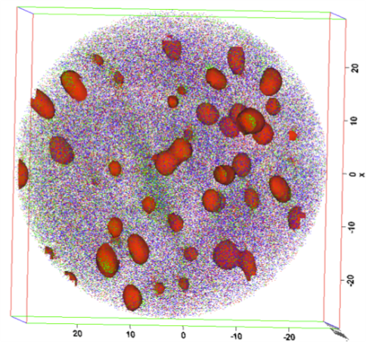
Figure 1 – Atom probe tomography reconstruction of homogenously distributed nanoscale (<5nm diameter) Al-Ni precipitates after extended aging at high-temperatures in a TPF alloy.
Impact and value to reactor applications: Optimization of current alloys and development of novel alloys will produce materials with improved mechanical properties, thermal service capabilities, and irradiation resistance. These modern materials will allow reactor designers greater flexibility to improve performance, durability, and safety.

Recent results and highlights: TPF alloy design strategies resulting from computational and experimental understanding have produced microstructures with nanoscale Al-Ni precipitates, as shown in Figure 1, and nanoscale Nb or V carbides. The homogenously distributed nanoprecipitates have been subjected to extended high-temperature aging experiments and the resulting nanoscale characterization shows excellent thermal stability. AHCr-FM steel alloys have been produced to exploit the benefits of low-carbon, high-nitrogen compositions to produce a high density of Nb or V nitrides. Thermodynamic calculations show that anticipated nitride precipitate volumes above 0.2 mass-percent are possible, while simultaneously improving creep rupture properties by reducing carbon content. Controlled thermomechanical treatments of both TPF and AHCr-FM alloys are underway to link nanoscale precipitate distributions with stable dislocation sinks and further optimize mechanical properties, thermal performance, and irradiation resistance. Initial irradiation testing technique development has shown the ability to differentiate between materials irradiation performance.

FY12
Nanostructured Fe-Cr Alloys for Advanced Nuclear Energy Applications

R. O. Scattergood, North Carolina State University
Funding: $788,156 (10/1/2012-9/30/2015)

Description of project : This research addresses the development of Fe-14Cr base alloys that have improved performance for nuclear energy applications. Alloy additions will be made to develop the microstructures for this purpose. The goal is to achieve model NFA alloys with nanoscale grain size that can remain stable to high temperatures. Non-equilibrium stabilizing alloying elements are incorporated into powders produced using SPEX ball milling. These segregate to grain boundaries (thermodynamic stabilization) and/or form nanoscale dispersoids for Zener pinning. Modeling is used to guide the selection of candidate stabilizer elements for Fe-14Cr.

Impact and value to reactor applications: Results obtained have shown that nanoscale microstructures consisting of nanoscale grains and nanoscale dispersoids can be developed. The long term thermal stability limits need to be further investigated. As described in the proposal, the potential enhancement of these microstructures in terms of radiation tolerance will be investigated in collaboration with Los Alamos National Laboratory.

Recent results and highlights:
Highlight 1: A study was done on SPEX milled Fe-14Cr-0.4Ti-xY₂O₃(wt%). Characterization of yttria additions has not been reported for the as-milled condition, and that motivated this work. Both nano and micron size yttria starting powders were used. HAADF/EDS image mapping (Figure 1) indicates that micron-size particles are no longer present after ball milling. The microstructure and chemical maps shown below reveal that the as-milled alloy containing 1 wt.% yttria has uniformity of elemental yttrium incorporated into the matrix. The microstructure studies, along with hardness tests, confirmed that identical results after annealing milled powders are achieved using micron-size versus nano-size yttria starting powders. The results have been submitted to the Journal of Nuclear Materials and are currently in revision.
Figure 1

Highlight 2: A high density of nano-size HfO₂ particles are observed in three Fe-14Cr-xHf alloys (x = 1, 2 and 4 at%). Figure 2 shows the HAADF/EDS image mapping of an area near the grain boundary in the Fe-14Cr-4Hf alloy (annealed at 900 ˚C). The nano HfO₂ particles were found uniformly dispersed in the matrix with an average size of ~4 nm, which rendered the alloy grain size stable in the nanocrystalline range after annealing for 1 hour up to 1000 ˚C. In addition, the particle size and dispersion of HfO₂ particles are comparable to those of Y-Ti-O enriched nanoclusters in conventional ODS alloys. The arrows in chemical maps (c) and (d) indicate Cr or Hf segregation, respectively, on grain boundaries. The results are being submitted to Philosophical Magazine.
Figure 2

FY12
SiC Composite for BWR Channel Application

Ken Yueh, Electric Power Research Institute
In Partnership with AREVA, GNF, INL, MIT, ORNL and WEC
Funding: $800,000 (10/1/2012-9/30/2015)

Description of project: The commercial LWR industry has experienced a number of severe BWR channel bow issues that required rechanneling of fuel assemblies. The issue is caused by fast flux gradient across the channel faces and the less understood shadow corrosion. SiC is known to be irradiation stable after saturation and thus could provide a total solution to the problem. After the Fukushima accident, the benefits of SiC high temperature performance in steam environment have gained more prominence. The goals of the projects are to (1) evaluate SiC properties against design requirements, (2) resolve any identified issues and (3) generate physical property data to support the commercial demonstration of a SiC composite BWR channel.

Impact and value to reactor applications: Successful commercialization of the technology is expected to solve the channel bow issue and provide margin in design basis and severe accidents. The channel makes up 40% of the zirconium in a BWR core. Under severe accident conditions, such as Three Mile Island and Fukushima, fuel melting is greatly accelerated by the exothermic zirconium-steam oxidation reaction. SiC has demonstrated miniscule reaction rate in steam up to 1600°C. Silicon carbide has a lower neutron capture cross-section relative to zirconium based alloys. The lower parasitic neutron loss can lead to significant economic savings in terms of reduced fuel enrichment requirement.

Recent results and highlights: Evaluations of majority of key issues have been completed. Fragmentation resistance under impact and thermal shock loading conditions has been successfully demonstration using near full sized channel cross-sections. Initial differential irradiation induced swelling that could lead to temporary channel bow was also found to be acceptable for nearly all of the core location. Under seismic conditions local stresses may approach the ultimate strength of the test article. More fiber content and thicker wall are needed to increase margin.

Corrosion testing at the MIT research reactor under BWR condition has completed one cycle of irradiation. The test coupons showed higher than expected weight loss. It is suspected the higher corrosion rate is the result of higher oxidizing potential under BWR conditions, as previous tests that showed good corrosion resistance were conducted under reducing PWR conditions. The accelerated corrosion under BWR environment is supported by weight loss experienced in oxygenated autoclave test results. Surface coating or modification strategies to mitigate the corrosion rate are being evaluated.

FY12
Radiation Resistant Electrical Insulation Materials for Nuclear Reactors
Using Novel Nanocomposite Dielectrics

Robert Duckworth, Oak Ridge National Laboratory
Funding: $940,000 (10/1/2012-9/30/2015)

Description of project: The primary objective of this project is to initiate the development of a transformative materials system using nanocomposite dielectric technology to increase the radiation and thermal resistance (>150 ºC) of electrical insulating materials for nuclear environments. Recently there has been renewed interest in nuclear reactor safety especially as it relates to cable insulation from commercial reactors approaching and surpassing their original 40 years’ service. While the current materials that are deployed in nuclear reactors have been effective, the next generation of nuclear reactors may push these materials beyond these limits where the combined environmental effects of radiation, temperature and moisture, or operation during abnormal conditions may become more important.

Impact and value to reactor applications:
Based on the results to date, we believe that feasibility of nanocomposite dielectrics has been demonstrated. While there is additional study needed to determine the best concentration for a given set of conditions, the formulations of these dielectrics has been tailored to allow with some optimization for manufacturers to replace their base resin system with this new mixture and improvements could be realized without a significant increase in manufacturing costs. Given the nature of the change in electrical properties with respect to nano-composite additions, deployment of these nano-dielectrics in power and instrumentation cables could result in improvements in in-situ electrical spectroscopic methods that could more effectively show cable aging due to accidents and/or long-term cable aging mechanisms.

Recent results and highlights:
Three different in-situ methods for three different base resin materials have been developed for the inclusion and production of nanoparticles in dielectrics. These base resin materials, polyvinyl alcohol (PVA/XLPVA), polyethylene (PE, XLPE), and polyimide (PI) have been paired with either MgO, SiO₂, Al₂O₃ to produce nanodielectrics whose electrical, mechanical, & chemical properties with and without irradiation have been impacted by these additions. An example is shown in Figure 1 where the breakdown performance improved for XLPE SiO₂ nano composites. When gamma irradiation was applied up to 18 MRad, concentrations above 3wt% caused parameters such as permittivity and tan δ to change especially at low frequencies. Current work aims to optimize and understand nanoparticle concentration for the combination of thermal aging and higher accumulated doses of gamma irradiation.
Figure 1. Weibull plot for the dielectric breakdown strength of XLPE SiO₂ nano-composites with different percentage of SiO₂ nanoparticles

FY12
Radiation-Induced Ductility Enhancement in Amorphous Fe and Al₂O₃+TiO₂ Nano-Structured Coatings in Fast Neutron and High Temperature Environments of Next Generation Reactors

Nikolaos Simos, Brookhaven National Laboratory (BNL)
Simerjeet Gill, BNL
T. Tsakalakos and K. Akdogan, Rutgers University
Funding: $990,000 (10/1/2012-9/30/2015)

Description of project: Irradiation studies at BNL on amorphous Fe-based nanocoatings revealed remarkable resistance to oxidation and ductility loss from fast neutron irradiation, findings that may have significant implications in reactor materials. A multi-faceted experimental study consisting of fast neutron irradiations, high temperature and corrosion studies, augmented by macroscopic and microscopic characterizations using electron microscopy and X-ray diffraction techniques has been launched to (a) evaluate irradiation-induced ductility restoration in amorphous Fe nanocoatings in conjunction with extreme temperatures and aggressive environments, and (b) to study the performance of Al₂O₃+TiO₂ and Al₂O₃ nano- and micro-structured coatings on Ti and steel substrates under similar fast neutron fluxes and high temperatures.

Impact and value to reactor applications: Oxidation and ductility loss resistance of Fe-based nanocoatings on steels can revolutionize the operating temperature regime of reactor materials provided that amorphous-to-crystalline transformations can be shifted upward. Understanding and controllability of phase diffusion in Al₂O₃+TiO₂ and Al₂O₃ coatings may have significant impact for materials to withstand extreme temperatures. The unique X-ray diffraction technique implemented at the synchrotron beam line for nano-structured coatings opened the way to an extremely capable approach for radiation damage characterization in next generation reactor materials.

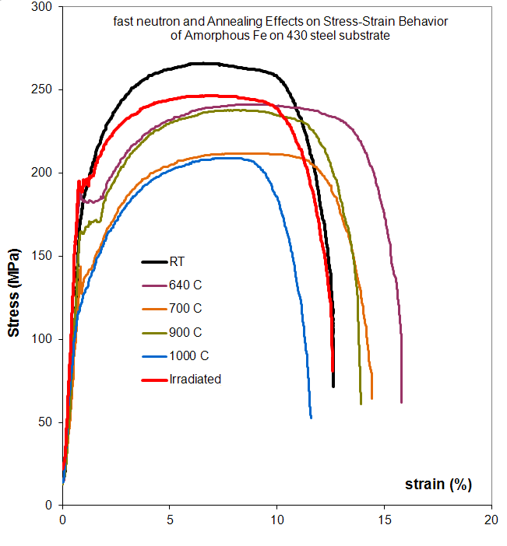
Recent results and highlights: Fast neutron irradiation and high temperature studies revealed that (a) in amorphous Fe-based coatings on steel two competing mechanisms govern the coating-substrate behavior namely the radiation induced excess volume and the temperature induced amorphous-to-crystalline transformations and (b) in Al₂O₃+TiO₂ and Al₂O₃ coatings on steels a metastable, α-alumina layer tends to form regardless of the environment as a result of phase diffusion weakening the coating-substrate interface. Representative results are shown in Fig.1. Highlights include the completion of a unique X-ray diffraction experiment of irradiated nano-structured coatings at the BNL synchrotron which will help enhance the understanding of irradiation and temperature-induced microstructural changes.

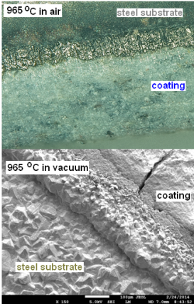
Figure 1
2013 NEET-RM Open Award Research Summaries
In 2013, the NEET Crosscutting Reactor Materials program sought applications for advanced reactor materials characterization techniques and tools. Successful applications proposed advanced methods for sample preparation and new tools and techniques for examining and understanding material microstructures in a variety of conditions ranging from as-received to treated or irradiated.
Developing an extensive understanding of reactor material behavior in extreme environments is vital to the development of new materials for service in advanced nuclear reactors. This understanding is also needed for the extension of the operating lifetimes of the current fleet of nuclear reactors. Advanced characterization methods utilizing advanced tools and techniques, coupled with modeling simulation and advanced sample preparation tools will further the understanding of the effects of irradiation, temperature, pressure and corrosive environments on material microstructures and mechanical behavior. Modern sample fabrication tools could also allow for more efficient use of existing irradiated materials and enable fabrication of smaller specimens from previously examined materials.
FY13
Developing Microstructure-Property Correlation in Reactor Materials Using In Situ High-Energy X-Rays

Meimei Li, Argonne National Laboratory
Jonathan D. Almer, Argonne National Laboratory
Yong Yang, University of Florida
Lizhen Tan, Oak Ridge National Laboratory
Funding: $1,000,000 (10/1/2013-9/30/2016)

Description of project: The objective of this project is to deepen our understanding of microstructure-property relationships in reactor materials through use of high energy synchrotron X-ray measurements under in situ thermal-mechanical loading. The gained knowledge is expected to enable accurate predictions of mechanical performance of nuclear reactor materials subjected to extreme environments, and to further facilitate design and development of new materials.

Impact and value to reactor applications: Developing this new capability of in situ thermo-mechanical deformation, in concert with multiple high-energy x-ray modalities on activated specimens is essential to fundamentally understand irradiated microstructure, their interaction with grown-in defects and second-phase precipitates, and how nano- and micro-scale structures behave collectively to yield the observed (and desired) macroscopic behavior.

Recent results and highlights: Containment for the activated specimen (Figure 1) for in situ straining/annealing with multiple high-energy x-ray probes (WAXS/SAXS/HEDM/imaging) at APS beam line 1-ID is shown below. Figure 2 shows that Wide-angle X-ray scattering (WAXS) revealed dislocation evolution during deformation in ferritic-martensitic steel, G92. Figure 3 shows that far-field high energy diffraction microscopy (HEDM) revealed more diffuse diffraction spots within grains of an irradiated HT-UPS (High-Temperature Ultrafine-Precipitation Strengthened) stainless steel specimen than in the unirradiated counterpart. This provides direct observations of irradiation defects in individual grains in a bulk polycrystalline specimen.
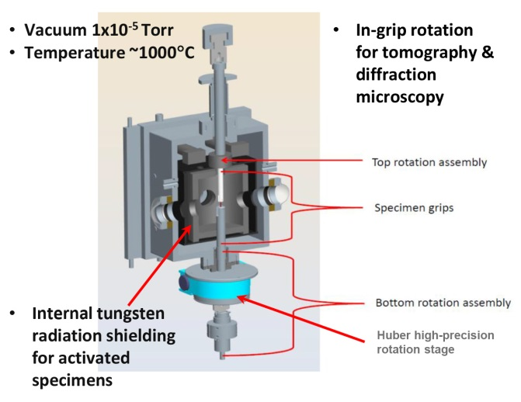

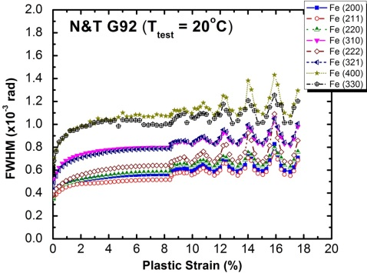
Figure 2
Fig. 1

Figure 1
Fig. 1
Fig. 1
Unirradiated
Fig. 1
3 dpa/500°C
Fig. 1
Figure 3
Fig. 1

FY13
Determining the Stress-Strain Response of Irradiated Metallic Materials via Spherical Nanoindentation

Nathan A. Mara, Los Alamos National Laboratory
Surya Kalidindi, Georgia Institute of Technology
Lance Kuhn, Hysitron, Inc.
Funding: $1,000,000 (10/1/2013-9/30/2016)

Description of project: Ion beam irradiation is a novel technique to impart large amounts of irradiation damage (several dpa or more) without activating the material in a relatively short time spans of hours or days that would require weeks or months to achieve in reactor conditions. However, the volume of irradiated material is limited by the beam energy to depths of microns or less, making the investigation of bulk mechanical properties very difficult. We utilize a novel approach for extracting indentation stress-­‐strain curves from spherical nanoindentation datasets in order to study the material behavior at such length scales. Due to their ability of reliably quantifying many of the important aspects of the local mechanical constitutive behavior in the samples – such as the loading and unloading elastic moduli, the indentation yield points, as well as some of the post-­‐yield characteristics from shallow indentation depths of ~50-­‐100 nanometers– these indentation stress-­‐strain curves are far more versatile than other nanomechanical test techniques which only provide data for hardness and modulus values as a function of irradiation depth, or require extensive sample preparation, often using FIB-­‐based techniques.

Impact and value to reactor applications: This project can potentially revolutionize mechanical testing of irradiated nuclear materials. It will provide: 1) Benchmarked measurement of the stress-­‐strain response from small volumes of material for direct mechanical characterization of ion-­‐irradiated materials (W, Zr, and stainless steels) with little surface preparation (only a polished surface prior to ion irradiation is needed). 2) Since such small quantities of material (less than 0.5 mm3) are needed for this technique, it can be expanded to indentation of radioactive materials in a glove box environment. In collaboration with Hysitron, Inc., a Triboindenter 900 is undergoing installation into a radiological glove box for the mechanical evaluation of radioactive materials

Recent results and highlights: In our manuscript currently under review at Nano Letters, we discuss applications of spherical nanoindentation stress-­‐ strain curves in characterizing the local mechanical behavior of irradiated materials. In Helium-­‐ implanted tungsten, a simple variation of the indenter size (radius) can identify the depth of the radiation-­‐induced-­‐damage zone, as well as quantify the behavior of the damaged zone itself. Using corresponding local structure information we study the effect of these changes for different grain orientations in tungsten. An example of the stress-­‐ strain response of tungsten before and after irradiation is seen in Figure 1, with the irradiated material showing distinct elastic, irradiated, and softer, unirradiated regimes of behavior.
Figure 1. Comparing the indentation stress-strain responses between annealed (orange curve) and irradiated (black curve) W grains of near (001) orientation. The contact radius a is an indicator of the indentation depth.

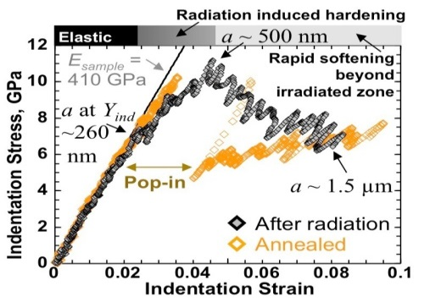

FY13
Predictive Characterization of Aging and Degradation of Reactor Materials in Extreme Environments

Jianmin Qu, Northwestern University
Rémi Dingreville and Khalid Hatta, Sandia National Laboratories
Funding: $999,812 (12/20/2013-12/19/2016)

Description of project: Understanding of reactor material behavior in extreme environments is vital not only to the development of new materials for the next generation nuclear reactors, but also to the extension of the operating lifetimes of the current fleet of nuclear reactors. To this end, we propose a suite of unique experimental techniques, augmented by a mesoscale computational framework to understand the long-term effects of irradiation, temperature, pressure and corrosive environments on material microstructures and mechanical behavior. The experimental techniques and computational tools will be demonstrated on two distinctive types of reactor materials, namely, Zr alloys and high-chromium (9~12wt%) ferritic/martensitic steels. These materials are chosen as the test bed because they are the archetypes of high-performance reactor materials (cladding, wrappers, ducts, pressure vessel, piping, etc.).

Impact and value to reactor applications: The micro scale simulations tools and in situ TEM techniques proposed here are not only unique and innovative, but also potentially groundbreaking in those new phenomena and new mechanisms will be discovered when the samples are subjected to multiple driving forces (heat, stress, ion radiation and He implantation) simultaneously.

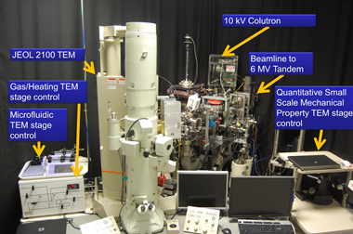Figure 1 TEM facility for simultaneous ion irradiation and He implantation.
Recent results and highlights: We demonstrated using ion beam induced luminescence that high energy, heavy ions and 10 kV He can be concurrently introduced into the TEM sample location (Figure 1). The alignment of the ion optics has been optimized such that only two to three hours is required before concurrent in-situ ion irradiation TEM (I3TEM) experiments can be initiated after start-up. We also demonstrated the feasibility of doing in-situ heating or quantitative tensile straining during ion irradiation. The former utilizing a combination of the I3TEM and a hummingbird 2.3 mm heating stage and the later utilizing the I3TEM in combination with the Hysitron PI-95 or Gatan 654. Electron transparent samples of proper geometries have been made for both holders from pulsed-laser deposited (PLD) Fe films. Work is currently underway to tailor the grain size in the PLD Fe for the planned in-situ TEM experiments. Neither has been attempted on the relevant alloys for this project. In addition, quantitative nanoindentation has been demonstrated in a variety of deposited films, but has still not been run in samples prepared from bulk metal alloys. Furthermore, we have developed a spatially resolved stochastic cluster dynamics (SRSCD) method to simulate defect distribution under irradiation. We also demonstrated the equivalence between the deterministic and stochastic representations of population evolution in irradiated materials. Advantages of the SRSCD method include computational efficiency and the ability to include arbitrary defect types and behaviors.

FY13
Advanced 3D Characterization and Reconstruction of Reactor Materials

Melissa Teague, PI, Idaho National Laboratory
Michael Tonks, Idaho National Laboratory; David Field, Bradley Fromm, Washington State University; Kumar Sridharan, University of Wisconsin
Funding: $1,000,000 (10/1/2013-9/30/2016)

Description of project: The objective of this proposed research is to develop a critical line of inquiry that integrates advanced materials characterization techniques developed for reactor materials with state-of-the-art mesoscale modeling and simulation tools. This 3-year project will consist of three key objectives that will push the limits of present technology, including:

- Explore new sample preparation techniques for reactor materials using broad beam ion-etching methods to decrease sample preparation time, improve scan quality, increase scan size, and reduce radiation exposure/waste.
- Implement an advanced characterization technique known as high-resolution EBSD (HR-EBSD) to enable estimation of critical material properties like dislocation density and residual strain from reactor materials.
- Develop necessary post-processing tools and procedures to utilize the HR-EBSD data obtained in Objective 2 for microstructure reconstruction into MARMOT and perform model validation based on the HR-EBSD data.

Impact and value to reactor applications: A coordinated effort to link advanced materials characterization methods and computational modeling approaches is critical to future success for understanding and predicting the behavior of reactor materials that operate at extreme conditions. The objectives described in this project will push the limit of current experimental capabilities and innovate means to bring new characterization and simulation techniques to bear on both irradiated and unirradiated reactor materials. These advances will result in improved understanding of microstructure evolution and its impact on pertinent material properties. They will also aid in initializing, calibrating, and validating current phase field models, used to predict microstructure evolution at the mesoscale.

Recent results and highlights: The team has identified a test matrix of reactor materials for testing during this program which include promising fast reactor cladding (HT9), current LWR cladding (Zircaloy 4), and proposed accident tolerant cladding/channel box material (SiC/SiC composite). We have begun sample preparation on the unirradiated samples, and plan irradiated samples within the next year. Recently the team has obtained HR-EBSD to study unirradiated HT9 prepared via broad ion-etching method (Figure 1), and will be studying irradiated HT9 cladding from FFTF by then end of the fiscal year.

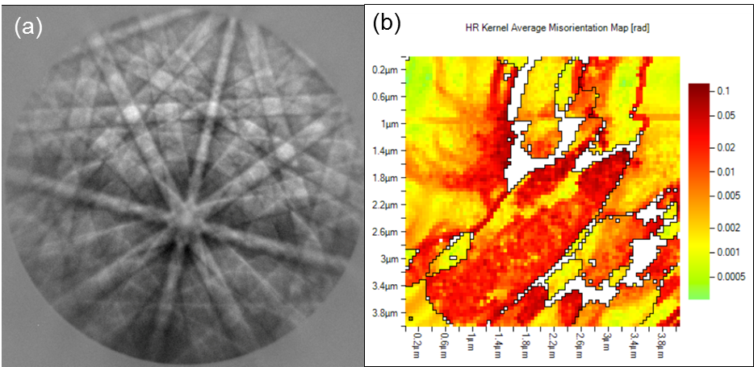

Figure 1: a) EBSD pattern from HT9 b) high resolution misorientation map of HT9 sample
FY13
Unraveling Dynamics of Radiation Damage Formation Via Pulsed-Ion-Beam Irradiation

S. O. Kucheyev, Lawrence Livermore National Laboratory
S. J. Shin, Lawrence Livermore National Laboratory
Funding: $1,000,000 (10/1/2013-9/30/2016)

Description of project: The primary cause of radiation damage to many nuclear materials is high-energy neutron recoils. Such recoils create collision cascades whose formation and thermalization are believed to be understood. In contrast, our understanding of the dynamic evolution of defects after cascade thermalization is still very limited. In this project, we are developing an experimental method to study radiation damage dynamics. Our method is based on pulsed-ion beam irradiation and aims to provide direct measurements of time constants, diffusion lengths, and activation energies of defect interaction processes in nuclear reactor materials.

Impact and value to reactor applications: This project offers an excellent opportunity to pioneer a new direction of advanced reactor materials characterization techniques and tools. It could establish the pulsed ion beam method as the primary approach to study defect interaction dynamics in nuclear materials. Experimental data on defect interaction dynamics is essential for building physically sound models to describe the formation of stable radiation defects.

Recent results and highlights: We have been developing the pulsed-ion-beam methodology with the simplest and best studied material system: high-purity single-crystalline Si at room temperature, with a goal to apply it to inherently more complex nuclear materials such as ceramic SiC. In our method, the defect diffusion length is revealed by the dependence of damage on the active part of the beam duty cycle (t_{on}), while the time constant of defect interaction (τ) is measured directly by studying the dependence of damage on the passive part of the beam cycle (t_{off}). Figure 1 reveals a τ of ~5 ms for Si irradiated with 500 keV Ne, Ar, or Xe ions despite very different cascade densities and levels of dynamic annealing. Although the defect relaxation behavior appears to be a second order kinetic process, we have found that τ is essentially independent of the maximum instantaneous dose rate (F_{on}), total ion fluence, and dopant concentration, pointing to the robustness of the pulsed beam method.
Figure 1

FY13
Automated Synchrotron X-Ray Diffraction of Irradiated Materials

Lynne E. Ecker, Eric Dooryhee, and Sanjit Ghose, Brookhaven National Laboratory
G. Robert Odette, University of California Santa Barbara
Funding: $979,200 (10/1/2013-9/30/2016)

Description of project: This project will develop an automated system with a robot to rapidly and safely acquire data on radioactive samples at the X-ray Powder Diffraction beam line at the National Synchrotron Light Source-II. Irradiated Reactor Pressure Vessel (RPV) steels, austenitic stainless steels and ferritic-martensitic steels will be characterized to improve the understanding and performance predictions of these materials in nuclear reactor environments.

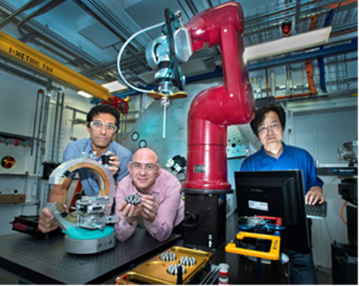
Impact and value to reactor applications: This research will provide a direct contribution to the understanding of aging in steel and a significant addition of data to materials databases that can be used for materials modeling that will impact life extension for existing light water reactors. The robotic system will address a gap in nuclear materials research by providing greater access to synchrotron data to the entire nuclear community. It will also allow the nuclear community to leverage large databases of irradiated materials that currently exist at facilities, such as test reactors. Obtaining additional data from them with state-of-the-art characterization techniques available at synchrotrons is an ideal way to maximize the investment in these expensive samples that required years of reactor exposure.

Recent results and highlights: A sample holder for radioactive materials that is compatible with the robot has been designed. Sample holders magazines, each containing twenty sample holders and providing additional shielding, will be supplied to users to load the samples at their home institutions. Software will be available with the capability to assist new synchrotron users and to process the large amounts of data that will be acquired (Figure 1).
Eric Dooryhee, David Sprouster and Hengzi Wang installing the robot at the NSLS-II

Recent data obtained on irradiated and unirradiated RPV model alloys demonstrate that the new phases, such as the G-phase, that are formed during irradiation can be observed using Small Angle X-ray Scattering, and the particle sizes measured are consistent with Atom Probe Tomography and neutron scattering experiments. X-ray diffraction and Pair Distribution Function analysis indicate that the new phases, which cause embrittlement of the steels, are likely disordered.
Figure 1 Data analysis support will be provided for new
users and batch processing will be available

FY13
Use of Micro- and Meso-scale Magnetic Characterization Methods to Study Degradation of Nuclear Reactor Structural Material

Pradeep Ramuhalli (PNNL), John S. McCloy (WSU-Pullman), Bradley Johnson (PNNL), Weilin Jiang (PNNL), Shenyang Hu (PNNL), Yulan Li (PNNL), Ryan Meyer (PNNL), Charles H. Henager (PNNL)
Funding: $919,661 (10/1/2013-9/30/2016)

Description of project: The goal of the project is to improve the fundamental understanding of reactor structural material performance under irradiation. This is being done by integrating magnetic signatures and microstructural characterization into phase-field models - at the same length scale. The intent is to develop meso-scale models that will provide an interpretive understanding of the state of degradation in a material. Predictive and interpretive computational models that correlate bulk non-destructive evaluation (NDE) data to the state of microstructural damage in a material will be developed and applied for condition monitoring of reactor structural materials.

Impact and value to reactor applications: The approach to understanding magnetic behavior in irradiated materials will provide insights into interpreting NDE measurements from irradiated materials such as RPV structural steel. Benefits will include the ability to ensure safe long-term operations of the existing U.S. nuclear fleet and the development and qualification of advanced materials for next generation nuclear power reactors.

Recent results and highlights: The focus of research is to understanding the response of magnetic signatures to microstructural changes due to irradiation damage, and correlates those changes to mechanical properties. We hypothesize that property changes can eventually be measured using micro-magnetic methods. We are using phase field modeling techniques to create meso-scale computational models of microstructures that can represent the damaged microstructure, its effect on magnetic signatures, and impact on mechanical properties.

Microstructure and magnetic measurements on thin films are being used to gain insights into the impact of microstructural state on magnetic properties of materials. Microstructure measurements include EBSD, XRD, and SEM, while magnetic force microscopy (MFM) and vibrating sample magnetometry are being used to characterize the magnetic properties of these same specimens.

Meso-scale phase field models (Figure 1) of magnetic behavior allow simulation of domain wall movement with applied magnetic fields, and shows wall-pinning behavior from defects that may be caused by irradiation. The ability to use variable field measurements for MFM has revealed some potential mechanisms of interest for characterizing the magnetic properties, including domain wall movement and pinning. These mechanisms appear to be a function of microstructure state (single crystal or polycrystalline, and boundary conditions such as presence of grain boundaries or precipitates, etc.).
Figure 1

Ongoing research is examining the changes in these properties due to irradiation damage, and correlating the findings from laboratory-scale experiments to simulation model predictions.
2014 NEET-RM Open Award Abstracts
In 2014, the NEET Crosscutting Reactor Materials program sought applications the development of advanced joining techniques for materials for nuclear fission reactor applications. As advanced materials are developed to increase the energy efficiency, cost efficiency, safety and security of the operation of nuclear reactors, advanced joining techniques must also be developed. Advanced welding or joining techniques will overcome traditional component limitations as well as allow for the use of more advanced materials in nuclear reactor applications.
These advanced joining techniques must maintain or improve properties at the joint, such as strength, irradiation resistance, corrosion resistance, and creep. Innovative methods to control and understand residual stress, heat affected zones, and/or phase stability during joining are also of interest.
Three projects have been awarded and began research in October 2014. The abstracts for these projects follow.

FY14
Functionally Gradient Transition Joint for Dissimilar Metal Welding using Plasma Arc Lamps

Evelina Vogli, Hebi Yin, Stephen Goss, MesoCoat Inc.
Zhili Feng, Xinghua Yu, Oak Ridge National Laboratory
Funding: $1,000,000 (10/1/2014-9/30/2017)

Description of project: The primary objectives of this research are to develop functional gradient transition joints between carbon steel and austenitic stainless steel for nuclear reactors. The research directly address the needs described in development of advanced joining techniques for materials for nuclear fission reactor applications. This collaborative project between Mesocoat Inc. and Oak Ridge National Laboratory capitalizes on recent advances made by each organization in the field of dissimilar metal joining and application of high-energy density plasma arc lamp processing. This research use high density infrared generated by a plasma arc lamp to build gradient transition joint for dissimilar metal welding. The task includes transition joint composition design, transition joint fabrication microstructure characterization, residual stress measurement and mechanical testing. The results of this research will provide: 1) Design approach and processing parameters for manufacturing gradient transition joints 2) Validation of controlled microstructure and composition in the gradient transition joint 3) Validation of reduction of residual stress and improved stress corrosion cracking resistance in gradient transition joints.

Impact and value to reactor applications: To solve DMW (Dissimilar Metal Welding) problems currently existing in nuclear reactor, this work applied an innovative manufacturing technology based on high density plasma, which has up to now, been mainly used for pipe cladding to produce functional gradient transition joints where no need for dissimilar weld will be needed during installation. SS pipe will be welded to SS sections of newly created gradual transition nozzle from SA508 CI to SS 316L. This technique is expected to improve transition area strength and phase stability, reduce residual stress/strain and SCC tendency. In addition, plasma arc lamp process (PALP) also is cheaper and consumes much less power than conventional arc welding. This joining technique will be not only beneficial to DMWs in existing boiling water reactor and pressurized water reactor, but also beneficial to DMWs in HTGR and small modular reactors which are under development.

Recent results and highlights: In order to minimize the alloy diffusion in the DMW, a proper composition gradient and structure of the DMW have been designed by using Thermodynamic (ThermoCalc) and kinetic (Dictra) software. Carbon is expected to gradually decrease from 0.2 wt.% (in SA508) to 0.04 wt.% and remain stable at service temperatures (290 to 360 °C). Initial simulation of C diffusion using Dictra after 4 month at a temperature of 300°C is shown in Fig. 1. The simulation result proved C segregation can be suppressed by designing composition gradient in functionally graded joints. Using initial simulation and modelling results, we apply a graded transition joint with gradual change of chemical potential by Gas Tungsten Arc Welding (GTAW). The results of the transition joints proved the first simulation results and approach. However, due to the dilution, Cr concentration is lower than the nominal composition. In addition, cladding tests of alloy 600H to 800H flat sample substrates were done using the PALP process. Different coating thicknesses and process parameters have been studied based on previous experience and similar coatings as well as based on Design-of-Experiment. After evaluating the dry powder coatings results as well as the results of fusing slurry deposited (precursor) samples, dry powder application was down-selected as the application method of choice. A few demonstration 0.25”x1”x4 coupons were produced within the test matrix parameters and will be used for validating the simulation.
Figure 1
Figure 1. C concentration profiles in FGJ and traditional DMW at 300°C for 4 month
FY14
Radiation Tolerance of Controlled Fusion Welds in High Temperature Oxidation Resistant FeCrAl Alloys for Enhanced Accident Tolerant Fuel Cladding Applications

Kevin G. Field, Maxim N. Gussev, Yukinori Yamamoto, Xunxiang Hu, and Richard Howard
Oak Ridge National Laboratory
Funding: $1,000,000 (10/1/2014-9/30/2017)

Description of project: FeCrAl alloys are currently under development for nuclear power production applications due to their excellent performance in extreme environments including high temperature corrosive media. The benefits of extreme environmental compatibility can be realized in a range of nuclear reactor applications, specifically as a cladding material with enhanced accident tolerance. However, FeCrAl alloys have not been deployed in commercial nuclear applications as a range of technological issues has yet to be resolved. Two areas of primary importance are hydrogen-induced embrittlement during fabrication and radiation-induced embrittlement while in-service for FeCrAl-based weldments. In the present project, mitigation strategies based on microstructure and composition refinement have been proposed and are currently under exploration to reduce or completely eliminate both degradation modes for weldments that use FeCrAl alloys as the base metal. A multifaceted, interdisciplinary approach is in use to assess the viability of the proposed mitigation schemes including a systematic alloy development and fabrication stage, an irradiation campaign, and an extensive post irradiation examination phase.
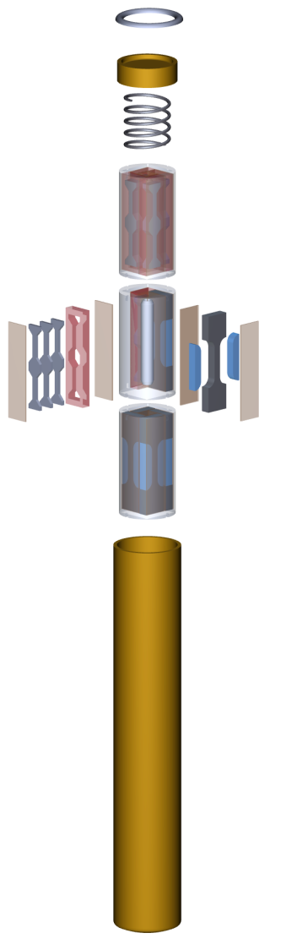

Figure 1. Finalized Irradiation Test Platform
Top view
3 module inner housing
(“can”) design
Standard
SS-J3
Specialized
SS-2E
SiC
thermometry
Outer housing
Exploded View
Plenum
spring
Impact and value to reactor applications: The demonstrations and thorough examination of mitigation strategies for hydrogen-induced and radiation-induced embrittlement will continue to drive the development of FeCrAl alloys for nuclear applications towards commercialization. Deploying FeCrAl alloys, in particular as an accident tolerant cladding option, would enhance the safety of the current fleet of nuclear power stations. Additionally, advanced FeCrAl alloys with enhanced radiation tolerance and weldability could be used in other extreme environments including as blanket materials for the dual-coolant Pb-Li blanket concept or as structural components for advanced fast reactor technologies.

Recent results and highlights: Several key steps within the first year of funding have been made, including: (1) design and fabrication of seven different FeCrAl alloys with custom tailored microstructures and specialized chemistries for enhanced weldability and radiation tolerance, (2) development and qualification of a specialized miniature tensile specimen which allows for rapid post irradiation assessment of mechanical properties and application of modern characterization techniques (see Figure right, labeled SS-2E), and (3) the development of a flexible irradiation test platform for different tensile specimen geometries, irradiation doses, and irradiation temperatures (see Figure right).

FY14
Extending the In-Service Life of Welded Assemblies Through Low-Energy Solid State Joining

Glenn Grant, Ken Ross, Nicole Overman, Mychailo Toloczko, Pacific Northwest National Laboratory
Gary Cannell, Fluor Corporation; Daniel Ingersoll, NuScale Power;
George Young, Knolls Atomic Power Laboratory; Scott Rose, MTI, Inc.;
Greg Fredrick, Electric Power Research Institute
Funding: $1,000,000 (10/1/2014-9/30/2017)

Description of Project: For a wide range of alloy systems being considered in the Advanced Reactor and the Small Modular Reactor R&D Programs, welded joints represent the weak link in the life of a fabricated assembly. Predicting the life of fusion welded materials in high-temperature, aggressive environments is a significant challenge in multiple reactor designs. For example, well documented cases of early Type IV creep failure of weldments in 9-12Cr steels, or stress corrosion cracking (SCC) in sensitized austenitic steels illustrate some of the degradation mechanisms causing concern for reactor safety and lifetime. Advanced joining methods that neither melt nor excessively heat the base material may provide better potential to preserve the original microstructure and performance of the base material. Numerous solid state welding methods exist that satisfy these criteria, but Friction Stir Welding stands out for its particular combination of advantages in mechanical properties, joint versatility, speed, low fabrication cost, high weld quality, and application to modular construction. This project will develop a variant of Friction Stir Welding where weld energy input is held to very low levels. The project will develop the weld process, produce coupon weldments, and document the improvements in residual stress, creep, creep/fatigue, and SCC susceptibility for alloys of interest to LWR, VHTR and SFR designs and specifically those of interest to small modular reactor (SMR) designs.

Impact and value to reactor applications: The project will focus on developing the process parameters for friction stir welds in two alloy classes, ferritic/martensitic and austenitic stainless steels, and on one example of a dissimilar, ferritic to austenitic steel joint. Austenitic alloys are the workhorse alloys in current and proposed reactor designs. But since their introduction, the well-known effects of sensitization with thermal input have forced compromise and inefficiencies in their use. Ferritic/martensitic (F/M) steels are also in current use and are strong candidate materials for a variety of new fission reactor applications. For LWRs, the Advanced Radiation Resistant Materials (ARRM) program and the Electric Power Research Institute (EPRI) have recognized F/M steels as important replacement materials for LWR core internals. Within the DOE-NE Fuel Cycle R&D (FCRD) program, F/M steels are candidate clad and duct materials for their fast burner reactor concept, as well as for fuel cladding in the Accident Tolerant Fuel concept. Within the Advanced Reactor Concepts (ARC) program and in the VHTR concept, F/M steels are a lead candidate class of material. Within the SMR Program, there is also a strong interest in F/M steels for pressure boundary and in-core components. For all of these reactor concepts, F/M steels will need to be joined to itself or to dissimilar metals. The well-known property knockdown inherent in fusion welding both austenitic, and especially the 9 to 12 Cr ferritics, limits their application in design. If FSW can significantly improve the performance of welded assemblies in these alloys, it has a chance to enable the higher energy efficiency, safety, and longevity that these materials can provide. Low thermal input FSW has the potential to produce welded assemblies could approach the properties of parent materials and contribute to, rather than degrade, the benefits of high performance materials to energy efficiency, cost efficiency, safety and security of the operation of new nuclear reactors and new designs.

Recent Results and Highlights: The project is in the early phases of acquiring materials and specifying weld process conditions and FSW tooling. Meetings have been held with project partners and we are developing a consensus on the materials of interest to our commercial partners at NuScale and Fluor. The industrial members of the team are a strong asset in helping to specify materials, joint geometries and applications to insure the project results will be immediately useful to the community.

