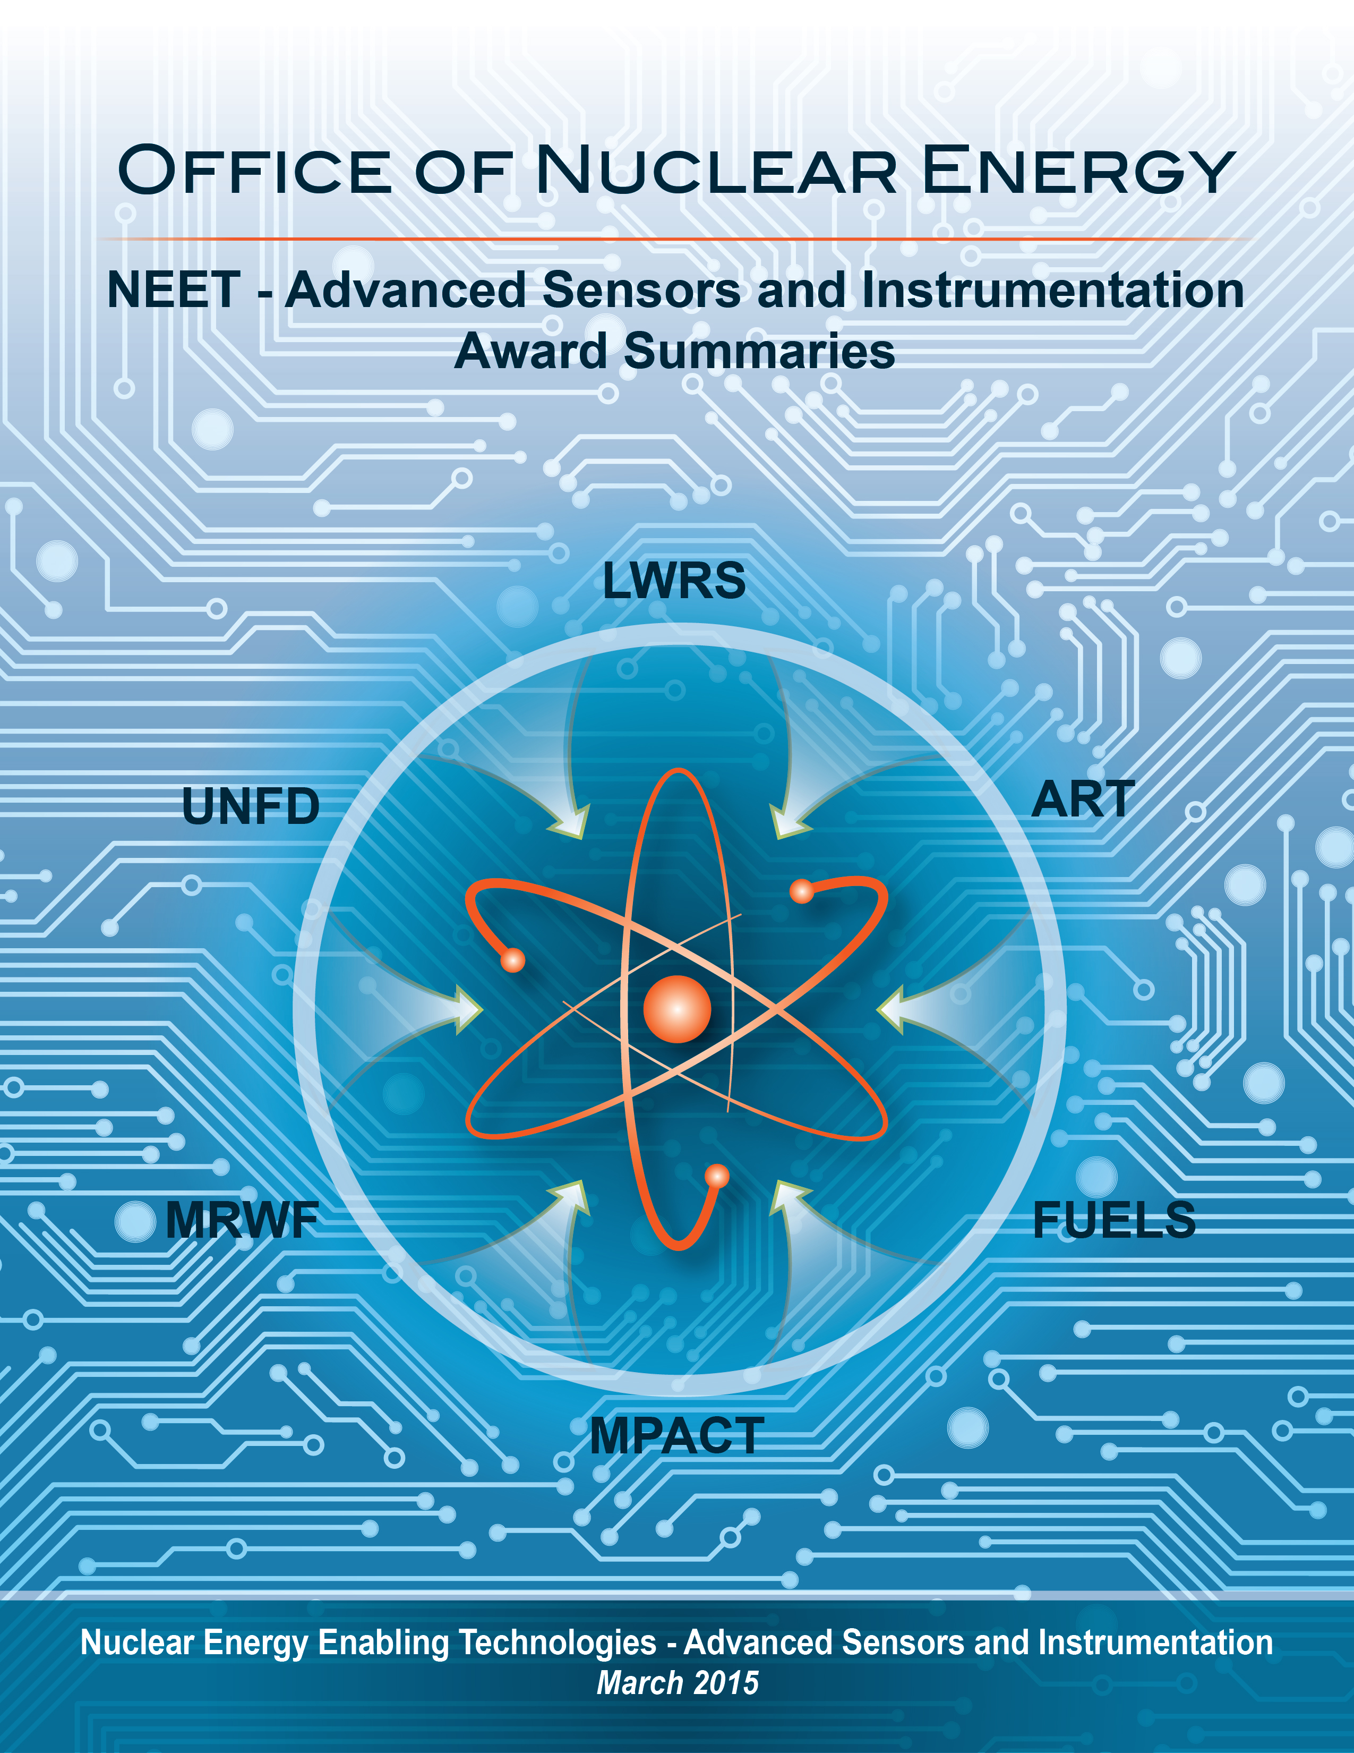

Introduction

Nuclear energy systems employ instrumentation and controls to measure important system parameters, provide control input to components that maintain systems within desired and safe limits, and provide owners and operators with the needed awareness of plant conditions to plan and safely manage operational evolutions. In a sense, instrumentation and control (I&C) systems function as the nervous system of a nuclear power plant and other nuclear system applications. They monitor all aspects of the plant’s behavior and provide automatic responses to many foreseeable conditions.
In 2012, the Nuclear Energy Enabling Technologies (NEET) Program was initiated by the Department of Energy’s Office of Nuclear Energy (NE) to conduct research, development, and demonstration (RD&D) in crosscutting technologies that directly support and enable the development of new and advanced reactor designs and fuel cycle technologies. Advanced Sensors and Instrumentation (ASI) is one program element of NEET Crosscutting Technology Development that is being carried out to foster the research and development required to identify and deploy innovative and advanced instrumentation and control capabilities for future nuclear energy systems, and to enable the advanced I&C technologies essential to NE’s R&D efforts to realize mission goals.
The NEET ASI program has the following two distinctive roles:
- To coordinate I&C research among NE programs to avoid duplication and focus I&C R&D in support of advances in reactor and fuel cycle system designs and performance.
- To develop enabling capabilities to address I&C technology gaps common across NE’s R&D programs.
The NEET ASI program has identified four strategic I&C areas of research based on input from the nuclear community during the NEET workshop and subsequent discussions with the I&C program leads.
These strategic areas are:
- Advanced Sensors. To develop and qualify new sensor capabilities and methods to detect and monitor behavior of reactor and fuel cycle systems and of desired parameters in integral tests to achieve needed accuracy and minimize measurement uncertainty.
- Digital Monitoring and Control. To enhance monitoring of process variables and implementation of control actions that increase system reliability, availability, and resilience.
- Nuclear Plant Communication. To research and develop communications technologies needed to support greater data generation and transmission demands expected to accompany advancements in digital sensor, measurement, and control technologies while maintaining reliability, resiliency, and data security.
- Advanced Concepts of Operation. To develop and test advanced concepts of operation for future nuclear energy systems designed to achieve highly automated control, where new human and system interaction is defined.
These areas correspond directly to the needed capabilities of future I&C technologies and systems, are familiar to the stakeholder community, and are largely recognized by the vendor community. As the timeframe for payoff on NEET ASI R&D investments becomes longer, new strategic areas may be added.

In fiscal year (FY) 2011, before the program was initiated, three three-year projects, totaling $1,366,886, were selected under mission supporting transformative (Blue Sky) portion of the Nuclear Energy University Programs (NEUP) under the ASI topic. These projects were completed in 2014.

In FY 2012, ten projects, totaling $7,622,000, were initiated to address a range of common and cross-cutting needs identified by the Office of Nuclear Energy R&D programs for the duration of two to three years. These projects were concluded in FY 2014 when the NEET ASI program transitioned to a fully competitive solicitation and selection process.

In FY 2013, three two-year projects, totaling $1,199,664, were awarded competitively in the area of design of a custom radiation-tolerant electronics systems and methods to quantify software dependability.

In FY 2014 six three-year projects, totaling $5,963,480, were awarded competitively in the areas of advanced sensors, communications, and digital monitoring and controls.

Since FY 2012, NEET-ASI has funded 19 projects for a total of $14,785,144.

These projects are successfully advancing the state of the art for measuring, controlling, and broadly managing nuclear energy systems being developed by the DOE Office of Nuclear Energy. Many of the individual technologies have the potential to impact systems and technologies far beyond nuclear energy eventually. They address critical needs that correspond to current gaps in our existing capabilities that are needed to successfully test and deploy nuclear energy technologies and are therefore aimed at many of the highest priorities shared by different R&D programs. They include participation from a broad range of laboratories, universities and industry. The eventual goal for this research is the deployment of NEET-developed technologies in a manner that most benefits individual Office of Nuclear Energy R&D programs. As this research progresses, the interest from stakeholders and industry increases.

FY 2011 NEET-ASI Research Summaries
In FY 2011, the NEET-ASI program selected three three-year projects under the Department of Energy’s (DOE) Office of Nuclear Energy (NE) Nuclear Energy University Programs (NEUP) for nuclear energy related mission supporting (MS) Transformative (Blue Sky) research and development (R&D) under the following topic:

Advanced Sensors and Instrumentation (MS-NT3) – The Advanced Sensor and Instrumentation Activity within the Crosscutting Technology Development will conduct necessary R&D on sensors and infrastructure technology to address critical technology gaps to monitor and control new advanced reactors. The key university research needs for that activity are to (1) develop a fundamental understanding of advanced sensors to improve physical measurement accuracy and reduce uncertainty, (2) develop novel adaptive digital monitoring and control technology to provide increases in control system performance and self-calibration capability, (3) develop fundamental understanding of integrated control system architectures for multiple reactor module, and (4) develop novel fiber optic and wireless digital instrument communication systems.

All three projects have been completed.
FY11
A High Temperature-tolerant and Radiation-resistant In-core Neutron Sensor
for Advanced Reactors

Lei Cao, Don Miller, The Ohio State University
Funding: $455,629 (9/29/11-9/30/14)

Description of project: The objectives of this project was to develop a small and reliable gallium nitride (GaN) neutron sensor that is capable of withstanding high neutron fluence and high temperature, isolating gamma background, and operating in a wide dynamic range. The first objective was the understanding of the fundamental materials properties and electronic response of a GaN semiconductor materials and devices in an environment of high temperature and intense neutron field. They also performed in-core irradiation of GaN up to the highest yet fast neutron fluence and an off-line performance evaluation.
Impact and value to nuclear applications:
This project will improve reactor safety by providing an additional and/or alternative neutron flux monitoring device in light water small modular reactors and high temperature reactors. Analysis of the experiments performed thus far show GaN as a suitable candidate for high temperature, high radiation field neutron detection in advanced reactors. With additional research, these devices could also be utilized for actinide inventory measurements during pyroprocessing, serving as both a process monitor and a nuclear safeguards technology.
Recent results and highlights:
- Delivered working devices that have achieved neutron detection in high flux environment;
- Devices have no response to gamma ray, demonstrated a good gamma discrimination capability;
- Characterized sensor performance in high temperature and at post in-core irradiation conditions;
- In-core irradiations of both GaN materials and devices have been performed at OSU Research Reactor, and the off-line evaluation shows that sensors were only slightly degraded at 1015 cm-2 fast neutron fluence.

- Delivered working devices; Achieved neutron detection in high flux environment; Characteri sensperformance in high temperature and at post in-core irradiation conditions;
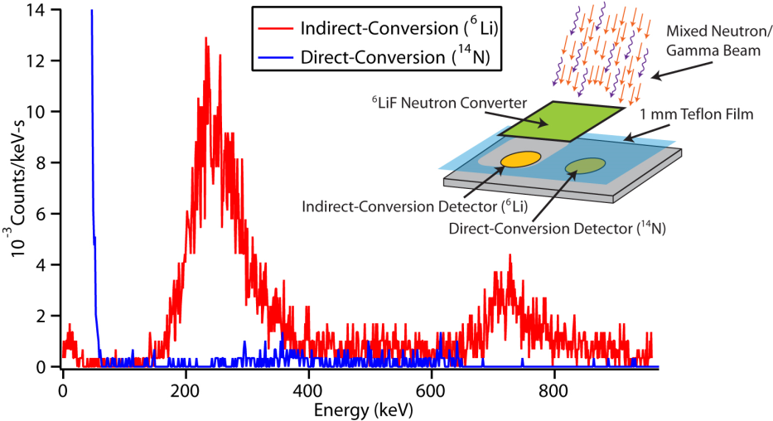

Figure - (left) Red curve shows the detected neutron signal in a high flux neutron beam, blue curve shows the fast neutron response; (right) shows the still functioning sensors after in-core irradiation at OSU Research Reactor.

FY11
FY11
High Temperature Transducers for Online Monitoring of Microstructure Evolution

Cliff Lissenden and Bernhard Tittmann, Pennsylvania State University (PSU)
Funding: $ 455,628 (10/12/11-12/31/14)

Description of project: The objectives of this project were to: (1) assess the concept viability of spray-on piezoelectric coatings to generate ultrasonic guided waves that are sensitive to microstructure evolution, (2) provide a detailed technology gap analysis, and (3) create a comprehensive technology development roadmap. Progress toward the much-desired ability to perform online condition monitoring in high temperature environments was achieved through development of sol-gel processing of zirconate titanate (PZT) and bismuth titanate in combination with bismuth titanate and lithium niobate powders and then air-sprayed directly onto a substrate. In addition, the sensitivity of nonlinear ultrasonic guided waves to microstructure evolution that precedes macroscale damage was investigated.
Impact and value to nuclear applications: Ultrasonic transducers can be sprayed onto curved surfaces in the field, and used for online condition monitoring of components in Light Water Reactors (LWRs) (up to ~400°C) and in the Next Generation Nuclear Plants (NGNPs) (up to ~950°C). Online monitoring of structural damage and precursors to damage will improve safety and operations of nuclear plants.
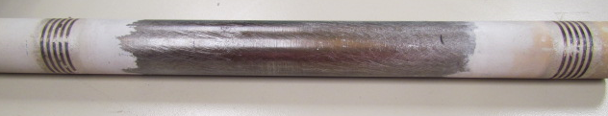
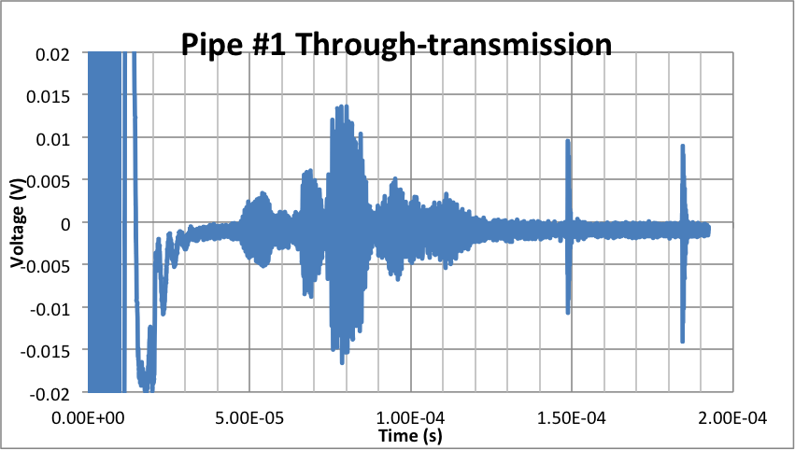
Recent results and highlights: Sol-gel processing of PZT/bismuth titanate and bismuth titanate/ lithium niobate provided transducers that can function up to 400ºC and 950ºC respectively. A method to process transducers in-situ was developed that includes: air-spray, pyrolyzation, densi-fication, electrode deposition, poling, and installation of lead wires. Further, methods to create patterned elect-rodes enabled pre-ferential generation and reception of guided wave modes. Analysis was per-formed to identify axisymmetric longitudinal wave modes in a pipe that generate strong second harmonics, which are sensitive to microstructure evolution. Gener-ation of higher harmonic flexural modes and nonlinear mutual interactions between multiple guided wave modes were also analyzed to improve sensitivity to microscale degradation.
Figure - Stainless steel pipe (25 mm diameter) with two PZT/Bismuth Titanate spray-on comb transducers (with 4-1.6 mm wide elements) generates axisymmetric L(0,n) modes when excited at 1.83 MHz.

FY11
NEUP: One-Dimensional Nanostructures for Neutron Detection

Yong Zhu, Jacob Eapen and Ayman I. Hawari, North Carolina State University
Funding: $ 455,629 (9/29/11- 9/30/14)

Description of project: The objective of this project was to evaluate the feasibility of using boron nitride nanotubes (BNNTs) as a direct-conversion neutron detector. 1D nanostructures (e.g., BNNTs) are expected to be promising materials for neutron detection due to their high crystalline quality and large carrier mobility. This project was focused on the electronic structure and irradiation damage of BNNTs.
Impact and value to nuclear applications: Indirect-conversion devices are inherently limited in their total efficiency; conversely, semiconductors capable of achieving higher total efficiency suffer from relative immaturity of manufacturing high-quality thin films. Therefore, 1D nanomaterials (e.g., BNNTs) are promising alternative materials. Little is known on the electronic structure and irradiation tolerance of such materials, which is critical for detector design and performance. The results obtained from this project will provide useful guidelines for future design of nanomaterials-enabled neutron detectors.
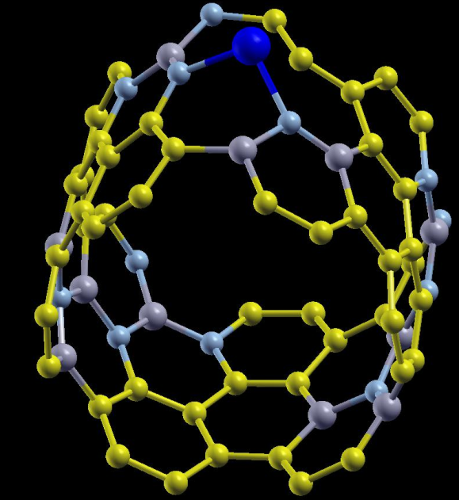
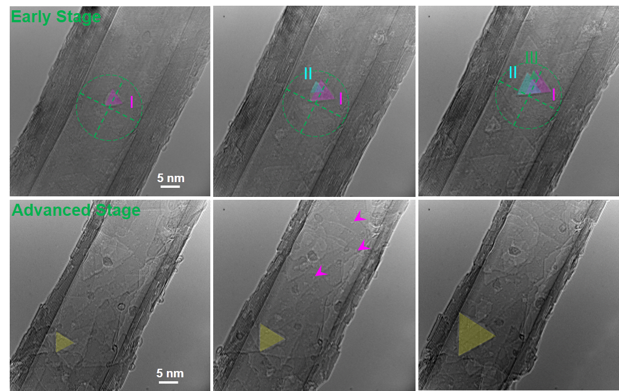
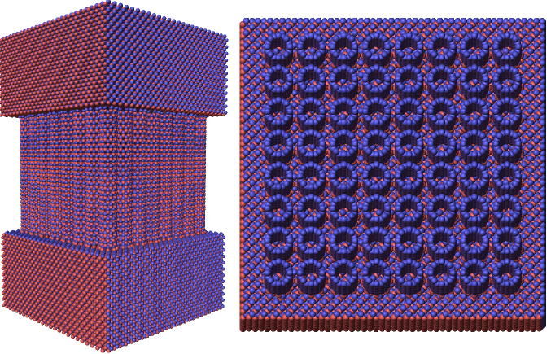
Recent results and highlights:
(a)
(b)
(c)
1) Using density functional theory (DFT) simulations, we have shown that addition of Li reduces the band gap of BN and BC₄N nanotubes, and makes them almost metallic. Fig. 1a shows relaxed structure of BC₄N nanotube with Li with near-zero bandgap). To prevent the reduction of band gap and to maintain the structural integrity, we have successfully identified several dopants (F, O, Cl) that can retain the semiconducting and structural properties of the nanostructures.
2) Using large scale classical molecular dynamics (MD) simulations, we have further shown that the large volume of vacant space in the nanostructures does not appear to damage the BNNTs significantly with knock energies that are O(1) keV (see Fig. 1b).
Fig. 1 - (a) DFT simulation of BC₄N nanotube with Li. (b) MD model of BNNTs for simulating displacement cascade. An 8×8 array of BNNTs is sandwiched by two cubic boron nitride substrates. (c) Early-stage evolution of irradiation-induced vacancy defects in multi-walled BNNTs as observed through in-situ TEM.
3) Using in-situ high-resolution transmission electron microscope (TEM) operated at 80 keV, the evolution of irradiation-induced vacancy defects in multi-walled BNNTs was carefully investigated. Triangle-shaped vacancy defects were gradually generated in MW BNNTs under a mediate electron current density (30 A/cm2), by knocking the boron atoms out (see Fig. 1c); these results are consistent with the MD cascade simulations.

FY 2012 NEET-ASI Research Summaries

In FY 2012, the NEET-ASI program selected 10 projects in the areas of sensors, digital controls, communication, and concepts of operation. These projects were initiated to begin addressing some of the common needs across the Office of Nuclear Energy that have the highest priority. Priorities were based upon the perceived value to multiple NE-R&D programs (e.g., deliver a needed capability to several reactor and fuel cycle programs), feasibility of the proposed research to achieve results, and availability of resources (e.g., personnel, test facilities, etc.) to support the R&D activity.
These projects focused on the following technical challenges and objectives:
- Improve physical measurement accuracy of a nuclear system process or integral test facility parameters and minimize uncertainty;
- Improve control of new nuclear energy processes through development of advanced monitoring and control technologies, including human factors, to achieve high reliability and availability;
- Enhance communications and data transmission needed for digital technologies, their environmental and regulatory qualification, and security issues, and;
- Integrate control of multiple processes, potential improvements in future plant staffing levels and personnel roles, and deliver advanced human machine interaction technologies.
These projects were concluded in FY 2014 as the NEET ASI program transitioned to a fully competitive solicitation and selection process, and the high-priority topics were included in the FY 2014 competitive solicitation to further the research.

FY12
NEET In-Pile Ultrasonic Sensor Enablement

Joshua Daw, Joy Rempe, Joe Palmer, Idaho National Laboratory (INL)
Pradeep Ramuhalli, Paul Keller, Robert Montgomery, Pacific Northwest National Laboratory (PNNL)
Hual-Te Chien, Argonne National Laboratory (ANL), Bernhard Tittmann, Brian Reinhardt, PSU
Funding: $1,000,000 (03/01/12-09/30/14)

Description of project: The objective of this project was to enable the use of ultrasonic sensor development for in-core reactor use. Ultrasonic technologies offer the potential to measure a range of parameters during irradiation of fuels and materials, including geometry changes, temperature, crack initiation and growth, gas pressure and composition, and microstructural evolution under harsh irradiation test conditions. The primary issue that currently limits in-core deployment of ultrasonic sensors is their survivability in high temperature, high radiation environments. The ability of ultrasonic transducer materials to maintain their useful properties during an irradiation must be demonstrated. To this end, a heavily instrumented test capsule was designed and promising piezoelectric and magnetostrictive materials were selected for irradiation. Piezoelectric materials included in this irradiation were aluminum nitride (AlN), bismuth titanate niobate (Bi₃TiNbO₉), and zinc oxide (ZnO). Magnetostrictive materials included are the commercial alloys Remendur and Galfenol. The test capsule was installed in the Massachusetts Institute of Technology Nuclear Research Reactor (MITR) in February of 2014.
Impact and value to nuclear applications:
Demonstration of radiation tolerance of two fundamentally different types of ultrasonic transducers will enable the development of a variety of new sensors capable of making in-situ, high fidelity measurements of a range of parameters, some of which are not possible with current technologies.
Recent results and highlights: At the time of the final project report, the capsule had reached a
fast fluence (Energy>1.0MeV) of 4.1*10²⁰ n/cm². The ZnO transducer was found to be inoperable at test temperatures and will be evaluated during post irradiation examination. The AlN and both magnetostrictive transducers have continued to operate, showing excellent tolerance to neutron and gamma irradiation. The irradiation is scheduled to reach a total fast fluence of 10²¹ n/cm².
Figure - Signal amplitude of transducers as a function of total fluence. Bismuth Titanate transducer has degraded, as expected. Other transducers continue to operate with minimal radiation induced degradation.

FY12
Micro Pocket Fission Detectors

Troy Unruh, Idaho National Laboratory (INL), Phillip Ugorowski, Kansas State University (KSU)
Jean-Francois Villard, Commissariat à l'Énergie Atomique et aux Energies Alternatives (CEA)
Funding: $1,015,000 (03/01/12-09/30/14)

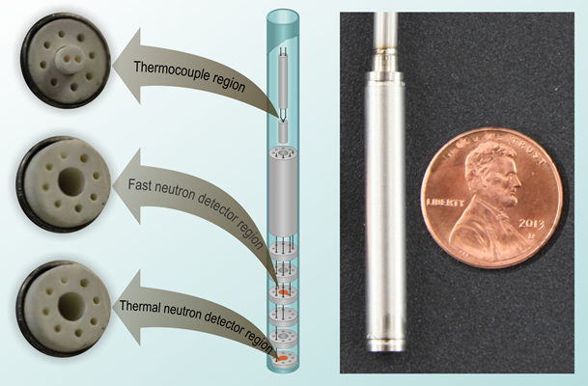
Description of project: This project developed and tested a small, multi-purpose, robust, in-core flux and temperature sensor called a Micro-Pocket Fission Detector (MPFD). MPFDs are compact fission chambers capable of simultaneously measuring thermal neutron flux, fast neutron flux, and temperature within a single sensor device. A collaboration between the Idaho National Laboratory (INL) and the Kansas State University (KSU) was used to develop and test the MPFDs. Because of the potential benefits of MPFDs, the French Commissariat à l'Énergie Atomique et aux Energies Alternatives (CEA), collaborated on MPFD research at their own expense.
Figure - Micro-Pocket Fission Detector diagram (left) and final assembly compared to a penny (right)
Impact and value to nuclear applications: The development, testing and analysis completed in this project have provided the necessary 'proof-of-concept' data to demonstrate the viability of MPFDs for high fluence irradiations. The small size, tunable sensitivity, and increased accuracy of MPFDs represent a revolutionary improvement over current non-real-time methods used to support irradiations in U.S. MTRs. Ultimately, continued evaluations may lead to a more compact, more accurate, and longer lifetime flux sensor for critical mock-ups and high performance reactors, allowing several Department of Energy Office of Nuclear Energy programs to obtain real-time higher accuracy, higher resolution flux and temperature data for irradiation tests of candidate new fuels and materials.
Recent results and highlights:
Select highlights from the research include the following accomplishments:
- Completed MPFDs redesigned to fit in a round geometry that is more suitable for installation in U.S. material test reactor (MTR) irradiation tests.
- Designed, built, and tested a new signal amplifier compatible with the MPFD.
- Assembled an electroplating system and characterized electroplating methods for MPFD fissile material deposition.
- Developed unique construction methods to reduce the number of welds and simplify wiring connections for the round geometry MPFD.
- Verified that the device leak rate was within minimum acceptable requirements for MPFD prototypes.
- Successfully performed a high temperature evaluation of 1000 hours at 500 °C of non-fissile prototype MPFD.
- Performed neutron evaluations of the MPFD prototype in-core at the KSU TRIGA reactor.
FY12
High Temperature Fission Chamber

Zane Bell, Oak Ridge National Laboratory
Funding: $574,000 (03/01/12-03/30/14)

Description of project: The overall goal of this project was to develop a high-temperature fission chamber suitable for in-core service from start-up to full power.
Impact and value to nuclear applications:
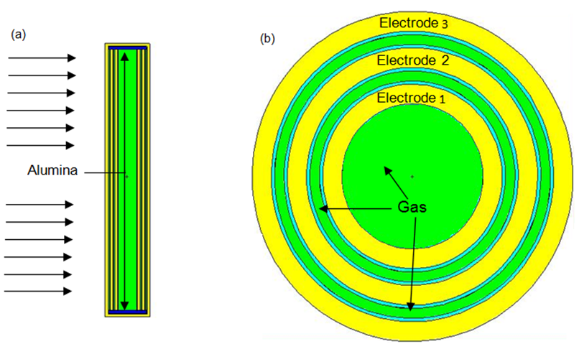
Monitoring a fission reactor’s neutron flux with an in-core instrument is a key safety and performance measurement. A lack of available high-temperature tolerant neutron flux monitors forces fission chambers to be backed away from the core. This condition is design- and operationally-limiting for several reactor classes such as those cooled by helium, CO₂, lead, or molten salt. High-sensitivity in-core flux detection is needed at startup to control the initial operation and promote the safety of the reactor. In addition, neutron flux can peak sharply within the core. Peaking has both safety and performance implications and it may be difficult to reconstruct local flux peaking from remote sensors due to the core’s fine spatial structure. Thus, the project’s results impact instrumentation of high-temperature reactors by developing a single instrument with sufficient sensitivity to operate at in-core in fluxes as low as 1 n/cm²/s, and sufficient robustness to operate at 800 °C in fluxes as high as 10¹³ n/cm²/s. The instrument’s increased safety margin conferred by its resistance to corrosion when in direct contact with high temperature coolants, such as molten FLiBe, also enables the collection of data in the event of a breach of its instrumentation thimble. Finally, the design also offers the possibility of operation outside a thimble.
Figure 1 - Conceptual model of fission chamber.
(a) Longitudinal view. (b) Cross-sectional view.
Recent results and highlights:
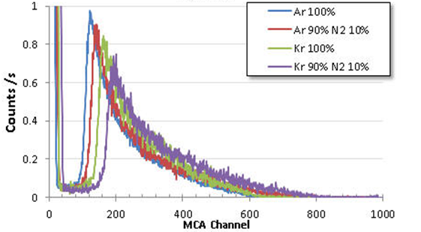
- Produced ORNL/LTR-2012/331, “Materials Selection for a High-Temperature Fission Chamber” report.
Figure 2 - Measured effects of admixture of nitrogen into a noble fill gas on the amplitude of pulses due to fission fragments.
- Evaluated the properties of fission chamber component metals, ceramics, and gases, techniques for joining ceramics, and deposition of uranium.
- Experimentally determined the properties of gas mixtures by Monte Carlo modeling.
- Experimentally determined a suitable braze for joining ceramic alumina parts.
- Measured the diffusion of nickel alloy components through pure nickel to project the time to failure of the outermost wall of the fission chamber when exposed to molten lithium fluoride beryllium fluoride (LiF-BeF2) salt (FLiBe).
- Developed thermal models of the chamber to estimate the highest temperatures likely to be encountered at full power.

FY12
Recalibration Methodology for Transmitters and Instrumentation

Pradeep Ramuhalli, Bledar Konomi, Guan Lin, and Susan Crawford, Pacific Northwest National Laboratory,
Jamie Coble, University of Tennessee, Brent Shumaker and Hash Hashemian, Analysis and Measurement Services Corporation
Funding: $529,000 (03/01/12-04/30/14)

Description of project: The objective of this research was to develop a model-neutral methodology for characterizing the sources of uncertainty, and quantifying the total uncertainty for on-line calibration monitoring (OLM) for sensor calibration interval extension and signal validation in nuclear systems. OLM technologies, though available for a number of years, have not been applied in U.S. nuclear plants, primarily because of a number of technical gaps that exist in current OLM technologies. Underpinning the developments needed to address these gaps is the need to better quantify OLM uncertainty. The overall uncertainty in an OLM system must be determined to provide a prescribed level of confidence that a sensor is operating within specifications so that anomalies in plant operation can be identified through accurate sensor measurements. Several sources contribute to the overall OLM uncertainty, including process noise, measurement error, electronic noise, process effects such as temperature stratification, and modeling errors and uncertainties.
Impact and value to nuclear applications: The ability to quantify uncertainty in OLM results supports the ability to perform high-confidence fault diagnostics and signal validation in OLM, and to develop novel, robust OLM methods. As a result, the results of this project are part of the technical developments that provide the regulatory basis for OLM-based calibration assessment. The utilization of the UQ methods in next-generation OLM algorithms are expected to improve the safety, reliability, and economics of current and planned nuclear energy systems, and increase the reliability of sensors used to monitor key parameters.
Figure - Data-driven uncertainty quantification showing uncertainty bounds from model and potential for detection of faults due to sensor signal drift
Recent results and highlights: This project developed a data-driven, model-neutral approach to uncertainty quantification (UQ), and used experimental data to verify the feasibility of the proposed approach.
The data-driven approach to UQ used a model built on a multi-dimensional Gaussian process (GP) that explicitly treats correlations between distinct output variables as well as space and time. GP models may be viewed as a generalization of classical regression models, in that they capture spatial and temporal relationships that may not be represented in classical kernel-regression models. As a result, the UQ method based on GP is applicable to a large class of OLM models. Results of applying this approach to data from an instrumented flow loop showed the ability to compute UQ bounds from measured data, as well as potential insights into the development of fault detection techniques for OLM sensor fault identification and localization. Results also indicated that the UQ method can track changes in the uncertainty bounds as operating conditions change.

FY12
Digital Technology Qualification

Richard Wood, Oak Ridge National Laboratory
Ken Thomas, Idaho National Laboratory
Funding: $1,269,000 (03/01/12-06/30/15)

Description of project: The objective of this project is to address key issues that affect digital technology qualification for nuclear power applications. The research focuses on two main technical issues:
(1) mitigation of digital common-cause failure (CCF) vulnerability and (2) suitability of digital alternatives to analog measurement and actuation equipment. The research results contribute to the basis for implementing fully digital instrumentation and control (I&C) systems in nuclear power plants.
Impact and value to nuclear applications:
Digital technology has been effectively employed in other industries. Impediments to its qualification must be resolved to enable its use in a full range of I&C applications at nuclear power plants. This research benefits new plants and advanced reactor designs by providing science-based solutions to key technical challenges and unresolved uncertainties that inhibit more extensive, effective use of digital technology. In particular, the identification and demonstration of digital measurement and actuation technologies that are suitable for high-integrity applications facilitates the transition from dated, burdensome equipment to fully digital systems that are reliable, accurate, and more-readily maintainable. The migration to more fully digital I&C systems increases the already substantial importance of providing an objective basis for mitigation of the potential for CCF posed by digital technology. Developing a fundamentally sound approach to address CCF vulnerability can enable architectural approaches for plant I&C systems with a well-defined safety basis, less imposed complexity, and, potentially, reduced cost.
Recent results and highlights:
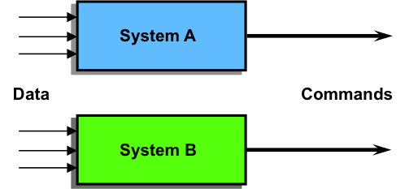
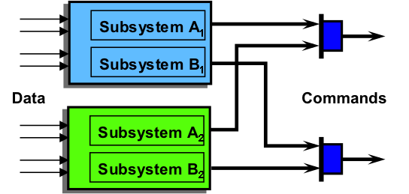
The research approach consisted of parallel investigations into digital instrumentation options and characterization of CCF vulnerability and mitigation approaches. The research on qualification of digital instrumentation involved assessment of current technology limitations and identification of digital technology alternatives. First, the propagation of legacy analog technology into new plant designs was identified, along with an assessment of the attendant performance limitations and maintenance burdens. Next, investigation of available digital sensor and actuator technologies was performed to identify suitable candidates, assess potential benefits, and evaluate qualification issues. The research on CCF vulnerabilities and mitigation involved investigation of the state of the practice for treating CCF and development of concepts and capabilities to characterize the threat of CCF and effectiveness of mitigative action. The first step was to investigate experience with CCF in high-integrity applications and capture current practices for CCF mitigation within nuclear and non-nuclear industries.
Figure - Typical safety system architectures for CCF mitigation: co-equal diverse systems (top) and functionally diverse subsystems (bottom).
Next, a taxonomy was developed to provide a consistent terminology and classification approach as a basis for assessment of CCF vulnerability and mitigation. The research concludes with investigation of various modeling approaches suitable for representing CCF. The outcome establishes the foundation for development of a science-based approach to resolving the threat of CCF. The research findings of this project are captured in publicly available technical reports.

FY12
Embedded Instrumentation and Controls for Extreme Environments

Roger Kisner, Alex Melin, David Fugate, David Holcomb, Tim Burress,
and Dane Wilson, Oak Ridge National Laboratory
Funding: $770,000 (03/01/12-03/30/14)

Description of project: The objective of this project was to demonstrate the capability of embedded instrumentation and controls (I&C) to provide performance and reliability improvements in major nuclear power plant components that would be unachievable through traditional methods. Results from the Embedded I&C in Extreme Environments project directly benefit future nuclear reactor designs including small, modular systems. The combination of modeling, simulation, fabrication of physical systems, and subsequent characterization and testing in this project will demonstrate the capabilities of deeply embedding I&C. A specific motor-pump type has been selected to demonstrate the integrated design process.
Impact and value to nuclear applications: Sensors and controls have not typically been embedded in nuclear power reactor components as compared with other industries. The design of closely coupled machine control requires a multi-disciplinary design effort i.e., I&C, mechanical, electrical, systems engineering, and materials science. Advanced I&C technologies were not available during the first nuclear era. Therefore, existing reactor system component designs pose limitations for new reactor concepts. Higher performance components needed for future reactor systems can exhibit inherent instability – witness high-performance aircraft. Benefits to high performance reactor system components are compact size, less bulk materials required, higher efficiency, and increased reliability. This demonstration creates a pathway for application of embedded I&C to many other systems.
Recent results and highlights:
Figure - Fault-tolerant, redundant, and diverse control embedded in coolant circulation pump
- Deeply embedding I&C into a canned rotor pump appears possible primarily using the functionally required wiring through measuring the induced signal on the non-energized motor phases.
- Switched reluctance drives can enable high-efficiency motors to operate at temperatures characteristic of high temperature reactors.
- Canned motors with magnetic bearings are only possible through deeply embedded I&C.
A failure modes and effects analysis (FMEA) was conducted on a preliminary systems design. Significant motor sensor technologies that can operate at extreme temperatures were identified including a sensor-less approach that utilizes the magnetic drive and suspension coils as position and rotation sensors. Additionally, a control strategy for the system was developed. Several engineering issues related to deploying the embedded concept for motor-pump applications were identified: (1) control of coupled response between motor torque and forces on magnetic bearings, (2) control of natural oscillatory modes and frequency response of sensors and control components, (3) magnetic materials for high-temperature environments, (4) minimization of magnetic gap, and (5) development of high temperature insulation.

FY12
Sensor Degradation Control Systems

Richard B. Vilim, Argonne National Laboratory
Funding: $360,000 (03/01/12-02/28/14)

Description of project: The objective of this project was to address a gap in capabilities for sensor validation using data-driven on-line monitoring. Sensor response time affects the stability of a power plant during normal operation and the peak conditions during off-normal operation. While present plant design procedures require that an upper limit for response time for key sensors be specified, there is essentially no provision to measure the response time unobtrusively in the operating plant in real time. An approach for on-line monitoring of sensor response time during at-power operation was developed.
Impact and value to nuclear applications: Implementation of the method developed in this work could provide for improved plant economics by allowing for recovery of thermal margin presently assigned to account for sensor response time uncertainty. Or the technique could be used to extend the operating cycle of a reactor through unobtrusive on-line validation of sensor response time. More fundamentally this technique has the potential for a lower false alarm rate compared to existing methods for detecting out-of-calibration sensors.
Recent results and highlights: Sensor validation for the transient case requires an algorithmic capability that is not found in existing methods. Existing data-driven methods for validating sensors search for a closest match of the current measurement vector to the training data set consisting of
Figure - General form of process amenable to treatment. Typically each sensor is represented by a first order lag. Measured inputs and outputs are shown.
prior measurements. A measurement vector consists of readings of multiple sensors taken at the same instant, and thus provides a snapshot of the plant. Upon finding the best match vector, the algorithm may detect a fault in one or two readings which are incongruent with the training data. Such an approach, however, is not practical for transient data. It is not feasible to adequately populate the measurement space of the transient domain since it is of exceedingly high dimension. In this project, an alternate approach to this pre-population was taken, whereby the features of this space can be abstracted from a limited number of transients and then used as a basis. This lead to generalization capability, such that a new transient not present in the training data set can in fact be recognized as belonging to the system for which the training data was collected. Therefore, a false alarm is averted. The algorithms for training and for monitoring were developed to provide this capability.
The capacity to generalize is retained even when the method is confined for operation in the steady state, which is the regime for which existing sensor validation techniques are limited in their applicability. The consequence is that the present method, unlike other methods, is able to operate with less plant data, and recognize data not previously seen (i.e. extrapolate and interpolate). The net result is potentially a reduced false alarm rate, compared to existing methods.

FY12
Design for Fault Tolerance and Resilience
Richard B. Vilim, Argonne National Laboratory
Kenneth Thomas, Idaho National Laboratory
Funding: $900,000 (03/01/12-03/30/14)

Description of project: The objective of this project was to develop advanced technologies that can lead to greater resilience of nuclear power plants through improved operator awareness and decision making. The present-day nuclear plant operator in responding to a fault-induced plant upset must correctly identify the fault and take the correct control action all in a timely manner. The response of the operator may be affected by the need to first process a myriad of sensor data to determine the fault. This work was developing fault diagnosis technologies and investigating the sensitivity of the diagnostic result to important parameters including the type of equipment fault, the severity of the fault, and the spatial coverage of the sensor set.
Impact and value to nuclear applications: A commercial nuclear power plant must operate safely, reliably, and with high efficiency and availability while meeting the production demands of a power grid. These performance goals can, however, be challenged by events external to the plant (such as grid disturbances) or internal faults (such as component degradation, component failure, and operator error). An operator’s response to an upset in present-day nuclear plants is largely driven by paper-based manual procedures and affected by the need to first process a myriad of sensor data to diagnose a fault. This research demonstrated that automated diagnosis of equipment faults is achievable and potentially could aid the operator in a more timely and informed response to upset events.
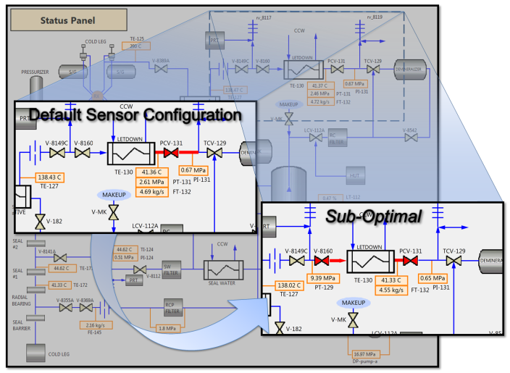
Figure - The Spatial Localization of a Fault is Sensitive to the Sensor Set Including Details such as the Number and Types of Sensors
Recent results and highlights: The sensitivity of fault diagnosis outcome to important parameters, including the type of equipment fault, the severity of the fault, and the spatial coverage of the sensor set, was investigated. The sensitivity was measured in terms of the fault diagnosis time (time elapsed between fault initiation and diagnosis) and the spatial precision of the diagnosis. The chemical and volume control system (CVCS) of a pressurized water reactor (PWR) served as a representative engineered system in this study. The dynamic behavior of the CVCS operating with equipment faults was simulated with a one-dimensional systems code. Equipment faults were introduced by appropriately modifying the physical characteristics of the component. For example, a failure of the CVCS pressure-letdown valve was simulated by changing the pressure loss characteristics of the valve by modifying the loss coefficient for the valve.
Three different equipment faults were examined: failure of the charging pump controller, failure of the letdown valve controller, and a fault in the cooling flowrate into the regenerative heat exchanger. The prototype system demonstrated spatial localization and identification of a fault using methods developed under this project consistent with the principles that underlie its operation. That is, the diagnosis result was consistent with what can be deduced from the available measurements and the conservation balances that govern operation of the faulted system.

FY12
Power Harvesting Technologies for Sensor Networks

Dwight A. Clayton, William H. Andrews, Jr., Roberto Lenarduzzi, and Richard A. Willems,
Oak Ridge National Laboratory
Funding: $380,000 (03/01/12-06/30/14)

Description of project: The overall goal of this project was to provide the foundation for an advanced, multi-functional, power-scavenging system for nuclear power plants. Most sensor systems have two primary wiring components: cabling for signal and control, and cabling for powering the sensors and processing electronics. While advances in wireless communications have addressed the need for signal and control cabling, cabling for power is still required. This research project addressed key technical issues that have prevented power harvesting techniques from being widely used in a nuclear plant environment. The defined research activities were focused on three main technical issues: 1) power harvesting methods applicable in a nuclear power plant environment, 2) development of highly efficient lower power electronics capable of supporting truly wireless sensors, and 3) energy efficient and secure wireless communications protocols.
Impact and value to nuclear applications: By combining wireless communications technologies with power harvesting techniques, development of truly wireless sensor nodes (WSNs) becomes a possibility. When wireless communications technologies and power harvesting techniques are ready for the nuclear reactor environment, the benefits will extend far beyond a reduction in cable installation and maintenance cost. Self-powered WSNs will provide a cost-effective way to add new or redundant measurements to existing plant instrumentation systems. Because nodes scavenging certain types of energy could continue to operate during extended station blackouts (SBOs) and during periods when operation of the plant’s internal power distribution system has been disrupted, measurements identified as critical to accident management could be among the first considered for redundant measurement. The availability of this data would be invaluable not only to operators trying to manage an accident situation but to teams responsible for post-incident analyses as well. Self-powered WSNs and the networks that tie them together will provide an opportunity to make substantial improvements in the reliability and safety of modern NPPs.
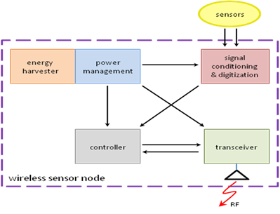
Recent results and highlights:
Figure - Elements of a self-powered wireless sensor node.
- Thermal energy harvesting is attractive because of the abundance of waste heat in nuclear power plants.
- Using modern electronics techniques, a wireless sensor node will consume 20 mW of continuous power.
- The majority of the electronic circuitry is independent of the harvesting technology employed.
- Robust digital instrumentation communication techniques and architectures are essential to address the potential for greater expansion in instrumentation in industrial environments that could augment human performance, provide additional data on plant equipment and component status, and facilitate online assessment of conditions.

FY12
Development of Human Factors Guidance for Human-System Interface Technology Selection and Implementation for advanced NPP Control Rooms and Fuel Cycle Installations

J. Hugo, D. Gertman, J. Joe, K. le Blanc, Idaho National Laboratory
Funding: $825,000 (03/01/12-02/28/14)

Description of project: The objective of this project was to investigate the potential use of state-of-the-art human-machine interface technologies in the nuclear industry, with the emphasis on their ability to provide error-tolerant and resilient operation in control rooms and to enable a superior degree of operator task performance. Specific objectives were to provide a sound technical basis for DOE and the nuclear industry for the evaluation and implementation of advanced human-system interfaces (HSIs) in preparation for technology selection and replacement, not only in the existing fleet of nuclear power plants (NPPs), but especially for deployment in future generations of light water reactors and other advanced reactor technologies. The result of the project would affect decisions related to human performance, operations, and digital instrumentation and control (I&C), including cross-cutting, emerging technology.
Impact and value to nuclear applications:
New HSI technologies have the potential to significantly improve human performance and safety in a wide variety of applications and work domains. While advanced devices have yet to be adopted by the nuclear industry, it is becoming clear that guidance is needed for the selection and implementation of new technologies. This is vital to ensure that chosen technologies support situation awareness, contribute to reduction of workload, and support efficient operations. The experience gained from this is important for all NPP I&C and HSI digital upgrades and new designs. Upgrades and new designs will rely to a much greater extent on digital technologies and employ newer and more kinds of automation. This means that technology-neutral, decision-centered, and performance-based approaches are needed to permit the selection of the best available technologies for eventual qualification for system operation, upgrades, maintenance and replacement. Because of the broad application potential of these technologies, even small improvements in efficiency across the application domains can yield significant benefits for human and system reliability, resilience, usability, and productivity. The approaches developed during this project will also help to ensure that the most suitable technologies can be deployed and that strategies for upgrade and replacement are sound and meet regulatory guidance.



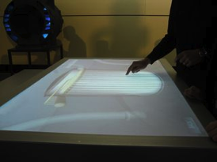
Recent results and highlights:
The project has categorized, assessed, evaluated, and prioritized a large selection of emerging HSI technologies, all of which are available to the nuclear industry in the next fifteen to twenty years. Specific outcomes included human performance criteria, and implementation and design strategies and special considerations for the selection and deployment of advanced technologies in NPPs. It also included a taxonomy and an analysis of technology readiness levels of advanced HSIs. The project concluded with a description of typical future trends, that is, how technologies are likely to develop over the next ten to fifteen years and how this will affect design choices for the nuclear industry.
Figure - Example of wearable and interactive devices

FY 2013 NEET-ASI Research Summaries
In FY 2013, the NEET-ASI program selected three two-year projects under the following solicited topics:
- Design of a custom radiation tolerant electronics system, using the best available commercial or near-commercial technologies necessary for operation in a severe nuclear environment. The proposed system will be tested in a radiation-tolerant multi-functional robot to overcome implementation challenges as well as to provide observable evidence of the technology capabilities.

- Methods to quantify software dependability characteristics can facilitate the resolution of factors that inhibit expanded use of modern digital technology by the nuclear power industry. The current reliance of process-oriented software quality assurance programs and the resultant subjective evaluation of digital system safety drive the nuclear industry to choose between maintaining legacy technologies that have proven licensable or embarking on costly, non-optimum implementations that are constrained to pose the least amount of licensing risk. Development of an objective technical basis for evaluating the suitability for software-based instrumentation and control (I&C) systems in safety applications at nuclear power plants would enable a science-based safety case to be demonstrated and thus reduce regulatory uncertainty. Measures, metrics, and methods are sought to permit quantification of the safety, quality, dependability, and reliability characteristics of software-based I&C systems.

FY13
Radiation Hardened Electronics Destined for
Severe Nuclear Reactor Environments

Keith E. Holbert and Lawrence T. Clark, Arizona State University
Funding: $399,674 (12/16/13-12/15/15)

Description of project: The objective of this project is to increase the radiation resilience of the more sensitive electronics such that a robot could be employed for post-accident monitoring and sensing purposes as well as for long-term inspection and decontamination missions within a nuclear reactor containment building. This is being accomplished by developing radiation hardened by design (RHBD) electronics using commercially available technology employing commercial off-the-shelf (COTS) devices and present generation circuit fabrication techniques. A dual research path is being taken by developing both board and application-specific integrated circuit (ASIC) level RHBD techniques for circuits destined for severe nuclear environments, specifically those that are vital to robotic circuits.
Impact and value to nuclear applications: Post nuclear accident conditions represent a harsh environment for electronics. The full station blackout experience at Fukushima shows the necessity for emergency sensing capabilities in a radiation-enhanced environment. The technology development in this project not only has applicability to severe accident conditions but also to facilities throughout the nuclear fuel cycle in which radiation tolerance is required. The methods being developed in this work will facilitate the long-term viability of radiation-hard electronics and robotic systems, thereby minimizing the incidence of obsolescence issues experienced in the nuclear power industry.
Recent results and highlights: Radiation and elevated temperature testing have led to the determination of specific physics-based failure mechanisms for embedded flash (eFlash) arrays (prior work has been behavior based). We have correlated the mechanisms between temperature and radiation effects in the first year of the project. Ascertaining limits to the technology and understanding the exact mechanisms allow better determination of the value of different system level mitigation approaches.
The ASIC design was fabricated (without cost to the project) at the foundry in late 2014. As seen in Figure 1, the 90-nm test die contains two 3.28 Mbit SST eFlash macros with separate power supplies to determine total ionizing dose (TID) impact independent of the surrounding logic. Separate on-die NMOS and PMOS power gating structures are provided to determine viability of gating flash power for longer TID lifetime. These ASIC devices will be mounted into chips so that radiation testing and characterization may be performed during the second (and final) year of the project.
Figure - Application-specific integrated circuit test die

FY13
Radiation Hardened Circuitry Using Mask-Programmable Analog Arrays

Chuck Britton, Jacob Shelton, Nance Ericson, Oak Ridge National Laboratory
Benjamin Blalock, The University of Tennessee
Funding: $400,000 (10/01/13-09/30/15)

Description of project: The goal of this project is to develop and demonstrate a general-purpose data acquisition system built from commercial or near-commercial radiation-hard analog arrays and digital arrays that will be the building blocks of a family of future fieldable radiation-hard systems. As the recent accident at Fukushima Daiichi so vividly demonstrated, telerobotic technologies capable of withstanding high radiation environments need to be readily available to enable operations, repair, and recovery under severe accident scenarios where human entry is extremely dangerous or not possible. Telerobotic technologies that enable remote operation in high dose rate environments have undergone revolutionary improvement over the past few decades. However, much of this technology cannot be employed in nuclear power environments due the radiation sensitivity of the electronics and the organic insulator materials currently in use. Radiation tolerant electronics are therefore one of the major limiting technologies preventing effective telerobotic application to high radiation environments present under severe accident conditions or in support of fuel reprocessing. Moreover, the electronics, once developed, are low cost enabling frequent replacement when used under high dose-rate conditions.
Impact and value to nuclear applications: This research will produce a prototype rad-hard data acquisition system that will be constructed and tested to demonstrate functionality and rad-hardness of the identified pre-commercial or commercial technology, as applied to a nuclear reactor environment. The system prototype will be delivered along with measured functional metrics for both pre- and post-radiation scenarios. Comparison of this data will be performed and will validate the radiation survivability of this technology path. In addition to a success/fail result, the measured degradation observed in each of the circuit functions will also be summarized and will provide valuable insight into the degree of radiation hardness of each system component following a 200-kR or greater total integrated dose. Successful completion of this project will demonstrate the feasibility of using commercial or near-commercial radiation-hardened custom circuits in severe nuclear environments.
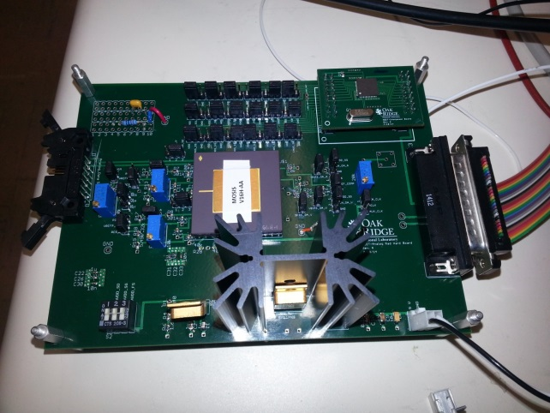
Recent results and highlights: Using the analog blocks available in our currently preconfigured via-configured array (VCA), we performed a detailed schematic design of our system to include the signal-processing blocks for temperature, radiation and pressure. Control and data acquisition were implemented with the Spartan-6 field-programmable gate array (FPGA), as well as with wired serial communications using a remote computer. In addition, batteries and associated voltage regulators were selected for powering the system. Five prototype systems [each system consisting of sensors, electronics board, battery power supply, and personal computer serial communications port] were constructed to support the testing objectives of this work. The system is presently being tested at Arizona State University using their ⁶⁰Co radiation facility. The plan is to test 3 complete systems up to approximately 200krad total integrated dose (TID).
Figure - Board with radiation-hardened analog array.

FY13
A Method for Quantifying the Dependability Attributes of Software-Based Safety Critical Instrumentation and Control Systems in Nuclear Power Plants

Carol Smidts, The Ohio State University,
Ted Quinn, Technology Resources
Funding: $399,990 (12/26/13-12/25/15)

Description of project: The objective of this project is to develop a method for software dependability quantification as well as its associated science basis. Dependability includes multiple attributes: reliability, availability, safety, security, and maintainability. The general approach is to identify measures for the different attributes through expert opinion elicitation; to develop causal models that link measures to threats to the application; to develop models asserting the dependencies between attributes; and to identify the most important dependability attributes for a specific application of interest. These models will help assess software dependability at different stages of the software lifecycle. This research will also lead to the development of hybrid causal maps, an advanced representation of knowledge, as well as to a more robust elicitation of causal maps which further enhance the science of elicitation.
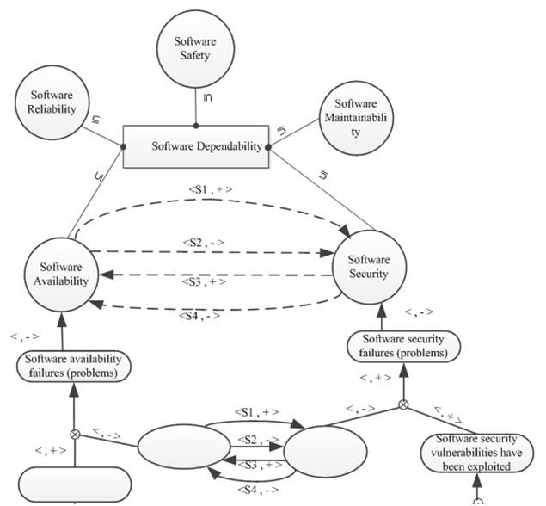
Impact and value to nuclear applications:
Figure - A snippet of the causal map between dependability attributes
The results of this research can be used in two different ways: 1) to guide development of software-based instrumentation and control systems; 2) to build a safety/dependability case. Development guidance will enhance dependability of the final software product thereby reducing the regulatory uncertainty. This will support the current NRC licensing regime and in particular support the application of Independent Verification and Validation (IV&V) techniques, which are required for new reactor or existing reactor upgrades in accordance with USNRC Regulatory Guide 1.168 and the associated IEEE-1012.
Recent results and highlights:
- Developed causal maps for software dependability attributes (i.e., reliability, availability, security, safety and maintainability) and their interdependencies (see Figure).
- Identified mechanisms leading to the occurrence of
events of interest (e.g., security failure, safety failure, etc.) for each of the dependability attributes.
- Identified measureable characteristics and corresponding measures for the outcome of interest associated with each software dependability attribute.
- Evaluated the coverage of the measures for each event of interest.

FY 2014 NEET-ASI Research Summaries
In FY 2014, the NEET-ASI program selected six three-year projects under the following solicited topics:
1. Power Harvesting Technologies for Sensor Networks
This program element focuses on development and demonstration of power harvesting technologies to power sensor networks in a nuclear environment and includes:
- Develop sensor requirements and sensor simulator to test and demonstrate concepts prior to full development;
- Develop, design, and fabricate power efficient solid-state devices; and
- Demonstrate that conceptual system design is capable of surviving in the intended environments representative of nuclear power plants.
2. Recalibration Methodology for Transmitters and Instrumentation
This program element focuses on development and demonstration of online calibration methodologies for transmitter and instrumentation calibration interval extensions.
- Develop a methodology to provide virtual sensor estimates and high-confidence signal validation, and provide the capability to integrate with uncertainty quantification methodologies;
- Evaluate the impact of emerging sensors and digital instrumentation on the proposed recalibration methodology(ies); and
- Demonstrate the candidate recalibration methodology(ies) in an appropriate test-bed or facility.
3. Design for Fault Tolerance and Resilience
This program element focuses on development and demonstration of control system technologies that are resilient to anticipated faults and transients and can achieve high plant and system availability and lead to improvements in safety.
- Develop and test fault-diagnosis algorithms for current and next generation plant components;
- Develop computer-enabled implementation of control algorithms for a simulator-based test;
- Develop a fully-integrated operator-support system for demonstration including fault detection, fault diagnosis, and control actions to mitigate fault(s);
- Perform full-scale simulator shakedown tests of integrated fault diagnosis and automated control for a thorough spectrum of faults; and
- Develop technical requirements for broad application of the operator support technology across multiple plant systems.
4. Embedded Instrumentation and Controls for Extreme Environments
This program element focuses on development and demonstration of embedded instrumentation and control technologies in major nuclear system actuation components (e.g. pumps, valves) that can achieve substantial gains in reliability and availability while exposed to harsh environments.
- Employ a multidisciplinary research effort to integrate sensors, controls, software, materials, mechanical and electrical design elements to develop highly embedded I&C in major component design;
- Construct and demonstrate a bench-scale and a loop-scale component with embedded controls; and
- Develop methods and metrics for assessing resulting system performance enhancements and demonstrate fault-tolerant control, high efficiency, and reliability in a test bed or representative facility environment.

5. High Temperature Fission Chamber
This program element focuses on fabrication and characterization of high temperature fission chambers that provide high-sensitivity, high-temperature neutron flux monitoring technology.
- Fabricate and test a high temperature fission chamber capable of operating from start-up to full power at 800°C;
- Design and fabricate a fission chamber followed by characterization at high temperature in a reactor that demonstrates sensitivity; demonstrates mechanical/thermal robustness; and enables path to safe high-temperature reactors.
6. Advanced Measurement Sensor Technology
This program element focuses on development and fabrication of advanced sensors for improved performance measurement technology that provides revolutionary gains in sensing key parameters in reactor and fuel cycle systems. These new sensor technologies should be applied to multiple reactor or fuel cycle concepts and address the following technical challenges:
- Greater accuracy and resolution;
- Detailed time-space, and/or energy spectrum dependent measurements;
- Reduced size; and
- Long-term performance under harsh environments

FY14
Enhanced Micro-Pocket Fission Detector (MPFD) for High Temperature Reactors
Troy Unruh, Idaho National Laboratory (INL), Phillip Ugorowski, Kansas State University (KSU)
Jean-Francois Villard, Commissariat à l'Énergie Atomique et aux Energies Alternatives (CEA)
Funding: $1,000,000 (10/01/14-09/30/17)

Description of project: The project seeks to extend the performance of Micro-Pocket Fission Detectors (MPFD) to survive environments up to 800 °C and to insure MPFDs are suitable for use in high-temperature advanced reactors. MPFDs are compact fission chambers capable of simultaneously measuring thermal neutron flux, fast neutron flux, and temperature within a single sensor package. During the last three years, our team has developed the design and evaluated the performance of MPFDs to 500 °C. This new project will focus on evaluating MPFD designs that incorporate high temperature materials and specialized fabrication techniques that are often used in similarly developed sensors that have been successfully deployed in materials testing reactors. In addition, supplemental research will be performed to evaluate the potential for connecting multiple MPFDs in a single expanded sensor package so that temperature and axial flux profile data can be obtained simultaneously.
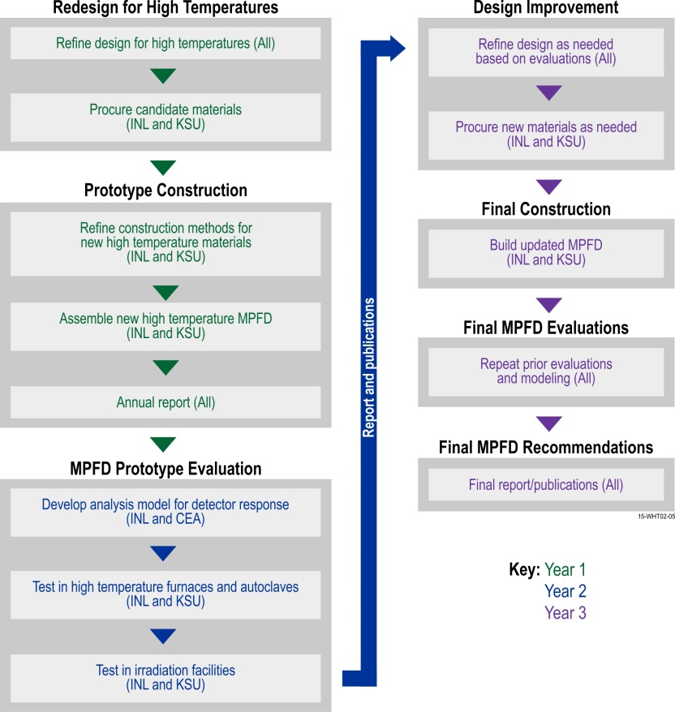
Impact and value to nuclear applications: Research and development tasks completed in this project will provide confidence that the MPFD has the high temperature and irradiation performance required for deployment in environments up to 800 °C. In addition, this project will be exploring other flux detector design features that are desired by several other DOE-NE and industry programs, such as the use of multiple MPFDs to allow axial profiling. This research will produce compact sensors, whose performance will be demonstrated to be capable of measuring fast and thermal flux and measuring temperatures up to 800 °C. The product of this research also leverages DOE-NE funding so that it is of interest to other programs and customers, such as the Fuel Cycle Research and Development, Accident Tolerant Fuel, Small Modular Reactor, and Light Water Reactor Sustainability programs; as well as industry efforts to develop and test advanced fuels, and evaluate material survivability required for plant lifetime extension.
Figure - Enhanced Micro-Pocket Fission Detector for High Temperature Reactors project schedule
Recent results and highlights:
This recently awarded project has focused initial research efforts on exploring new designs and construction methods for developing high temperature capable MPFDs. This includes design improvements and needs for high temperature MPFD enhancements. Candidate materials have been procured and are being evaluated for high temperature compatibility with MPFD construction techniques.

FY14
Nanostructured Bulk Thermoelectric Generator for Efficient Power Harvesting
for Self-powered Sensor Networks

Yanliang Zhang and Darryl P. Butt, Boise State University;
Vivek Agarwal, Idaho National Laboratory; Xiaowei Wang, GMZ Energy, Inc.
Funding: $980,804 (01/01/15-12/31/17)

Description of project: The project will conduct research and develop high-efficiency thermoelectric generators (TEGs) for self-powered wireless sensors nodes (WSNs) utilizing thermal energy from nuclear reactors or fuel cycle (shown in Figure a). The project will be based on the high-performance thermoelectric materials and generators that the team has recently identified. The TEG properties and performance will be evaluated in an environment representative of nuclear power plant under different operating conditions. In addition, the project will ensure reliable transmission of information from self-powered WSN to a remote location.
Impact and value to nuclear applications:
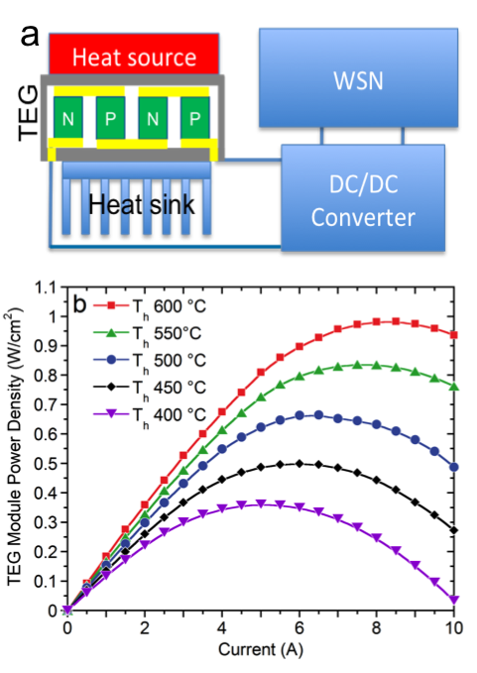
Figure - (a) Schematic of self-powered wireless sensor node (WSN) using thermoelectric generator (TEG) (b) Electric power density vs. current for various hot-side temperature of nanobulk half-Heusler TEGs.
The power harvesting technology has a crosscutting significance to address critical technology gaps in monitoring nuclear reactors and fuel cycle. The outcomes of the proposed research will lead to significant advancement in sensors and instrumentation technology, reducing cost, improving monitoring reliability and therefore enhancing safety. The self-powered wireless sensor networks could support the long-term safe and economical operation of all reactor designs (including advanced reactor technologies), fuel cycle concepts, spent fuel storage, and other nuclear science and engineering applications.
Recent results and highlights:
The proposed research is based on recent breakthroughs in high-performance nanostructured bulk (nanobulk) thermoelectric materials that enable high-efficiency direct heat-to-electricity conversion over a wide temperature range. The nanobulk thermoelectric materials that the team has identified yield up to a 50% increase in the thermoelectric figure of merit, ZT, compared with state-of-the-art bulk counterparts. Fig. 1b shows the power density of thermoelectric generators fabricated using the nanobulk Half-Heuslers (HH).
The team is currently investigating nanobulk HH and Bismuth Telluride (BiTe) that covers temperature range from 30 °C to 600 °C. The performance in this temperature range would make both HH and BiTe excellent candidates for power harvesting for WSNs in the nuclear industry. The team is investigating to identify a suitable hot surface for initial TEG development and evaluation.

FY14
Robust Online Monitoring Technology for Recalibration Assessment
of Transmitters and Instrumentation

Pradeep Ramuhalli, Pacific Northwest National Laboratory, Jamie Coble, University of Tennessee, Brent Shumaker and Hash Hashemian, Analysis and Measurement Services Corporation
Funding: $1,000,000 (10/01/14-09/30/17)

Description of project: The goal of this research is to develop the next generation of online monitoring (OLM) technologies for sensor calibration interval extension and signal validation in nuclear systems, through the development of advanced algorithms for monitoring sensor and system performance and the use of plant data to derive information that currently cannot be measured. Specific objectives are: (i) apply methods for data-driven uncertainty quantification (UQ) to develop methodologies for high-confidence signal validation; (ii) develop robust virtual sensor technology to derive plant information that currently cannot be measured (either due to sensor failure or lack of sensors); and (iii) develop a general framework for OLM of both calibration and response time assessment for current and future sensors and instrumentation.
Impact and value to nuclear applications: Outcomes of this project will lay the groundwork for wider deployment of advanced OLM in U.S. nuclear facilities by developing a methodology to: (1) support the regulatory basis for OLM-based calibration assessment, (2) provide the high confidence levels needed for signal validation, (3) provide virtual sensor estimates with meaningful confidence, (4) integrate response time testing of pressure transmitters with the OLM framework, and (5) evaluate the efficacy of these techniques for new sensors systems. These advances are expected to improve the safety, reliability, and economics of current and planned nuclear energy systems as a result of higher accuracies and increased reliability of sensors used to monitor key parameters, as well as targeted instrumentation maintenance actions during planned outages.
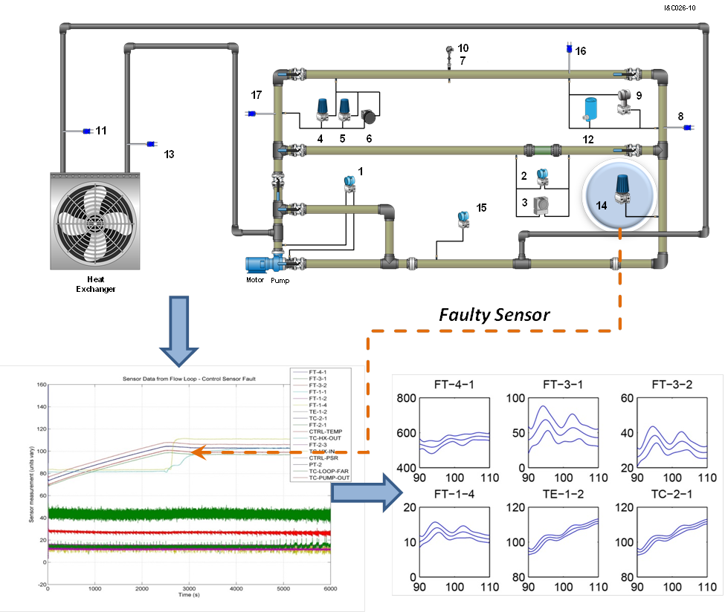Figure - Data-driven uncertainty quantification, using data from an instrumented flow loop.
Recent results and highlights: The focus of this research is on temperature, pressure, level, and flow instrumentation used for measurement of process variables for control of the plant and monitoring of its safety. During operation, these sensors may degrade due to age, environmental exposure, and even maintenance interventions. These factors result in anomalies such as signal drift and response time changes in the measured signal and failure of the sensing element, and challenge the ability to reliably distinguish between signal changes due to plant or subsystem performance deviations and those due to sensor or instrumentation issues. Research has been initiated to address the following technical gaps: (1) signal validation using data-driven uncertainty quantification methods to evaluate accuracy of signal measurements and differentiate between sensor fault and process drift, (2) virtual sensing, where OLM model information is used to compute measurement estimates for faulty sensors or measurements not currently available, (3) methods for monitoring sensor response time, and (4) determining requirements for next-generation instrumentation to support on-line monitoring. Instrumented flow loops as well as available plant data is planned for use in verification and validation (V&V) of algorithms developed to address the above gaps. Collectively, these algorithms provide a complete picture of health, reliability, accuracy, and speed of response of process instrumentation in legacy and future nuclear facilities.
FY14
Operator Support Technologies for Fault Tolerance and Resilience
Richard B. Vilim, Argonne National Laboratory
Kenneth Thomas, Idaho National Laboratory
Funding: $995,000 (10/01/14-09/30/17)

Description of project: The objective of this project is to develop a prototypic computerized operator support system (COSS) to assist operators in monitoring overall plant condition, in making timely and informed decisions, and in taking appropriate control actions. Operator support technologies have the potential to significantly enhance operator response to time-critical component faults, resulting in fewer nuclear safety challenges and higher plant capacity factors. Presently the timeliness and suitability of an operator’s response suffers from an inadequate ability to quickly diagnose the cause of the upset and the subsequently required actions. This is traceable to a limited instrumentation set for accurate fault characterization and the difficulty in formulating the instrument readings into a correct diagnosis.
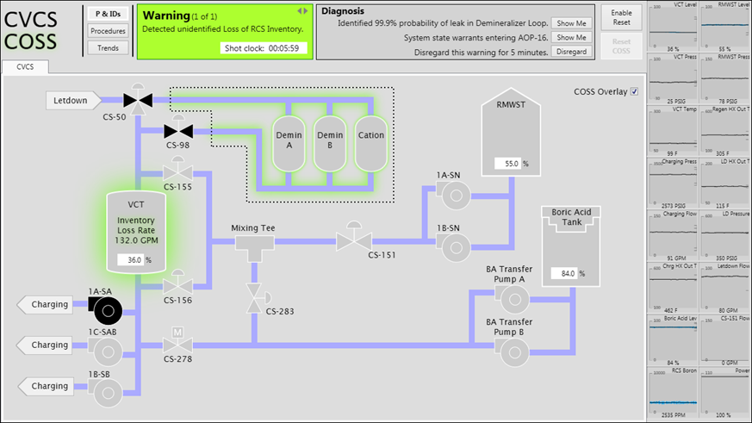
Figure - COSS display featuring suggested mitigation actions and components related to the fault and the mitigation of the fault.
Impact and value to nuclear applications: The capability being developed could prove to be enormously beneficial to currently-operating nuclear plants, as well as the future advanced nuclear plants that are being built or proposed. Benefits include better management of plant upsets and improved operator performance. Ultimately, the capability could make a positive impact on the industry’s fundamental objectives in the areas of nuclear safety, production, and cost management.
Recent results and highlights: The system provides a means to manage the enormous amount of information that an operator must process and assimilate to arrive at an understanding of how the plant is operating and how its future trajectory will unfold. This is a daunting task for even the most experienced operators during rapidly changing plant conditions. This system will assist the human operator with operation of the plant as opposed to serving as an extension of the control system. Existing automatic control systems lack “awareness” of the plant state and the larger world in which they operate; they simply track a setpoint. In our system process variable values are observed and in conjunction with the conservation laws that govern plant operation, an automated reasoning process determines a mutually consistent plant state, possibly a faulted one. The system can then recommend operator actions that can mitigate undesirable plant events and return the plant to a safe operating condition with minimal deviation. The system under development operates as a multi-stage process that sequentially aids the operator in the remediation and resolution of an upset event. The overall technique involves six distinct stages: validation, detection, diagnosis, mitigation, monitoring (for successful mitigation), and recovery (to pre-fault plant conditions).

FY14
Embedded Instrumentation and Controls for Extreme Environments

Roger Kisner, Alex Melin, David Fugate, David Holcomb, Tim Burress, Curt Ayres, and Kyle Reed
Oak Ridge National Laboratory
Funding: $1,000,000 (10/01/14-09/30/17)

Description of project: The objective of this project is to demonstrate the capability of embedded instrumentation and controls (I&C) to provide performance and reliability improvements in major nuclear power plant components that would be unachievable through traditional methods. Results from the “Embedded I&C in Extreme Environments” project directly benefit future nuclear reactor designs including small, modular systems. The combination of modeling, simulation, fabrication of physical systems, and subsequent characterization and testing in this project will demonstrate the capabilities of deeply embedding I&C. A specific motor-pump type has been selected to demonstrate the integrated design process. The demonstration will be of a test bed that includes design, fabrication, and control of magnetic bearings and main drive motor, which can be operated in extreme environments.
Impact and value to nuclear applications: Sensors and controls have not typically been embedded in nuclear power reactor components as compared with other industries. The design of closely coupled machine control requires a multi-disciplinary design effort e.g., I&C, mechanical/electrical and systems engineering, and materials science. Because advanced I&C technologies were not available during the first nuclear era, existing reactor component designs have limitations for new reactor concepts. High performance components needed for future reactor systems can exhibit inherent instability – witness high-performance aircraft. Benefits to high performance reactor system components are compact size, less material bulk, high efficiency, and increased reliability. This demonstration creates a pathway for application of embedded I&C to many other systems.
Recent results and highlights:
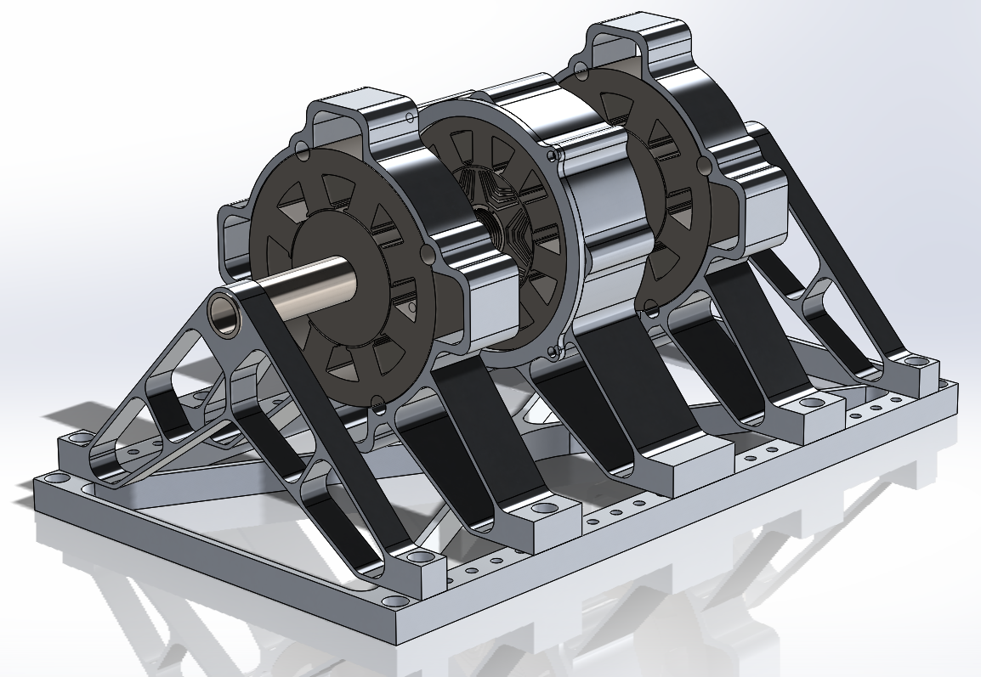
Figure - Test bed includes magnetic suspension bearings and main rotor drive.
- Deeply embedding I&C into a canned rotor pump appears possible primarily using the functionally required wiring through measuring the induced signal on the non-energized motor phases.
- Switched reluctance drives can enable high-efficiency motors to operate at temperatures characteristic of high temperature reactors.
- Canned motors with magnetic bearings are only possible through deeply embedded I&C.
- Test bed design is nearing completion. The next step in the project is component fabrication.
Significant motor sensor technologies that can operate at extreme temperatures were identified including a sensor-less approach that utilizes the magnetic drive and suspension coils as position and rotation sensors. The test bed that is under construction will be a significant tool in the development of sensor-less position measurements. A sensor-less approach is important because it simplifies motor design and potentially increases system reliability. Sensor-less designs have been used but never for motors that can be operated at 700 degrees Celsius. The test bed will also be used to examine a variety of control strategies that were developed in previous years of this project. Several control and engineering issues related to deploying the embedded concept for motor-pump applications are (1) coupled response between motor torque and forces on magnetic bearings, (2) natural oscillatory modes and frequency response of sensors and control components, (3) high-temperature magnetic materials, (4) magnetic gap, and (5) high temperature insulation.
FY14
High Spatial Resolution Distributed Fiber-Optic Sensor Networks for Reactors
and Fuel Cycle Systems

Kevin P. Chen, University of Pittsburgh
Ming-Jun Li, Corning Inc., Michael Heibel, Westinghouse Electric Company LLC.
Funding: $987,676 (10/01/14-09/30/17)

Description of project: The objective of this project is to develop multi-functional, remotely activated, and distributed fiber optical sensor networks to monitor a number of parameters critical to the safety of nuclear power systems with high sensitivity and high spatial resolution. To accomplish this objective, radiation-hard, application-specific air-hole microstructural fibers will be developed as sensor platforms. Radiation-hard nano-functional coating will be developed to respond chemical species important to safety of nuclear power systems. Through ingenious fiber structure designs, the integration of nano-functional coating, and robust fiber packaging, we will develop fiber optical sensing systems to perform multi-parameter measurements of temperature, pressure, liquid level, and hydrogen concentrations with –cm spatial resolution in radiation environments under both normal operation and in post-accident scenarios.
Impact and value to nuclear applications: This program will develop radiation-hard fibers and fiber sensing solutions with capabilities of performing simultaneous multi-parameter measurements. The new distributed fiber sensing capabilities and new radiation-hard microstructural fibers developed by this program will address critical technology gaps for monitoring advanced reactors and fuel cycle systems under both normal operation and in post-accident scenarios.
Recent results and highlights:
- Developed nano-porous metal oxide functional coating and their doped variants with appropriate refractive indices and porosities for hydrogen measurement.
- Integration of functional nano-functional coating on fiber and demonstrated distributed hydrogen measurement from 0.5% to10% with 5-mm spatial resolution from the room temperature to 700ºC.
- Designed radiation-hard air-hole fibers to perform simultaneous temperature and pressure measurements from the room temperature to 1000ºC with 0.3-psi pressure measurement sensitivity and 1-cm measurement spatial resolution.

Figure - D-shaped fiber used for distributed hydrogen measurement and the results of hydrogen concentration measurement from 0.5% to 10% with 5-mm spatial resolution at 700ºC.
Current Fiber Design
SEM Photo
Distributed H₂ Sensing at 700ºC

