Introduction
Advances in manufacturing technologies, including modular construction, improved factory and field fabrication and other innovative construction technologies, are essential to the future of nuclear energy. They are strategically important to the economics of new nuclear power plant construction in the United States and to the competitiveness of the U.S.in the nuclear energy market.
In 2012, the Nuclear Energy Enabling Technologies (NEET) Program was initiated by the Department of Energy’s Office of Nuclear Energy (NE) to conduct research, development and demonstration (RD&D) in crosscutting technologies that directly support and enable the development of new and advanced reactor designs and fuel cycle technologies. Advanced Methods for Manufacturing (AMM) is one program element of NEET Crosscutting Technology Development whose focus is to improve the methods by which nuclear equipment, components, and plants are manufactured, fabricated and assembled by utilizing practices found in industries such as oil, aircraft and shipbuilding.
The NEET AMM program includes two goals:
- To reduce cost and schedule for new nuclear plant construction
- To make fabrication of nuclear power plant components faster, cheaper and more reliable.
By evaluating state-of-the-art practices found in other large manufacturing industries, the nuclear community has identified four major areas of innovation the NEET AMM program is currently helping to advance. These innovation areas are:
- Welding and Joining Technologies. New technologies focused on high speed, high quality and code acceptable welds is needed in both factory and field fabrications. Electron beam and laser welding are examples of technologies needed to join heavy section components to improve their efficiency. On-line, non-destructive testing that can provide real-time, or near real-time, feedback on the quality of the weld would improve the productivity in both the shop and the field.
- Additive Manufacturing. This process, compared to subtractive manufacturing, utilizes lasers, electron beams, friction stir welding or conventional technologies to fuse thin layers of solid or powdered material in a precise two dimensional pattern to create a near-net shape component provided by a computer-aided design and manufacturing (CAD/CAM) information. Additively manufactured components could provide necessary cost and schedule savings over traditionally manufactured components.
- Modular Fabrication. This concept will move new nuclear reactor builds away from “piece built” fabrication and construction techniques and allow them to be built economically. The modules must be factory built, transportable, capable of precise placement, engineered to their function in their environment, and easily mated to form a single entity.
- Concrete Materials and Rebar Innovations. High strength, high performance concrete and rebar will both improve the quality and reduce the construction time required for new nuclear power plants. Advancements that enable integrated prefabrication of reinforced steelform assemblies will also help to move new builds away from the traditional “stick builds”.
The NEET AMM program is developing these advanced manufacturing technology innovations through competitive solicitations issued annually which are open to industry, academia and national laboratories. AMM is also closely involved with the DOE’s Clean Energy Manufacturing Tech Team (CEM-TT) which is a cross cutting collaboration that leverages manufacturing development efforts between DOE’s applied energy offices such as programs within the Offices of Nuclear Energy, Fossil Energy and Energy Efficiency and Renewable Energy.
In FY 2011, two projects, totaling $1,074,274, were selected through the Nuclear Energy University Program (NEUP). The first was awarded to the University of Houston for the development of an innovative seismic isolation system. The second award was given to the Pennsylvania State University for the study of laser-arc hybrid welding of thick section nickel-based alloys.
In FY 2012, four projects, totaling $3,032,798, were awarded. Two awards were given to Electric Power Research Institute and Lockheed Martin for the development of additive manufacturing processes. Purdue University was awarded for the development of modular connection technologies for steel plate composite walls. Lastly, an award was given for the monitoring of the hybrid laser-gas metal arc welding process to the Idaho National Laboratory.
In FY 2013, two awards, totaling $737,374, were issued through the Consolidated Innovative Nuclear Research (CINR) solicitation to the Georgia Institute of Technology and the University of Houston for the advancement of self-consolidating and ultra-high performance concrete.
In FY 2014, three projects, totaling $2,400,000, were selected through the CINR. The first was awarded to the University of Houston for the further development of their FY11 NEUP periodic material-based seismic base isolators. Oak Ridge was selected to improve weld productivity by creating a real-time close-looped weld monitoring system. Purdue University was awarded to evaluate accident thermal conditions and other parameters on the seismic behavior of nuclear structures.
Since 2011, the AMM program has awarded a total of $7,244,446 to 11 projects. These open, competitively selected awards have already begun to make significant progress in the advancement of manufacturing technologies. Each year, the participation in the solicitations has grown to include more partnerships and include a more diverse selection of industries applying their technology to the nuclear energy sector. In the following sections, it will be seen that the developments and innovations continue to surpass the expectations of the NEET AMM program.

FY 2011 NEET-AMM University Award Research Summaries

In FY 2011, proposals were sought through the Nuclear Energy University Program solicitation to conduct necessary R&D to reduce cost and schedule for new nuclear plant construction and make fabrication of nuclear power plants (NPP) components fast and cheaper with better reliability. A parallel intention is to restore the U.S. position as a manufacturer and constructor of NPP designs both domestically and worldwide. Based on past work and new stakeholder input, the program will focus on opportunities that provide simplified, standardized, and labor-saving outcomes for manufacturing and construction. The key university research needs solicited were to develop;
- Innovations in seismic design using base isolation systems,
- Modeling and simulation of weld metal solidification,
- Advanced NDE sensors for use on real time welding inspection systems,
- New formulations in high-strength concrete, and
- Modeling methods for advanced steel plate concrete composite structures.
FY11
Development of Seismic Isolation Systems Using Periodic Materials
Y. L. Mo, University of Houston, Houston, Texas
K.H. Stokoe, II, The University of Texas, Austin, Texas
J. Perkins, Prairie View A&M University, Prairie View, Texas
Y. Tang, Argonne National Laboratory, Argonne, Illinois
Funding: $538,154 (10/10/2011 - 10/10/2104)

Description of Project: The research sought to develop seismic isolation systems for nuclear power plants using periodic material. The concept of periodic material or phononic crystal in solid-state physics has been known for several decades. The distinct feature of this material is that it cannot pass elastic waves under certain frequency ranges. Inspired by the unique behavior of phononic crystal, the periodic material was proposed to be used as a foundation to protect the superstructure from incoming seismic waves. The focus was be on the development of a concept that utilizes periodic materials to completely obstruct or change the pattern of the earthquake event energy before it reaches the structural systems of nuclear power plants. The goals were to experimentally verify the principle of periodic material and to demonstrate the application of 1D, 2D, and 3D periodic foundations for the seismic isolation of nuclear power plants.

Impact and Value to Nuclear Applications: The value of this material for nuclear power plant applications is that the use of the periodic foundation attenuates seismic waves inside certain frequency ranges before the waves reach the superstructure. Because the superstructure is firmly fixed to the periodic foundation, no excessive relative displacement occurs. The advantages are beneficial not only for the structural components but also for nonstructural components of nuclear power plants.

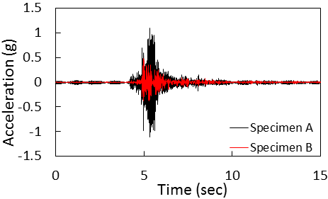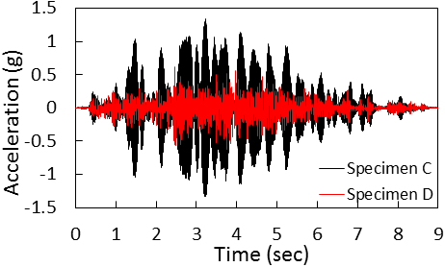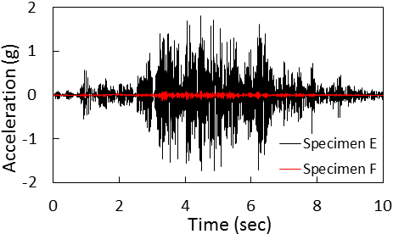
- (b) (c)
Figure 1. Test results of (a) 1D periodic foundation; (b) 2D periodic foundation; and (c) 3D periodic foundation.

Recent Results and Highlights: Shake table tests were conducted on a steel frame supported by either a 1D periodic foundation or without a periodic foundation. The two structures with and without periodic foundations were fixed on a shake table and shaken with input seismic waves. Fig. 1(a) shows that the peak acceleration at the top of specimen B (with 1D periodic foundation) was reduced by 56 % as compared to that of specimen A (without periodic foundation). Shaker trucks were utilized to generate seismic waves to the specimens on the free field tests for 2D and 3D periodic foundations. Fig. 1(b) shows that under the same seismic input waves, the peak acceleration on the top of specimen D (with 2D periodic foundation) was reduced by 52% as compared to that of specimen C (without periodic foundation). Fig. 1(c) shows that the peak acceleration on the top of specimen F (with 3D periodic foundation) was reduced by 92 % as compared to that of specimen E (without periodic foundation).

FY11
Laser-Arc Hybrid Welding of Thick Section Ni-base Alloys – Advanced Modeling and Experiments
T. DebRoy, Penn State University, University Park, PA 16802
Funding: $536,117 (10/03/2011 – 12/31/2014)

Description of Project: Laser-arc hybrid welding process is an attractive alternative for the welding of Alloy 690 in the repair and fabrication of power plants, however there was still much about the process that needed to be investigated. Because of the interaction of a large number of processing parameters there are complex interactions between the plasma, keyhole formation, and mixing of filler metal in the weld pool. A fundamental multi-disciplinary approach was needed in order to develop a firm understanding of the interactions between these various processing parameters. This enhanced understanding of the physical mechanisms will lead to improved welding processes and filler metal compositions and to improved performance of these materials in high temperature applications.
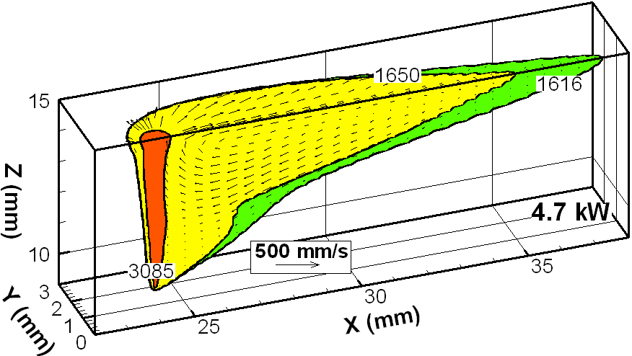
Impact and Value to Nuclear Applications: Traditionally, thick sections of reactor vessel alloys and steels have been welded with multi-pass gas-tungsten arc (GTA) and submerged arc (SAW) welding processes. Multiple passes are required to join thick sections of 25 mm or more, significantly raising the fabrication cost. In addition, the repeated exposure of the components to weld thermal cycles increases the weld distortion and structural inhomogeneity, particularly in multi-pass Ni-base superalloys. Laser-gas metal arc (GMA) hybrid welding, which combines a laser and an arc, represents a potentially attractive technique for the joining of thick section components because of its ability to achieve deep weld penetrations with low distortion in a single pass. The potential of single pass, deep penetration welding of these components can provide significant benefits to the construction of new power plants and the refurbishment of existing ones.
Figure 1. The temperature and velocity fields in an Alloy 690 laser weld are shown and used to calculate the solidification parameters.
Recent Results and Highlights: Solidification structures and their sizes have an important impact on the performance of fabricated parts during service, so it was important to understand how welding parameters affect solidification parameters, such as temperature gradient, solidification rate, and cooling rate. In order to determine these solidification parameters, the temperature fields and fluid velocity fields must be known across the entire weld. Figure 1 shows the fields, which were calculated using a 3D mathematical model, for a 4.7 kW laser weld. From the temperature fields, the cooling rate (GR) during solidification could be calculated as shown in Figure 2. The cooling rates vary spatially across the weld from less than 100 K/s to more than 10,000 K/s. This information is very important for understanding how welding parameters affect solidification.
Figure 2. The cooling rates during solidification are calculated everywhere along the 3D solidification surface.

FY 2012-2014 NEET-AMM Award Summaries
Beginning in FY 2012, proposals were sought to pursue innovative methods to manufacture or fabricate components faster and with better quality; and to improve factory assembly and field deployment of plant modules, thereby reducing the cost and schedule requirements for new nuclear plant development. Specific goals include:
- Accelerate deployment schedule by at least 6 months compared to current new plant construction estimates;
- Reduce component fabrication costs by 20% or more;
- Increase installation of key subsystems without cost increase or schedule delay.

The program requested to develop manufacturing and fabrication innovation, assembly processes and materials innovation that support the “factory fabrication” and expeditious deployment of reactor technologies. Potential areas for exploration include:
- Factory and field fabrication techniques that include strength assistance tooling, advances in verification of designed configuration, improvements in manufacturing technologies such as advanced (high speed, high quality) welding technologies, practical (shop floor) applications of electron beam welding for fabricating heavy sections, surface modification and metal spraying techniques that reduce erosion, corrosion and wear on component surfaces.
- Assembly and material innovation to enhance modular building techniques such as advances in high performance concrete and rebar, design innovation using concrete composite and steel form construction methods, inspection processes and equipment, and innovative rebar pre-fab and placement systems. Innovations in concrete materials or design of structures that can reduce the total volume of concrete poured or the overall thickness of concrete sections are relevant to this program.
- Advances in manufacturing processes for reactor internals, fuel cladding and fuel support assemblies. Research could include advanced manufacturing methods for individual components or fabrication of assemblies. Cladding or surface modification methods to resist corrosion and wear are relevant to this research topic.
- Improved concrete inspection, measurement and acceptance technology, techniques and methods to facilitate the pour and curing of nuclear plant concrete.

FY12
Innovative Manufacturing Process for Nuclear Power Plant Components via Powder Metallurgy-HIP
D. Gandy, B. Sutton, D. Purdy, Electric Power Research Institute
M. Connor and J. Robinson, General Electric-Hitachi
S. Lawler, Rolls Royce
L. Lherbier and D. Novotnak, Carpenter Powder Products
Funding: $800,000 (10/01/2012 – 09/30/2015)

Description of Project: For more than 60 years the nuclear power industry has relied on structural and pressure retaining materials produced via established manufacturing practices such as casting, plate rolling-and-welding, forging, drawing, and/or extrusion. The current project is aimed at the development and introduction of another process, powder metallurgy and hot isostatic pressing (PM-HIP), for the manufacture of near-net shaped (NNS) reactor pressure internal and external components. The RD&D project has been focused on the manufacture and assessment of large components from three alloy families: low alloy steel, stainless steels, and nickel-based alloys to both demonstrate and assess the technology for future use in nuclear applications.
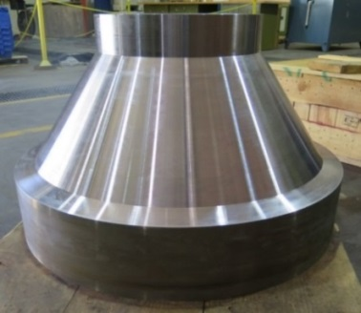
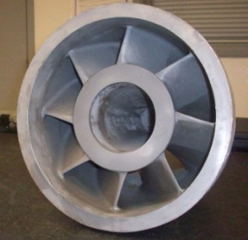
Impact and Value to Nuclear Applications: Powder metallurgy technology integrated with advanced alloy modeling/design capabilities, and state-of-the-art HIP technology, can have a significant impact on the energy industry's goals to lower manufacturing costs and energy consumption, shorten production schedules by up to 6 months, and reduce emissions. Specific benefits of manufacturing near-net shaped (NNS) components via PM/HIP include: increased material utilization (resulting in reduced machining and fabrication costs), material cost reduction, elimination of welding repairs, and a significant improvement in the inspectability of components. This research will have a tremendous impact as we move forward over the next few decades on the selection of new alloys and components for advanced light water reactors and small modular reactors. Furthermore, fabrication of high alloy materials/components may require the use of new manufacturing processes to achieve acceptable properties for higher temperature applications such as those in Generation IV applications.
Recent Results and Highlights: To date, multiple test blocks and two full-sized NNS components have been manufactured including: 1) a 16-inch (~400mm) diameter Boiling Water Reactor low alloy steel feedwater nozzle (Figure 1a) and 2) an austenitic stainless steel Advanced Light Water Reactor steam separator inlet swirler (see Figure 1b). The 3700 lb (1678 kg) nozzle was manufactured to meet a chemistry consistent with SA508, Class 1-Grade 3 low alloy steel, while the complex inlet swirler was produced to a 316L stainless steel chemistry. Excellent strength, ductility, and toughness properties have been achieved with both alloys consistent with those of wrought or forged products used today in nuclear applications.
Figure 3. (a) Boiling Water Reactor Feedwater Nozzle, (b) Advanced Light Water Reactor Steam Separator Inlet Swirler.
In 2015, an ALWR chimney head bolt from 600M (a corrosion resistant nickel-based alloy) and a partial ring section made from a low alloy steel similar to what would be used in a reactor pressure vessel applications today are currently being manufactured.

FY12
Laser Direct Manufacturing of Nuclear Power Components
Dr. S. A. Anderson, Lockheed Martin Space Systems Company – Advanced Technology Center, Palo Alto, California
Funding: $640,226 (10/01/2012 – 09/30/2015)

Description of Project: Lockheed Martin (LM) has been a leader since the 1990s in the development and implementation of Laser Direct Manufacturing (LDM) processes, including the adaptation to articles on the well-known F-35 Fifth Generation Jet Fighter and the next generation human space vehicle, the Orion Multi-Purpose Crew Vehicle. The objective of this project is to extend Laser Direct Manufacturing (LDM) expertise, developed for the aero-space industry, towards manufacturing nuclear power reactor components that demonstrate accelerated schedule for deployment with the cost and fabrication benefits of improved radiation resistance over standard state of the art components.

Impact and Value to Nuclear Applications: For the nuclear industry, laser direct manufacturing promises faster build schedules and reduced costs. Novel and challenging parts for improved performance can be tested quickly and with high fidelity. Digital design optimization can be combined with simulation to dramatically improve new reactor designs, fluid flow performance and overall reactor safety. Additive manufacturing is changing the way all industries view manufacturing and the nuclear industry is well positioned to reap the benefits.

Figure 1. (a) The sequence of steps in the layered build of a 316SSL demonstration article using DMLS, (b, c) the Inconel 600 10x10 fuel rod spacer grids fabricated using DMLS demonstrating the structural detail that can be achieved.
Recent results and Highlights: The Direct Metal Laser Sintering (DMLS) used for fabricating parts on this project is a powder bed method using a stationary bed of powdered metal as the base for the layered build. A series of experiments varying build process parameters (scan speed and laser power) was conducted at the outset to establish the optimal build conditions for each of the Inconel alloys. The density of all sample specimens was measured and compared to literature values. Optimal build process conditions giving fabricated part densities close to literature values were chosen for making mechanical test coupons. Test coupons whose principal axis is on the x-y plane (perpendicular to build direction) and on the z plane (parallel to build direction) are being built and tested as part of the experimental build matrix to understand impact of the anisotropic nature of the DMLS process.

For most materials, the microstructure is dependent on alloy composition and thermal history. The microstructure in turn determines the mechanical properties. Additive manufacturing offers more flexibility in optimizing process conditions and alloy microstructure leading to better control of mechanical properties.

FY12
Modular Connection Technologies for SC Walls of SMRs
A. H. Varma, Purdue University, West Lafayette, IN 47906
Funding: $792,572 (08/15/2012 – 08/14/2015)

Description of the Project: Steel plate composite (SC) walls can significantly enhance the construction schedule and economy of nuclear power plants. However, connections between SC-to-SC walls and SC-to-Reinforced Concrete (RC) walls or slabs have been particularly challenging because: (i) there are no clear performance requirements specified by any code or standard, and (ii) there are no pre-qualified or pre-developed and tested connections for engineers to select from. The overall goal of this project is to develop design details, benchmarked numerical models, and experimental results for SC wall connections to other SC walls, RC slabs, and the concrete basemat.
The project involves the following detailed tasks:
- Develop modular SC wall connection strategies, and evaluate their structural behavior
- Develop and benchmark numerical models that can be used to investigate the structural behavior, performance and failure of SC wall connections
- Conduct experimental investigations to verify SC wall connection performance
- Develop standardized connection details and design guidelines to expedite the design, review, licensing, and construction processes for SMRs
(a) 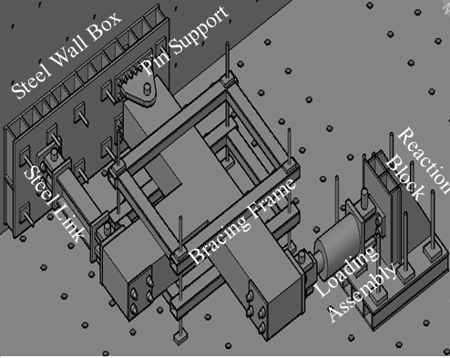 (b)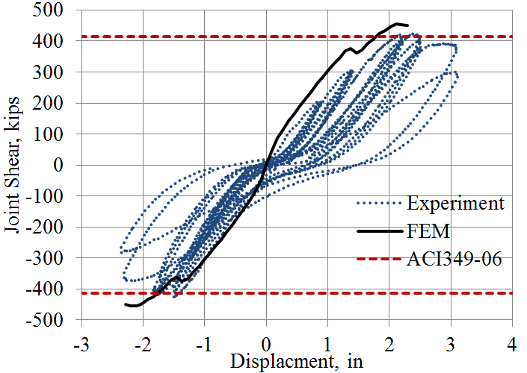 (c) 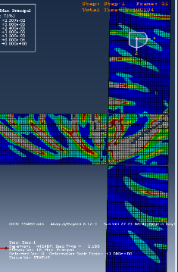
Figure 1. Experimental and Analytical Investigations of T- Joints Between SC Walls.
Impact and Value to Nuclear Applications: There is no governing design code in the United States for the design, inspection, and review of modular (SC) composite structures. This has been a significant challenge for the reviewers and delayed the licensing schedule for new power plants. The project results include: (i) standardized connection details, (ii) experimental performance, (iii) benchmarked models, and (iv) design approaches for SC wall connections, joints, and anchorages. This will expedite the design and the licensing of new power plants, thus benefiting the design industry, utilities, and regulators.
Recent Results and Highlights: In containment internal structures (CIS), SC Walls intersect with other SC walls forming T or L joints. The shear strengths of these T- or L- joints govern the performance of the structure for accident thermal, pressure, or other extreme events. The shear strengths of full-scale T- and L- joints were evaluated experimentally using the test setup shown in Figure 1(a) above. The experimental results shown in Figure 1(b) were compared with design equations from ACI 349-06 and 3D finite element models were developed and benchmarked as shown in Figure 1(c). The benchmarked models were used to conduct analytical parametric studies. The results from experimental and analytical studies were used to confirm the ACI 349-06 design code equation for estimating shear strength of T- and L- joints. Additionally, a full strength connection design approach was developed to prevent non-ductile (catastrophic) failure during extreme events.

FY12
Monitoring and Control of the Hybrid Laser-GMAW Process
D. C. Kunerth, Idaho National Laboratory, Idaho Falls, Idaho 83415
Funding: $800,000 (10/01/2012 – 09/30/2015)

Description of Project: Welding is a key fabrication process, a critical element in any nuclear system, and the subject of many sections of the relevant construction codes. One promising welding process of interest combines gas metal-arc welding (GMAW) and laser beam welding (LBW) into Hybrid Laser-Gas Metal-Arc Welding (LBW/GMAW), exploiting the synergistic effects of the conventional GMAW process and a new generation of powerful lasers. The dynamics of this relatively new process can be exploited by advanced weld control models and nondestructive sensing technologies to provide real-time diagnostics and control to join metal components reliably at weld travel speeds measured in inches per second. High speed processes provide the potential for high productivity, however, this can also contribute to the high productivity of flawed welds not necessarily detected by welder or system prior to post weld examination—possibly at an entirely different facility (i.e. radiography cave). Advanced process diagnostics combined with process modeling, an understanding of materials, and near-real time NDE of completed welds will provide a highly efficient joining process for the nuclear industry. Advanced automation like this enhances the productivity, quality and safety of fabrication processes for the new critical energy infrastructure. The project is collaboration between Idaho National Laboratory, Edison Welding Institute, and Electric Power Research Institute.

Impact and Value to Nuclear Applications: This work can provide enhancement in the operations for nuclear relevant joining processes by developing and demonstrating a prototype system based on a number of sensing and diagnostic tools to monitor and provide real-time weld process control information. The application of real-time sensors to the high-throughput welding process can provide measureable improvements in production rates and quality by detecting problems that lead to expensive repairs or scrapped material early in the process. The application also has the potential to provide automatic feedback to proactively adjust the process through feedback to the welding system (e.g. adjust laser power, travel speed, or GMAW parameters) to maintain weld quality. Ultimately, the technology seeks to achieve acceptance by nuclear energy safety stake holders for incorporating the inspection into the welding process, saving time and money in fabrication of nuclear power plants.

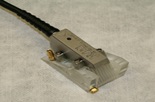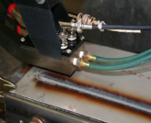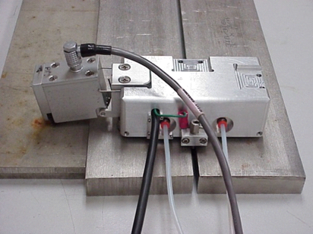
(a) (b) (c)
Figure 1. Shown in (a) phased array ultrasonic probe for real time diagnostics, (b) eddy current sensor for GMAW lack of fusion inspection, and (c) full weld eddy current inspection probe.

Recent Results and Highlights: Multiple sensor prototypes for near real-time deployment on hybrid welding systems have been developed and tested on the bench top. Real-time eddy current sensor for lack of fusion defects tested concurrent with GMAW welding. Probes, shown in Figure 1, are configured and designed to take advantage of hybrid weld temperature gradients while giving feedback in as near real time as possible.

FY 2013 Projects

FY13
Ultra-High Performance Concrete and Advanced Manufacturing Methods
for Modular Construction
Y.L. Mo and M. Li, University of Houston, Houston, Texas
J. G. Hemrick and D. Naus, Oak Ridge National Laboratory, Oak Ridge, Tennessee
M. Guimaraes, Electrical Power Research Institute, Charlotte, North Carolina
Funding: $337,374 (01/15/2014 – 01/14/2016)

Description of Project: This project successfully developed a new type of ultra-high performance concrete (UHPC), which features a compressive strength greater than 22 ksi (150 MPa) and that has self-consolidating characteristics desired for Small Modular Reactor (SMR) modular construction. With a high-strength and dense microstructure, this UHPC will facilitate rapid construction of steel-plate concrete (SC) beams and walls with thinner and lighter modules. This concrete can withstand harsh environments and mechanical loads anticipated during the service life of nuclear power plants. The self-consolidating characteristics are crucial for the fast construction and assembly of SC modules with reduced labor costs and improved quality. A database for the UHPC material characterization of mechanical and long-term durability properties will be established. Furthermore, steel-plate UHPC (S-UHPC) beams will be fabricated with cross ties and tested to verify the structural integrity of the system. The bond between UHPC and steel plates will be examined, and their interaction will be studied. The developed UHPC will be used in examining the S-UHPC wall module’s structural performance by large-scale testing and finite element simulation.

Impact and Value to Nuclear Applications: The value for reactor applications is that UHPC can significantly enhance the fabrication and manufacturing methods of modular construction. UHPC is expected to have superior durability and mechanical characteristics over conventional concrete. These characteristics include higher resistance to embedded steel corrosion and temperature, which is of great importance to the safe operation of nuclear power plants.

Recent Results and Highlights: For the first time, a new class of ultra-high performance concrete (UHPC) materials has been developed based on a systematic approach specifically for modular construction. The approach integrated micromechanics theory, design of experiments, hydration chemistry, rheology tailoring methods, and time-dependent computed microtomography (micro-CT) that can characterize material 3D microstructure formation and degradation. The new UHPC possesses a compressive strength exceeding 22 ksi (150 MPa) without special heat and pressure treatment by using a conventional concrete mixer and ingredients commercially available in the U.S.
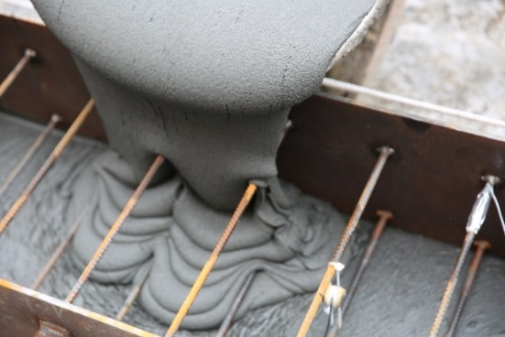
To achieve an ultra-high compressive strength of 22 ksi (150 MPa) of cementitious materials, the particle size distribution and the combined amount of water and chemical admixtures were determined, and a homogeneous cementitious material was obtained. With a slightly adjusted mixing procedure using large-scale gravity-based mixers (compared with small-scale force-based mixers), the self-consolidating UHPC has been successfully processed at six cubic yards (Fig. 1). The product met both minimum compressive strength requirements and self-consolidating concrete standards.
Figure 1. Large-scale production of UHPC.

FY13
Self-Consolidating Concrete Construction for Modular Units
Drs. Russell Gentry, Kimberly Kurtis, Bojan Petrovic,
Lawrence Kahn and Giovanni Loreto, Georgia Institute of Technology
Jurie Van Wyk and Carlos Cantarero-Leal, Westinghouse Corporation
Funding: $400,000 (02/01/2014 – 01/31/2016)

Description of Project: The primary objective of this project is to develop a unique concrete with self-roughening and self-consolidating properties, so that concrete can be placed into steel plate composite (SC) modular reactor structures without the need for continuous concreting operations. The self-roughening aspect of the material allows for concrete placement to stop and restart later, as the concrete develops a self-roughened surface that can transmit shear forces across the so called “cold-joint”. As part of the research, concrete mixtures are being developed and validated to ensure sufficient shear capacity across cold-joints, while minimizing shrinkage and temperature rise during concrete curing. A small-scale test article has been developed to assess the in-plane shear capacity of SC construction across the cold joint. This will allow us to assess a wide range of concrete material properties and steel plate configurations. Larger-scale beam specimens will be tested with in-plane and out-of-plane loading to confirm the small-scale test findings. One full-scale test, on an SC wall-section provided by Westinghouse, will be completed to validate the scale models. The team will propose code provisions for shear friction for the AISC N690 Appendix N9 code used for the structural design of SC modular reactors.

Impact and Value to Nuclear Applications: This new concrete will improve the construction and economy of modular reactor systems by facilitating the concrete construction while assuring high quality bonding of concrete and composite steel elements. This will be achieved through innovations in the composition and properties of the self-roughening self-consolidating concrete, where mixtures and processes are optimized to overcome challenges of cold-joint shear capacities, while also addressing heat generation and shrinkage at cold joints.

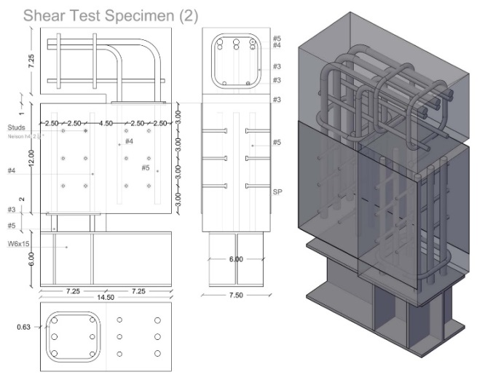
Updates to the SC design code and concrete specifications will allow for engineers to take advantage of these new materials and construction sequencing in future SC reactor construction.

Recent Results and Highlights: The first task of the research is complete, and the trial concrete mixes show excellent self-consolidating and self-roughening properties. The roughened surface amplitude exceeds the requirements set forth in ACI 349-06 for rough cold-joints – indicating that the full shear-friction action can be anticipated across the joints. Concrete shrinkage has been assessed using AASHTO T-160, and the observed shrinkage of 250 µε is well below the recommended upper limit of 400 µε. The production of small-scale shear specimens (see Fig.1) is almost complete, and it is anticipated that testing of these specimens were completed by the end of March 2015.
Figure 4. In-Plane Shear Specimens.

FY 2014 Projects

FY14
Improving Weld Productivity and Quality by means of Intelligent Real-Time Close-Looped Adaptive Welding Process Control through Integrated Optical Sensors
Jian Chen, Oak Ridge National Laboratory, Oak Ridge, TN 37831
Funding: $800,000 (09/01/2014 – 08/30/2017)

Description of Project: This project aims at developing a novel close-looped adaptive welding quality control system based upon multiple optical sensors. It will enable real-time weld defect detection and adaptive adjustment to the welding process conditions to eliminate or minimize the formation of major weld defects typically encountered in welding of high-performance engineering structural materials for nuclear structural components. The multi-optical sensing system mainly consists of a Digital Image Correlation (DIC) sensor, an infrared (IR) thermography sensor, a weld pool surface measurement sensor and the necessary auxiliary illumination sources and filters. The sensing system will be capable of concurrently measuring, in real-time, the changes in the welding temperature field (via IR camera), the strain field (DIC), and the weld pool surface vibration (high-speed camera). On the control side, an artificial intelligence (AI) based close-looped adaptive welding control unit will correlate the above measurement signals to the weld quality and provide feedback control signals in real time to the welding power source to adaptively adjust welding parameters producing defect-free high-quality weld.

Impact and Value to Nuclear Applications: The overarching goal of this project is to develop a novel close-looped adaptive welding quality control system that will enable real-time weld defect detection and adaptive adjustment to the welding process conditions to eliminate or minimize the formation of weld defects. It is highly relevant to the goals of significantly reducing the manufacturing cost of nuclear reactor structures and accelerating the deployment schedule. It specifically addresses the needs to develop “advanced (high-speed, high quality) welding technologies” for factory and field fabrication to significantly reduce the cost and schedule of new nuclear plant construction.

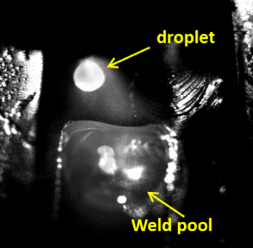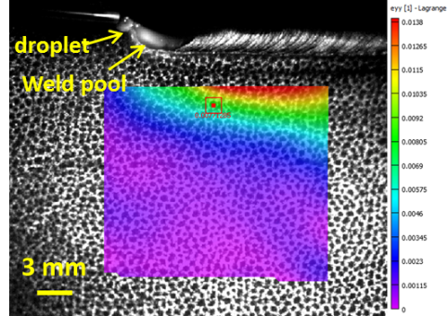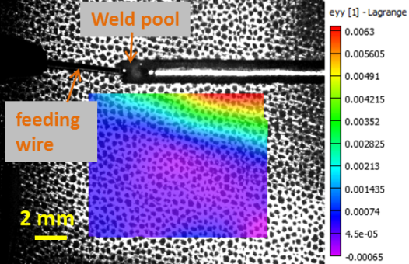
(a) (b) (c)
Figure 1. Shown in (a) a droplet formation and the weld pool during MIG welding; (b) transverse total strain distribution during TIG welding; (c) transverse total strain distribution during laser welding.

Recent Results and Highlights: The multi-optical sensing system is being tested in different welding conditions. The weld pool can be clearly visualized with our special optical system as shown in Fig. 1(a) during the MIG welding. The real-time strain evolution can also be measured using our newly developed high-temperature DIC technique. To the best of our knowledge, this is the first portable optical system that is able to measure in-situ strain field adjacent to the weld pool. The measurement system is immune to the intense welding arc/laser flume and high temperature. Figs.1 (b) and (c) are two examples of strain distribution maps in the transverse direction (normal to the welding direction) during TIG and laser welding processes respectively.

FY14
Periodic Material-Based Seismic Base Isolators for Small Modular Reactors
Y.L. Mo, University of Houston, Houston, Texas
Y. Tang, Argonne National Laboratory, Argonne, Illinois
K. Barry, Electrical Power Research Institute, Charlotte, North Carolina
K.C. Chang, National Center for Research on Earthquake Engineering, Taipei, Taiwan
Funding: $800,000(10/01/2014 – 09/30/2017)

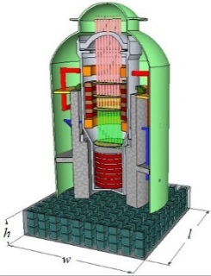
Description of Project: The research seeks to develop periodic foundations for small modular reactors (SMR) using innovative periodic material. The periodic material is inspired by the concept of phononic crystal in solid-state physics. This material lacks certain frequency bands and cannot transmit motions in the frequency band gaps. This deficiency, however, is a much-needed feature for the seismic base isolation system. With a proper design, the periodic foundation will be able to block incoming seismic waves before they reach the superstructure. The focus will be on the design of a periodic foundation with a SMR as the superstructure (Fig. 1) and will be verified by shake table tests.
Figure 1. SMR with (3D) periodic foundation.

Impact and Value to Nuclear Applications: The value of this material for SMR foundation applications is that it can be properly designed according to the site-specific earthquake and/or the natural frequency of the SMR. The use of periodic foundations for a SMR will allow for a reduction of the input acceleration transmitted to the reactor while maintaining the minimum relative displacement. These two advantages will increase the safety of both structural and nonstructural components of a SMR and eliminating the need of special design and restrictions on the components.

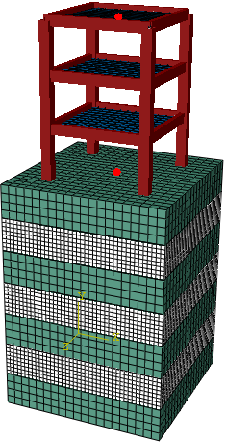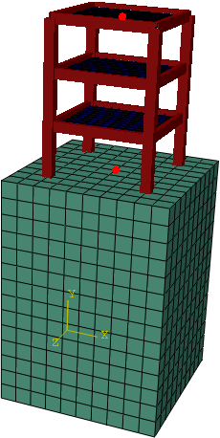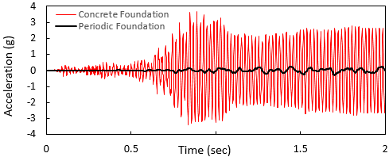
- (a) (b)
Figure 2. (a) Different foundation type case studies (b) Top of the superstructure acceleration comparison.

Recent Results and Highlights: In a 1D periodic foundation, a single unit cell typically consists of two different layers and is periodically repeated in one direction. Concrete and rubber are considered as the most suitable material for 1D periodic foundations due to the material properties and the economic feasibility. Finite element simulations were conducted to study the behavior of 1D periodic foundations. The responses were compared to two identical three-story frame superstructures attached to a periodic foundation and a concrete foundation (Fig. 2a). Because the seismic waves completely pass through the concrete foundation, the acceleration at the top of the superstructure was amplified significantly. Conversely, as the periodic foundation blocked the seismic waves inside the attenuation zone, the acceleration response at the top of the superstructure was reduced effectively (Fig. 2b). Therefore, it is proven that the periodic foundation is effective in protecting the superstructure.

FY14
Improvement of Design Codes to Account for Accidental Thermal Effects on Seismic Performance
A. H. Varma, Purdue University, West Lafayette, IN 47906
Funding: $800,000 (10/01/2014 – 09/30/2017)

Description of Project: The Fukushima nuclear accident of 2011 has highlighted the importance of designing safety-related nuclear facilities for accident thermal scenarios combined with design basis and beyond design basis shaking. While the probability of both events occurring simultaneously is low, severe environmental conditions may trigger accident thermal loading. Furthermore subsequent aftershocks, potentially as intense as the main shock, may occur during the accident thermal event. Current design codes and standards in the United States and abroad provide little-to-no guidance for including the effects of accident thermal loading on seismic behavior (stiffness, strength, ductility or reserve margin) of structures. The overall goal of this research project is to develop knowledge-based design guidelines for safety related nuclear facilities subjected to combined accident thermal conditions and seismic loading.

The project involves the following detailed tasks:
1. Identification of parameters influencing behavior and finalization of accident thermal conditions,
- Experimental evaluation of the effects of accident thermal conditions on the seismic (in-plane shear) behavior of SC and RC walls,
- Development and benchmarking of numerical models for predicting experimental results and observed behavior,
- Comprehensive analytical parametric studies to evaluate the influence of various parameters,
- Development of design guidelines and analysis recommendations for design basis and beyond-design basis events involving combinations of accident thermal conditions and seismic loading
(a) 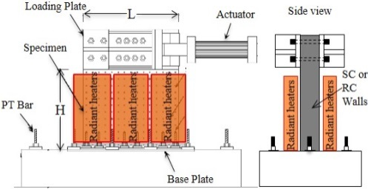 (b) 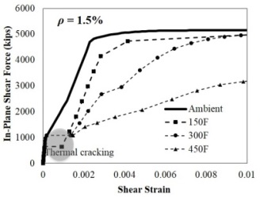
Figure 1. Experimental and Analytical Investigations of Accident Thermal + Lateral Loading of SC Walls
Impact and Value to Nuclear Applications: The project outcomes will include fundamental knowledge in terms of experimental results, benchmarked numerical models, and analytical results regarding the influence of accident thermal conditions and various parameters on the seismic behavior (stiffness, strength, and ductility) of SMRs and ALWRs. This knowledge will expedite future design and licensing through validated recommendations for analysis and design, suitable for consideration by committees of ACI 349 and AISC N690 (design and detailing) and ASCE Standards 4 and 43 (analysis and design).

Recent Results and Highlights: The test setup for conducting the experimental investigations is shown in Figure 1(a). The walls will be subjected to cyclic lateral loading using two 1000-kip capacity hydraulic actuators in displacement control. The specimens will be subjected to heating (accident thermal histories) on their exterior surfaces. Figure 1(b) shows sample results from shell finite element analyses of SC wall panels subjected to accident thermal loading followed by mechanical loading. The figure includes the in-plane shear force-shear strain responses for SC walls with 1.5% reinforcement ratio. It includes the response for ambient conditions, 150, 300 and 450°F maximum temperature for three hours. As shown, accident thermal conditions potentially have a significant influence on the in-plane shear stiffness, strength, and deformation capacity of walls for safety-related nuclear facilities.

