Office of Indian Energy Policy and Programs
NREL Team Bios

National Renewable Energy Laboratory Project Team
The U.S. Department of Energy’s National Renewable Energy Laboratory (NREL) provides technical support to the Office of Indian Energy Policy and Programs. The NREL team includes:
Dan Beckley
Dan Beckley is a Principal Laboratory Program Manager at NREL. He provides oversight and guidance for the NREL Office of Indian Energy Policy and Programs project team. Mr. Beckley was a Presidential Management Fellow in the U.S. Department of Energy’s Office of Energy Efficiency and Renewable Energy prior to joining NREL.

Liz Doris
Liz Doris is a Senior Project Leader at NREL specializing in understanding strategies for developing clean energy technologies in a variety of markets. She is the project manager for the NREL Office of Indian Energy Policy and Programs project team. Ms. Doris has managed state and local policy and technical assistance project teams for NREL since 2006. Prior to NREL, she managed state and local efforts at the American Council for an Energy-Efficient Economy.

Alexander Dane
Alexander Dane is a Project Leader at NREL, specializing in clean energy planning and project implementation at a local level. Mr. Dane focuses on implementation and document recasting for the NREL Office of Indian Energy Policy and Programs project team.

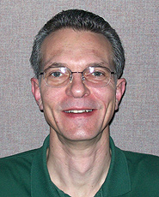
Erik Ness
Erik Ness is a Project Leader at NREL. His responsibilities include education and document recasting for the NREL Office of Indian Energy Policy and Programs project team. Mr. Ness’ experience includes Treasury 1603 management and tribal communications.

Dr. Brian Hirsch
Dr. Brian Hirsch is a Senior Project Leader for NREL’s Alaska initiative, working with Alaska native tribes and other stakeholders on development of local energy resources. As part of the NREL Office of Indian Energy Policy and Programs project team, Dr. Hirsch is responsible for technical assistance and project implementation in Alaska.

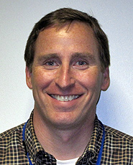
Robert Springer
Bob Springer is a Senior Project Leader at NREL. As part of the NREL Office of Indian Energy Policy and Programs project team, Mr. Springer is responsible for technical assistance and project implementation in the lower 48 states. His experience includes project development and finance.

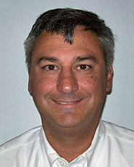
Jeffrey Bedard
Jeff Bedard is a Senior Project Leader at NREL, helping to develop large-scale renewable energy projects and to create sustainable, net zero energy communities. As part of the NREL Office of Indian Energy Policy and Programs project team, Mr. Bedard is responsible for technical assistance and project implementation in the lower 48 states.

