Investment Grade Audit and
Insert user logo
Project Proposal
Attachment J

ATTACHMENT J. Deep Energy Retrofit Planning

What is a deep energy Retrofit?
A Deep Energy Retrofit is the integrative analysis and design process that enables projects to achieve over 50% annual operational cost savings with attractive financial returns. Key aspects to the deep energy retrofit process include:

- Timing the deep retrofit to coincide with planned capital improvements, breaks in occupancy and other key timing indicators;
- Applying integrative design principles to achieve more holistic retrofits at equal or lower capital costs;
- Using advanced energy modeling, auditing and life cycle cost analysis methods and tools; and,
- Engage occupants to modify behavior, one of the biggest factors impacting energy use.
- Metering and continuous recommissioning to verify savings and to provide feedback for optimizing building performance over time .

Lessons learned from deep energy retrofits can go beyond energy savings on individual buildings to impact a whole portfolio of similar buildings.

ESCO’s in general currently get 15-30% savings-we think 40-60% could be profitable for ESCO and building owners who have aligned goals to minimize life cycle costs, and improved processes and tools.

Describe the value, risk and risk management on a Deep Retrofit?
The following tables summarize the potential value of a deep retrofit to an ESCO and an owner. They also summarize risks and ways to manage those risks.

Value of a Deep Retrofit to an ESCO
- Larger project size
- Increase market size (new access)
- Increase market share (differentiated offer)
- Builds longer-term customer relationships

ESCO’s Risks on a deep retrofit | Risk management
Increased project development and construction time/complexity (more capital at risk) | More extensive analysis leads to a better understanding of the building, less risk of poor project performance . More comprehensive solutions = bigger overall project funded with more savings. Workshops with owners and technical experts help compress time, get a variety of design/construction perspectives. Multiple projects cause learning curves to reduce project time for future deep retrofits. Owners commit to pay for a greater percentage of the actual upfront analysis costs and are committed to the goal of a deep retrofit project.
Savings calculations inaccuracy/complexity | Use experienced modelers, train in-house experts
Lack of design integration competency/coordination of skills | Bring in experts other than traditional Mechanical and Electrical engineers.
Challenging determining good deep retrofit candidates | Make sure owner is on board, understand ripeness indicators, continue to refine with lessons learned
Real value beyond ‘business as usual’ - how to quantify non energy benefits, take credit and account for their economic value | Educate client regarding other benefits beyond energy cost savings. The value needs to be included in the economic business case decision.
Lack of owner interest/motivation | Owner education, mandates (federal), recognition, values beyond energy cost savings (branding, space efficiency, productivity, and asset value), industry awareness and competition, case studies. Federal and state government need to provide financial incentives for case studies.
Decrease excessive design safety margins (smaller mech equipment, more focus on load reduction and passive ECM’s) | Leverage other building technologies for overall larger project, monetize additional services (O&M savings, space efficiency, health improvement)

Value of a Deep Retrofit to an Owner
- Reduced/controlled energy costs
- Advantageous long term financing terms/cost-benefit matching
- High occupant value
- Deferred maintenance
- Space efficiency/flexibility

Owners Risks on a deep retrofit | Risk management
Potential for longer project construction, occupant interruption | Understand process at onset, learning curve to overcome. Proper owner education on the full long term project value. Careful designs can minimize/eliminate occupant interruption.
Potential for budget overrun since longer list of ECM’s | Proper analysis of ECM interactions justifies the selection of the ECMs included in the project. Due to complexity of design owner approves a larger contingency for project costs.
More extensive contract oversight | Better understanding of building stemming from rigorous ESCO analysis reviewed by a technically competent owner’s representative familiar with ESCO deep retrofit design yields fewer uncertainties.
With additional complexity, challenge meeting performance guarantee | Owner invests in appropriate performance based maintenance and continuous commissioning services to optimize performance over time
Longer contract term | Approval by project finance decision makers to extend the term for financing and project performance.

Example:
- Integrative design can lead to smaller mechanical equipment (since loads have been reduced) but a broader bundle of ECM’s.
- Makes total project bigger, even though smaller mech equipment
- This very optimistic example makes it clear that only rather large buildings with high energy costs could afford the extra design and M&V services and large envelope measures needed to justify a deep retrofit

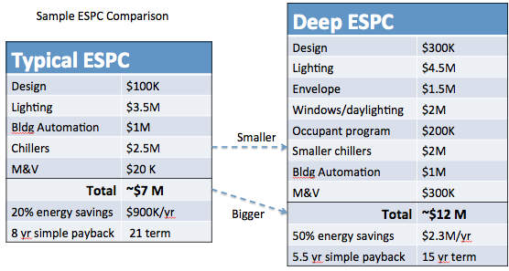

Key learnings from successful deep retrofit projects:
- Collaborative, multidisciplinary team was challenging to maneuver but ultimately highly beneficial to ECM’s. Would go smoother on future projects.
- A highly informed and motivated client is a must – too hard to drag an unreceptive client through the process. These are few unfortunately.
- Documenting the business as usual baseline is critical for demonstrating the business case. Also very challenging to get consensus on realistic, agreed-upon long term avoided costs that include non-energy benefits.
- The additional time for the technical potential workshop and investigating a large number of ECM’s (i.e.72) is worth it. It changes the design objective-leaving nothing on the table. Time could be saved in the future with the same team.
- Including tenant related ECM’s is key, although rarely included in ESPC due to the split incentive problem.

How do we tell if a building is ‘ripe’ for a deep energy retrofit?
Not every building is ready for a deep retrofit. Deep retrofits should be carefully timed based on the long-term plan for a building. The following are situations in a building’s life cycle that should trigger a deep energy retrofit design and analysis.

Deep Retrofit Trigger | Description
Adaptive reuse or market repositioning | Redeveloping an existing building will require significant capital expense to which the cost of a deep retrofit would be incremental and likely small in comparison.
End (or near end) of life roof, window or siding replacement | Planned roof, window and siding replacements provide opportunities for significant improvements in daylighting and efficiency at small incremental cost, providing the leverage for a deep retrofit that reduces loads and therefore the cost of replacing major equipment such as HVAC and lighting.
End (or near end) of life HVAC, lighting or other major equipment replacement | Major equipment replacements provide opportunities to also address the envelope and other building systems as part of a deep retrofit. After reducing thermal and electrical loads, the marginal cost of replacing the major equipment with much smaller equipment (or no equipment at all) can be negative. This logic only works if the owner has the capital to fund the major capital improvements.
Upgrades to meet code | Life safety upgrades may require substantial disruption and cost, enough that the incremental investment and effort to radically improve the building efficiency becomes not only feasible but also profitable.
New Acquisition or Refinancing | New acquisition or refinancing at historically low interest rates can put in place attractively financed building upgrades as part of the transaction, upgrades that may not have been possible at other times.
Fixing an “energy hog” | There are buildings, often unnoticed, with such high energy-use or high energy-prices (perhaps after a major rate increase) that deep retrofits have good economics without leveraging any of the factors above.
Major occupancy change | A company or tenant moving a significant number of people or product into a building or major turnover in square footage presents a prime opportunity for a deep retrofit, for two reasons. First, a deep retrofit can generate layouts that improve energy and space efficiency, and can create more leasable space through downsizing mechanical equipment. Second, ownership can leverage tenant investment in the fit-out.
Energy management planning | As part of an ongoing energy management plan for a group of buildings, the owner may desire a set of replicable efficiency measures. These measures can be developed from the deep retrofit of an archetypical building.

How is the process for a deep energy retrofit different?
When targeting aggressive building energy goals, understand what is technically feasible for lowering your building’s energy use before bending to the constraints of schedule, timing, and budget. When we use constraints as our design guidelines, we often arrive at incremental energy reductions. Understanding what is technically possible before leaping to what is implementable can help design teams to arrive at more creative and cost-effective solutions.
The technical potential approach is a process used to first identify the lowest possible energy use of a building or system using integrated efficiency measures and available technology, and then, determine what is implementable by systematically reintroducing project constraints. As each constraint (e.g. budget, schedule) is reintroduced, the team can understand and quantify the true impacts of that constraint and determine a strategy (if any) to implement desired measures.
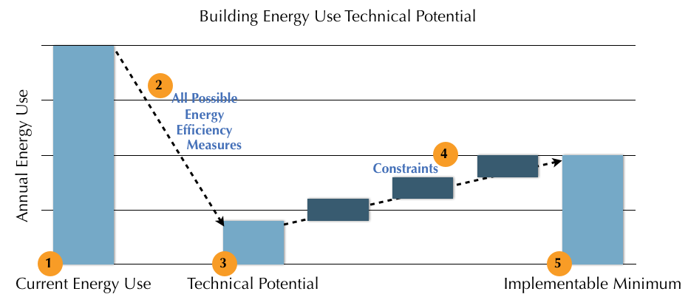
Step 1: Determine the current energy use and energy-use break down
Step 2: Brainstorm an extensive list of energy efficiency measures (ranging from envelope measures to day lighting to system efficiencies to system elimination). Model various bundles of measures.
Step 3: Identify the technical potential-the lowest possible technically feasible energy use
Step 4: Apply constraints (i.e. time, financial)
Step 5: Arrive at the implementable minimum
The technical potential changes the engineering conversation from ‘we can’t because…’ to ‘how can we do that despite…’

Resources:
All things related to Deep Retrofits
www.retrofitdepot.org

Deep Retrofit case studies
http://newbuildings.org/existing-buildings

NEEA Existing Buildings Renewal Program
http://neea.org/initiatives/commercial/existing-building-renewal

Deep energy retrofits at GSA
http://www.rmi.org/Knowledge-Center/Library/2013-10_GSAReportCharette

